MASTER OF COMPUTER APPLICATIONS

**ALIGARH** **MUSLIM** **UNIVERSITY**









CAMS 1P01: LABORATORY COURSE 1

## SUBMITTED BY: SUBMITTED TO:

MOHD YUSUF Mr. Imshad Ahmad Khan

23CAMSA138

GL7626



|  |  |  |  |  |
| --- | --- | --- | --- | --- |
| **WEEK NO.** | **PROBLEMS WITH DESCRIPTION AND CONTENTS** | | **PAGE NO.** | **SIGNATURE OF TEACHER WITH DATE** |
| **WEEK 1** | #1 | Enclosure: Resume (the format given below).   1. Save the document as "Letter.doc." 2. Send the document to 3 recipients using Mail merge. (Use 3 different addresses) 3. Define a Macro 'Decorate' which makes the text bold, Red in color and italic, font size Assign a shortcut key Alt + Z to this macro. 4. Close the document. 5. The Sample Addresses are: 6. Mr. Amit Tandon   13, New Estate,  Ring Road, Chandigarh   1. Mr. Rohit Saluja   15, Karol Bagh, New Delhi   1. Ms. Jyoti Parmar   Sector 16, New Building, Gurugram. |  |  |
| #2 | Create a table in word and complete the given exercise.   1. In the total marks' column, entries should be calculated using formulas and it is the sum of marks in physics and marks in chemistry. 2. Insert a new row at the end of the table and also find grand total using formula. 3. Sort the table based on total marks. 4. The date and heading should be center aligned. 5. Heading should be in bold and underlined |  |  |
| #3 | Using a spreadsheet package you have studied, construct T Morongo's pay slip for December 2016 following the instructions below. Insert a custom footer with your name, subject, course, exam/Test &question number. Save it as Salary advice.   1. Housing Subsidy 6000.00 per year. 2. Car Allowance 100.00 per month, 3. Pension 8% on Basic Salary. 4. PAYE 636.83 5. Medical Aid 70.00 6. U.I.F. 1% on Basic Salary + Housing Subsidy 7. Bond Repayment 630.00 8. Calculate Net Salary. 9. Format all figures to two decimal places and insert ₹ currency symbol. 10. Insert a custom footer with your name, subject, and question number. Save it as salary advice2. |  |  |
| #4 | Use a new workbook & construct a worksheet with the data given & save it as LYONS.   1. The MARKUP % (35%) must be inserted in a separate cell under the heading. USE IT as an absolute cell reference in the formula to calculate the mark up per item. 2. Calculate the mark up for each item. 3. Calculate the selling price for each item. 4. Calculate the Total Income for each item. 5. Calculate the profit for each item. 6. Format the column LITRES SOLD to display the number of litres as integers. The rest of the worksheet must be formatted to display two decimals. 7. Use statistical functions to calculate the: ✓ AVERAGE ✓ HIGHEST (MAX.) ✓ LOWEST (MIN) for Selling Price column up to Profit Column. 8. Show all formulas you have used in a new sheet. Adjust the column width so that the formulae are displayed in full and the sheets fits into one side of A4 landscape format and save it as formulas. 9. Under the worksheet Create a pie chart titled PRODUCT COST PER UNIT for Product & Cost price per Litre columns. Data labels indicating percentages should be displayed. 10. Put borders neatly on the on the work sheet & save it as LYONS2. |  |  |
| **WEEK 2** | #1 | Design Seasonal Greeting cards using MS-Power Point. |  |  |
| #2 | Design an AMU Magazine cover in MS-Power Point. Use the following:   1. Select a theme for the page, 2. Insert either a picture or clipart, and 3. Use WordArt. |  |  |
| #3 | Design a poster inviting all students of your department to the IT Fest (using MS-Power Point). |  |  |
| #4 | Create a 5-slide presentation on any topic. Use Images, Graphs, Chart, Tables, Animation, Time, Bullets, Transition, Sound, Hyperlink, Background template, Header and Footer (using MS-Power Point). |  |  |

|  |  |  |  |  |
| --- | --- | --- | --- | --- |
| **WEEK 3** | #1 | Basic concept of C++, Dev C++ IDE Installation guide, Code Block installation guide. |  |  |
| **WEEK 4** | #1 | Write a C++ program to check whether a number is even or odd using ternary operator. |  |  |
| #2 | Write a C++ program to perform the addition of two numbers without using + operator. |  |  |
| #3 | Write a C++ program to evaluate the arithmetic expression  ((a + b / c * d - e) * (f - g)). Read the values a, b, c, d, e, f, g from the standard input device. |  |  |
| #4 | A Fibonacci sequence is defined as follows: The first and second terms in the sequence are 0 and 1. Subsequent terms are found by adding the preceding two terms in the sequence. Write a C++ program to generate the first n terms of the sequence. |  |  |
| #5 | Write a C++ program to generate all the prime numbers between 1 and n, where n is a value supplied by the user. |  |  |
| #6 | A character is entered through keyboard. Write a C++ program to determine whether the character entered is a capital letter, a small case letter, a digit or a special symbol using if-else and switch case. The following table shows the range of ASCII values for various characters. Characters ASCII values A – Z: 65 – 90, a – z: 97 – 122, 0 – 9: 48 – 57 Special symbols 0 – 47, 58 – 64, 91 – 96, 123 – 127 |  |  |
| #7 | Write a C++ program to find the roots of a quadratic equation. |  |  |
| #8 | Write a C++ program to check whether a given 3-digit number is Armstrong number or not. |  |  |
| **WEEK 5** | #1 | Write a C++ program to find the second-largest integer in a list of integers. |  |  |
| #2 | Write a C++ program to perform the following: a. Addition of two matrices b. Multiplication of two matrices |  |  |
| #3 | Write a C++ program to count and display positive, negative, odd and even numbers in an array. |  |  |
| #4 | Write a C++ program to merge two sorted arrays into another array in sorted order. |  |  |
| #5 | Write a C++ program to find the frequency of a particular number in a list of integers. |  |  |
| **WEEK 6** | #1 | Write a C++ Program for Add Two Numbers Using Pointer. |  |  |
| #2 | Write a program for reading elements using a pointer into an array and display the values using an array.   1. Declare a set of elements. 2. Declare the pointer and initialize it to the first element address of a set of elements(array). 3. Repeat the loop until the pointer reaches to the last element and displays each element. |  |  |
| #3 | Write a program through a pointer variable to the sum of n elements from the array. |  |  |
| #4 | Write a program for reading elements using a pointer into th e array and display the values using an array. |  |  |
| #5 | Write a C++ program to reverse a string using pointers. |  |  |
| **WEEK 7** | #1 | Write a C++ program using pointers to compute the sum, mean and standard deviation of all elements stored in an array of n real numbers. |  |  |
| #2 | Write a C++ program using pointers to compute the sum, mean and standard deviation of all elements stored in an array of n real numbers. |  |  |
| #3 | Develop a C++ program to find the greatest of two numbers using this pointer which returns the member variable. |  |  |
| #4 | Write a C++ program to implement flight class with data member as flight_no., source destination and fare. Write a member function to display the flight information using this pointer. |  |  |
| #5 | Write a C++ program to use this pointer and return the pointer reference. |  |  |
| **WEEK 8** | #1 | Write a C++ program that uses functions to perform the following operations:   1. To insert a sub string into a given main string from a given position. 2. To delete n characters from a given position in a given string. |  |  |
| #2 | Write a C++ program to determine if the given string is a palindrome or not. |  |  |
| #3 | Write a C++ program to find a string within a sentence and replace it with another string. |  |  |
| #4 | Write a C++ program that reads a line of text and counts all occurrence of a particular word |  |  |
| #5 | Write a C++ program that reads a line of text and counts all occurrence of a particular word |  |  |
| **WEEK 9** | #1 | Write C programs that use both recursive and non-recursive functions to find:   1. The factorial of a given integer. 2. To find the greatest common divisor of two given integers. |  |  |
| #2 | Write C programs that use both recursive and non-recursive functions to solve towers of Hanoi problem. |  |  |
| #3 | Write a C++ program to print the transpose of a given matrix using function. |  |  |
| #4 | Write a C++ program to swap two number by both call by value and call by reference mechanism, using two functions swap_value() and swap_reference respectively, by getting the choice from the user and executing the user’s choice by switch-case. |  |  |
| #5 | Write a C++ program to display all array elements using recursion. |  |  |
| #6 | Write a C++ program to find sum of elements of array using recursion. |  |  |
| #7 | Write a C++ program to find maximum and minimum elements in array using recursion. |  |  |
| **WEEK 9** | #8 | Consider the insurance database given below. The primary keys are made bold and the data types are specified. PERSON (driver_id:string , name:string , address:string ) CAR(regno:string , model:string , year:int ) ACCIDENT(report_number:int , accd_date:date , location:string ) OWNS(driver_id:string , regno:string ) PARTICIPATED (driver_id:string, regno:string, report_number:int , damage_amount:int).   1. Create the above tables by properly specifying the primary keys and foreign keys. 2. Enter at least five tuples for each relation. 3. Update the damage amount for the car with specific regno in the accident with report number 12 to 25000. 4. Add a new accident to the database. 5. Find the total number of people who owned cars that were involved in accidents in the year 2008. 6. Find the number of accidents in which cars belonging to a specific model were involved. |  |  |
| **WEEK 10** | #1 | Write a C++ program that uses functions to perform the following operations:   1. Reading a complex number. 2. Writing a complex number. 3. Addition and subtraction of two complex numbers. 4. Multiplication of two complex numbers. Note: represent complex number using a structure. |  |  |
| #2 | Write a C++ program to compute the monthly pay of 100 employees using each employee’s name, basic pay. The DA is computed as 52% of the basic pay. Gross-salary (basic pay + DA). Print the employees name and gross salary. |  |  |
| #3 | Create a Book structure containing book_id, title, author name and price. Write a C++ program to pass a structure as a function argument and print the book details. |  |  |
| #4 | Create a union containing 6 strings: name, home_address, hostel_address, city, state and zip. Write a C++ program to display your present address. |  |  |
| #5 | Write a C++ program to define a structure named D.O.B., which contains name, day, month and year. Using the concept of nested structures display your name and date of birth. |  |  |
|  | #6 | Consider the following database for a banking enterprise. BRANCH (branch_name:string , branch_city:string , assets:real ) ACCOUNT( accno:int , branch_name:string , balance:real ) DEPOSITOR( customer_name:string , accno:int ) CUSTOMER ( customer_name:string, customer_street:string , customer_city:string ) LOAN ( loan_number:int , branch_name:string , amount:real )BORROWER( customer_name:string , loan_number:int )   1. Create the above tables by properly specifying the primary keys and foreign keys. 2. Enter at least five tuples for each relation. 3. Find all the customers who have at least two accounts at the main branch. 4. Find all the customers who have an account at all the branches located in a specific city. 5. Demonstrate how you delete all account tuples at every branch located in a specific city. |  |  |
| **WEEK 11** | #1 | Write a program in C++ to display your name, Branch, Year on to the computer screen without using classes and object. All information should be displayed in the separate line. |  |  |
| #2 | Write a menu driven program in C++ to perform all basic arithmetic operation addition, subtraction, multiplication, and division of two given values. Program receives two values and required operation to be performed from the keyboard and display particular result of the required operation. |  |  |
| #3 | Write a menu driven program in C++ that receives 4-digit integer value the keyboard and perform following operations:   1. Reverse of that no. 2. sum of number with its reverse. 3. sum of alternative digits (1 digit+3 digit and 2 digit+4 digit) |  |  |
| #4 | Write a menu driven program in C++ to receive integer number and convert equivalent binary, octal, hexadecimal number. |  |  |
| #5 | Write a menu driven program in C++ to perform all basic arithmetic operation addition, subtraction, multiplication, and division of two given values using function and switch case. Program receives two values and required operation to be performed from the keyboard and display particular result of the required operation. |  |  |
|  | #6 | Define a class Bank Account to represent a bank account. Include the following members:  Data Members:   * Name of the depositor. * Account Number * Type of account * Balance amount in the account   Member Functions:   * To assign initial value * To deposit an amount * To withdraw an amount after checking |  |  |
| **WEEK 12** | #1 | Write a program in C++ to demonstrate default constructor. Create a class having two data members in the private section. Define a default constructor to initialize these data members to initial value and display these values with the help of member function. |  |  |
| #2 | Write a program in C++ to demonstrate parameterized/constructor overloading constructor. Create a class calculator that contains four data members in it. Initialize data members with different values using parameterized constructor and perform various arithmetic operation over these values and display result on to the computer screen. |  |  |
| #3 | Create a class called Triangle that stores the length of the base and height of a right triangle in two private instance variables. Include a constructor that sets these values. Define two functions. The first is hypo( ), which returns the length of the hypotenuse. The second is area ( ), which returns the area of the triangle. |  |  |
| #4 | Create a class for counting the number of objects created and destroyed within various block using constructor and destructors. |  |  |
| #5 | Create an inter University Database with the following relations. Include at least four attributes for each table. • University • Department • Program • Course • Syllabus • Faculty(Teacher)   1. Create above tables and mention primary keys and foreign keys. Also create secondary index for each table. 2. Insert at least 5 relevant records in each of the created tables. 3. Write following SQL queries based on above created database: 4. List of Universities situated at Delhi. 5. List of all Departments of AMU. 6. Find the location of JNU. 7. List of all Programs run by University of Jammu. 8. List of Universities that run Program "MCA". 9. List of Courses of "MCA" run by AMU. 10. List of Faculties specialized in "Information Security" across different universities. 11. Syllabus of "Computer Architecture" of different Universities. |  |  |
| **WEEK 13** | #1 | Declare a class Number that contains two data member value1 and value2 of the type of integer, define constructor to give initial value, and perform addition, subtraction, multiplication and division of these two numbers using operating overloading of +, -, *, / operator respectively [hint- binary operator overloading using member function] |  |  |
| #2 | Declare a class Number1 that contains two data member value1 and value2 of the type of integer, define constructor to give initial value, and perform addition, subtraction, multiplication and division of these two numbers using operating overloading of +, -, *, / operator respectively [hint- binary operator overloading using friend function] |  |  |
| #3 | Declare a class Number3 that contains a data member value of the type of integer, define constructor to give initial value, and perform unary minus, increment and decrement this number using operating overloading of -, ++, - - operator respectively [hint- Unary operator overloading using member function] |  |  |
| #4 | Write a program to demonstrate explicit type conversion   * from basic type to user defined data type. * from User Defined data type to Basic data type data type. |  |  |
| #5 | Create a class publication which has title of book and writer’s name. Create other class sales which account no. of sales for every month (up to 3 months)and then calculate total sales. |  |  |
| #6 | Write a program to demonstrate the following: STAFF Teaching Non-Teaching Officer Regular Casual |  |  |
|  | #7 | Write a program to solve the ambiguity problem in inheritance where two different classes are inherited from single base class and a new class is derived from these two derived classes. How this problem is solved with the help of virtual base class concept. |  |  |
| **WEEK 14** | #1 | Write a program to use ‘this’ pointer to find elder from two person. Define a class Person to store age of the person. Define constructor/member function to give initial value to the data member age. And then define a function elder to compare ages of two different persons using this pointer to find out the elder person. |  |  |
| #2 | Create a simple “shape” hierarchy: a base class called Shape and derived classes called Circle, Square, and Triangle. In the base class, make a virtual function called draw ( ), and override this in the derived classes. Make an array of pointers to Shape objects that you create on the heap (and thus perform up casting of the pointers), and call draw ( ) through the base-class pointers, to verify the behavior of the virtual function. If your debugger supports it, single-step through the code. |  |  |
| #3 | Write a small program to show the difference between calling a virtual function inside a normal member function and calling a virtual function inside a constructor. The program should prove that the two calls produce different results. |  |  |
| #4 | Write a program in C++ to calculate mean value of n numbers using friend function. |  |  |
| #5 | Write a program to accept five different numbers by creating a class called friend func1 and friend func2 taking 2 and 3 arguments respectively and calculate the average of these numbers by passing object of the class to friend function. |  |  |
| #6 | Write a program in C++ to display student’s information using friend function.. |  |  |
| #7 | Write a C++ program to write text in the file. Read the text from the file from end of file. Display the contents of the file in reverse order. |  |  |
| #8 | Write a C++ program to count the no. of characters present in the file. |  |  |
| #9 | Create a class with a main () that throws an object of class Exception inside a try block. Give the constructor for Exception a String argument. Catch the exception inside a catch clause and print the String argument. Add a finally clause and print a message to prove you were there. |  |  |



WEEK 1

### WEEK 1

**#1 Open a new document and type the given letter.**

1. **Save the document as “Letter.doc.”**
2. **Send the document to 3 recipients using Mail merge. (Use 3 different addresses)**
3. **Define a Macro ‘Decorate’ which makes the text bold, Red in color and italic, font size Assign a shortcut key Alt + Z to this macro.**

***STEPS:***

**For (i):**

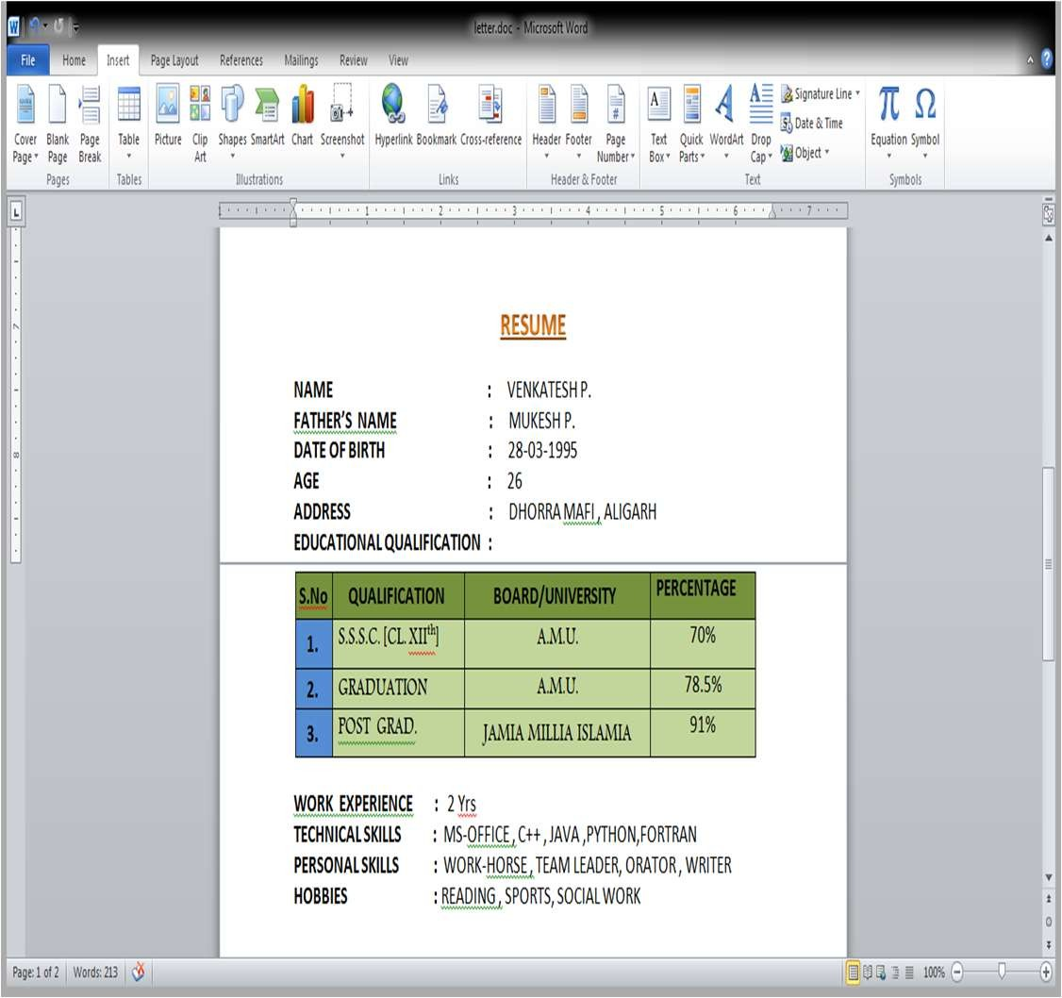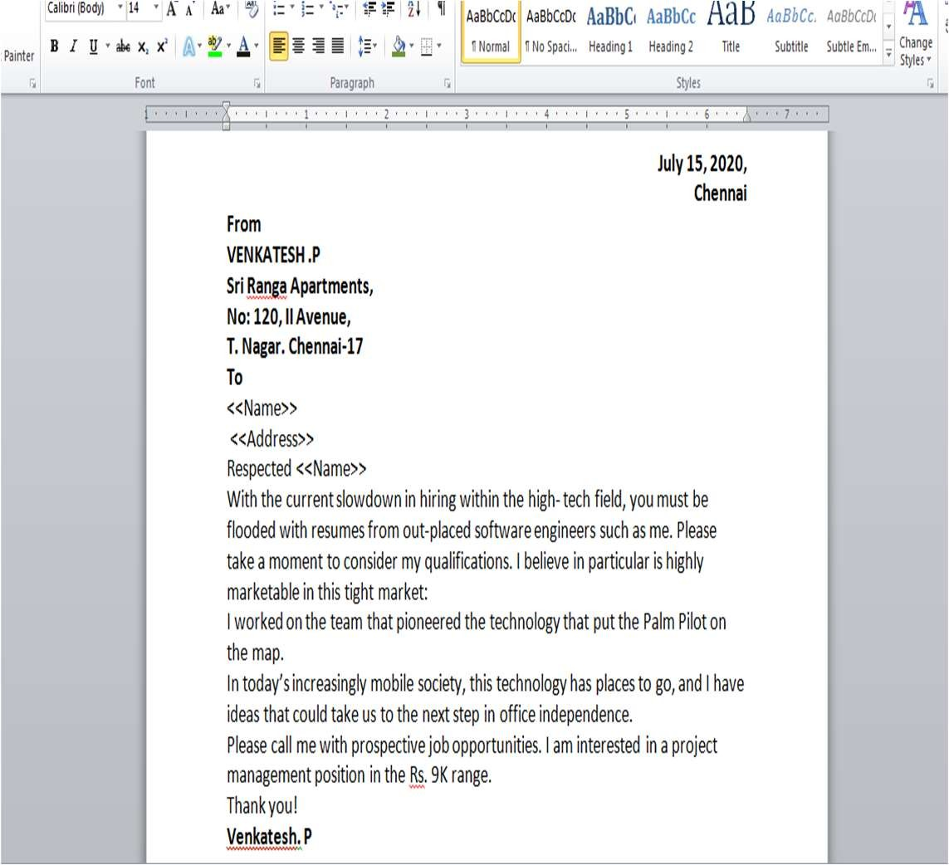

•

**For (ii)**

**FOR MAIL MERGE:**

• 



:

**:**

•

•

•



**Next:Write your letter**

**.**

**Next:Preview your letters**

•

•

•

•

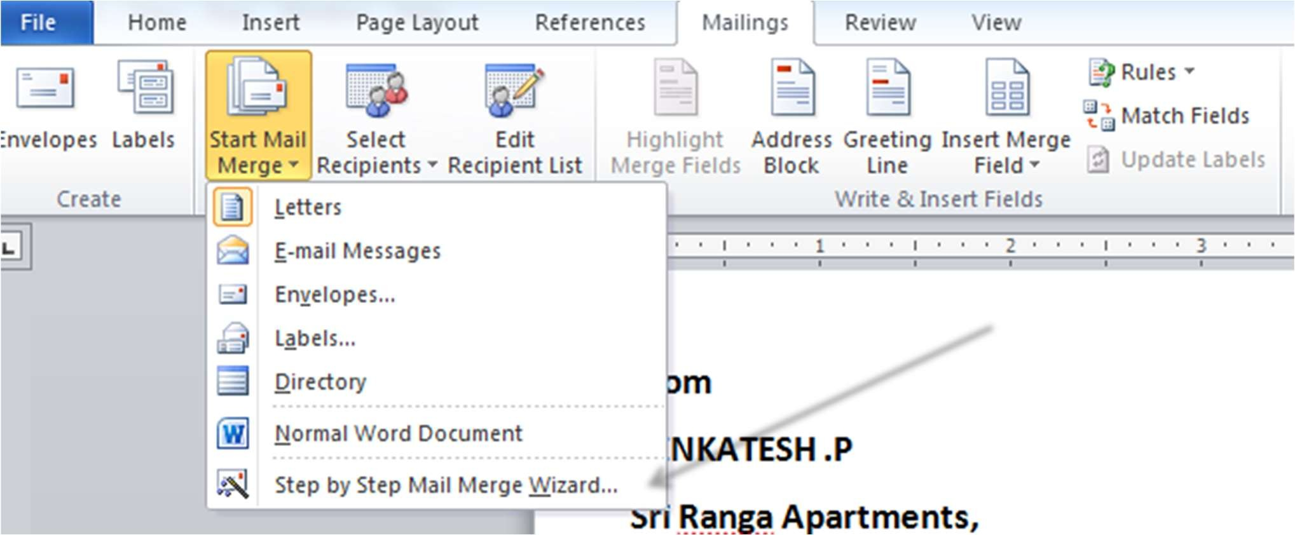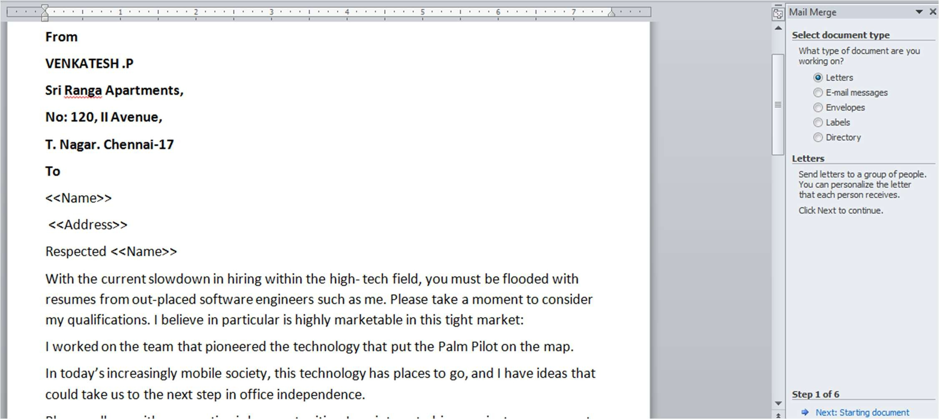



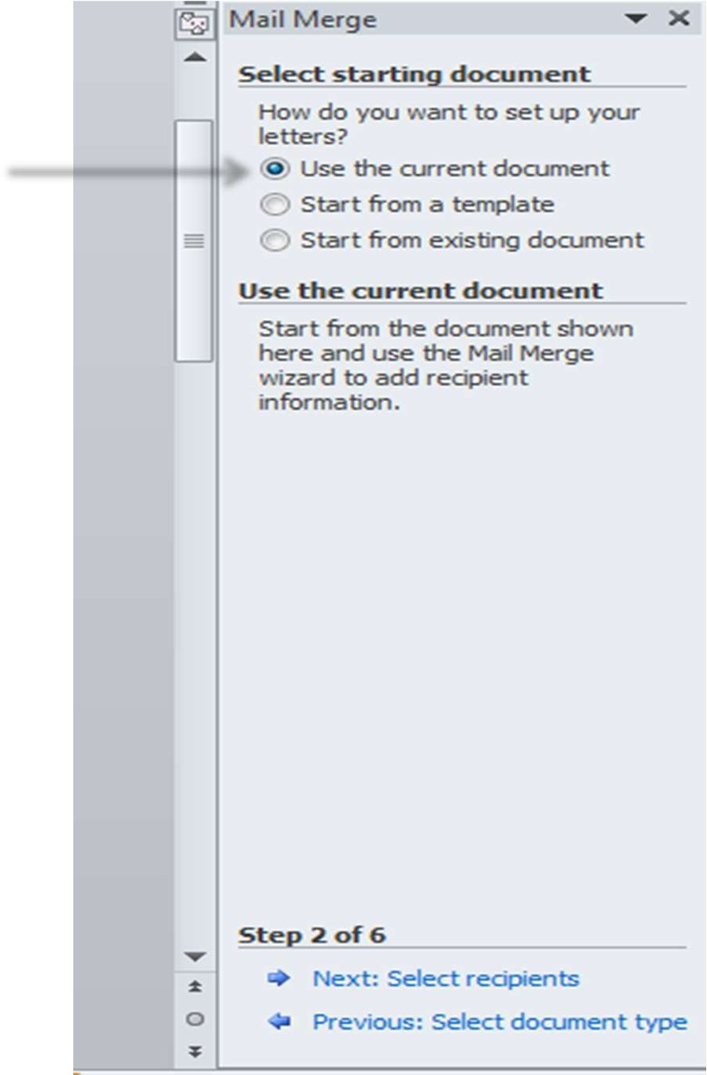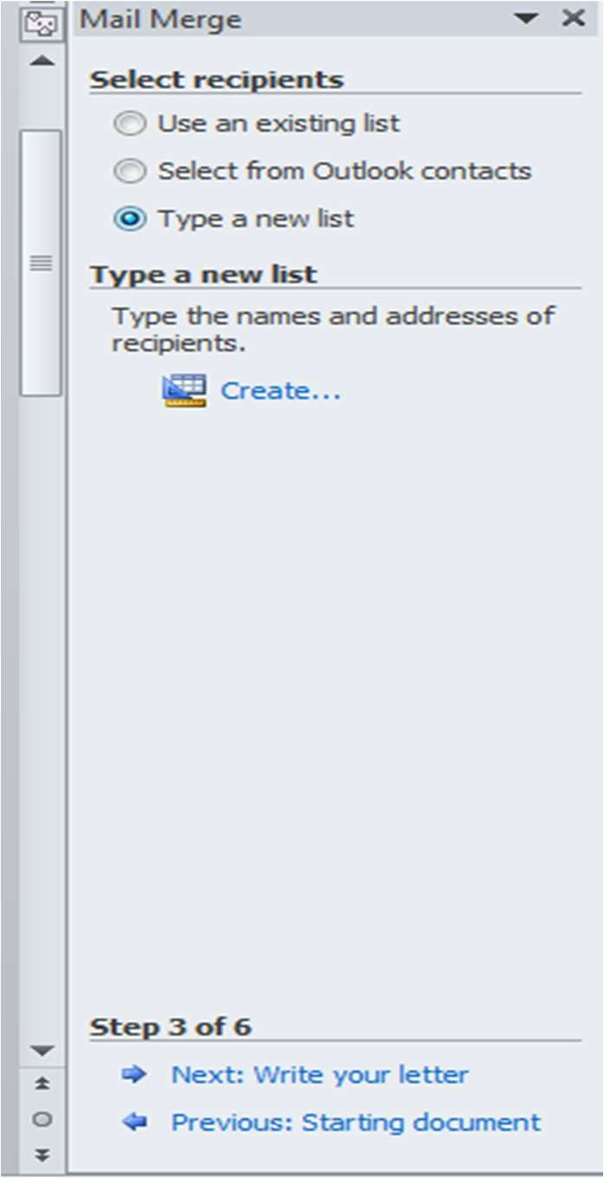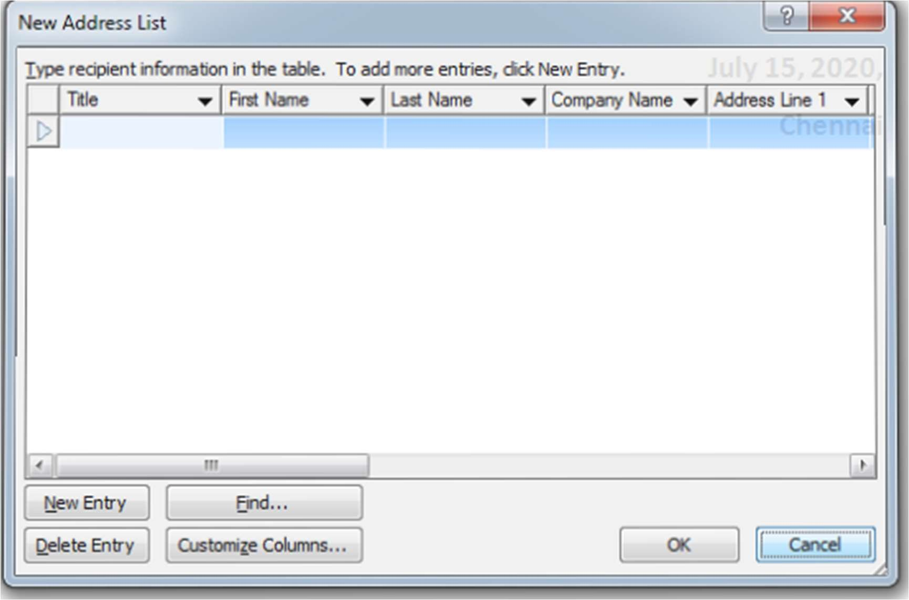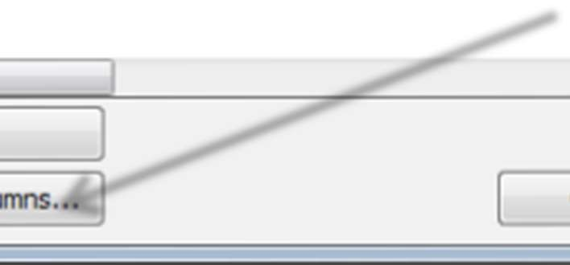

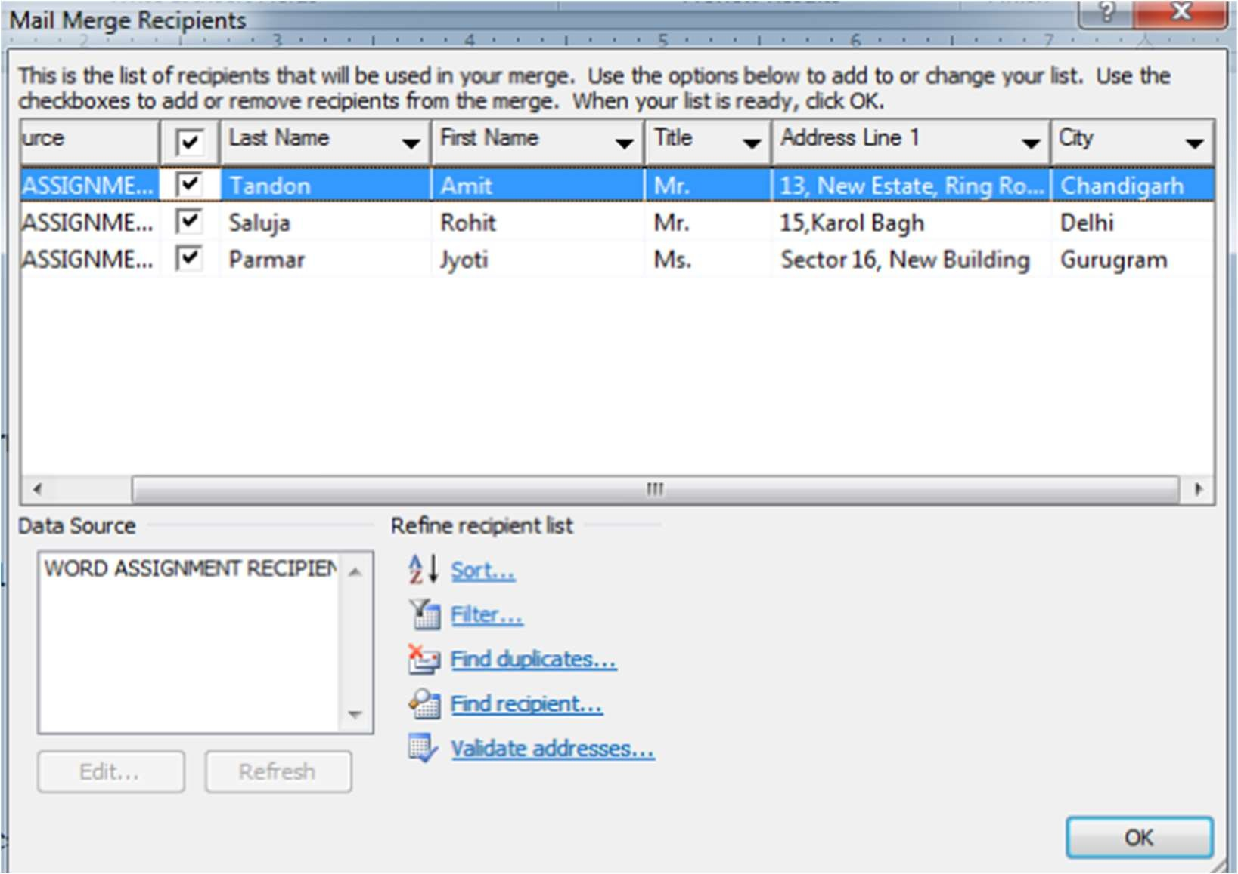

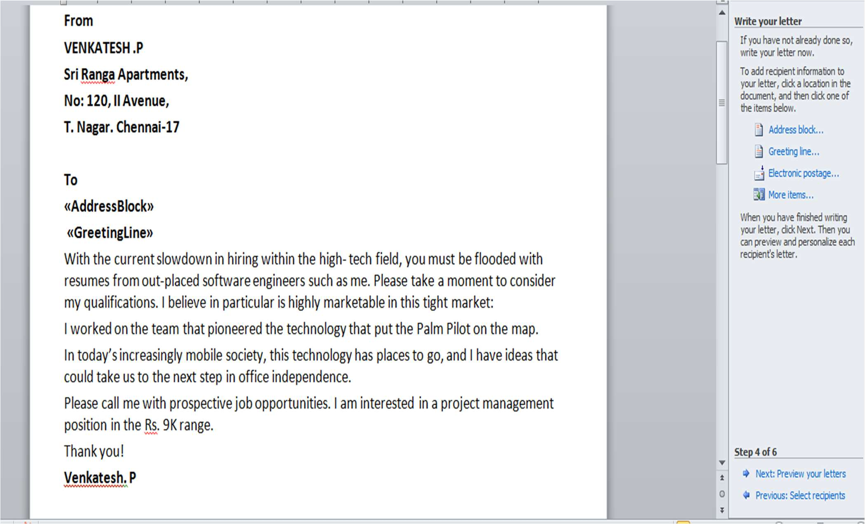



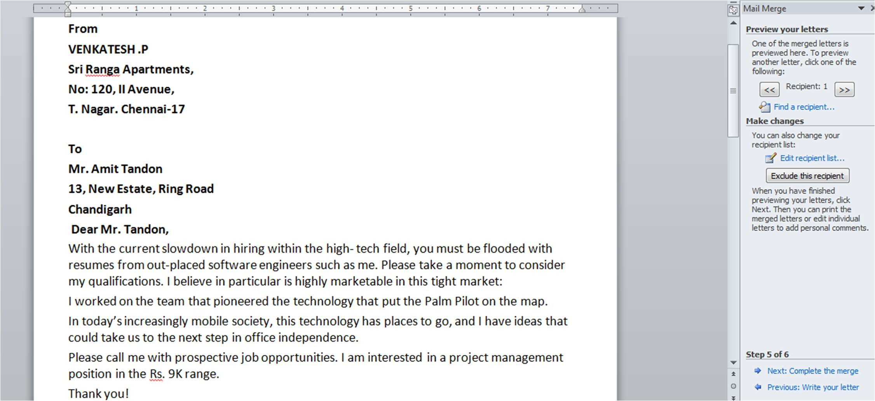

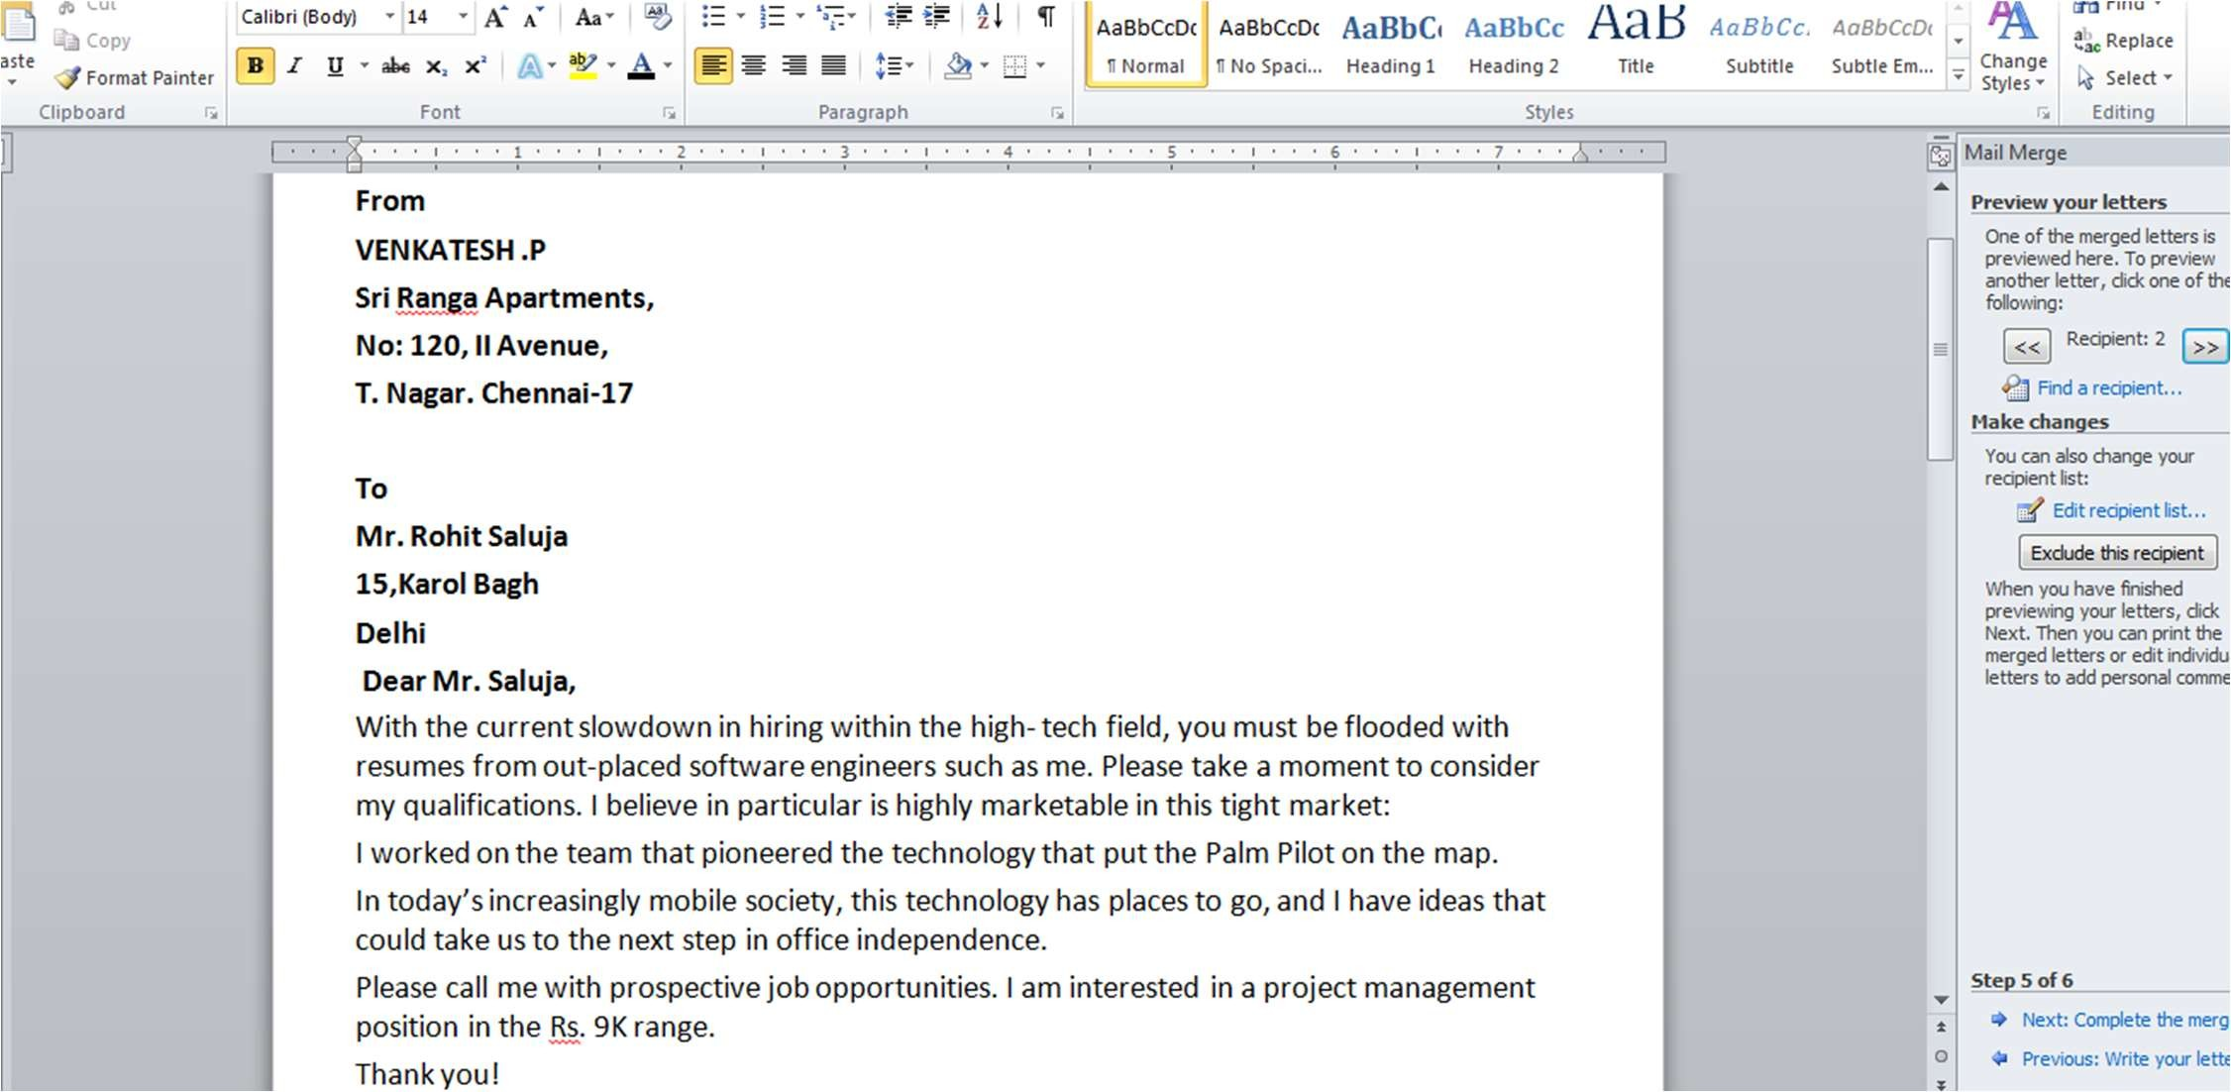

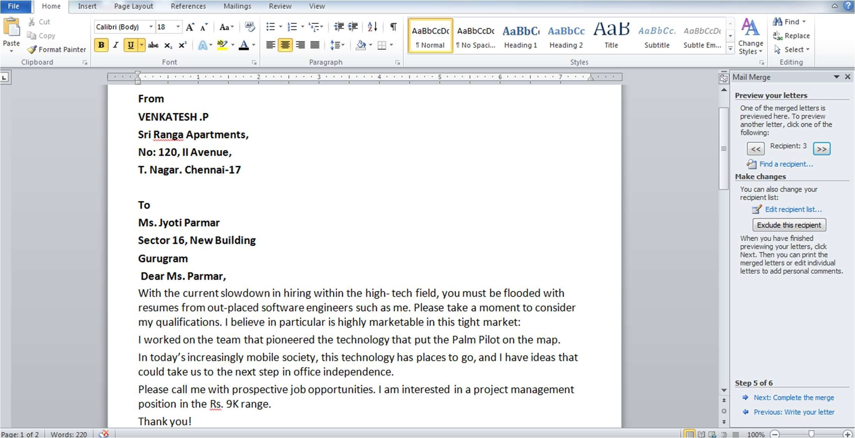



**:**

•



•

•

•

•

•

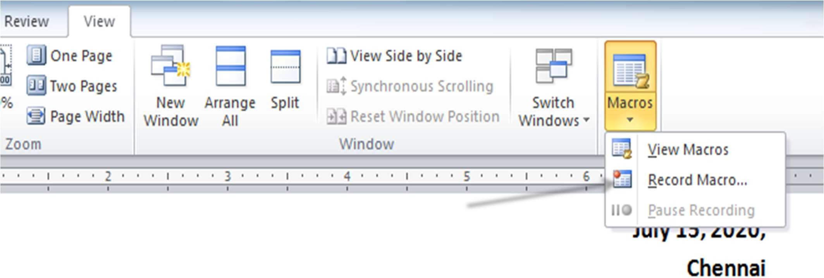

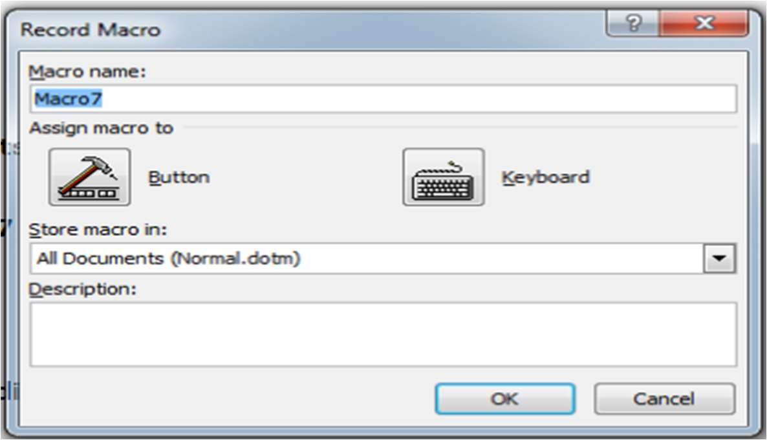

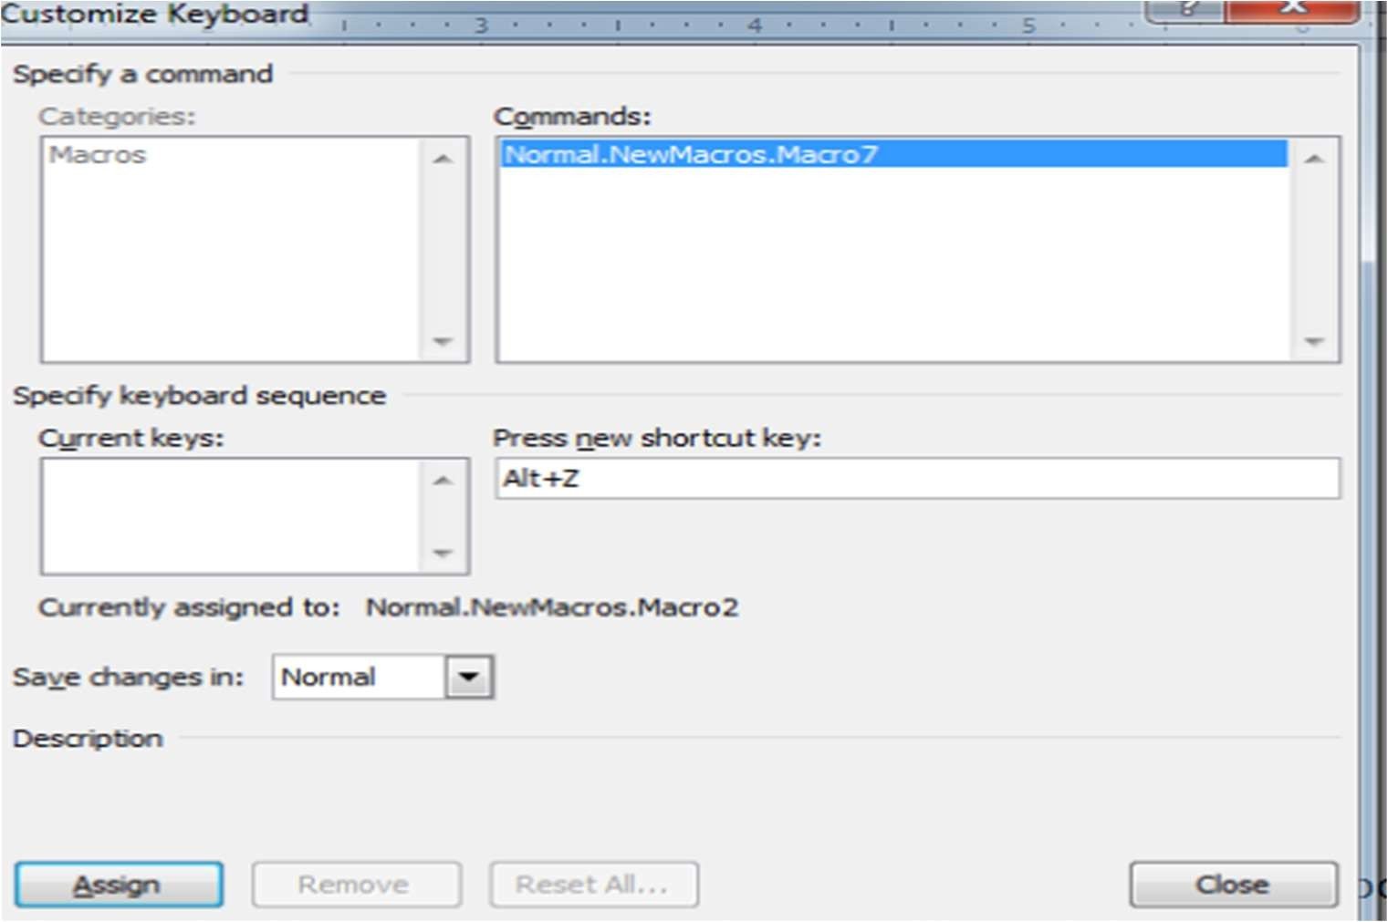

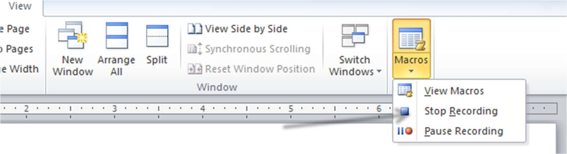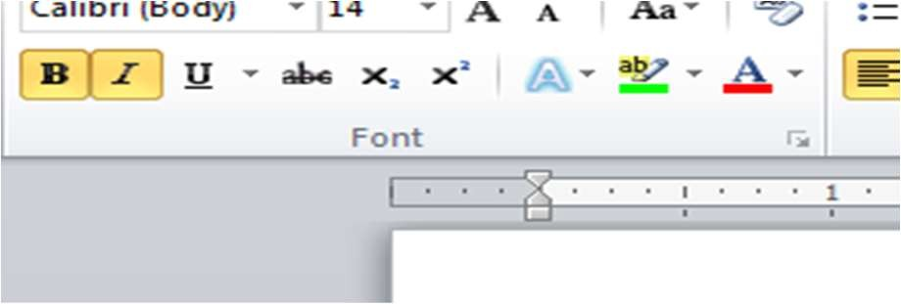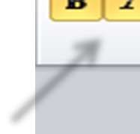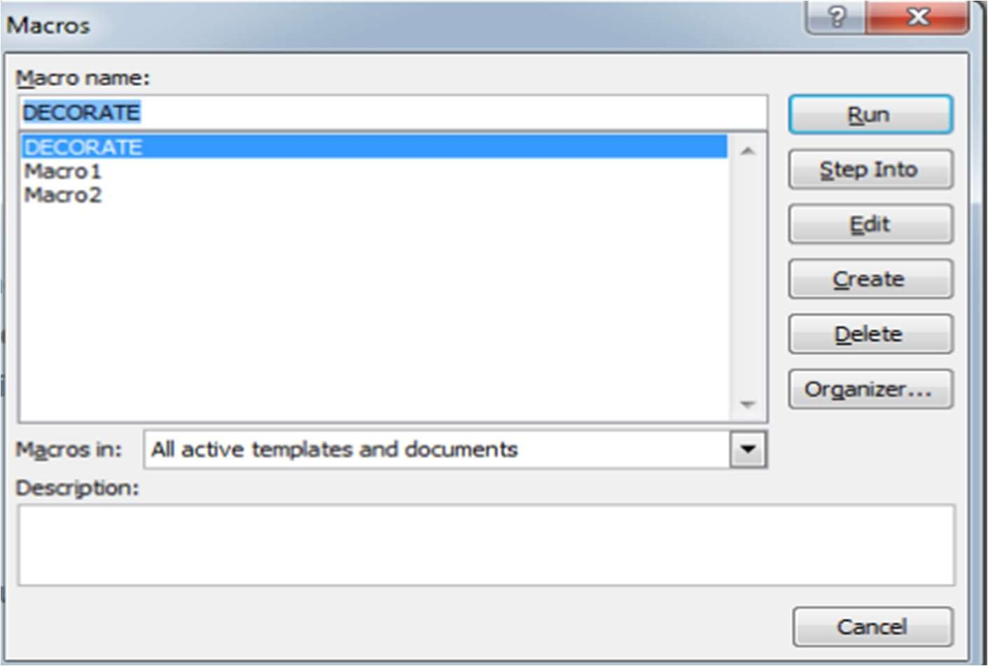

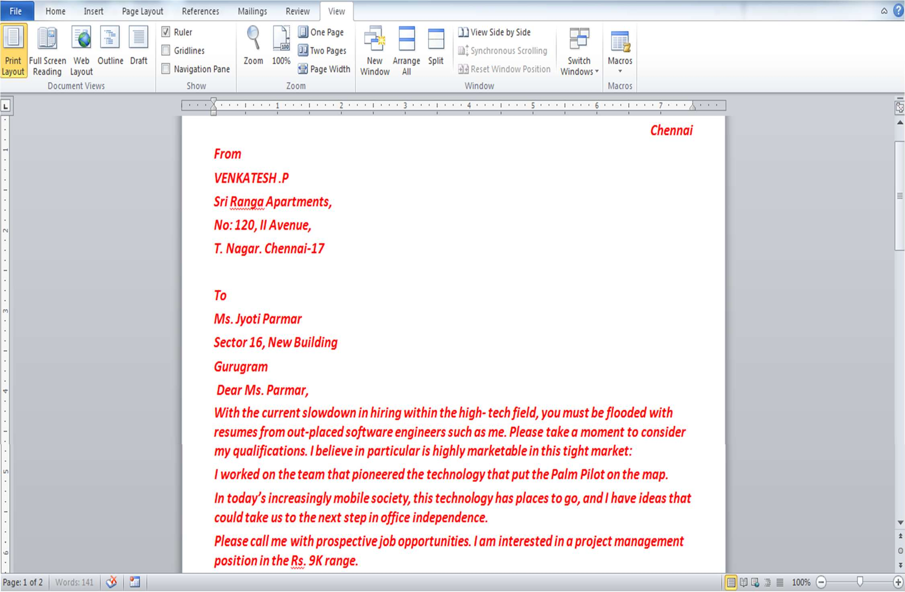

 **Create a table in word as shown below:**

**Do the following:**

* 1. **In the total marks column, entries should be calculated using formulas and it is the sum of marks in physics and marks in chemistry.**
  2. **Insert a new row at the end of the table and also find grand total using formula.**
  3. **Sort the table based on total marks.**
  4. **The date and heading should be centre aligned.**
  5. **Heading should be in bold and underlined**

***STEPS:***

•



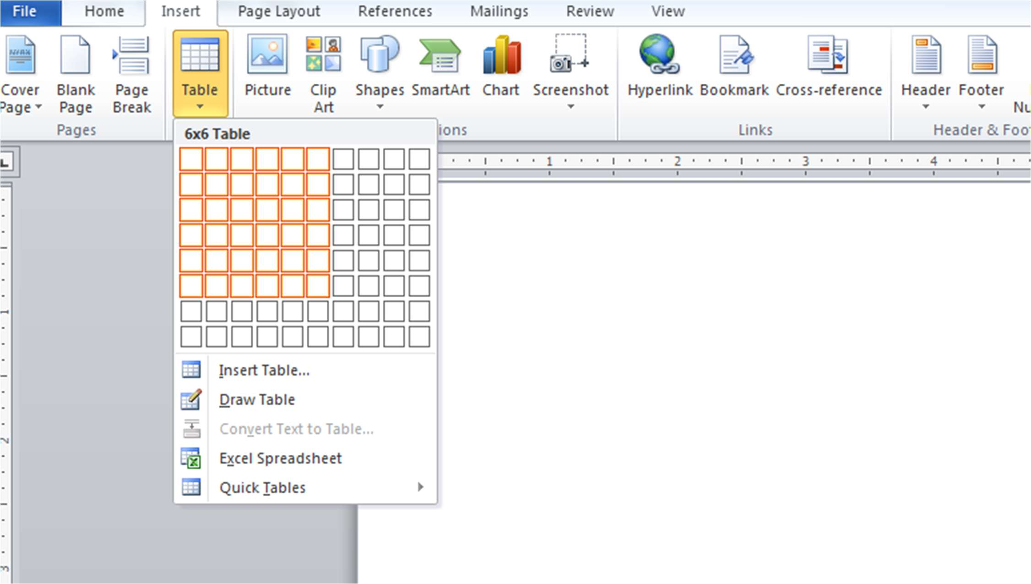

* Enter the headings of every column. From the **LAYOUT** tab ,keep the headings centre aligned. From the **HOME** tab select bold and underlined to keep the headings that way as per the requirement of the question.Type down the rest of the entries.

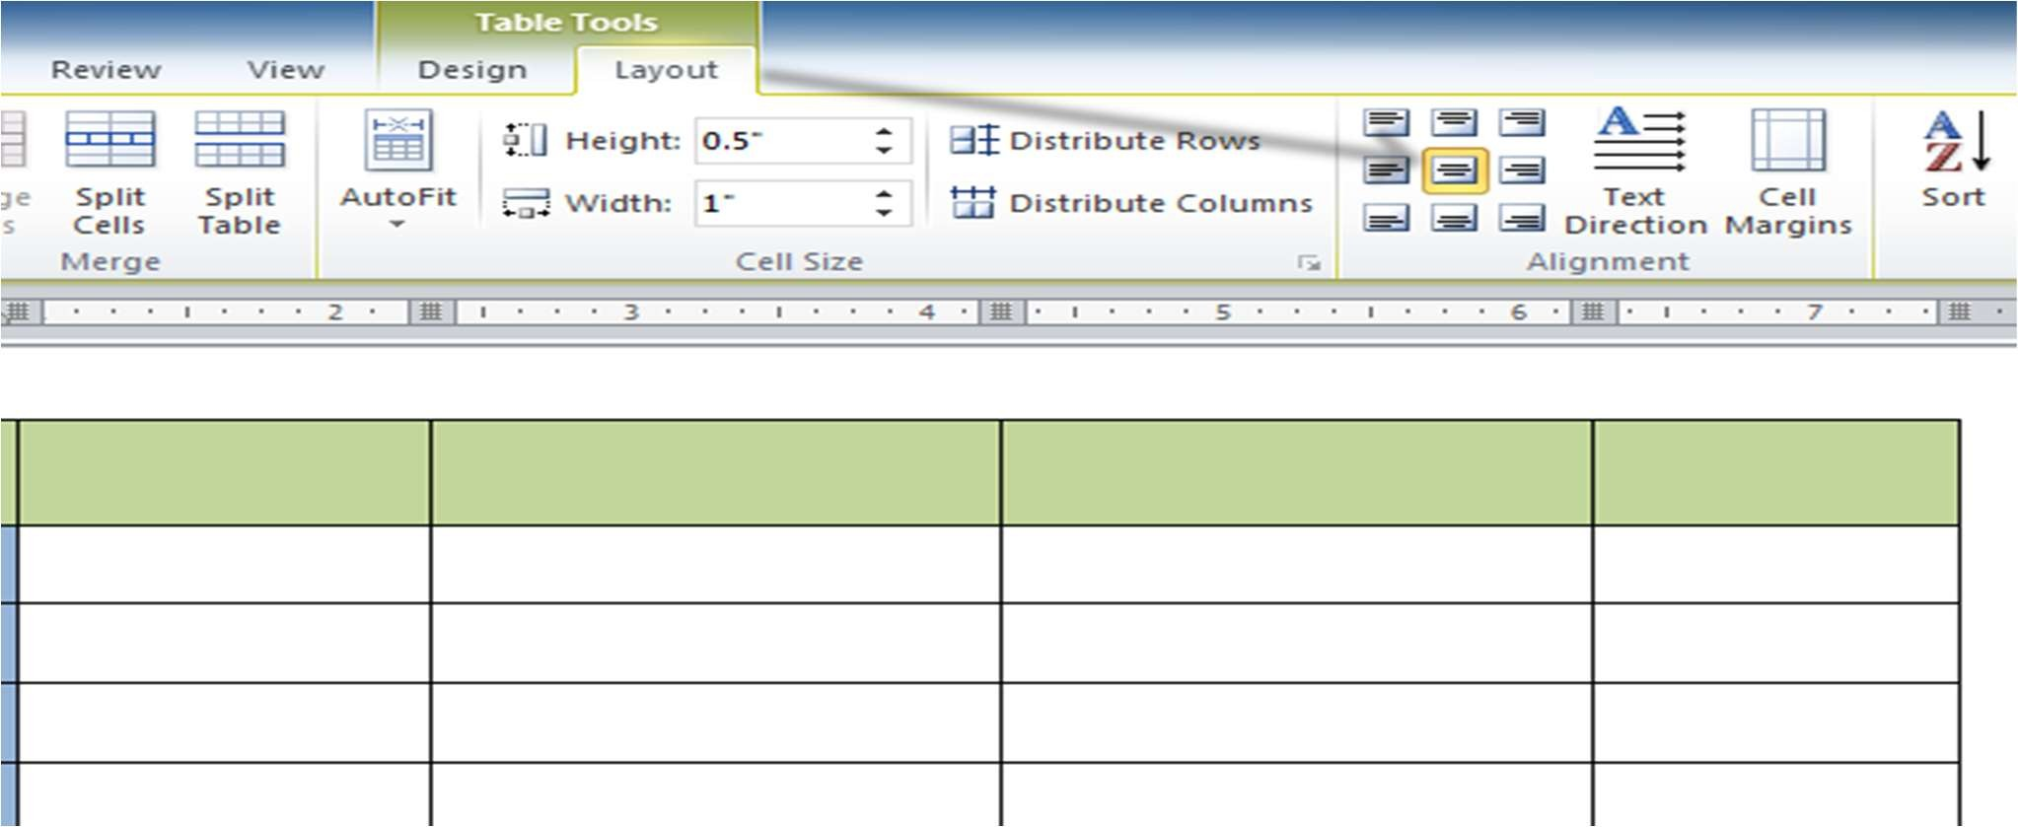

* To calculate the values for the 5th column select the given cell and then click on ***formula*** from the **LAYOUT** tab. We are using sum formula since marks of physics and chemistry are to be added as per the question.

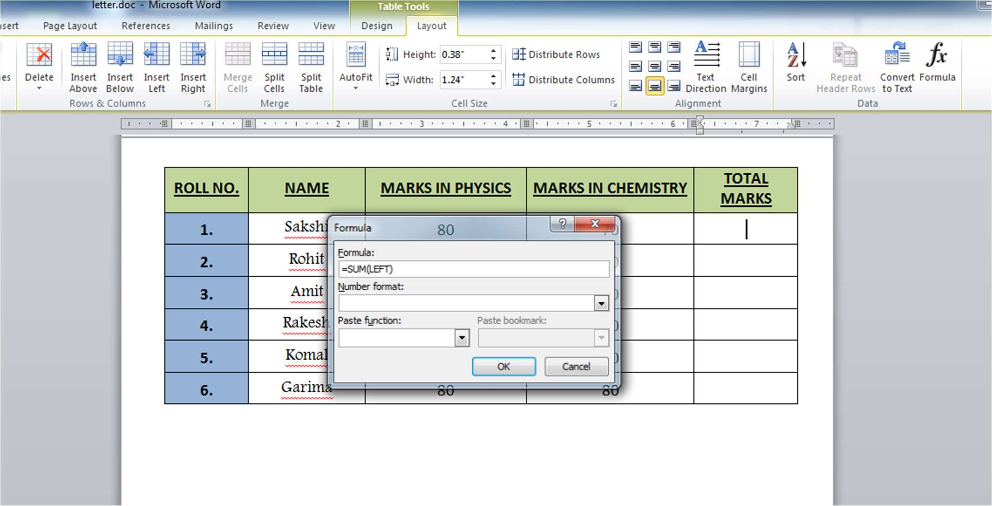

* After calculating the sum for each cell of the 5th column, insert a new row at the end of the table by using the **Insert Below** option from **LAYOUT** tab. Now calculate the grand total by clicking on the last cell and then using ***formula*** from **LAYOUT** tab. Type “**ABOVE**” in the formula to calculate the grand total of the marks.

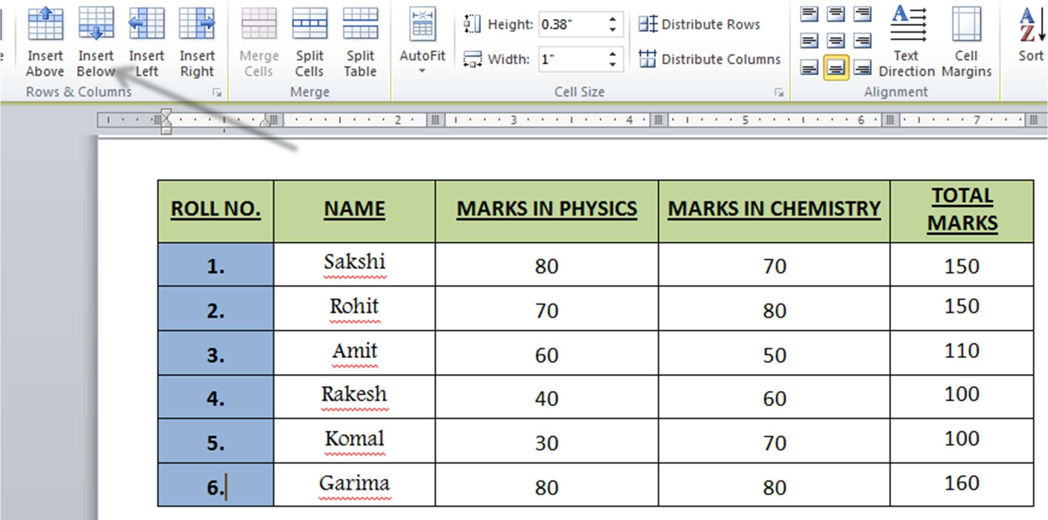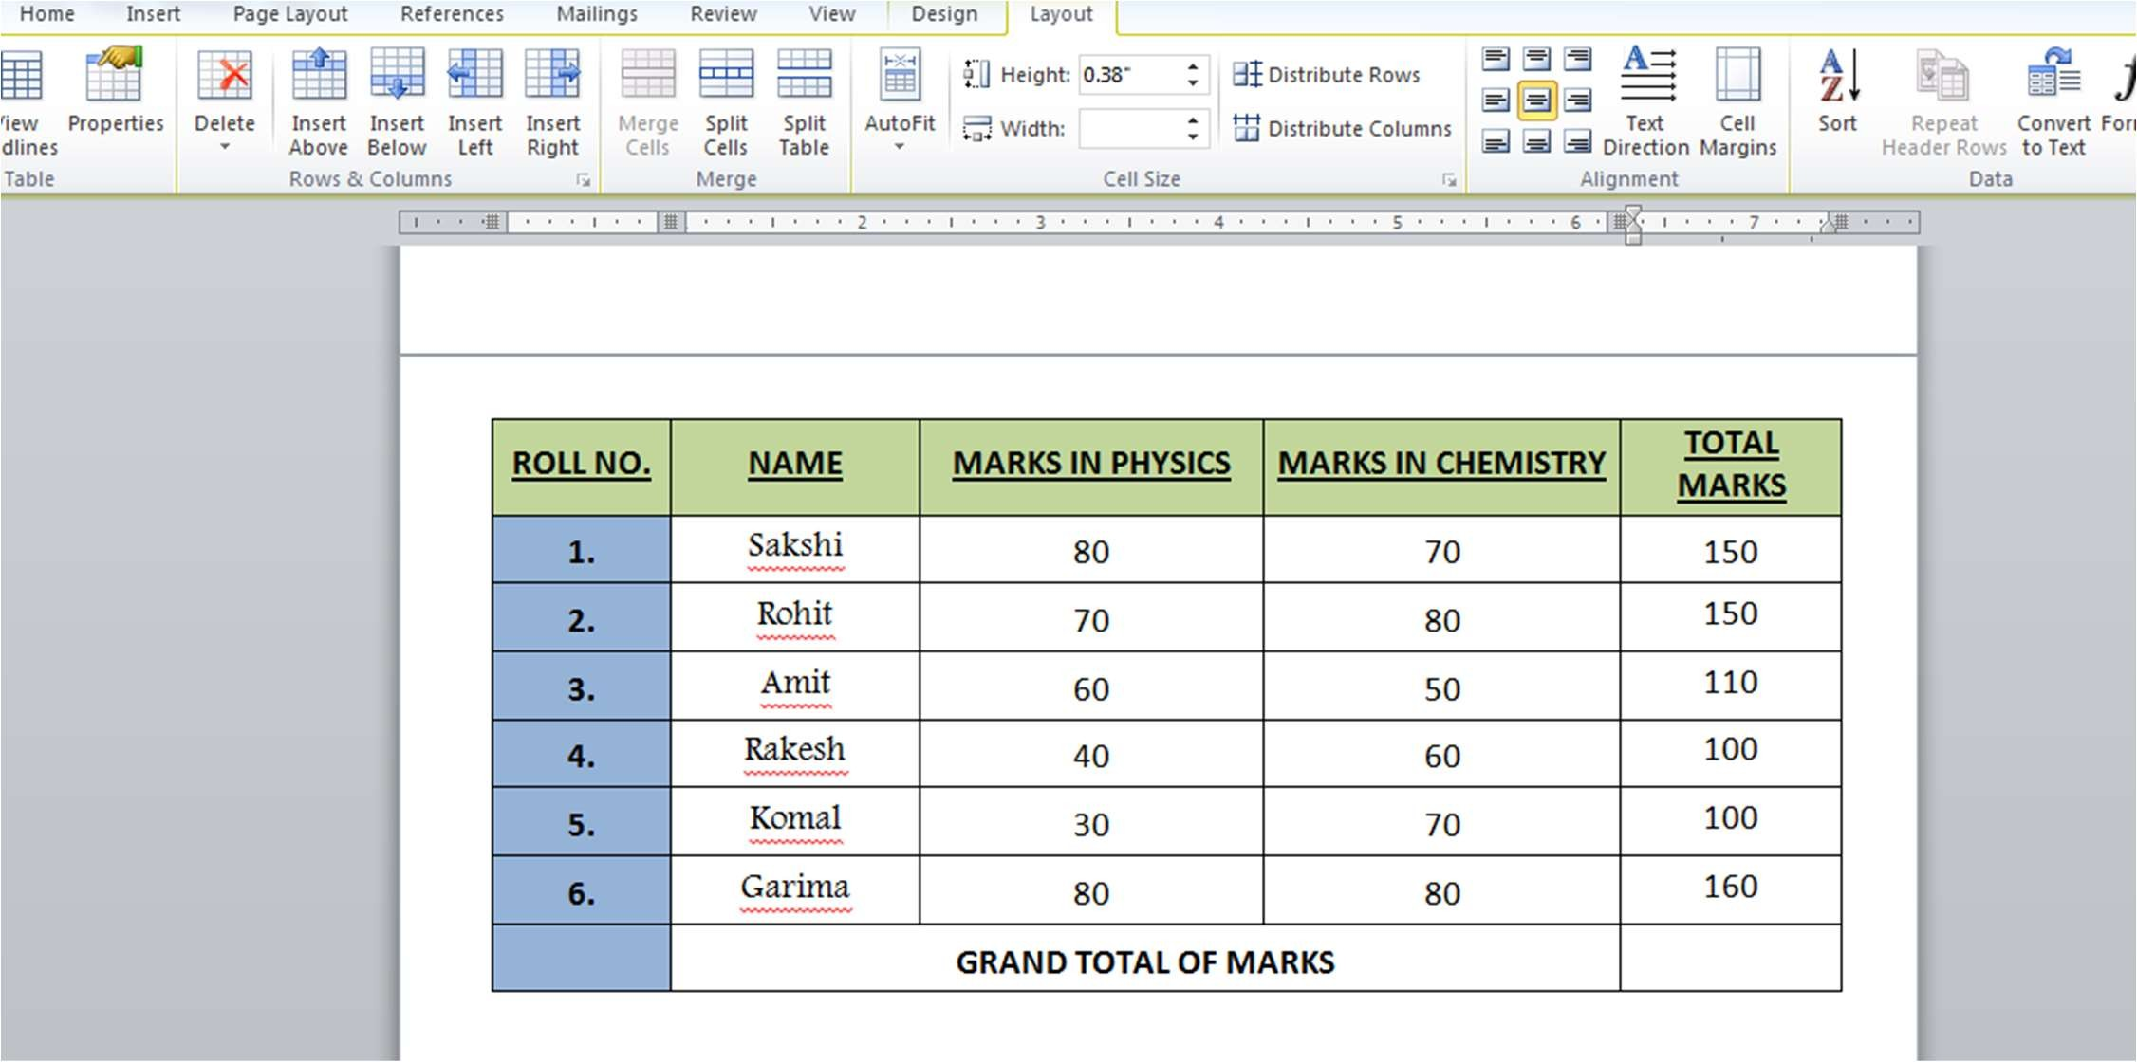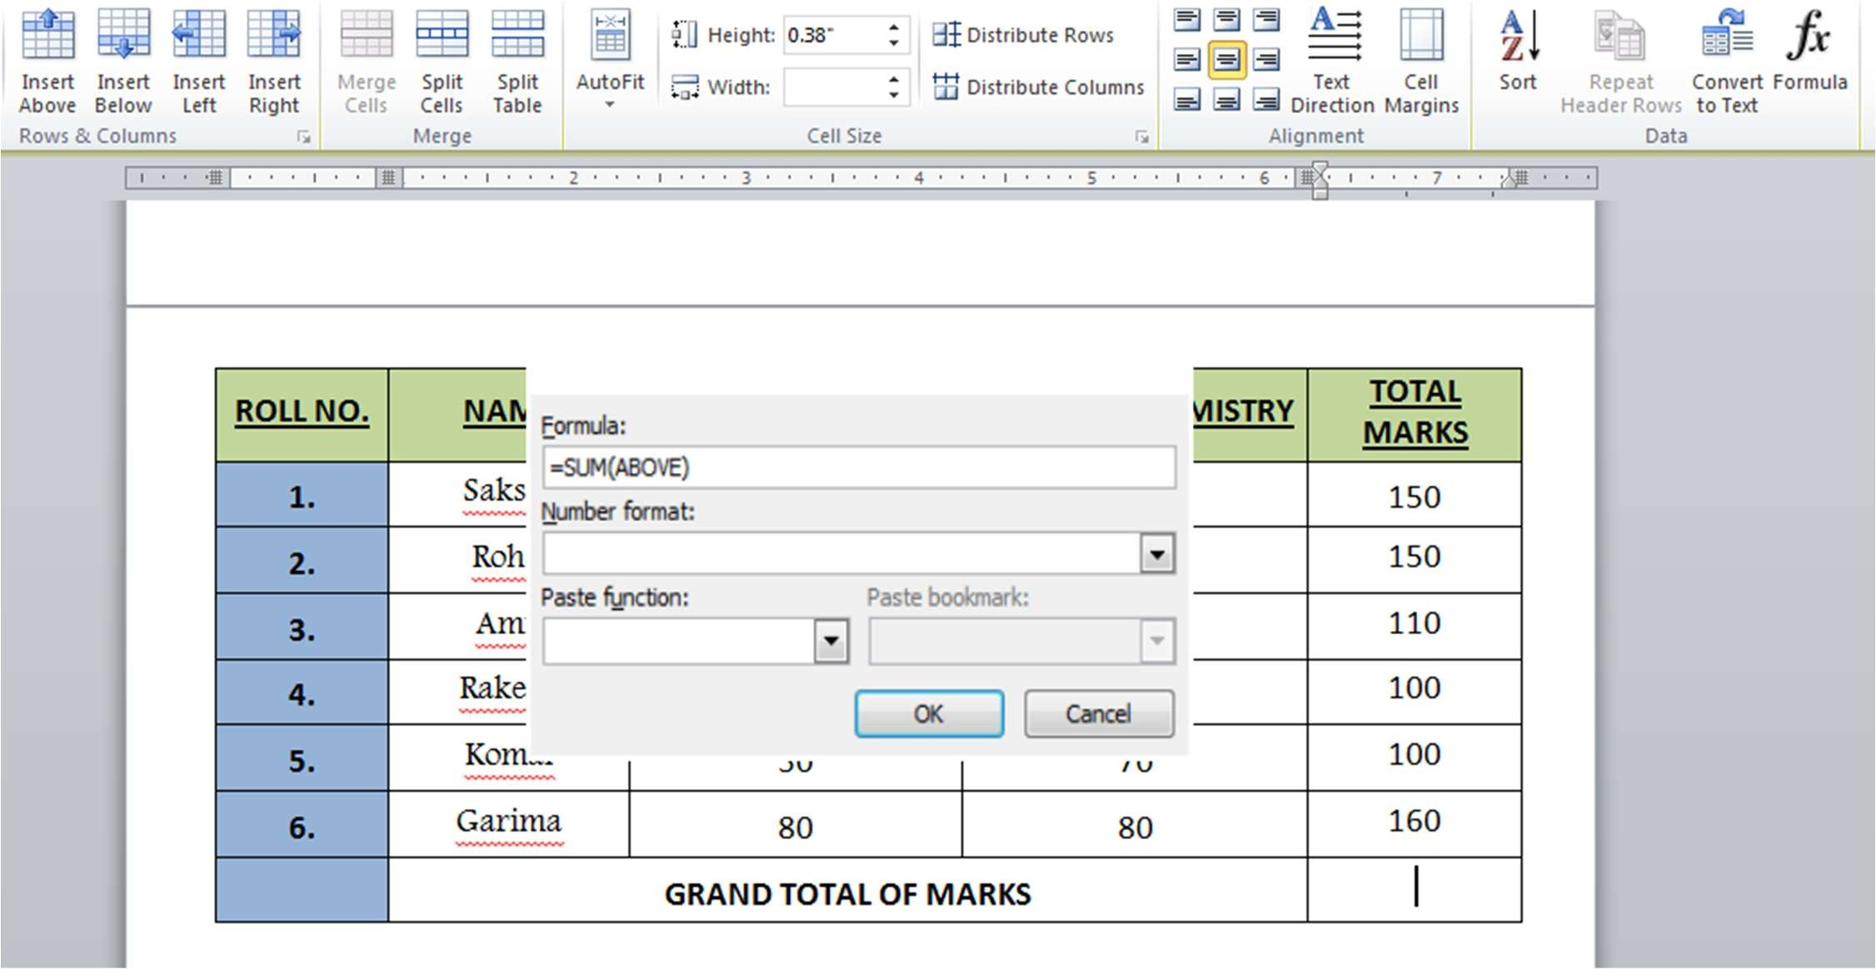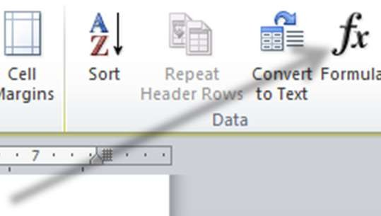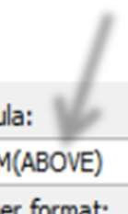

* For sorting the table based on total marks, select the 5th column and click on the

**SORT** option, and in the dialog box choose “descending order”.

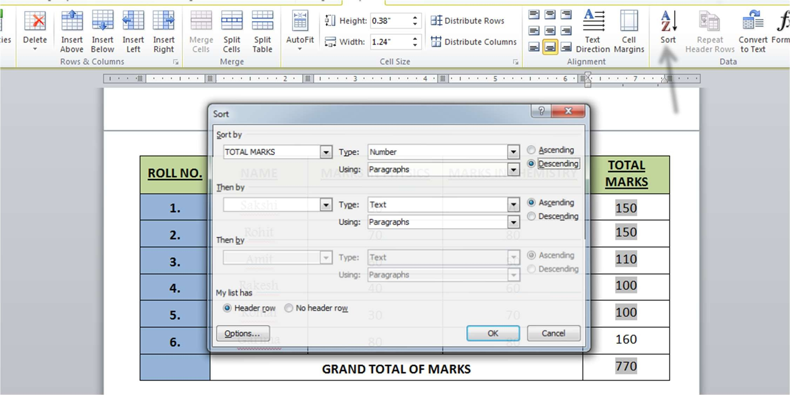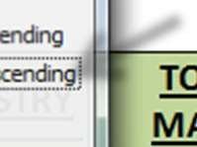

* **This is the final table before sorting:**

|  |  |  |  |  |
| --- | --- | --- | --- | --- |
| **ROLL NO.** | **NAME** | **MARKS IN PHYSICS** | **MARKS IN CHEMISTRY** | **TOTAL MARKS** |
| **1.** |  | 80 | 70 | 150 |
| **2.** |  | 70 | 80 | 150 |
| **3.** |  | 60 | 50 | 110 |
| **4.** |  | 40 | 60 | 100 |
| **5.** |  | 30 | 70 | 100 |
| **6.** |  | 80 | 80 | 160 |
|  | **GRAND TOTAL OF MARKS** | | | 770 |

* **And this will be the final table after sorting based on total marks:**

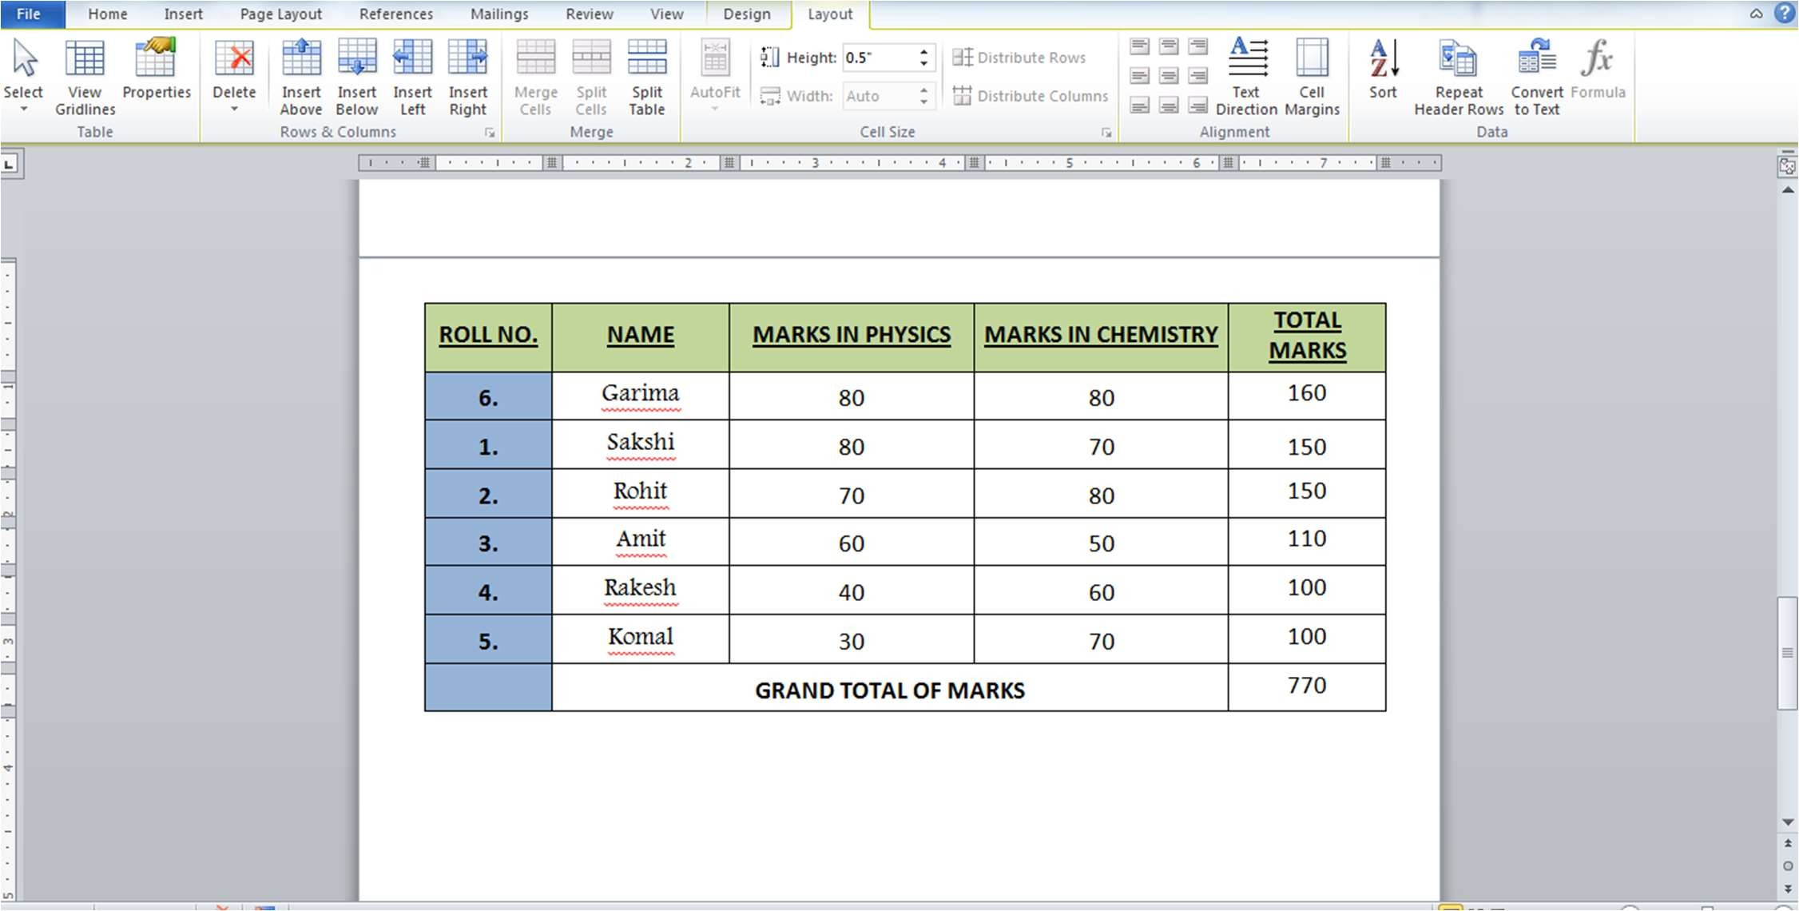

**TABLE:**

|  |  |  |  |  |
| --- | --- | --- | --- | --- |
| **ROLL NO.** | **NAME** | **MARKS IN PHYSICS** | **MARKS IN CHEMISTRY** | **TOTAL MARKS** |
| **6.** |  | 80 | 80 | 160 |
| **1.** |  | 80 | 70 | 150 |
| **2.** |  | 70 | 80 | 150 |
| **3.** |  | 60 | 50 | 110 |
| **4.** |  | 40 | 60 | 100 |
| **5.** |  | 30 | 70 | 100 |
|  | **GRAND TOTAL OF MARKS** | | | 770 |

**#3 Using a spreadsheet package you have studied, construct T Morongo’s payslip for December 2016 following the instructions below.**

**Instructions:**

1. **Housing Subsidy 6000.00 per year.**
2. **Car Allowance 100.00 per month,**
3. **Pension 8% on Basic Salary, iv) P.A.Y.E. 636.83**
4. **Medical Aid 70.00**
5. **U.I.F. 1% on Basic Salary + Housing Subsidy**
6. **Bond Repayment 630.00**
7. **Calculate Net Salary.**
8. **Format all figures to two decimal places and insert ₹ currency symbol.**
9. **Insert a custom footer with your name, subject, and question number. Save it as salary advice2.**

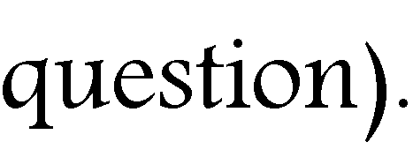

▪

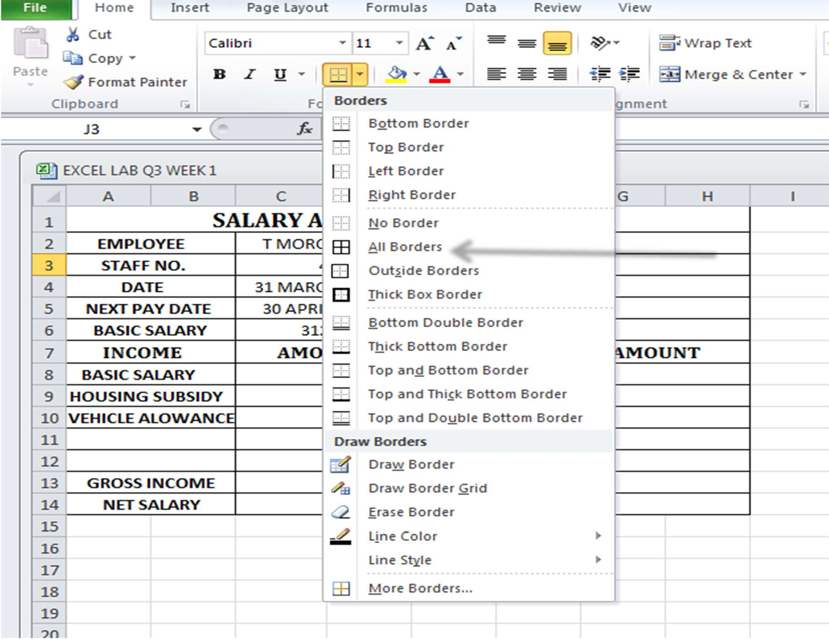





▪

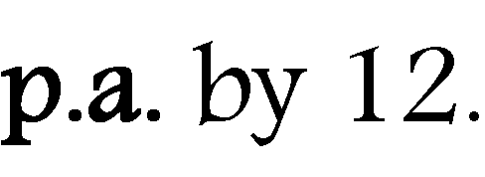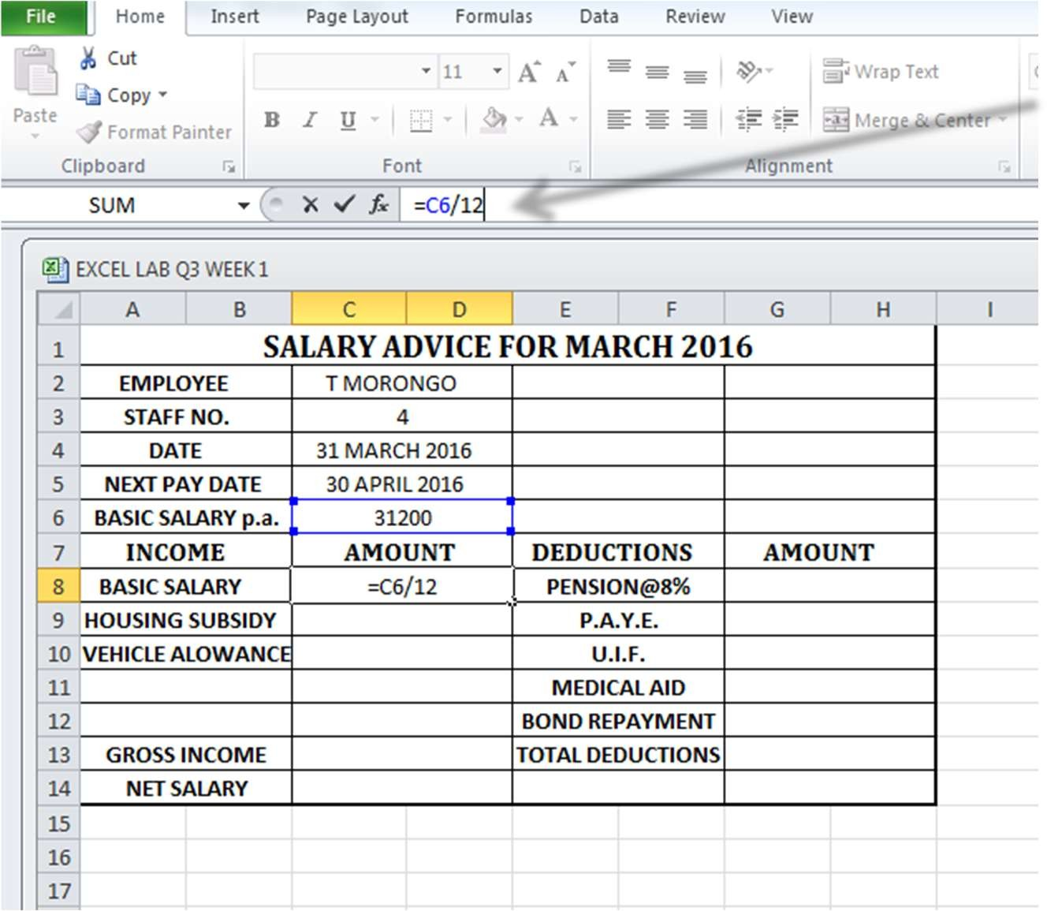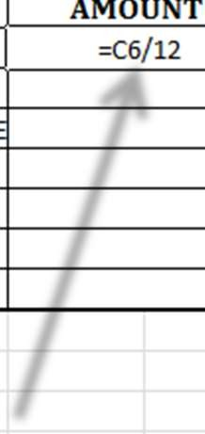

* + **“=**

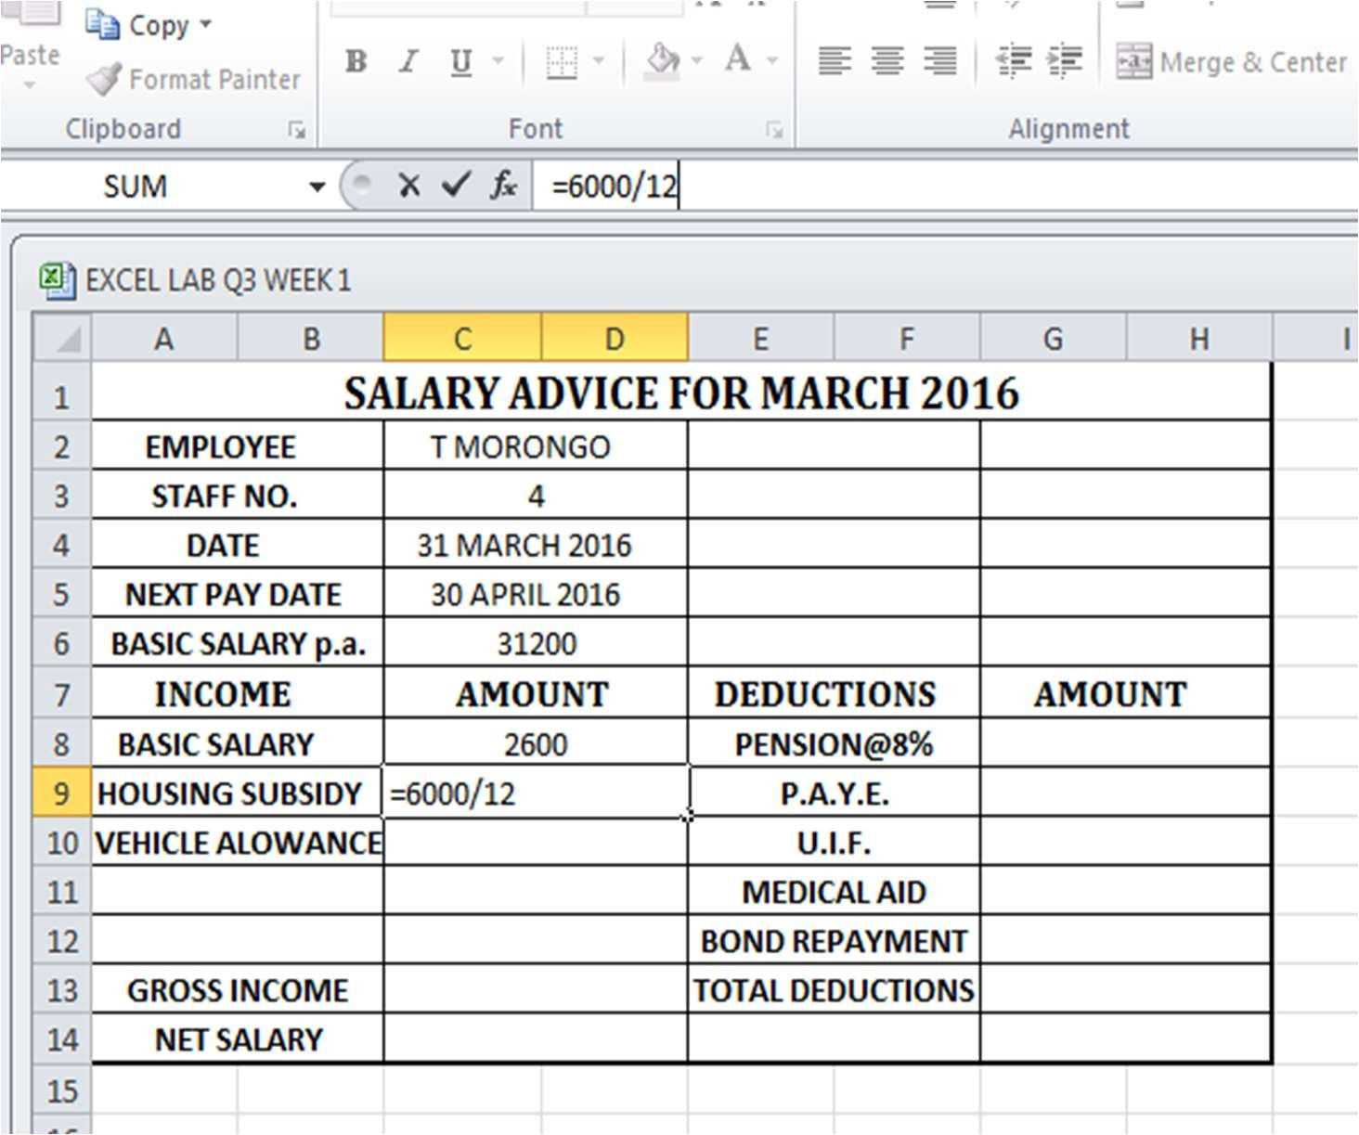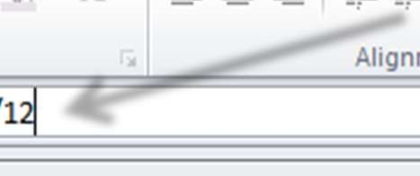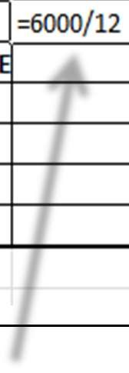

▪

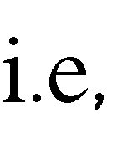

:

**=C8*(8/100).**

**= C8*(1/100)+C9.**

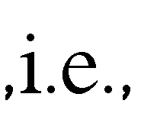

**=C8+C9+C10.**

**=G8+G9+G10+G11+G12.**

**=C13-G13.**

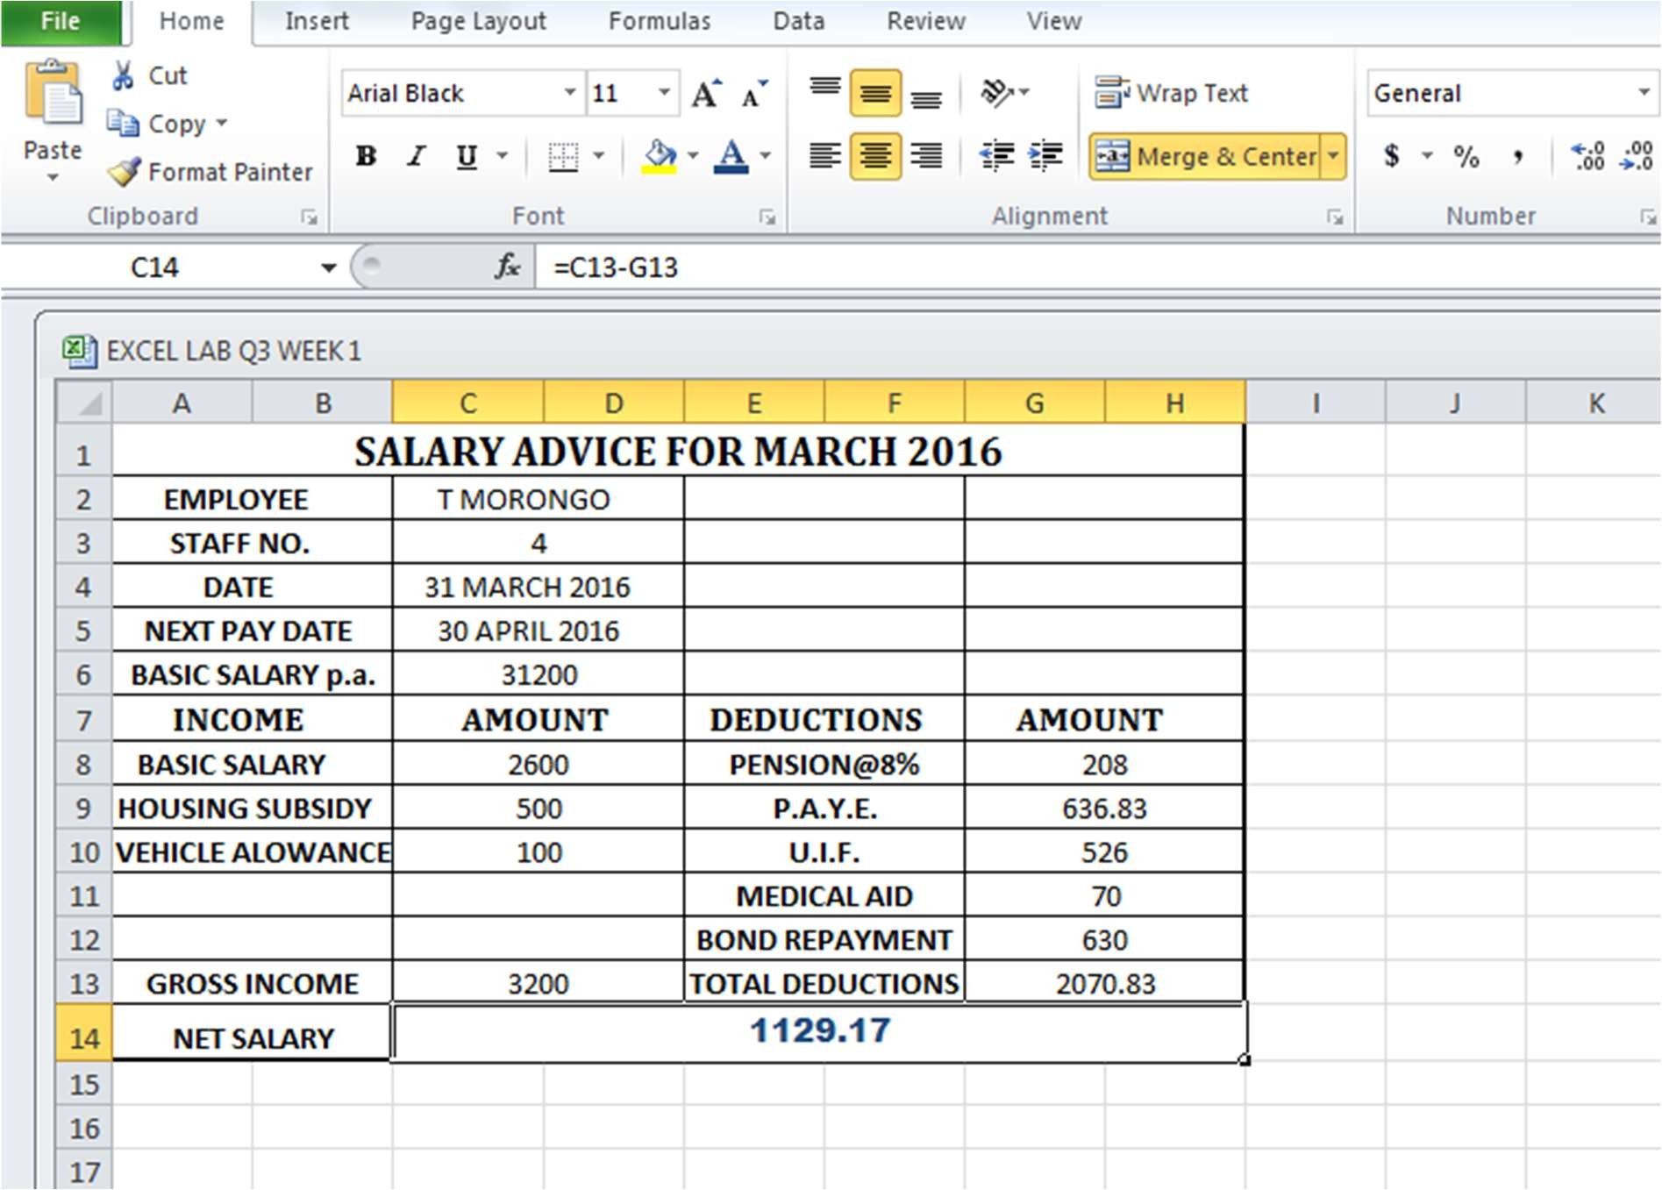

▪



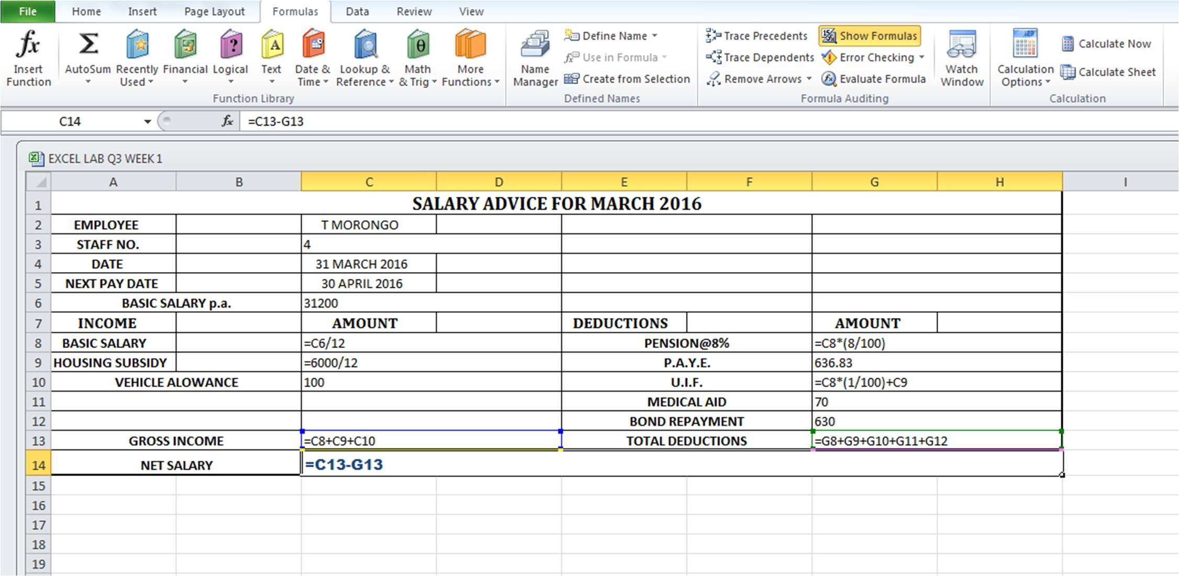

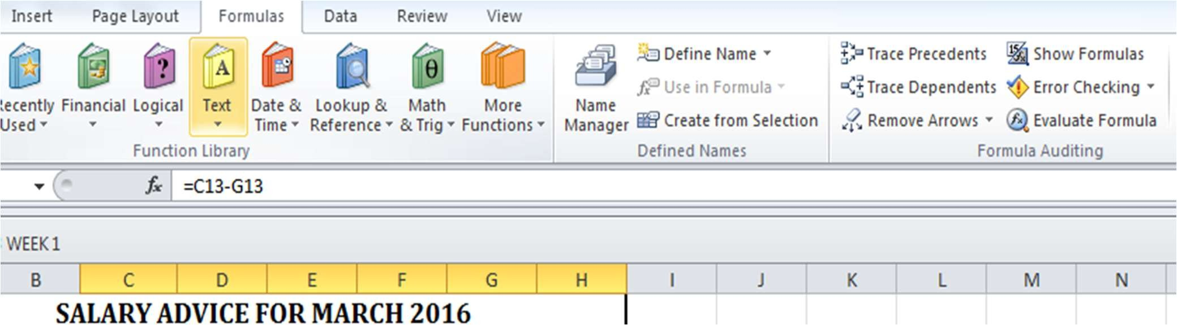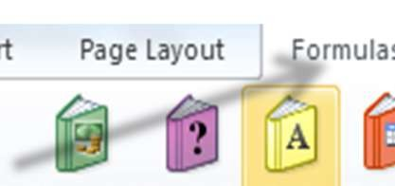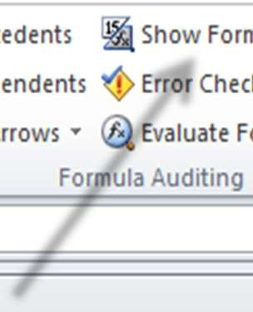

▪

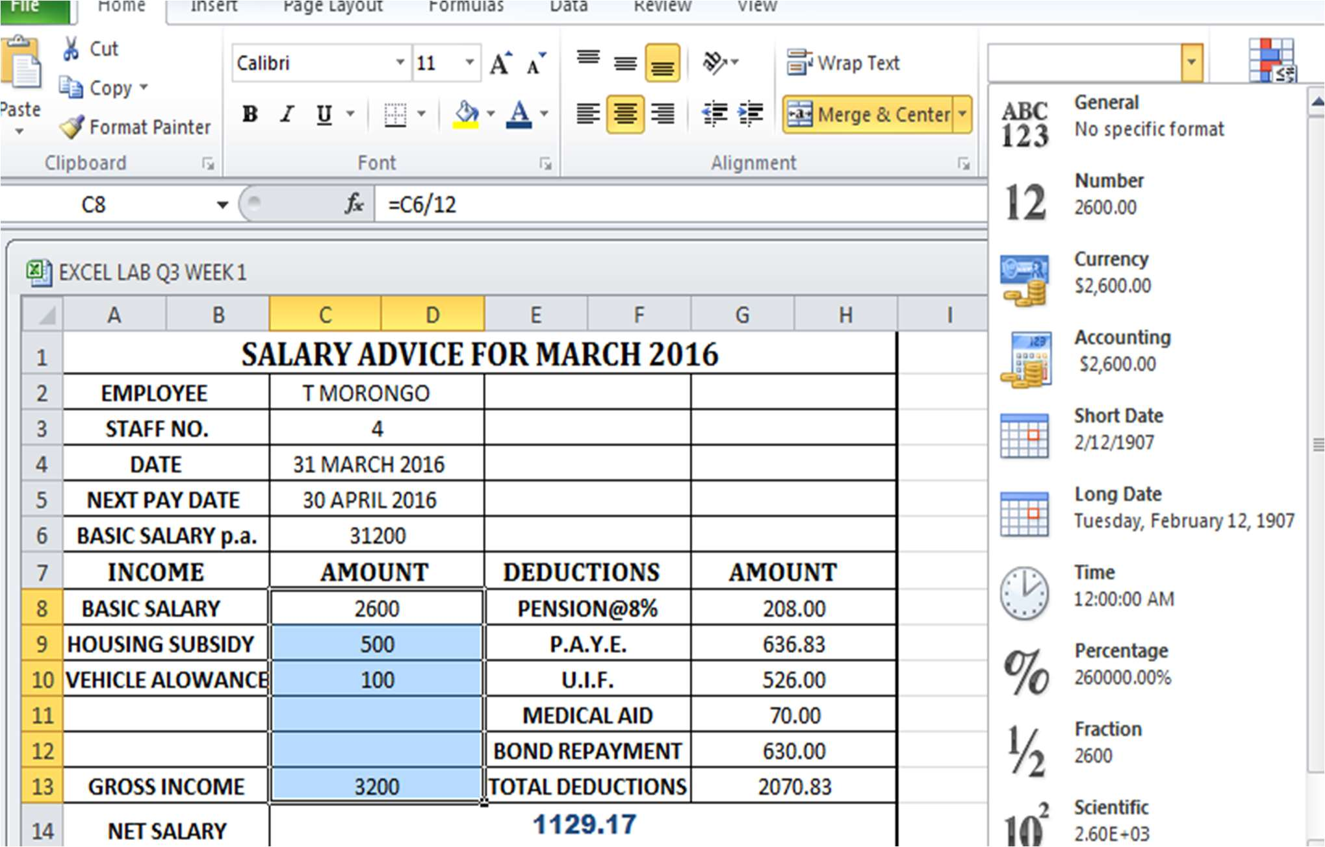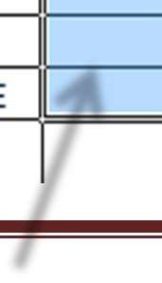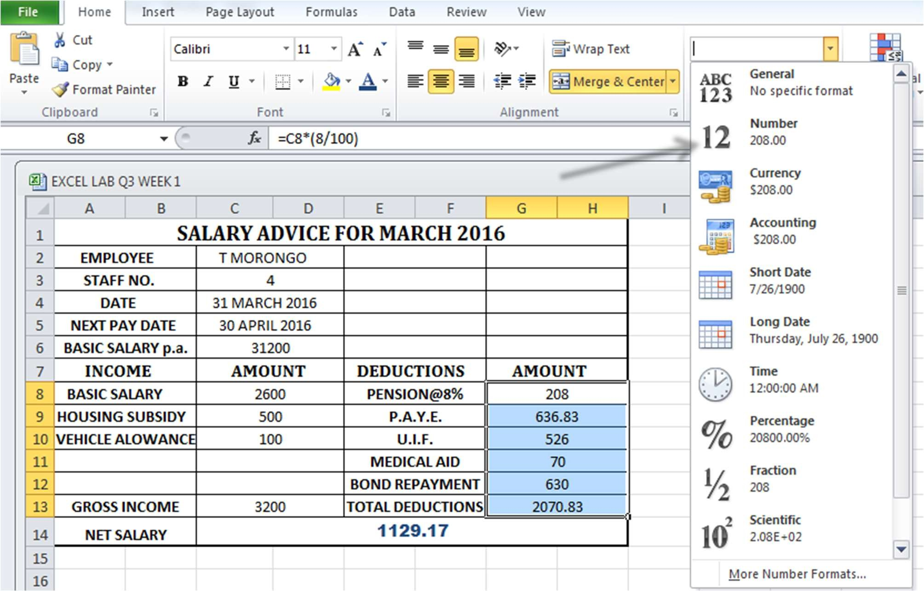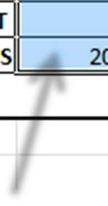

* + For applying currency symbol, select the column of cells where the currency sign needs to symbol needs to be applied , then click on the **Format** drop-down menu on the left (from the **HOME** tab).In the drop-down menu , select **Format Cells.**

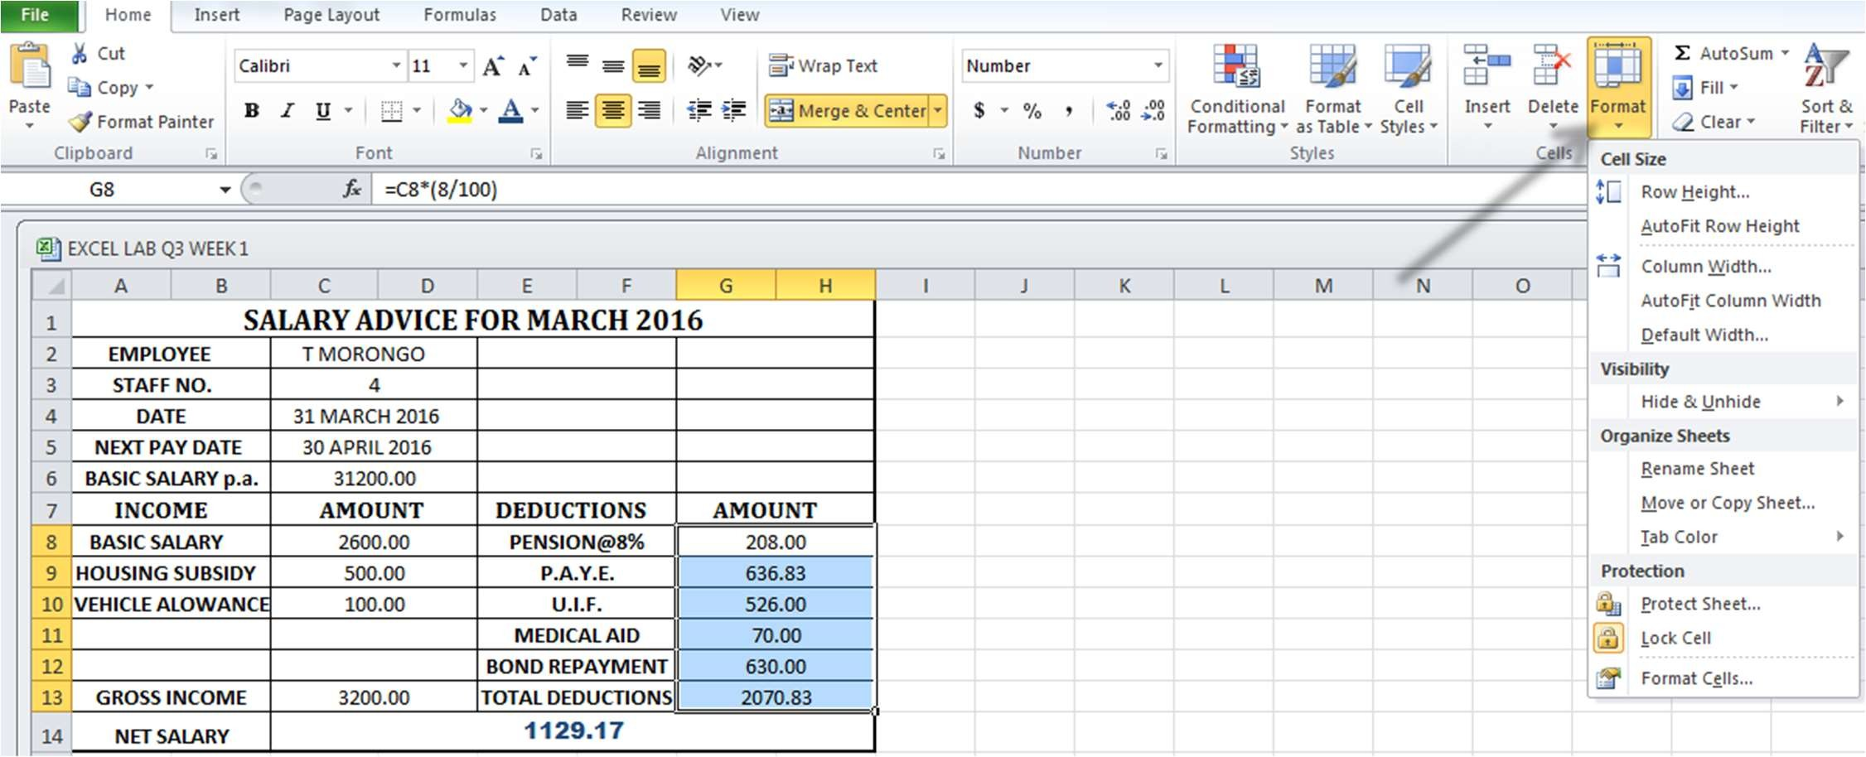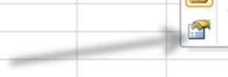

* + A pop-up window will appear. Select the **Currency** option and choose the **INR**

symbol. Press **OK.**

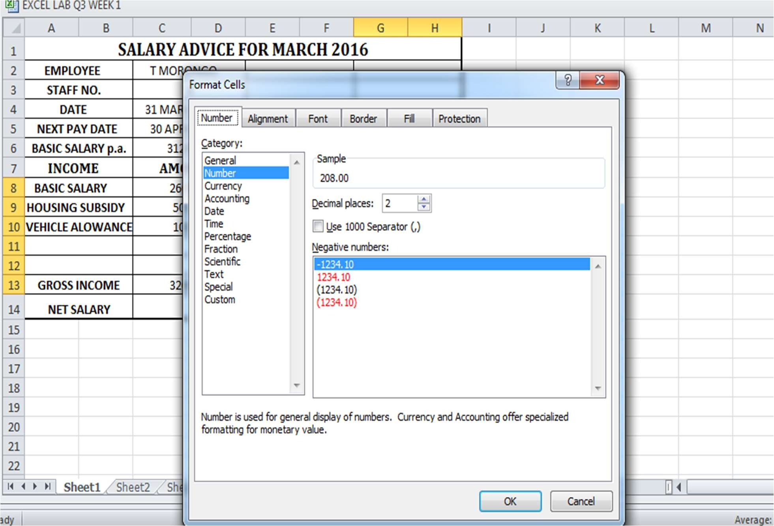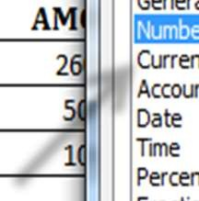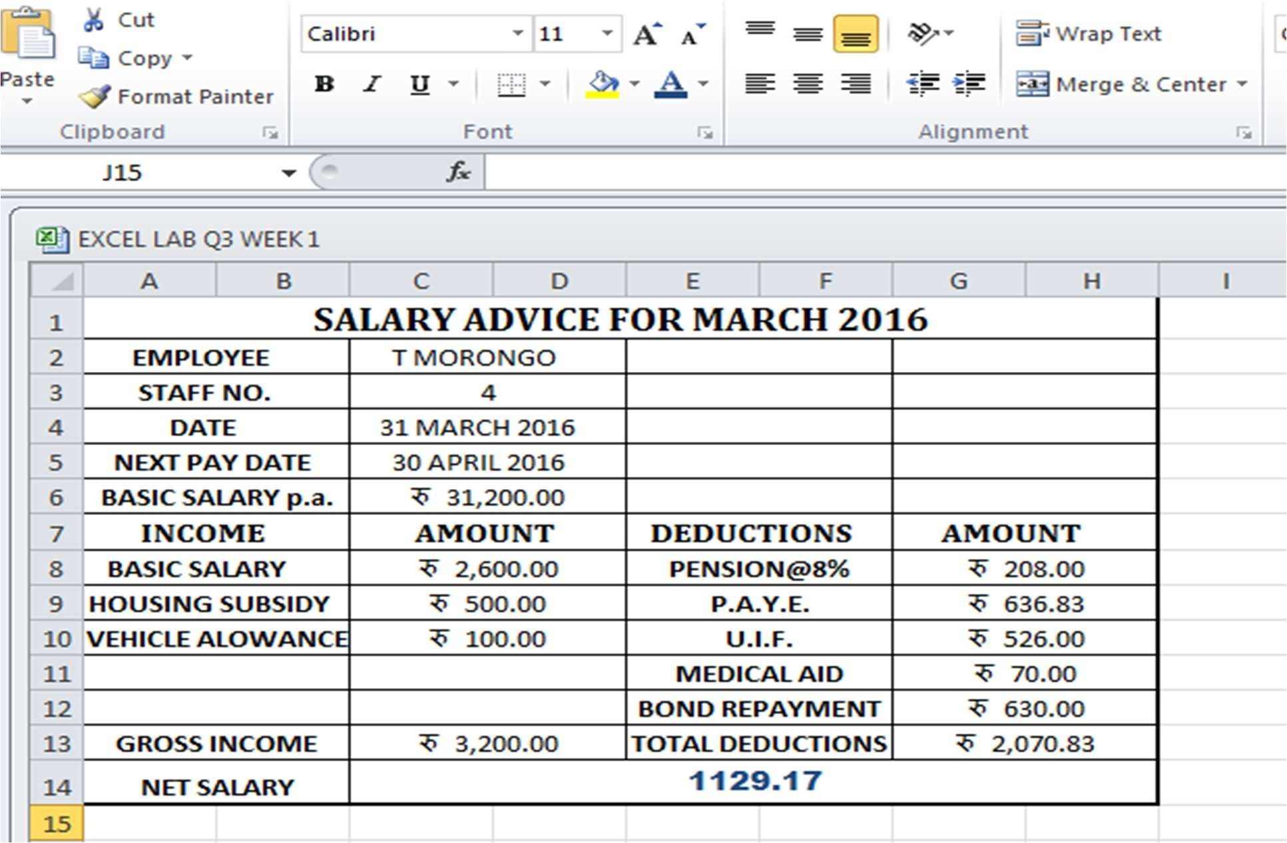

* + For adding custom footer, go to the **PAGE LAYOUT** tab and click on **page setup** at the bottom of the ribbon. A new window appears. Select **Header/Footer** and next click on custom footer.

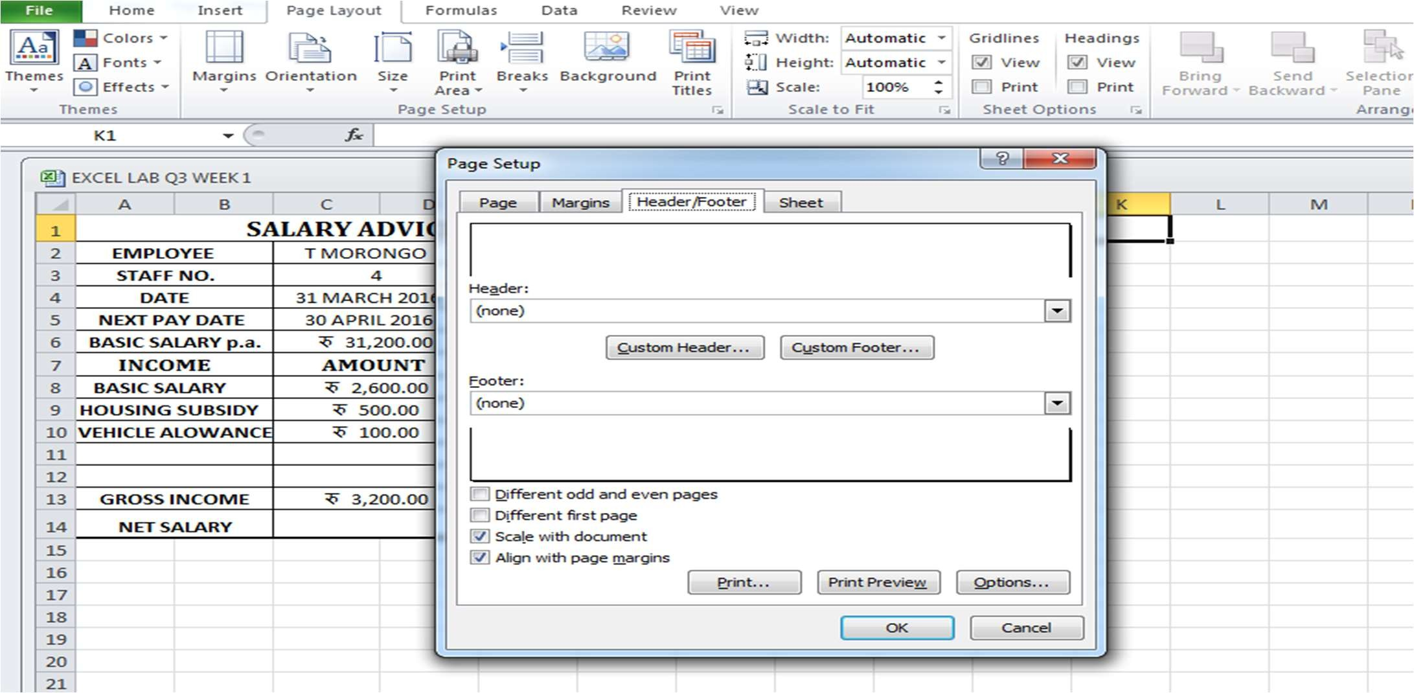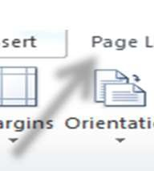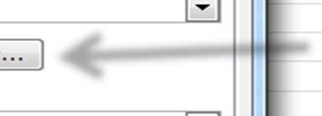

* + A new window **Footer** opens. As per the question, write down your name , subject and question number and then click on **OK.**

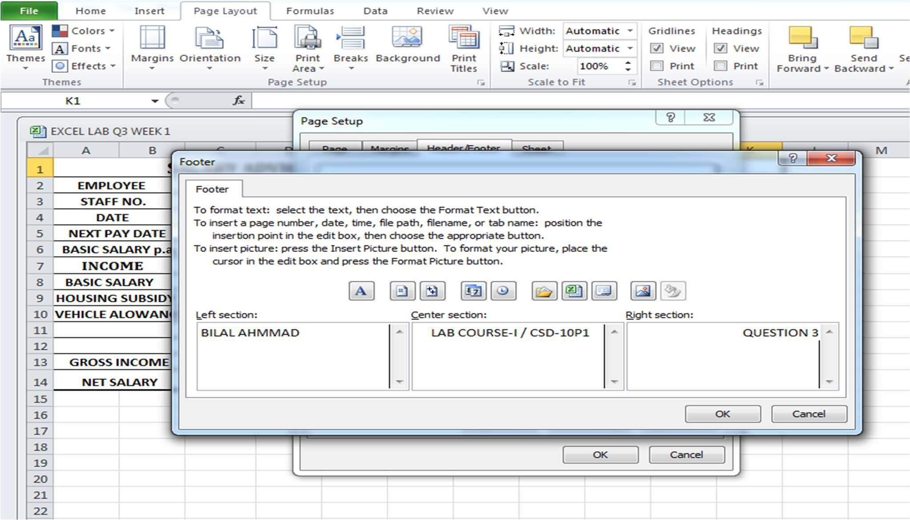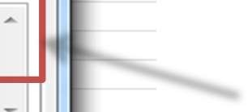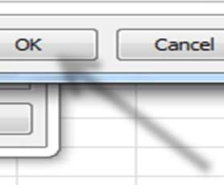

* + Click on **Print.**

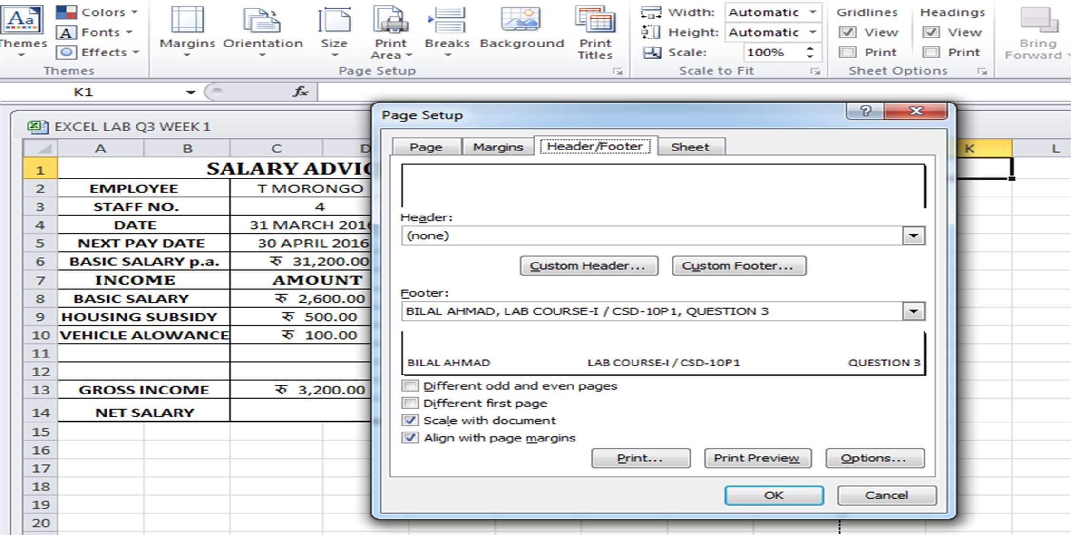

* + **Here is the final result :**

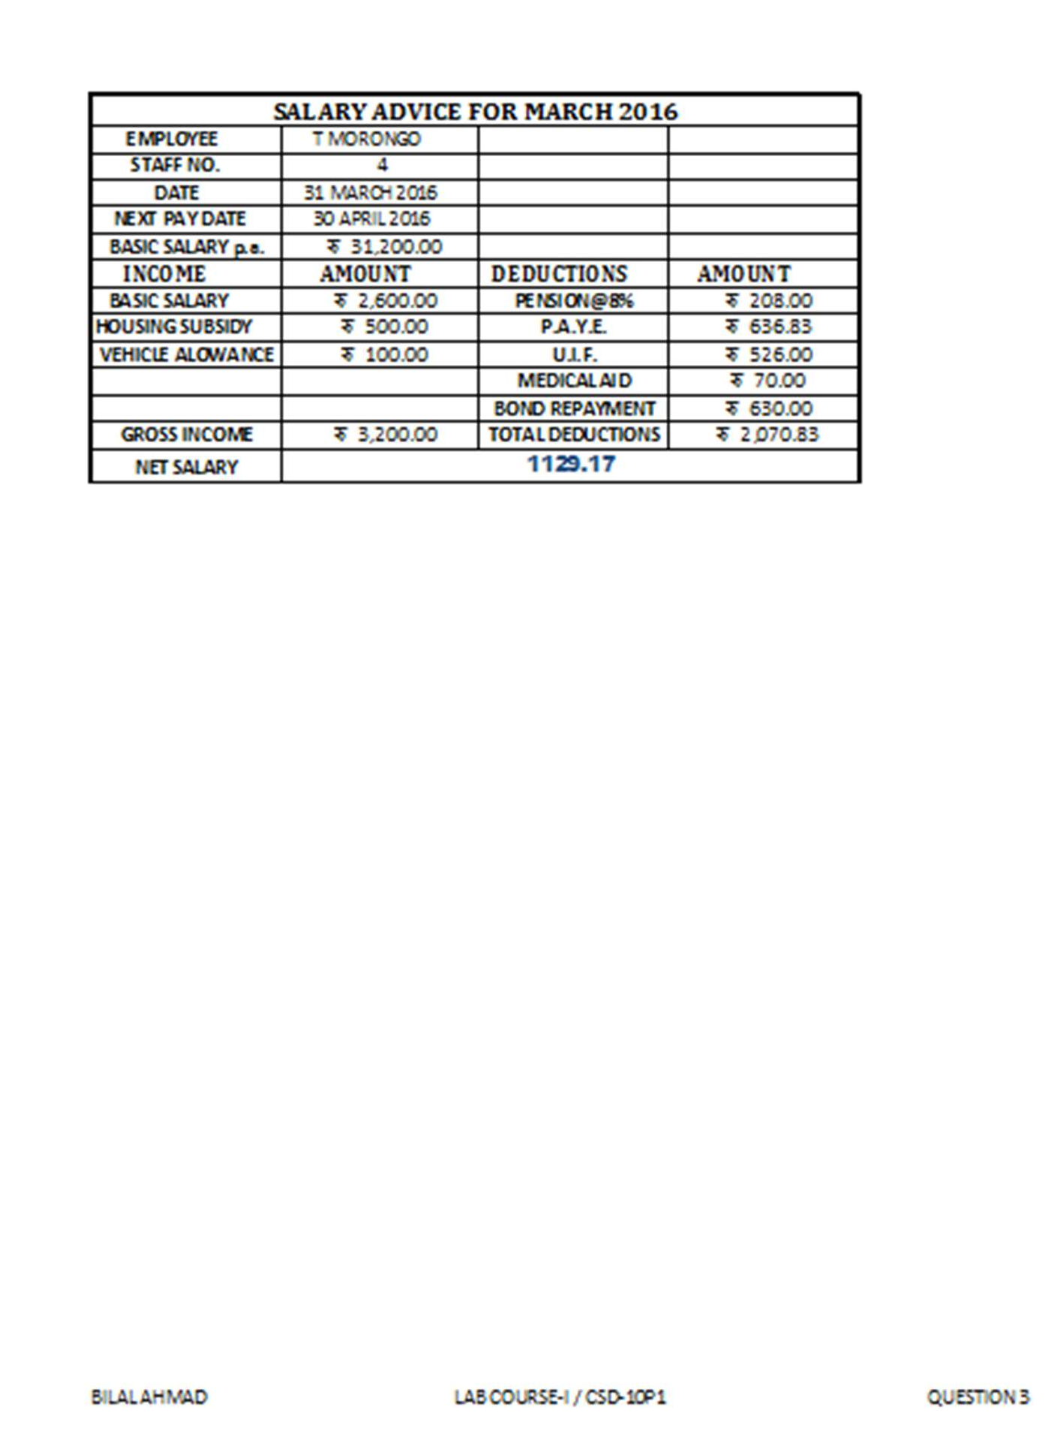

**#4 Use a new workbook & construct a worksheet with the data given & save it as LYONS.**

1. **The MARKUP % (35%) must be inserted in a separate cell under the heading. USE IT as an absolute cell reference in the formula to calculate the mark up per item.**
2. **Calculate the mark up for each item.**
3. **Calculate the selling price for each item.**
4. **Calculate the Total Income for each item.**
5. **Calculate the profit for each item.**
6. **Format the column LITRES SOLD to display the number of litres as integers. The rest of the worksheet must be formatted to display two decimals.**
7. **Use statistical functions to calculate the:**

**✓ AVERAGE**

**✓ HIGHEST (MAX)**

**✓ LOWEST (MIN) for Selling Price column up to Profit Column.**

1. **Show all formulas you have used in a new sheet. Adjust the column width so that the formulae are displayed in full and the sheets fits into one side of A4 landscape format and save it as formulas.**
2. **Under the worksheet Create a pie chart titled PRODUCT COST PER UNIT for Product & Cost price per Litre columns. Data labels indicating percentages should be displayed.**
3. **Put borders neatly on the on the work sheet & save it as LYONS2.**

***STEPS:***

▪

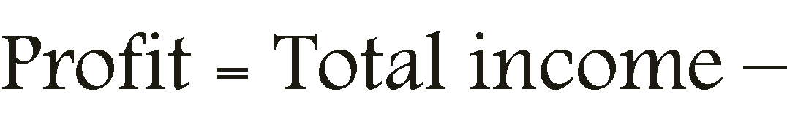

:

➢

➢

➢

➢

▪



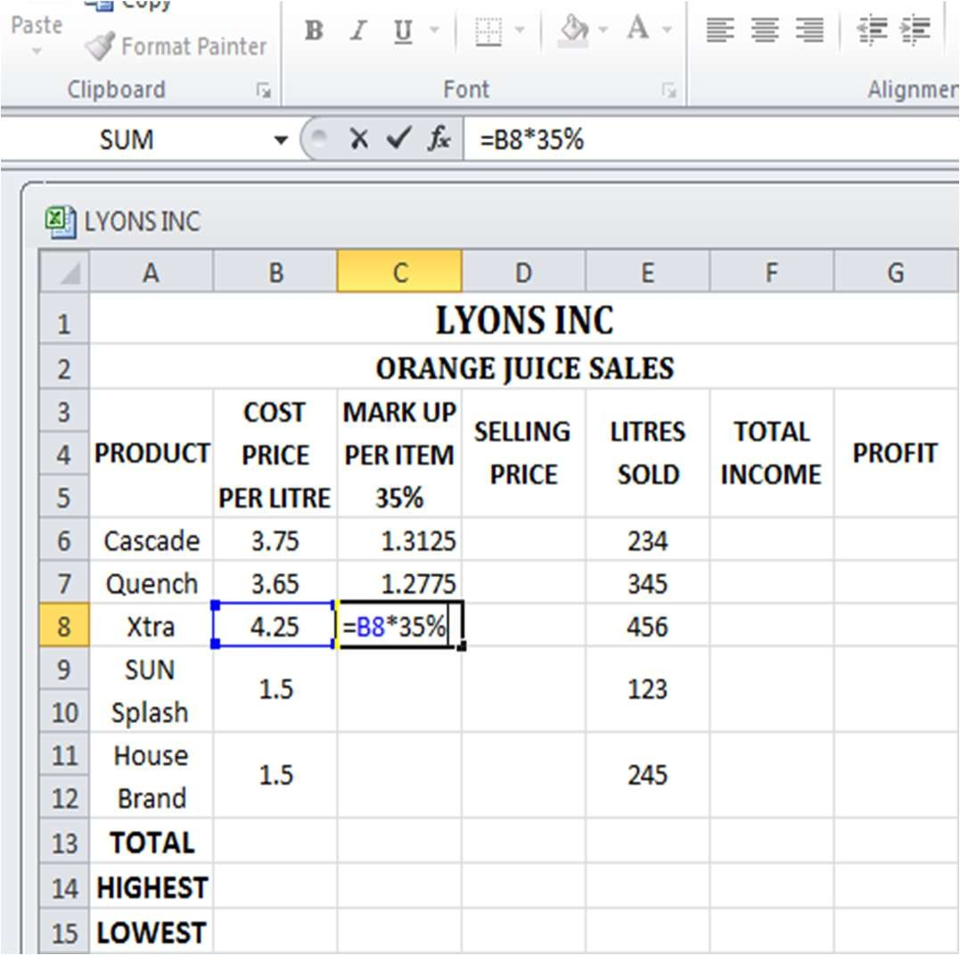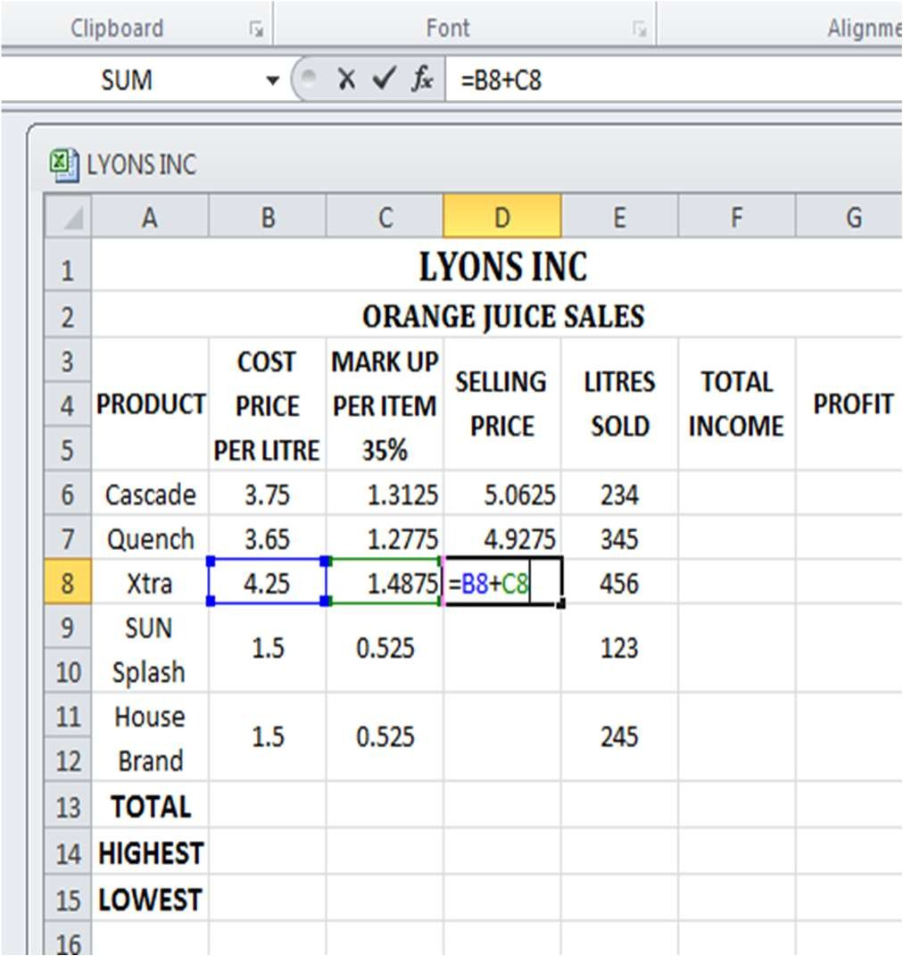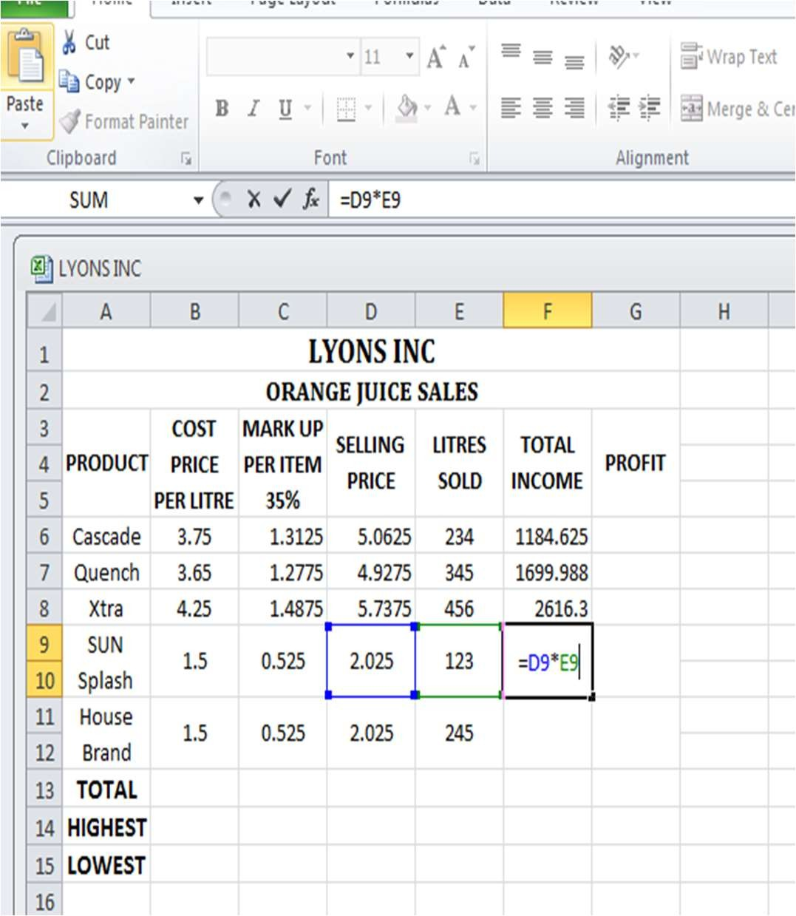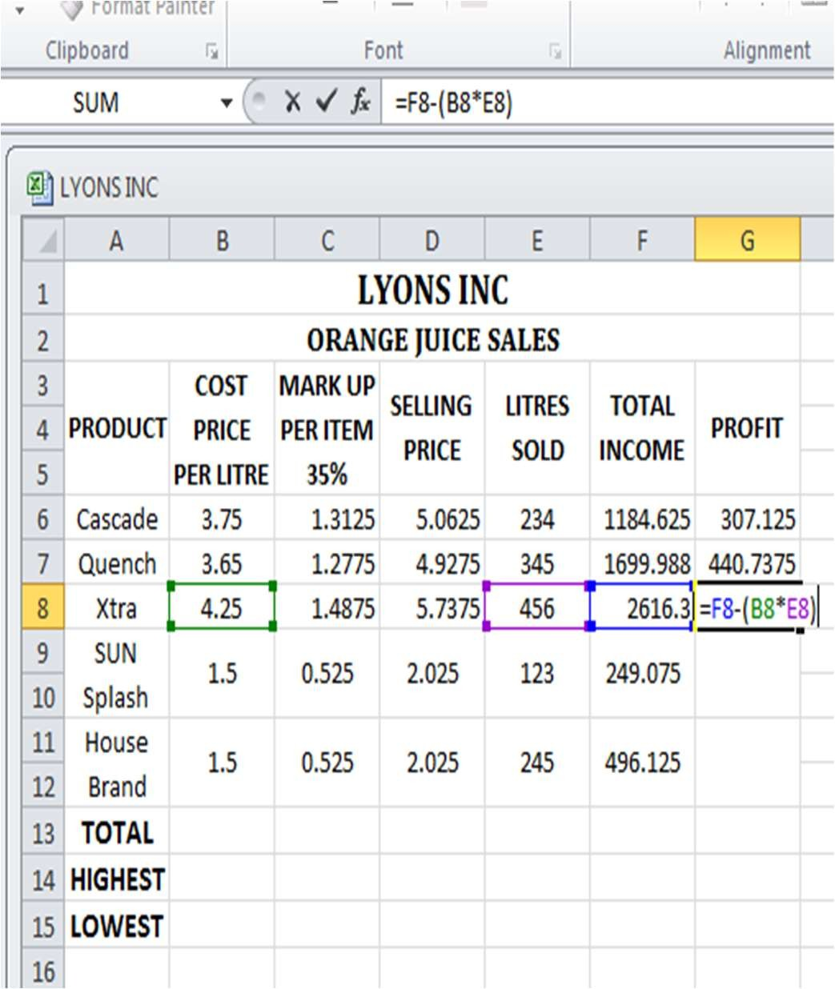

* + Now calculate the **total** value , the **highest** ,the **lowest** and **average** values for each column using the given statistical formulas:

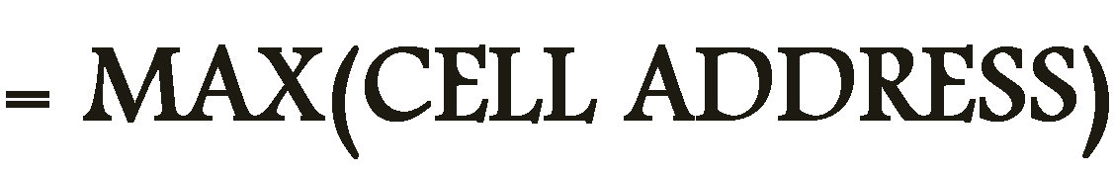

➢

➢

➢

➢



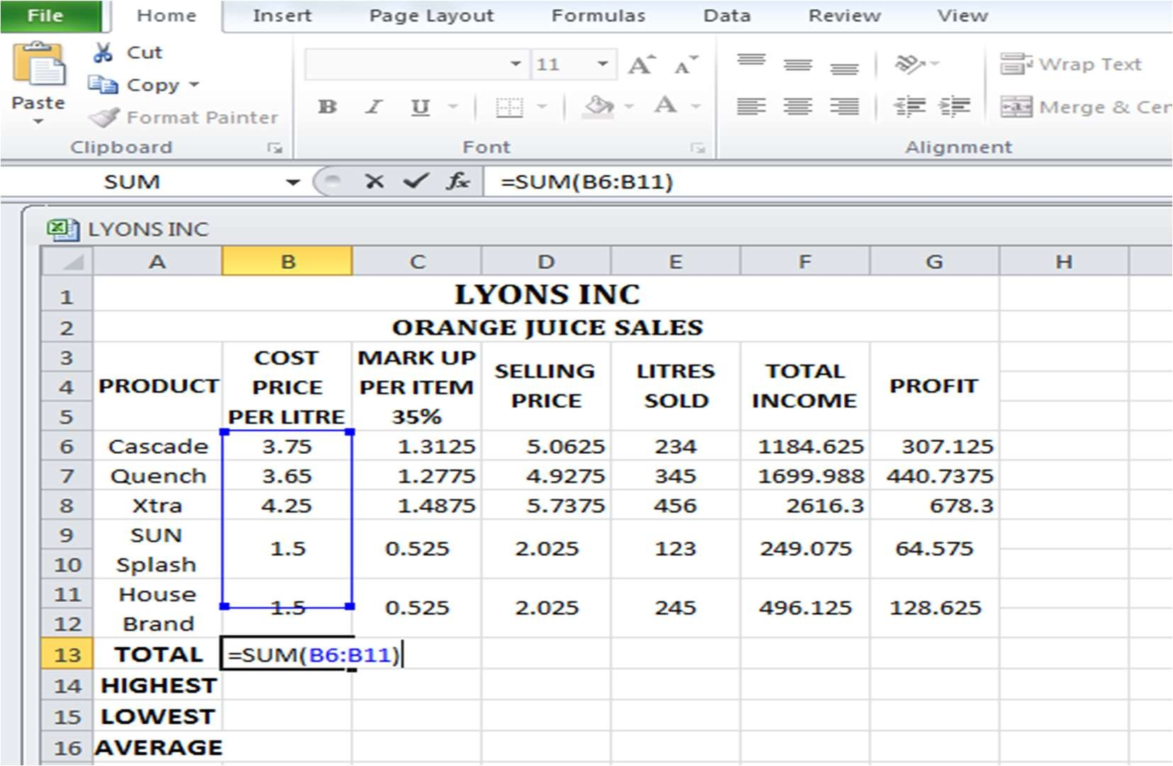



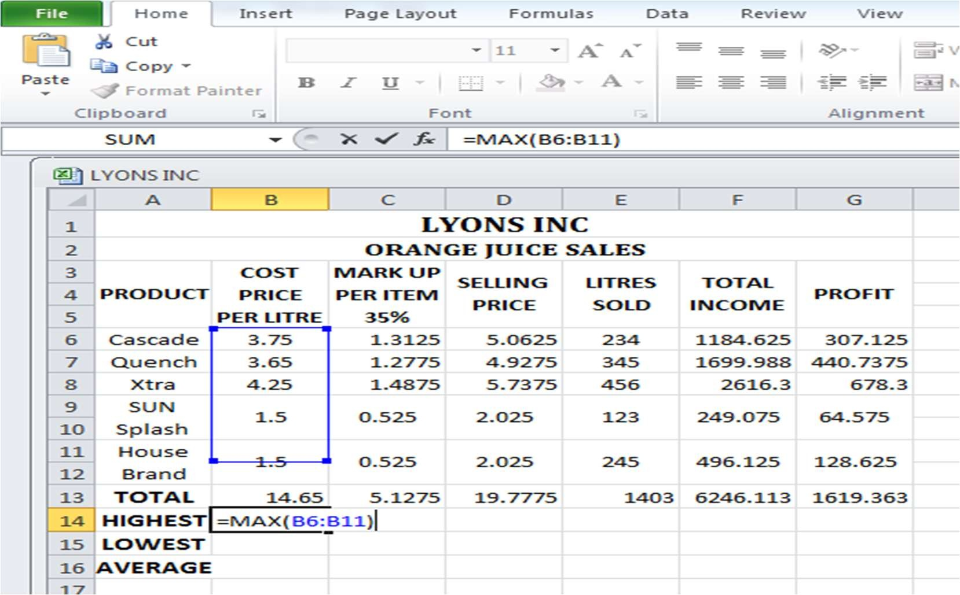



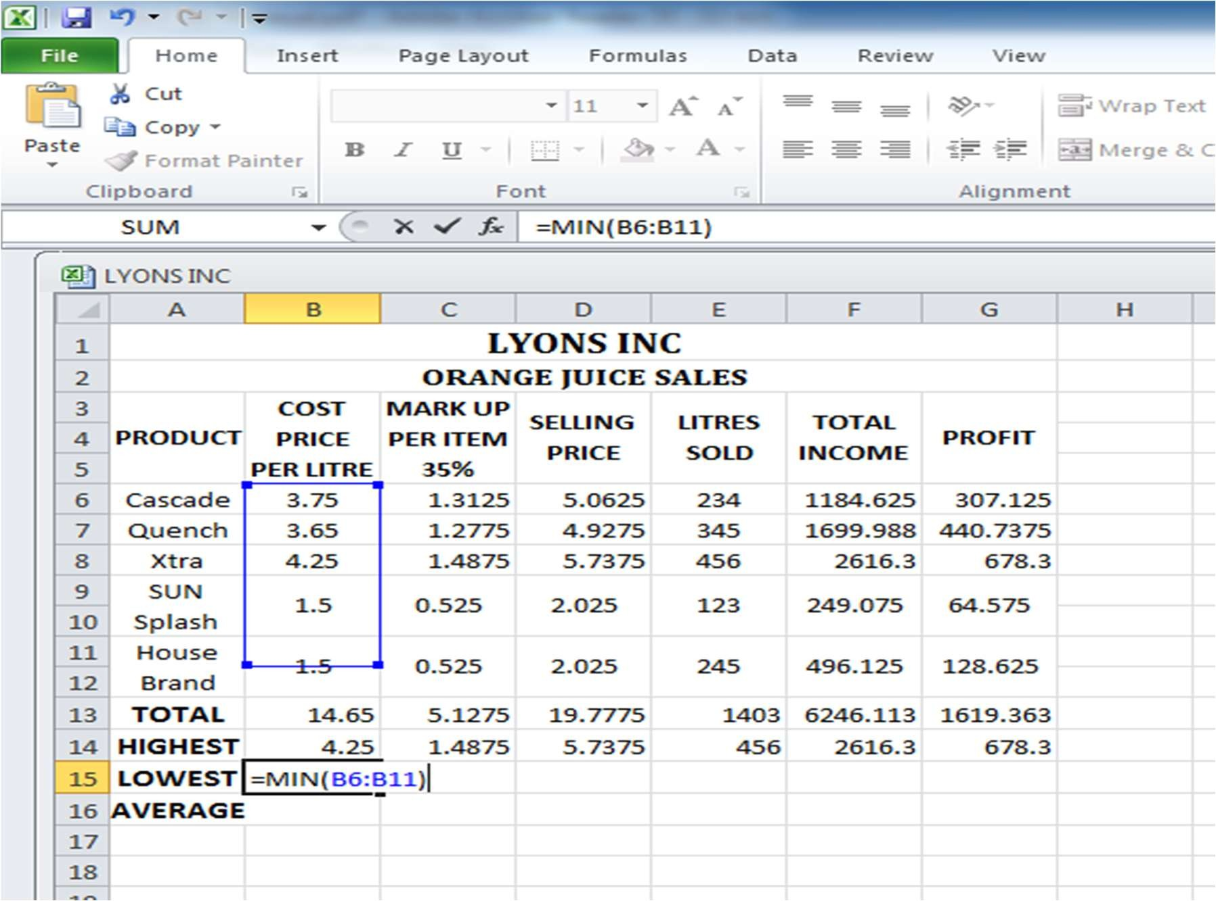



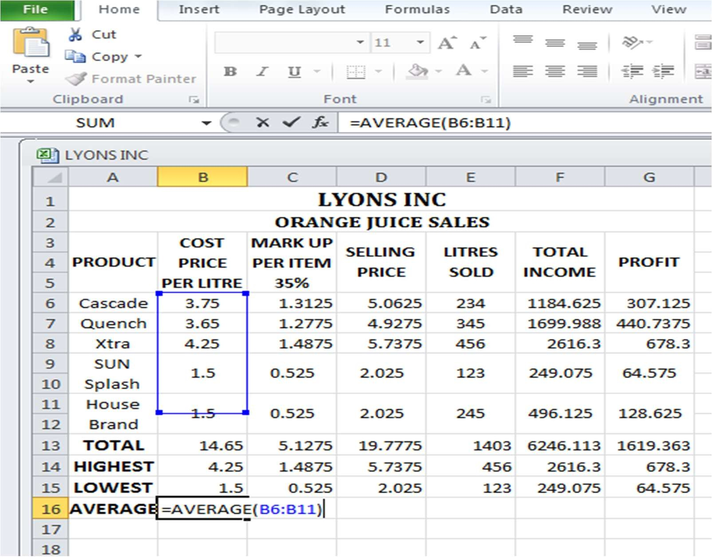

▪

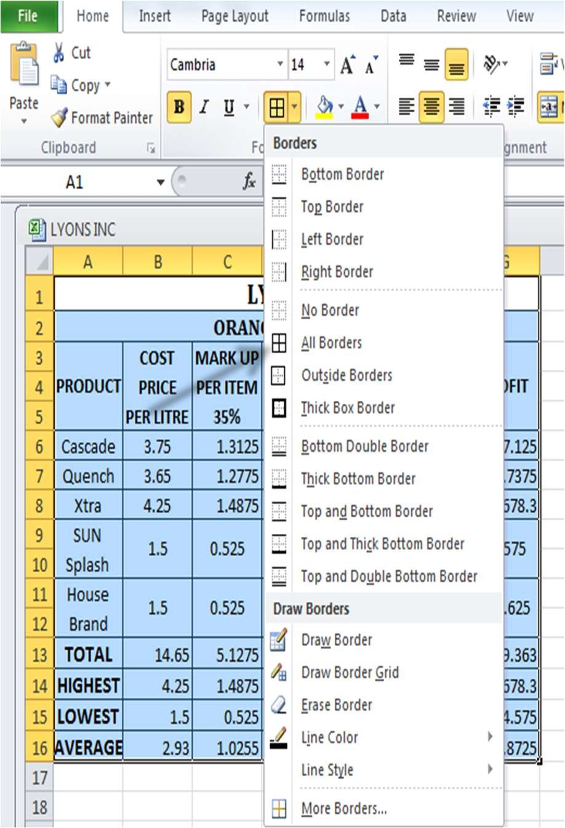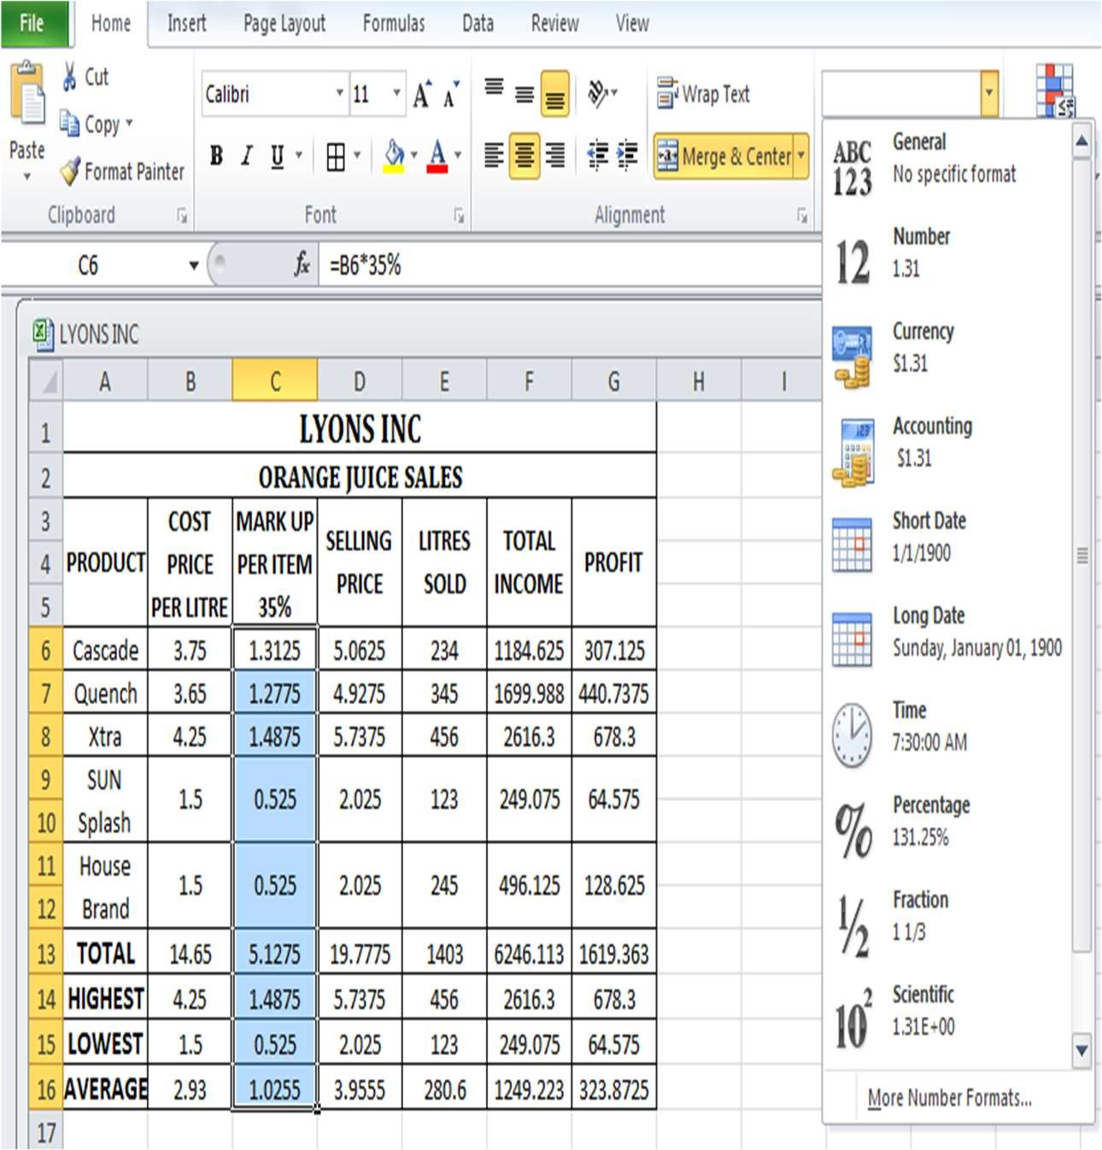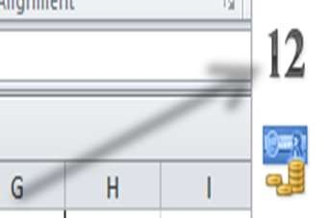

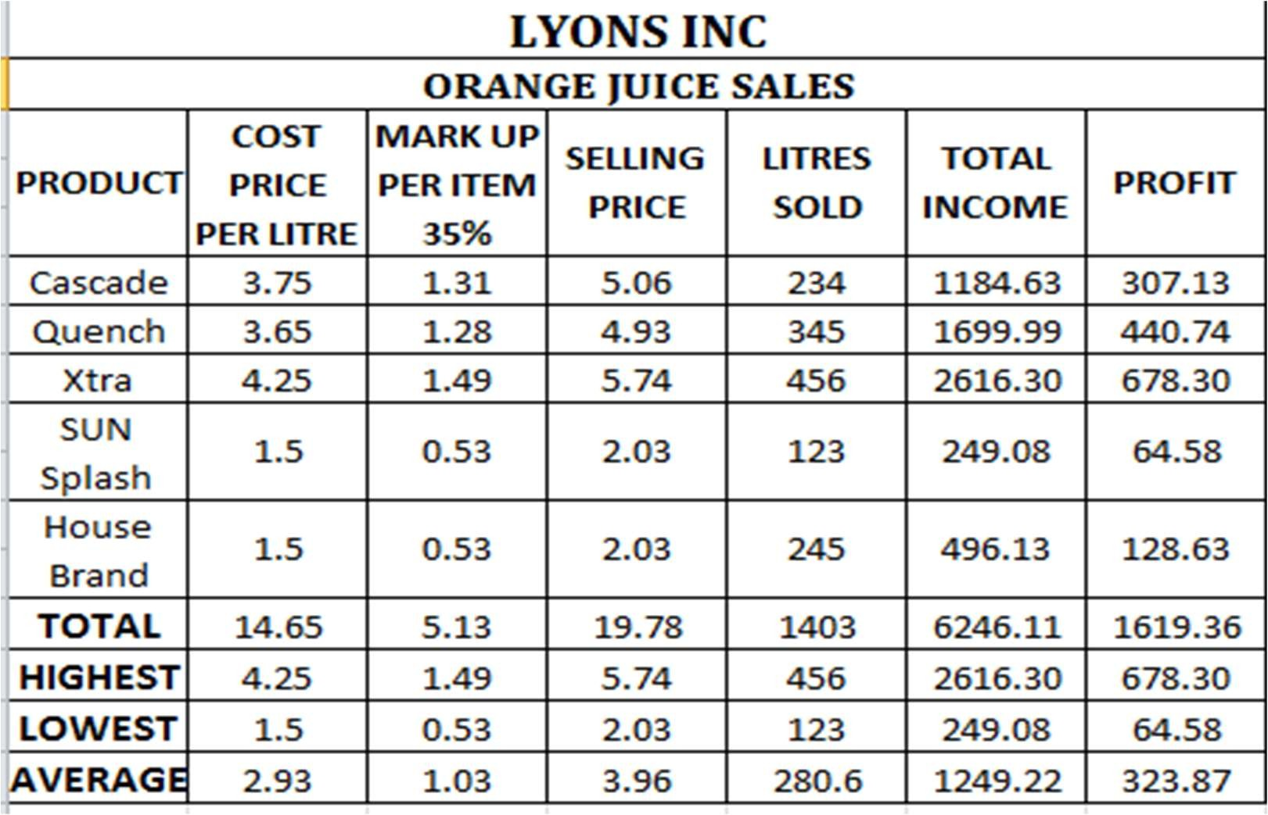



▪

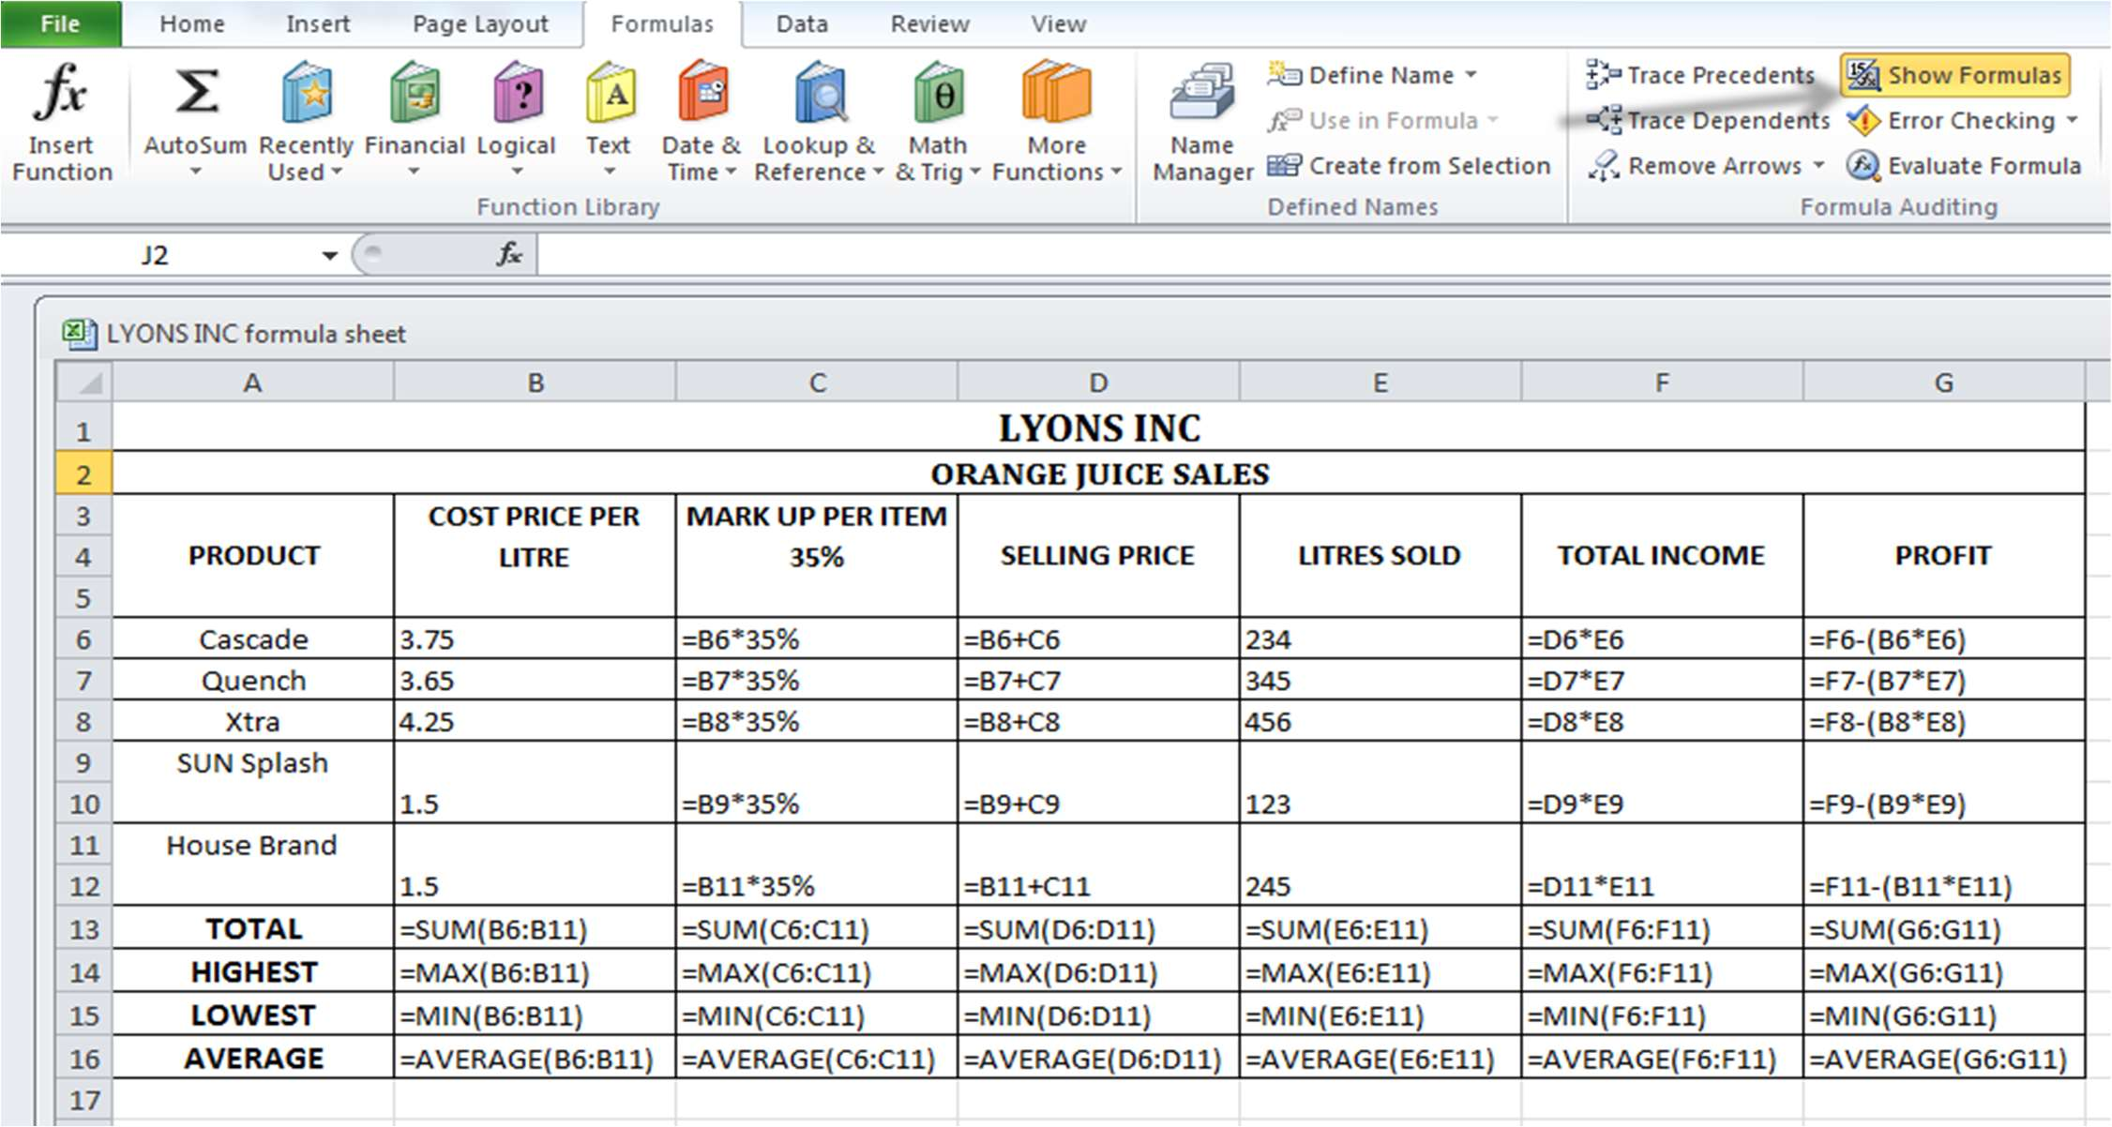

▪

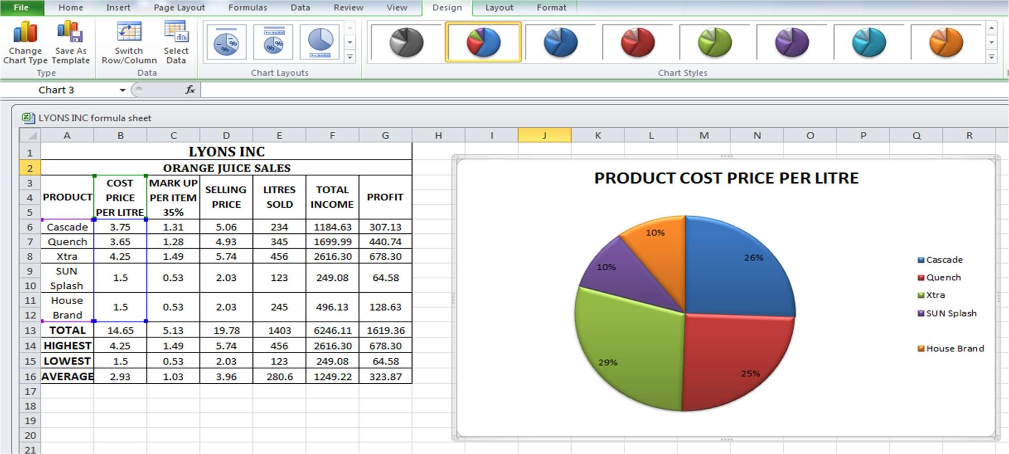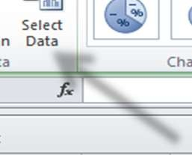

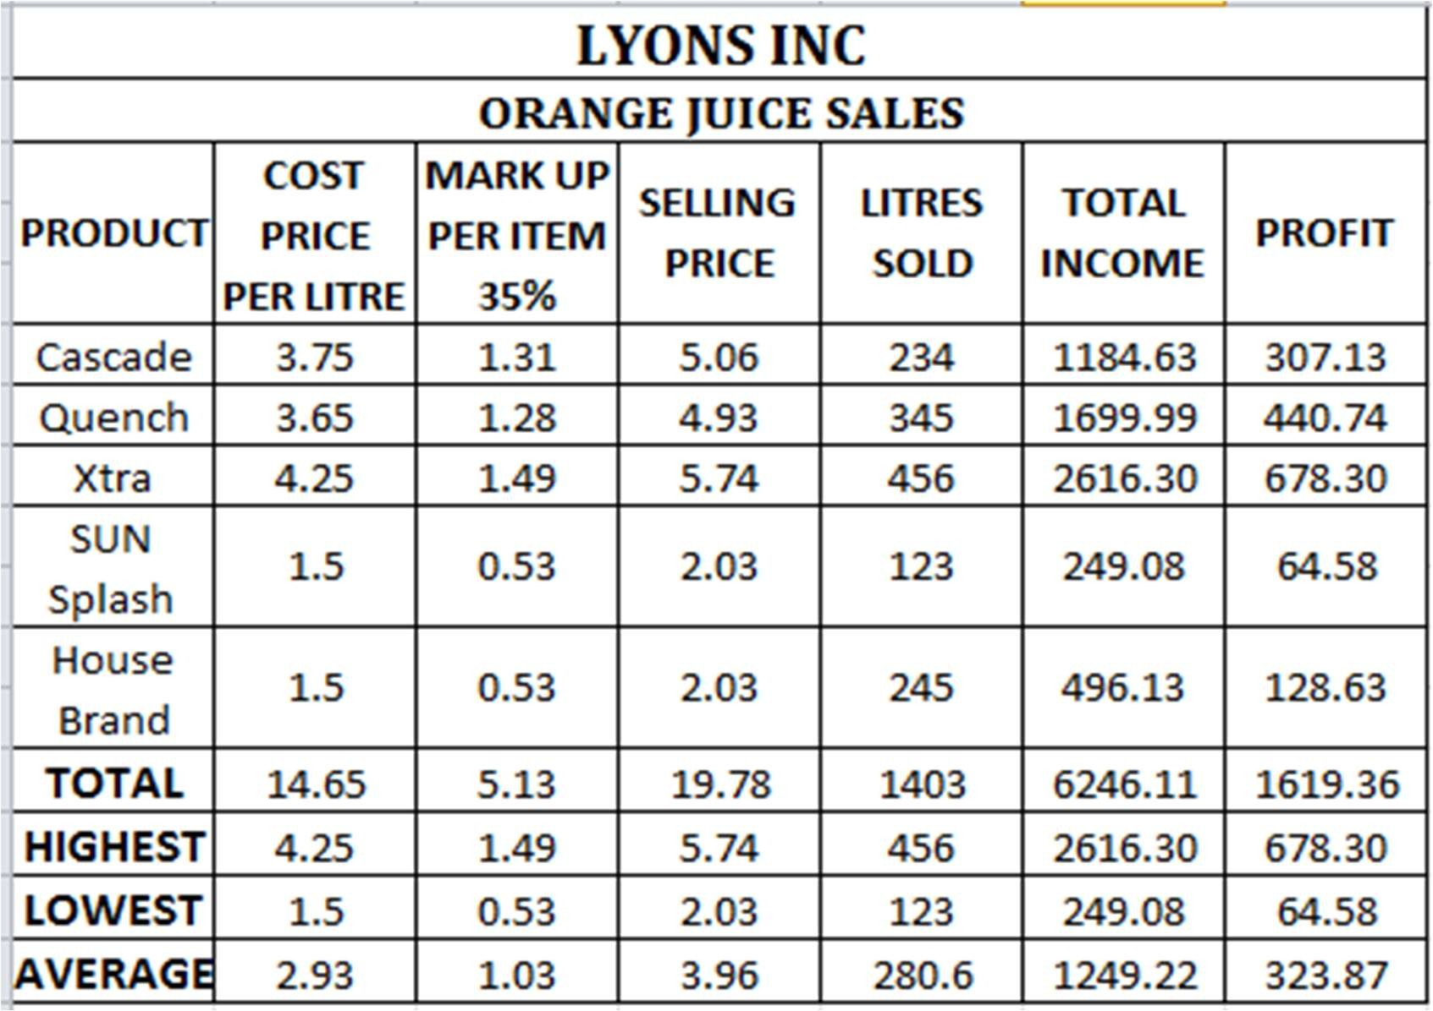

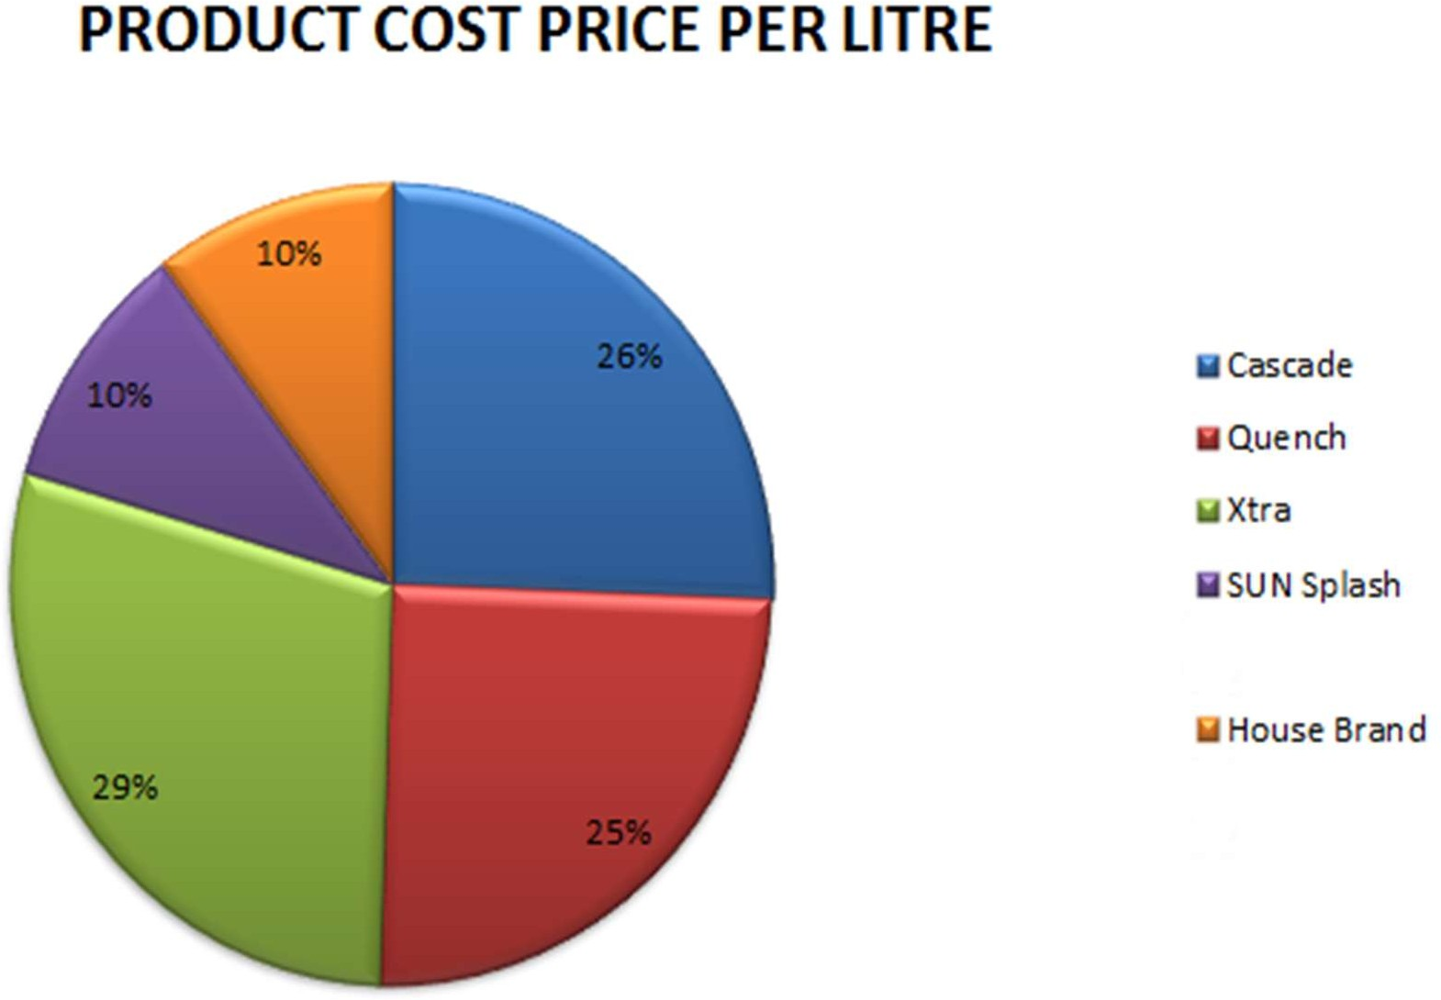



WEEK 2

### WEEK 2

**#1 Design Seasonal Greeting cards using MS-Power Point.**

**OUTPUT:**





➢ 

➢ 

➢













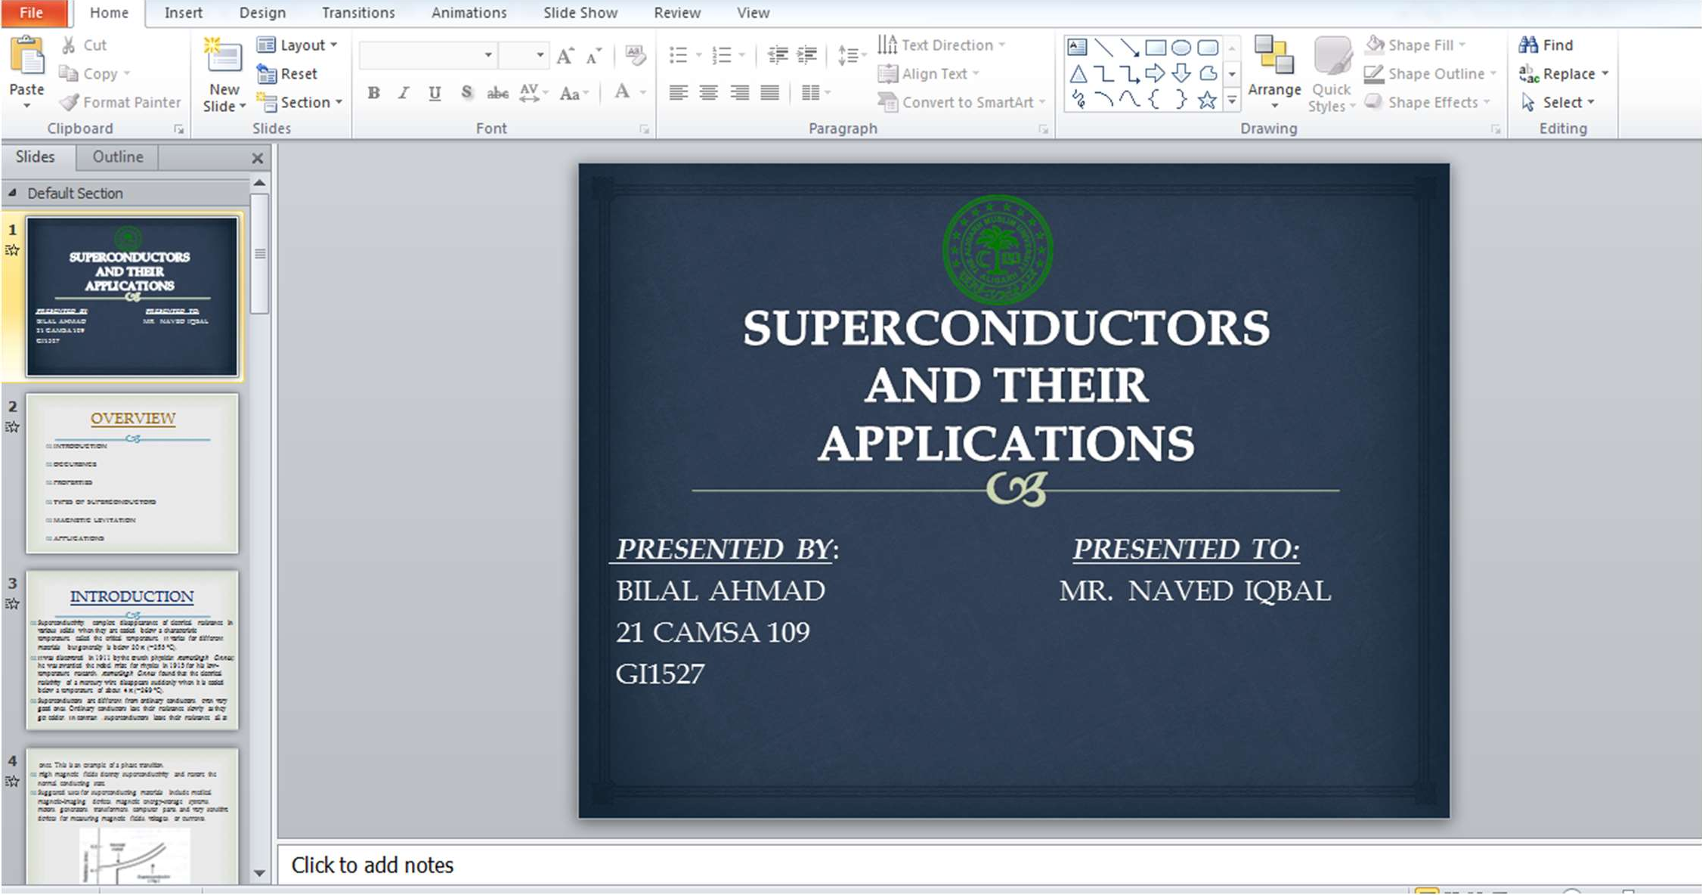

**SLIDE 2**

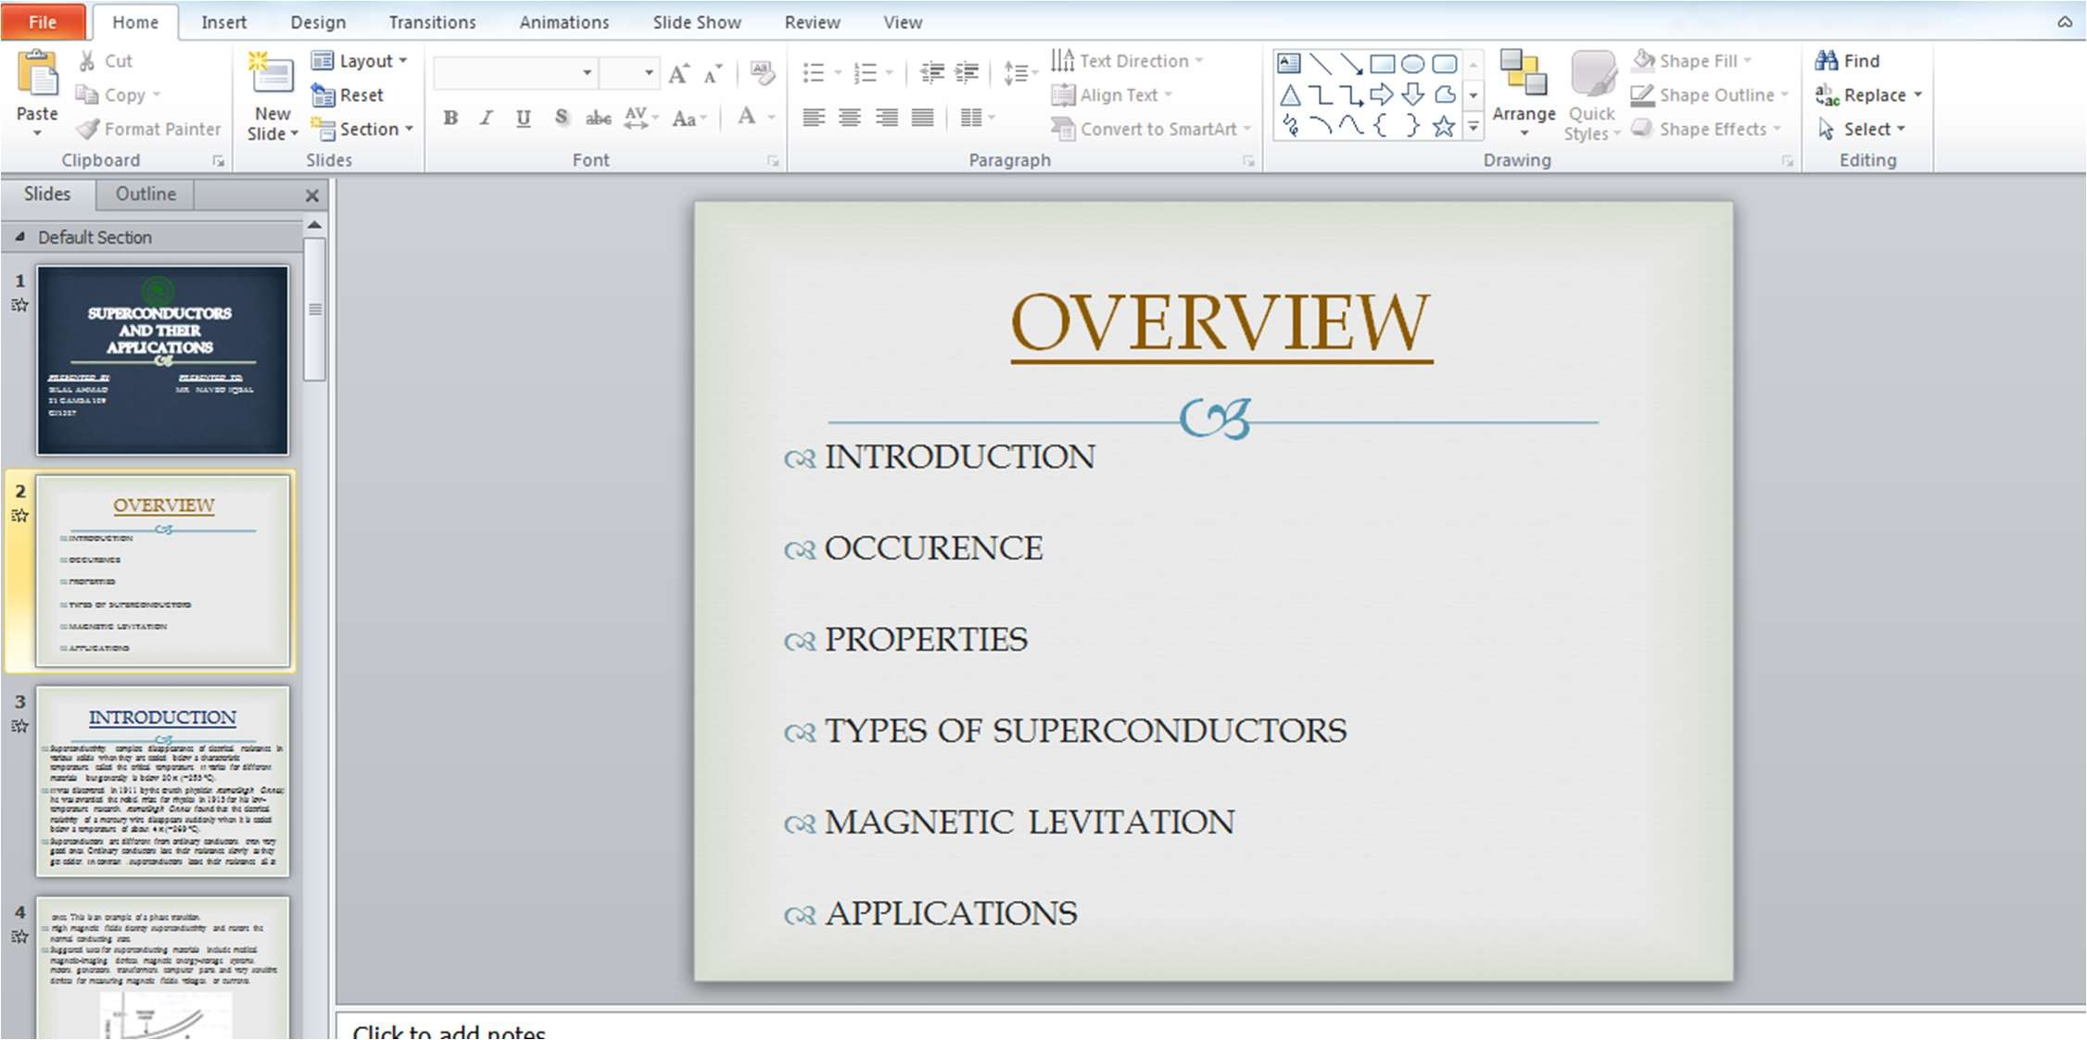

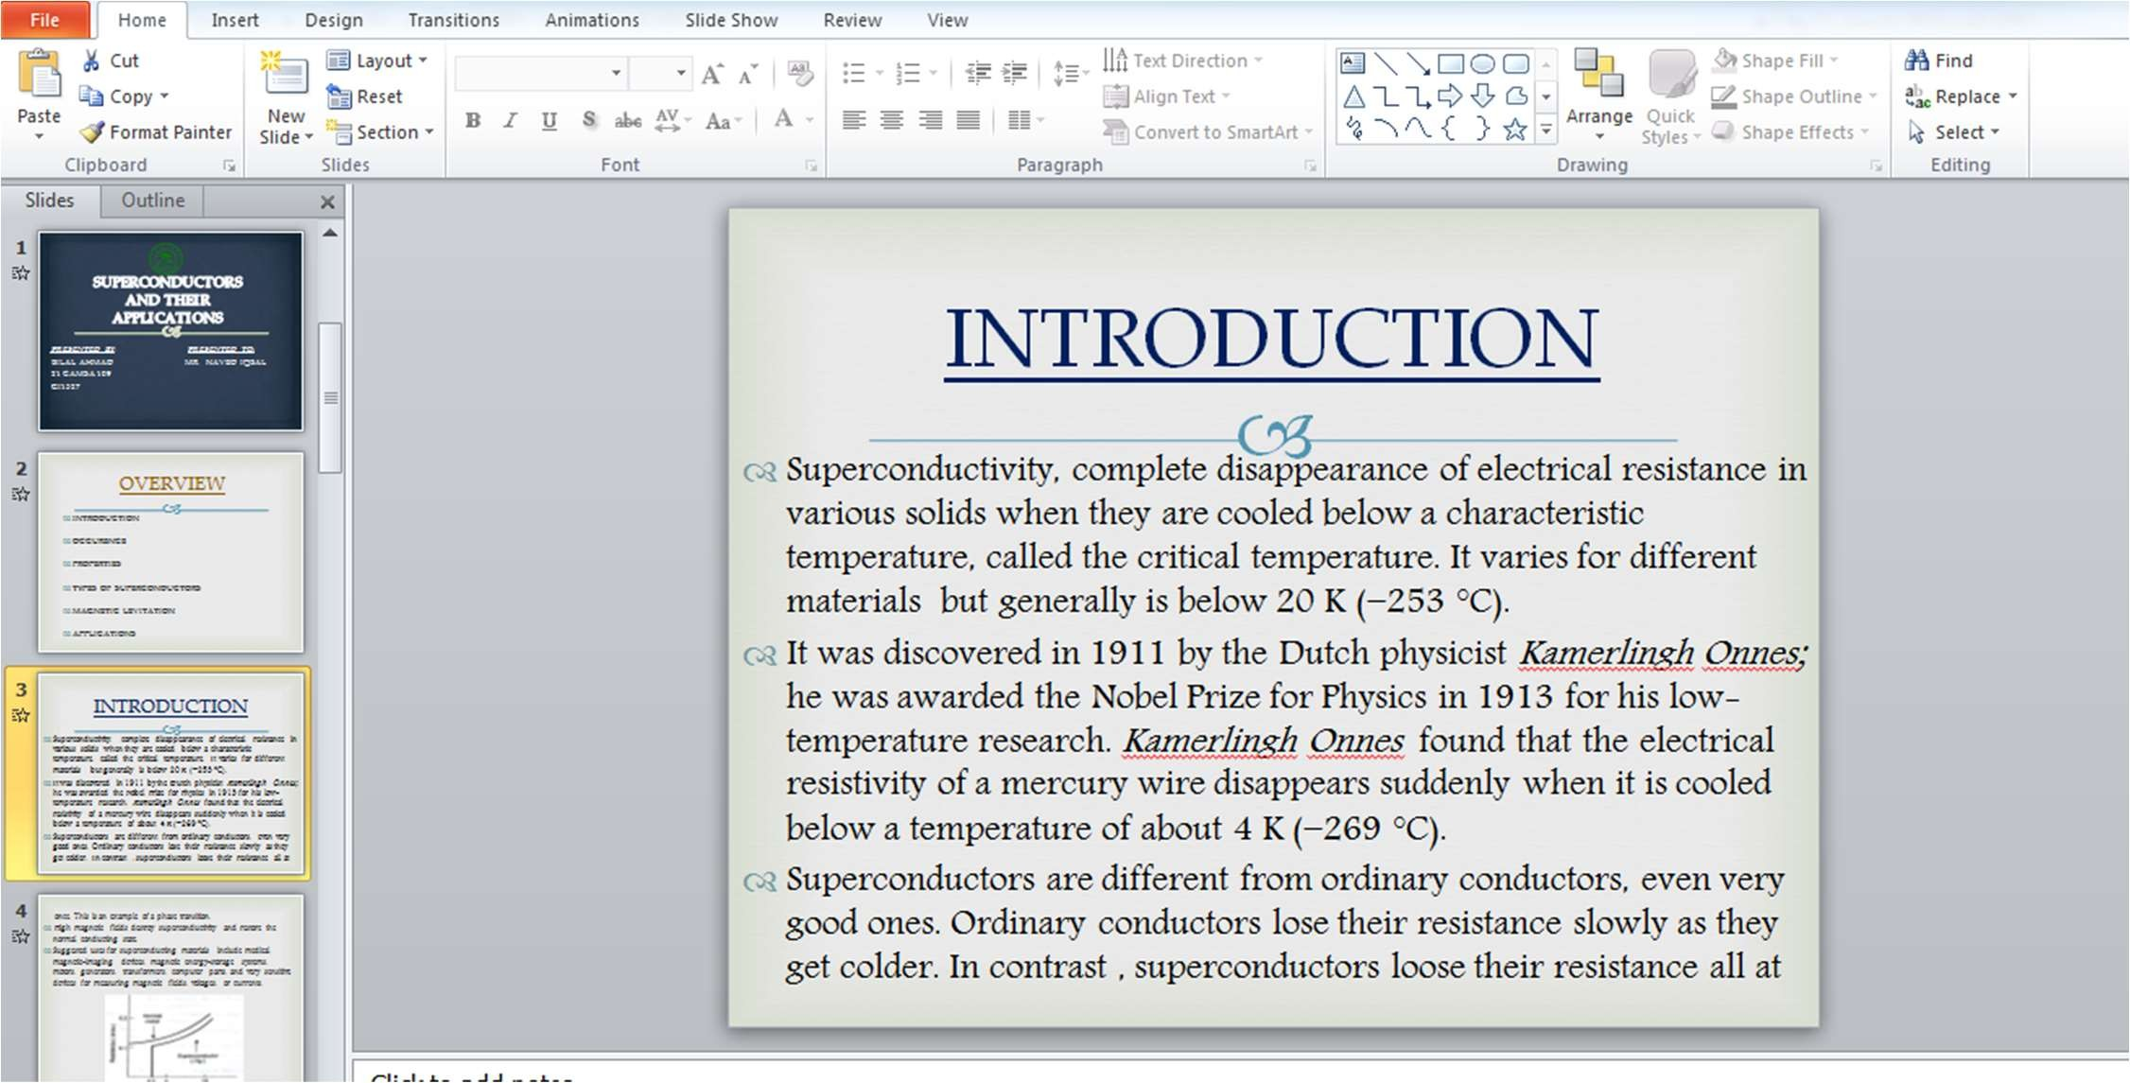

**SLIDE 4**

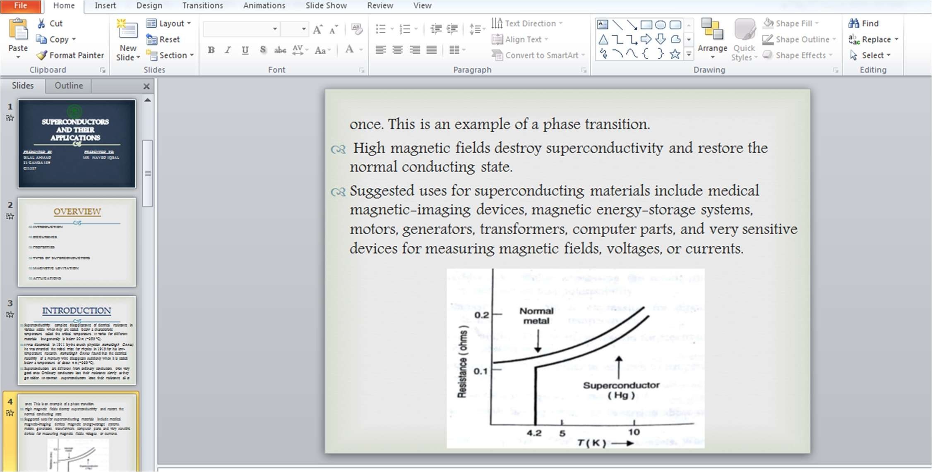

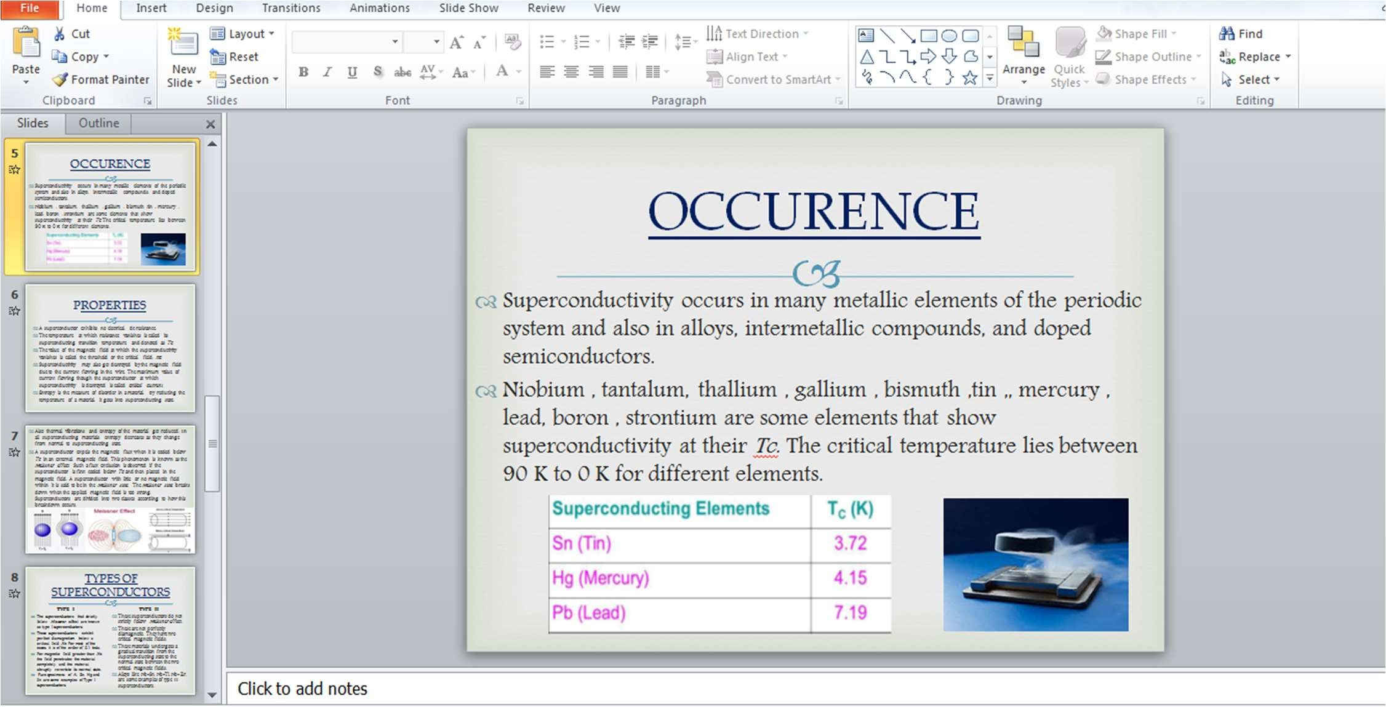

**SLIDE 6**

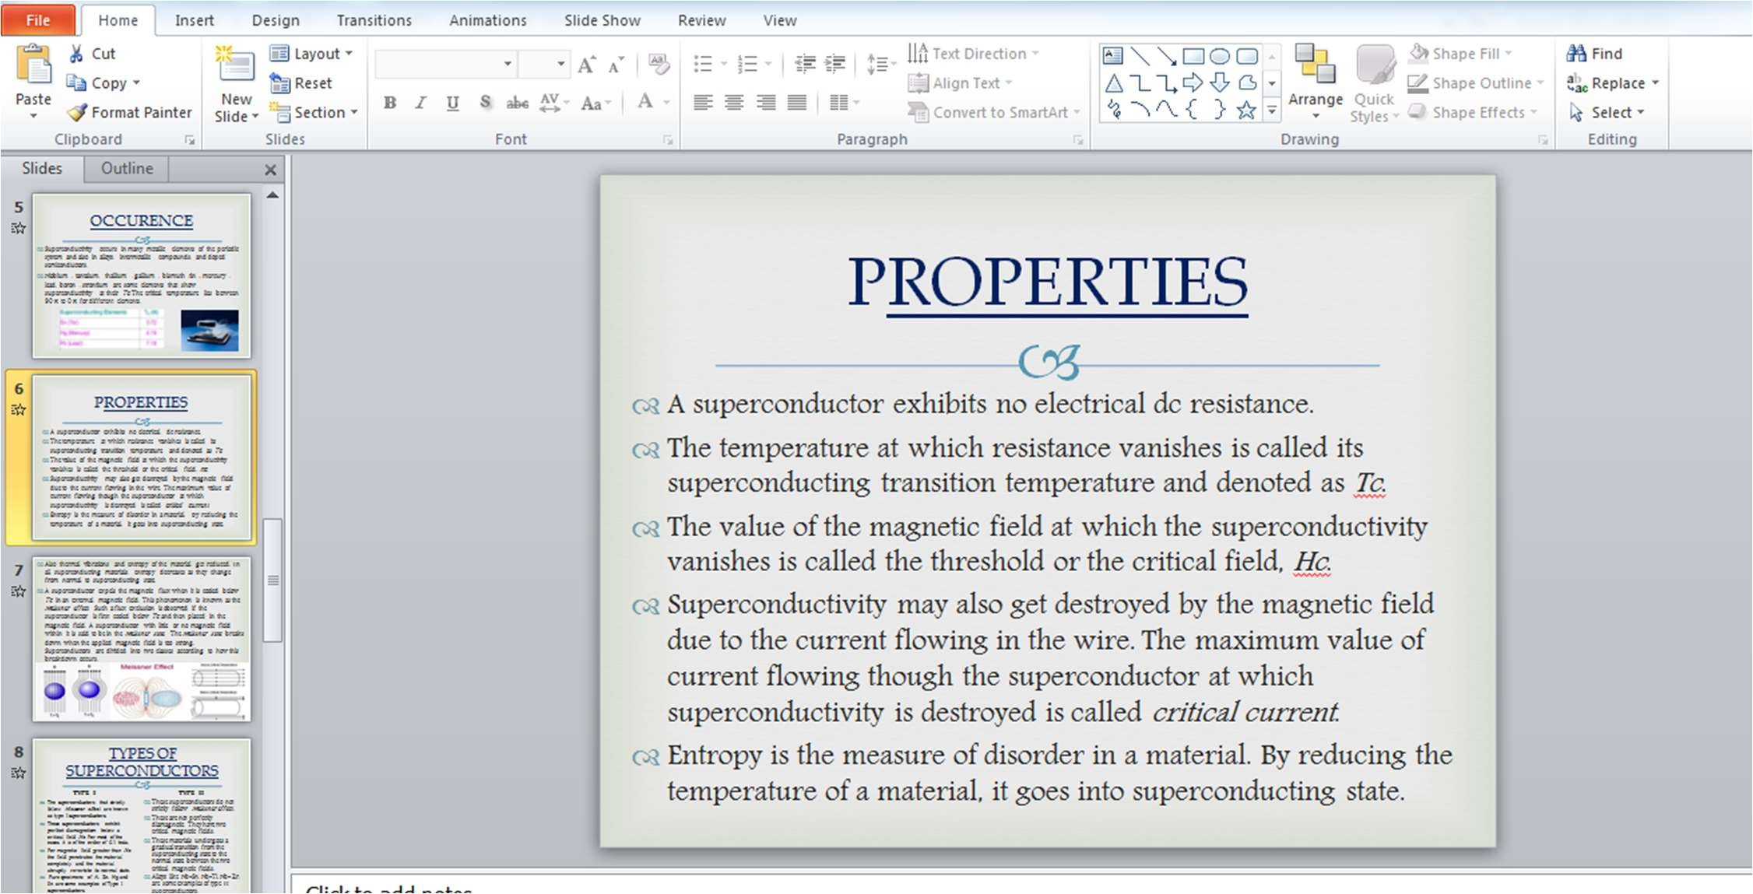

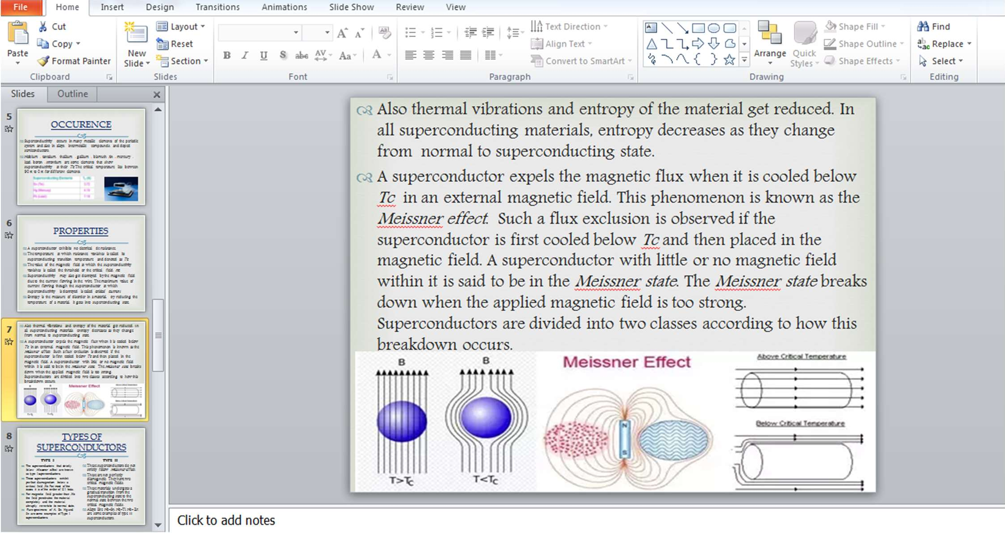

**SLIDE 8**

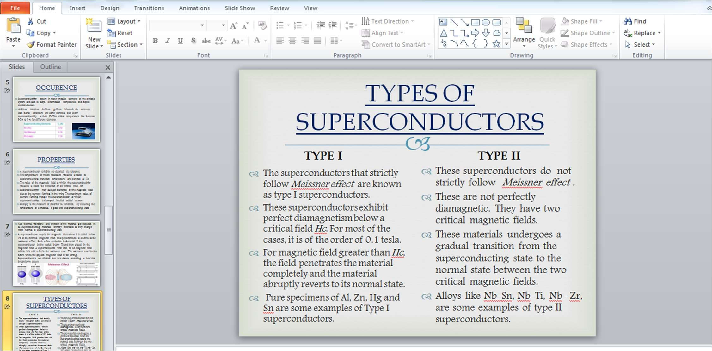

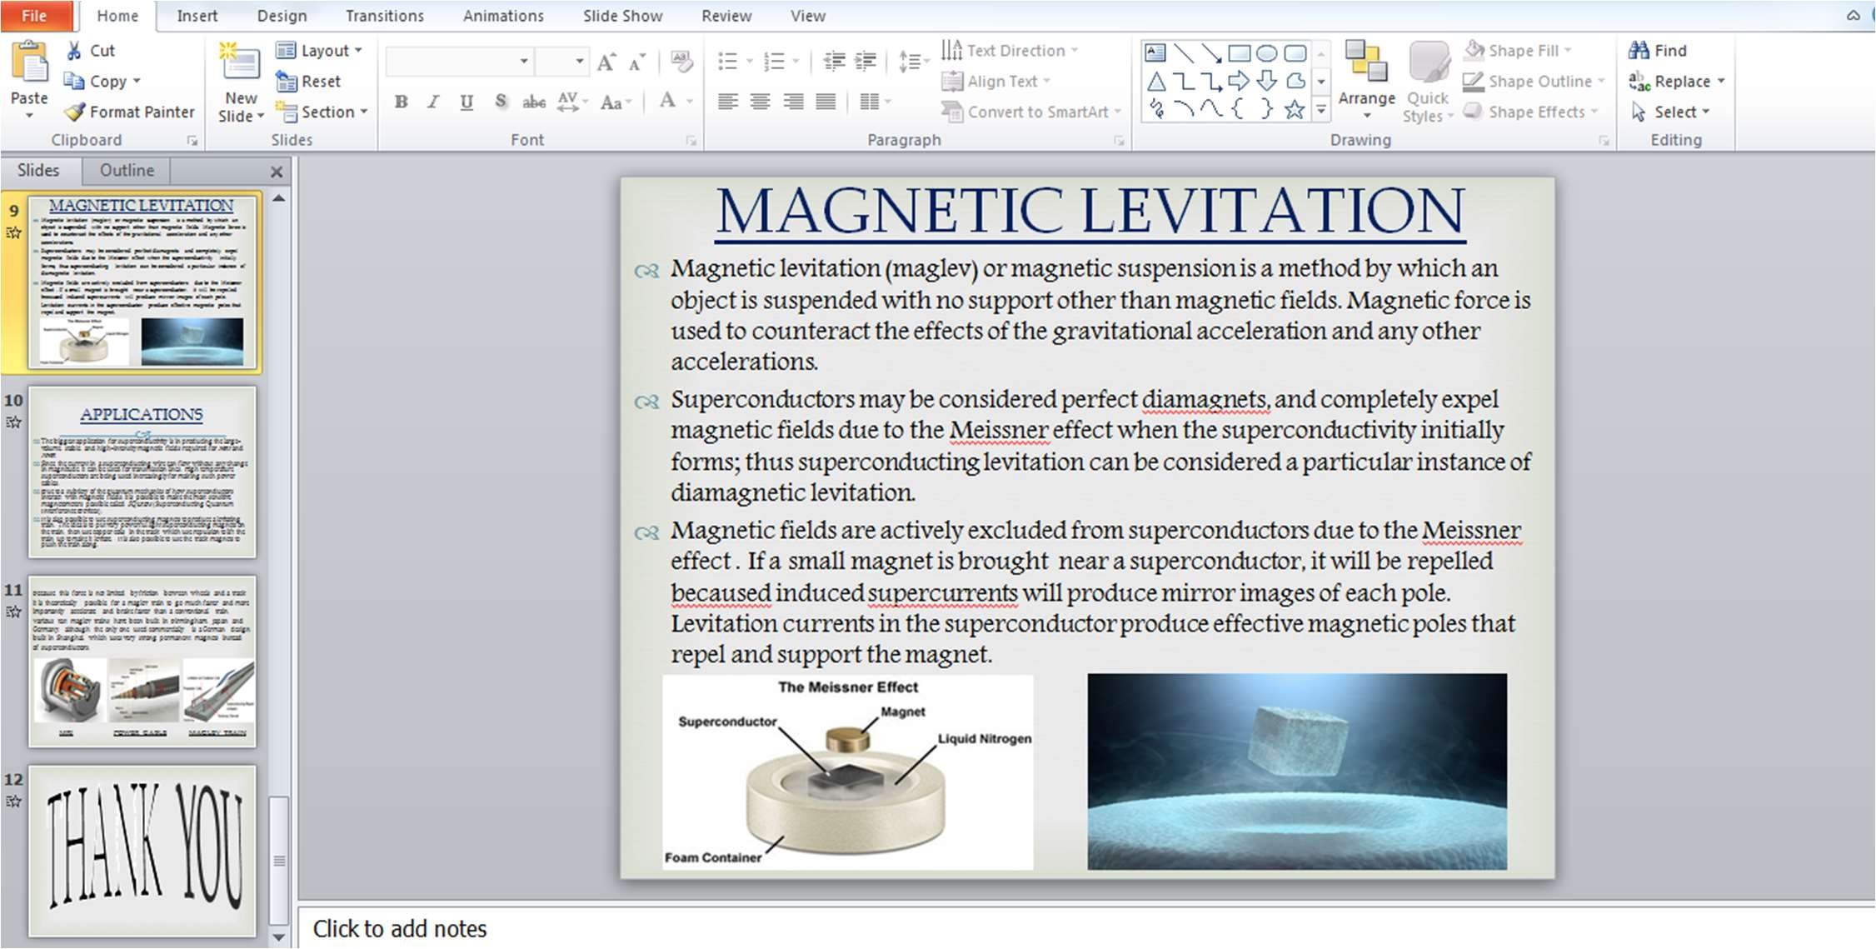

**SLIDE 10**

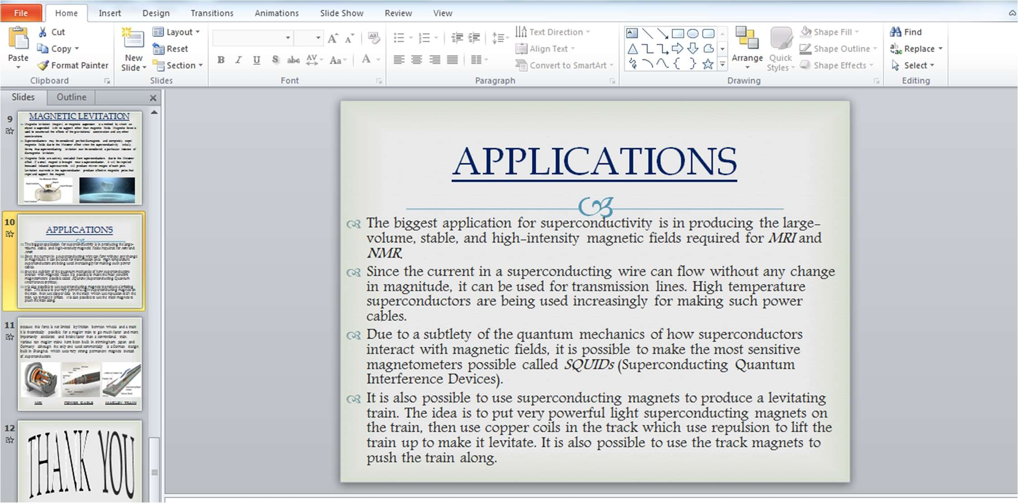

**SLIDE 11**



**SLIDE 12**





WEEK 3

# WEEK 3

## INSTALLATION OF DEV C++

STEPS:

▪ ++

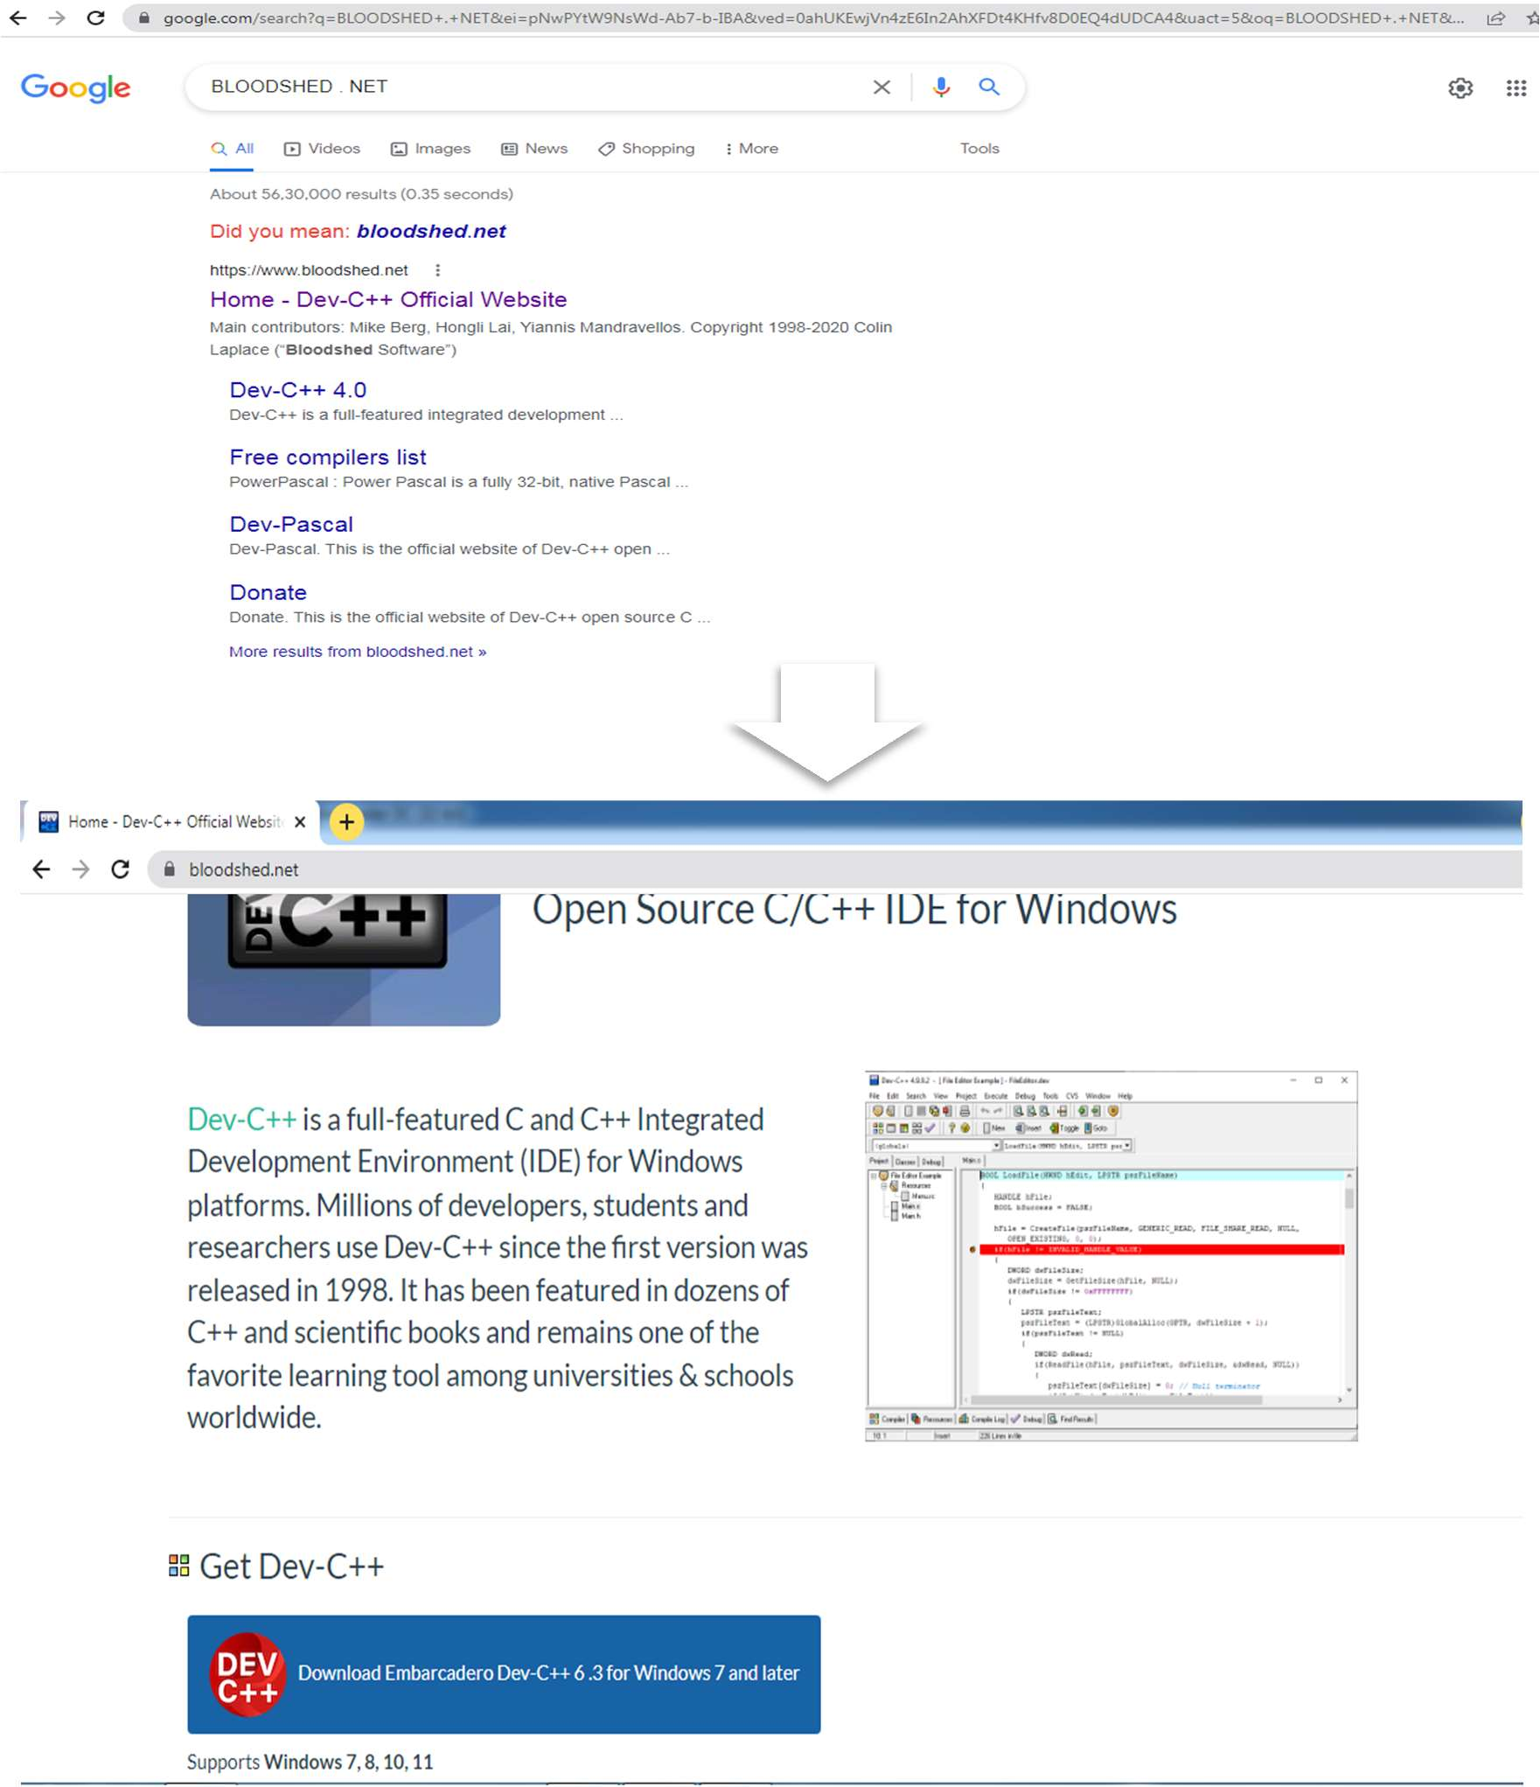

▪  

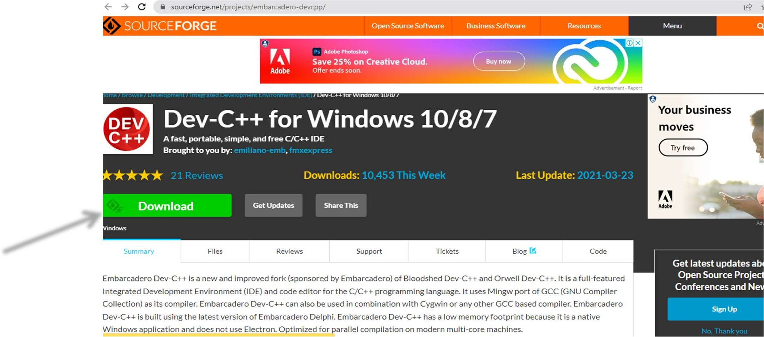

▪

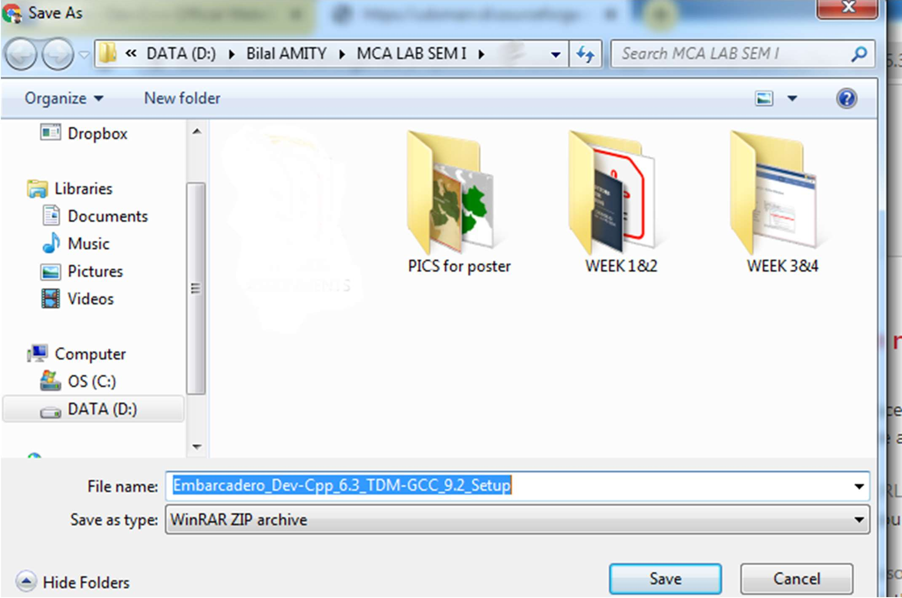

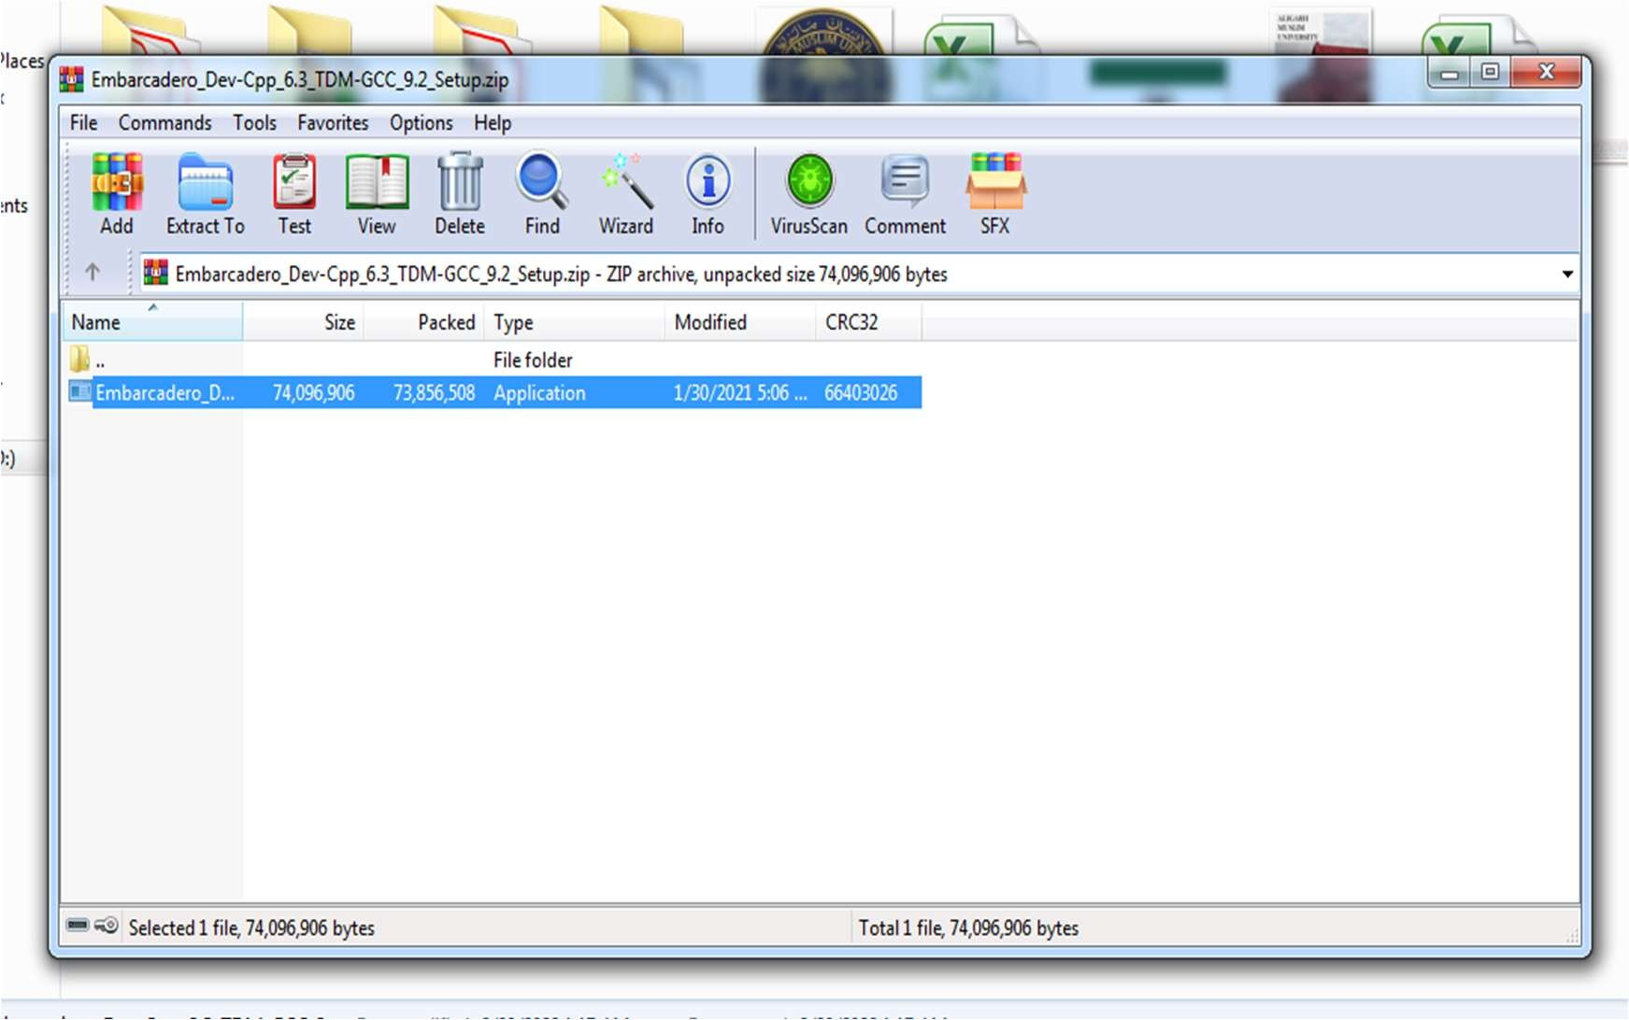▪ 



▪

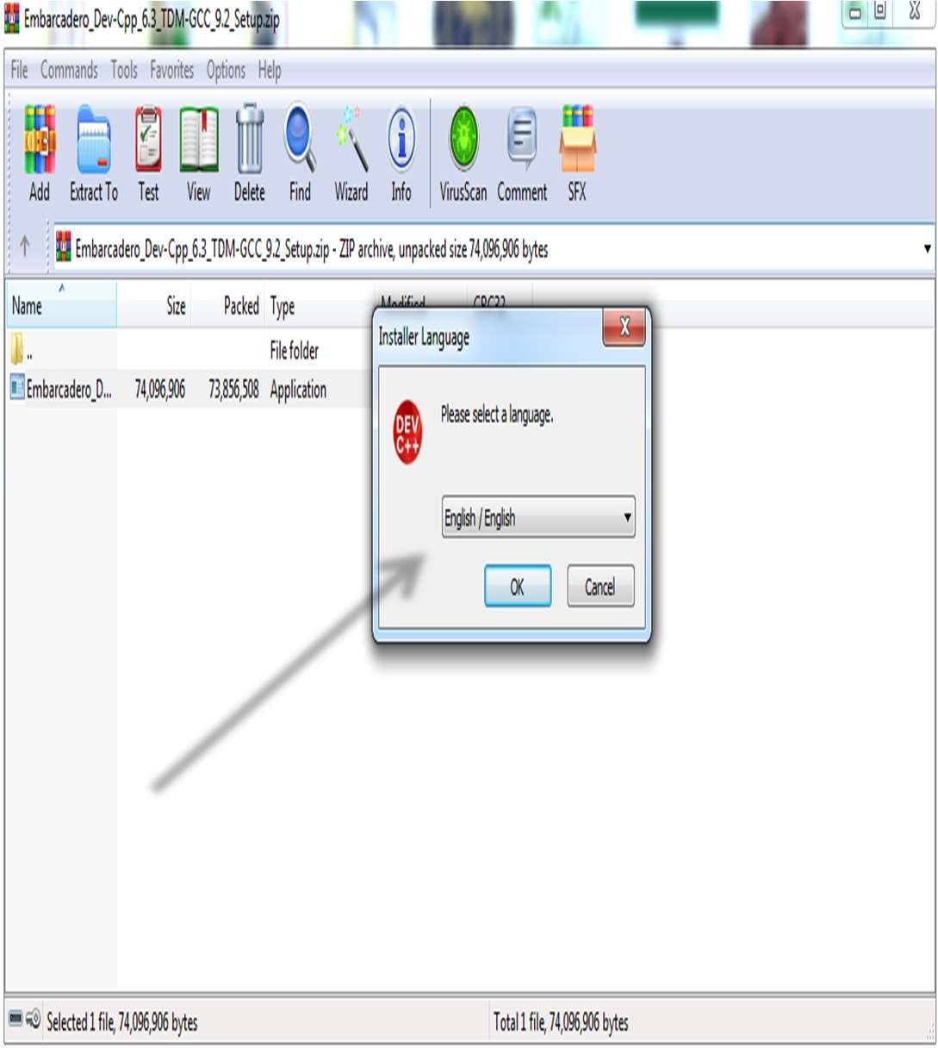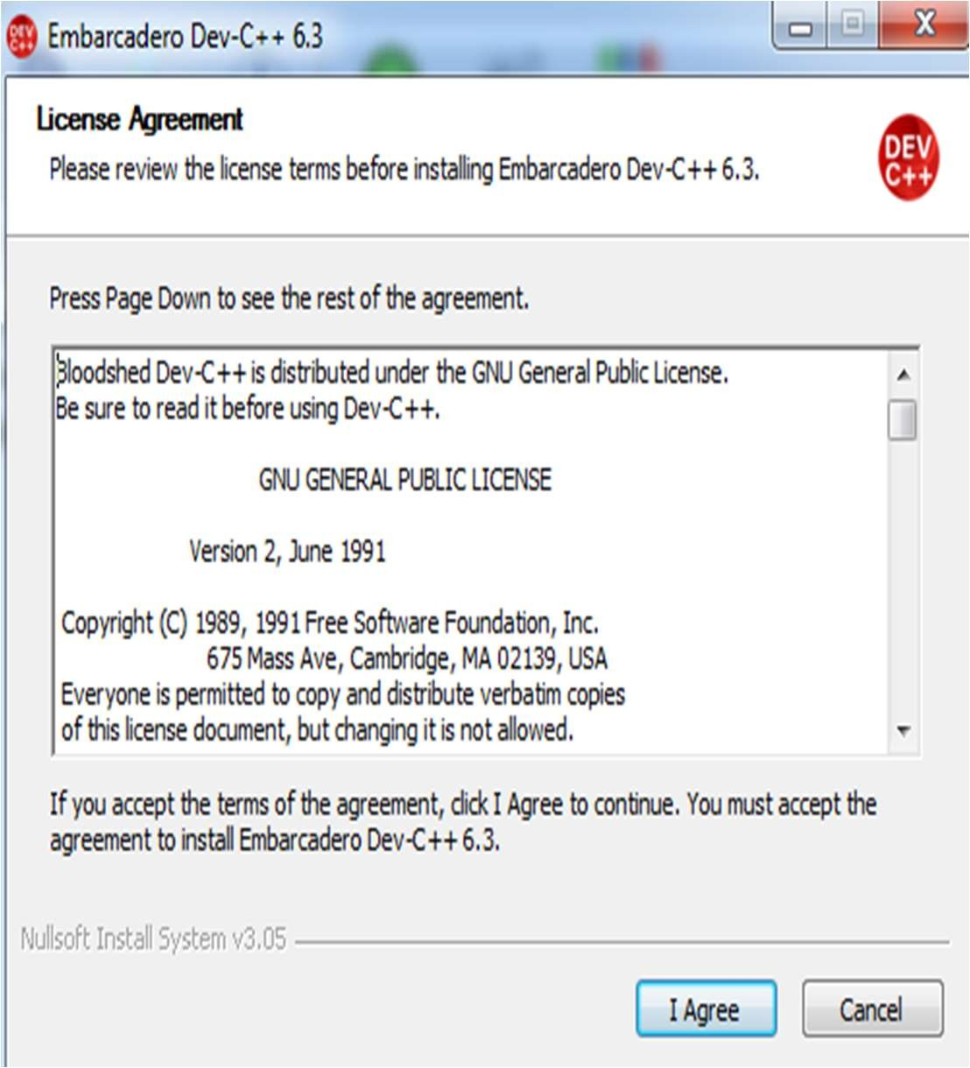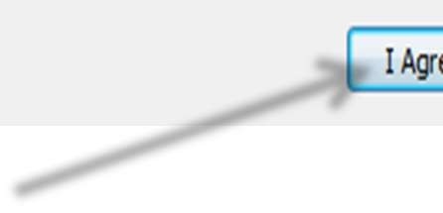

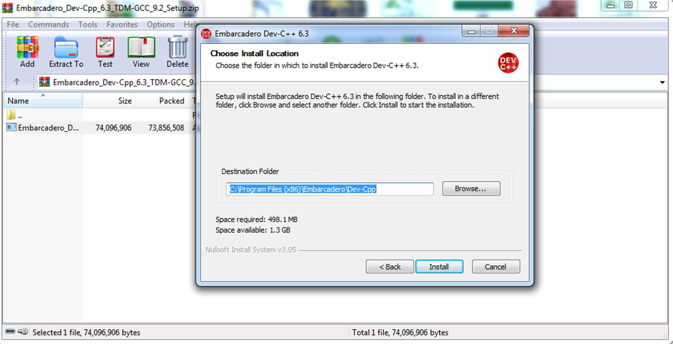

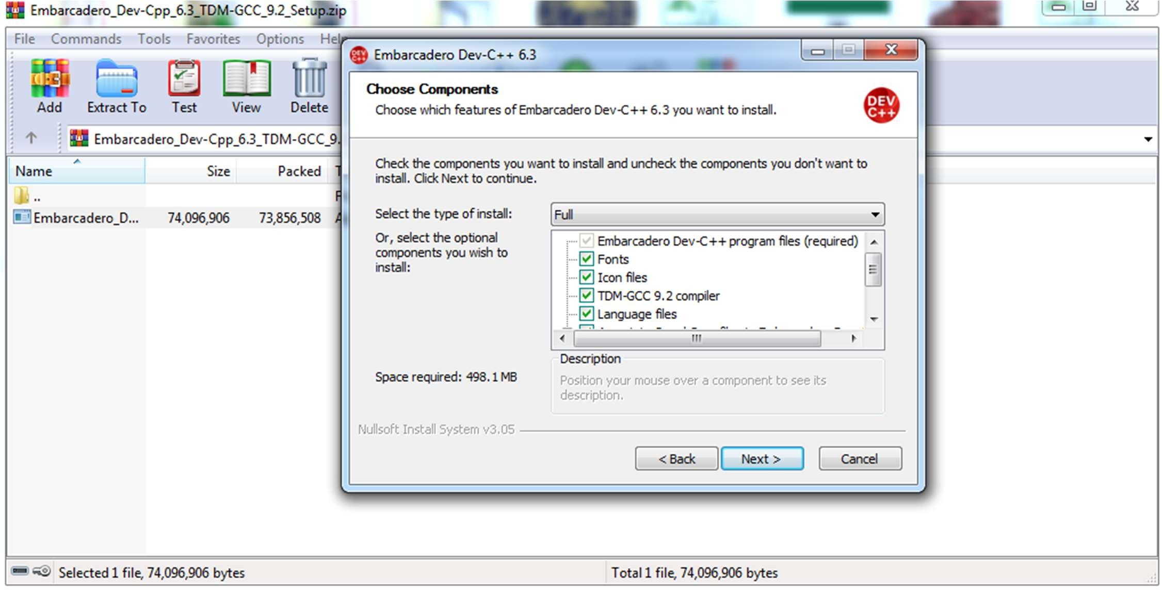

▪

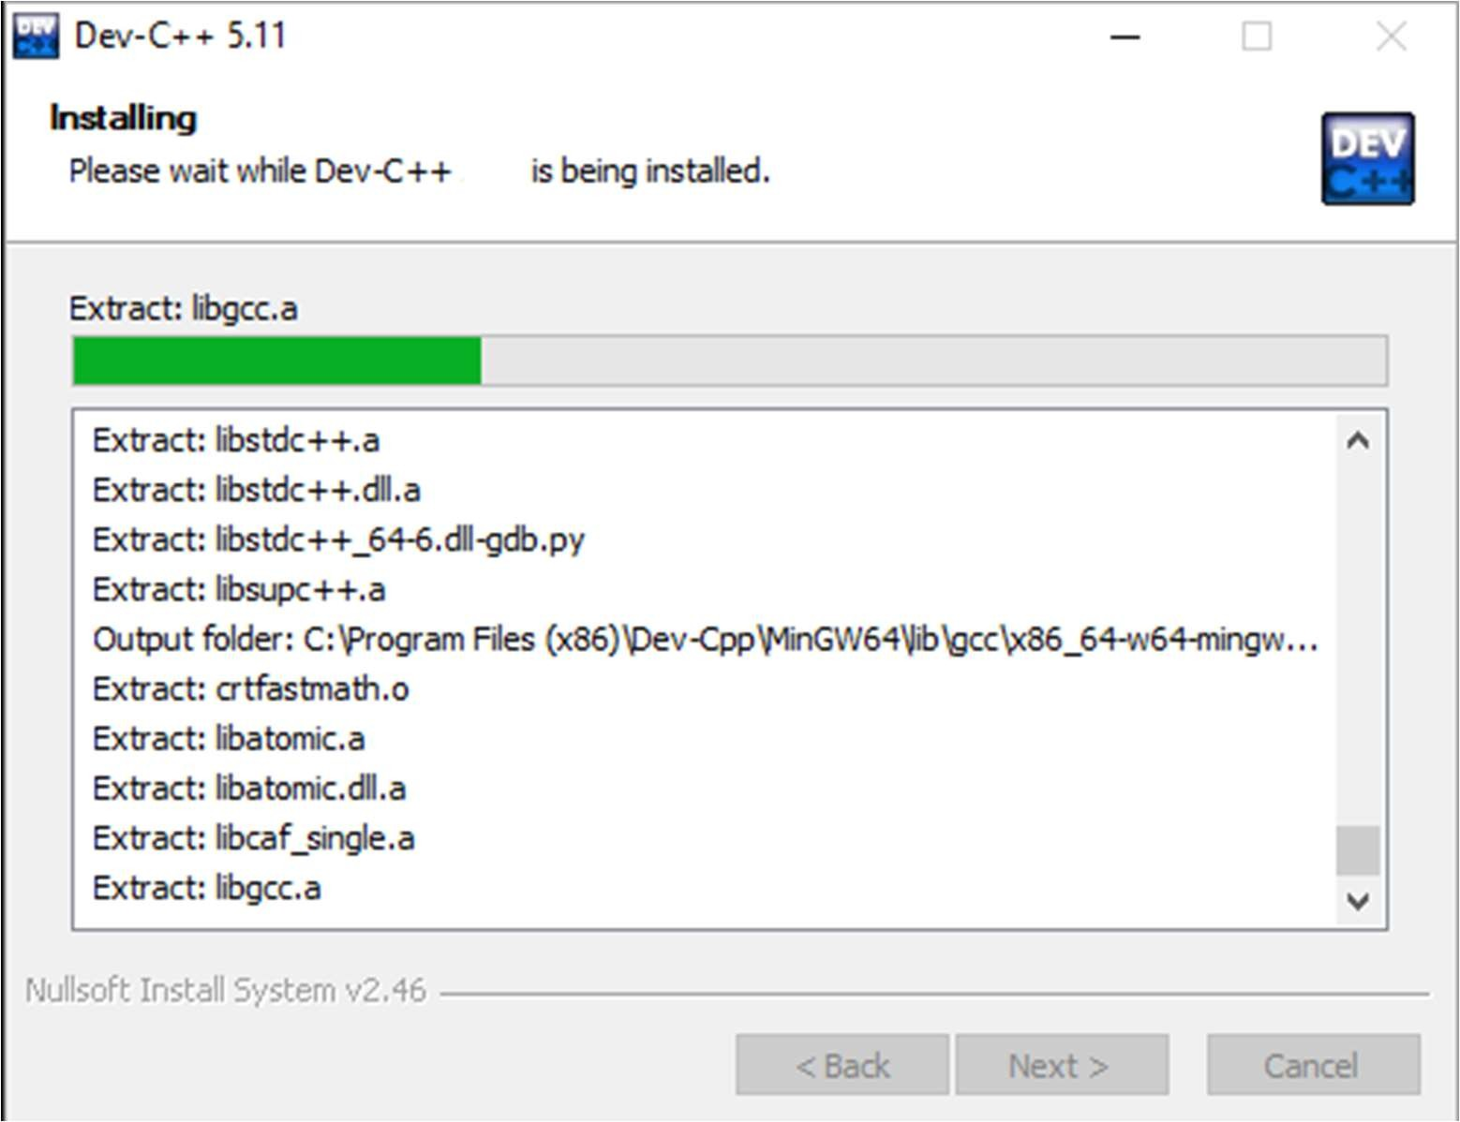

▪ ++

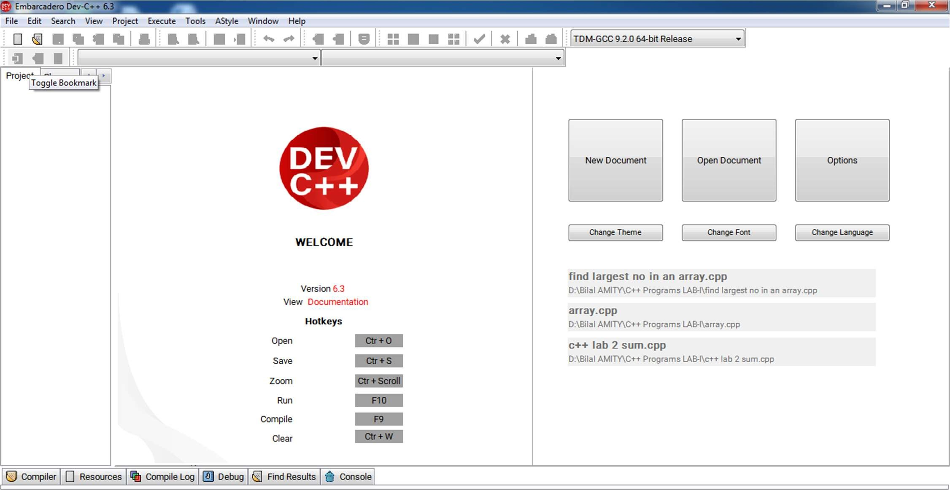

▪

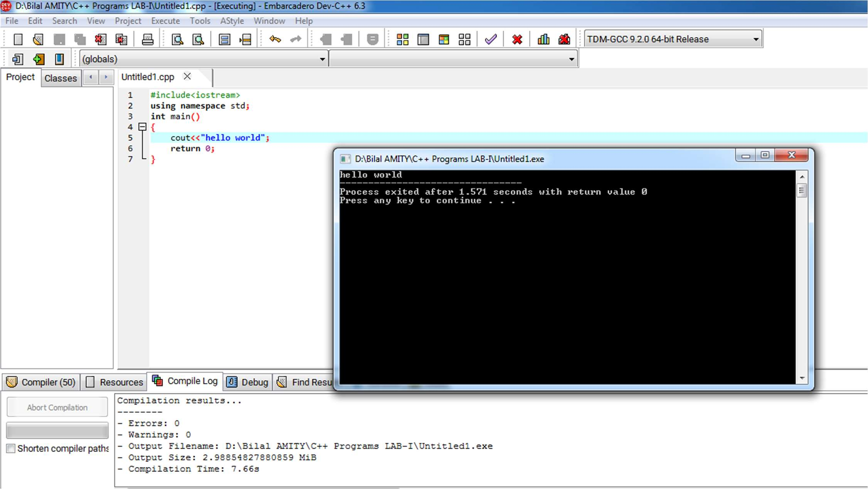



WEEK 4

# WEEK 4

#1 Write a C++ program to check whether a number is even or odd using ternary operator.

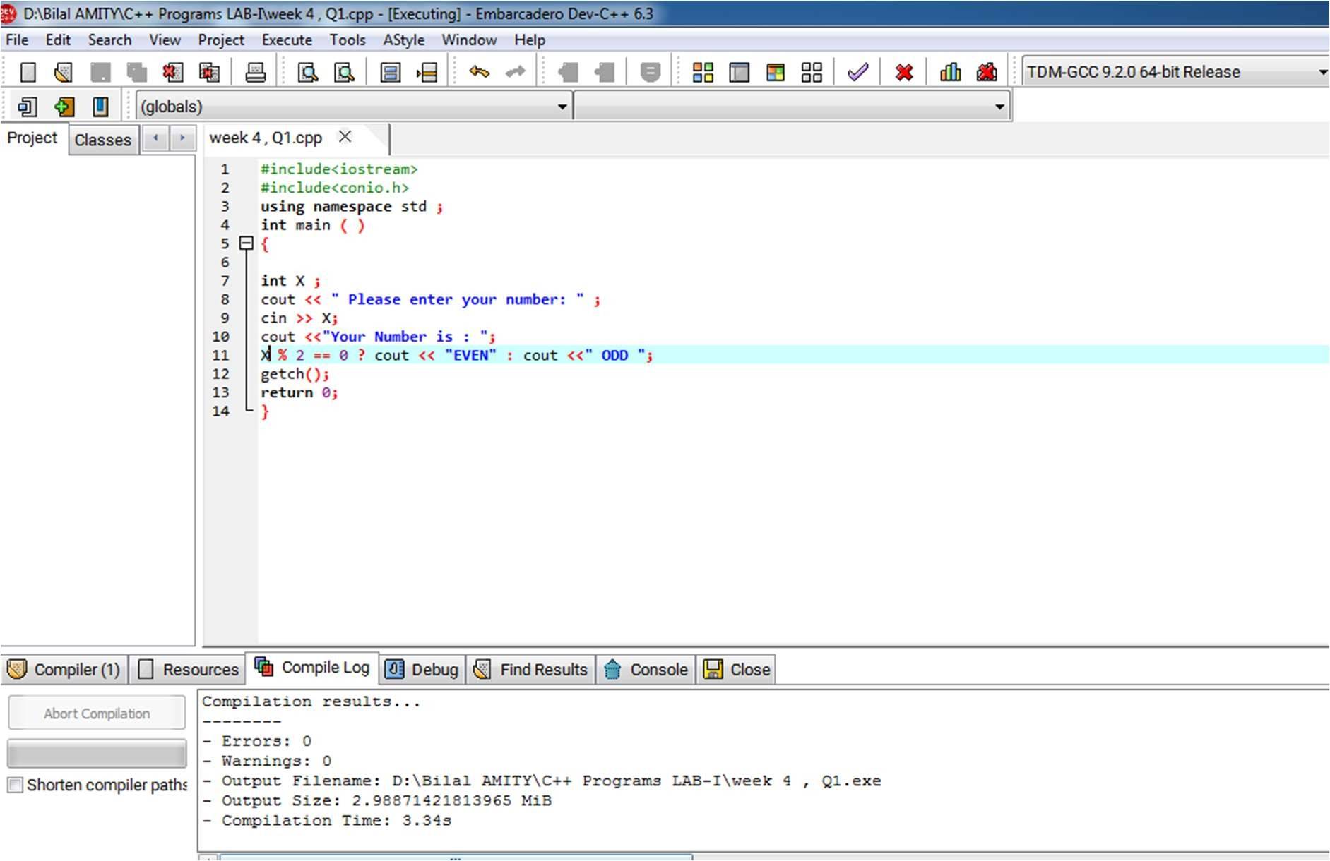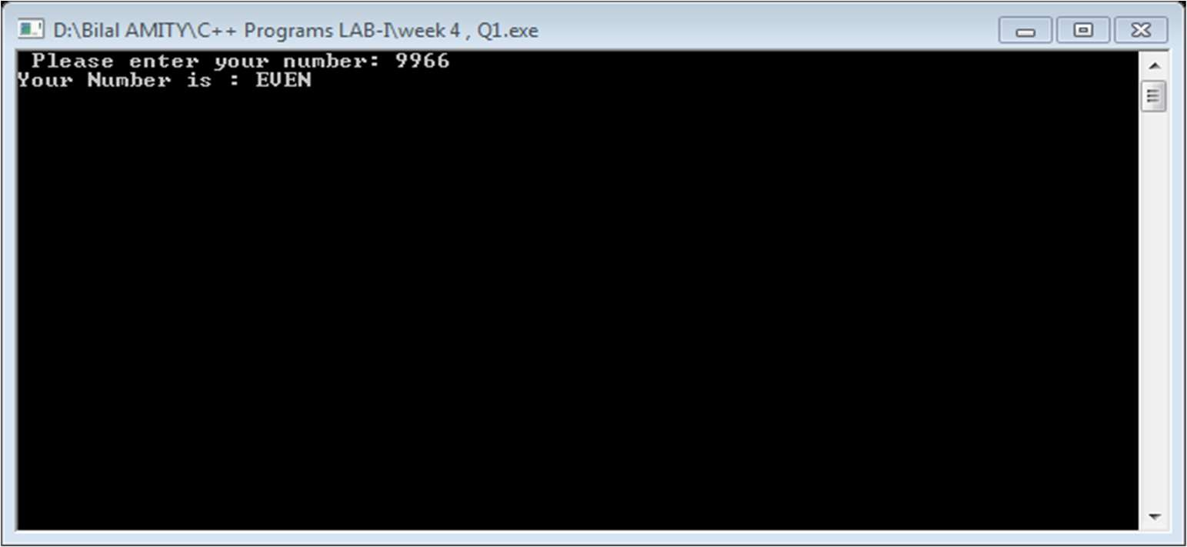

#2 Write a C++ program to perform the addition of two numbers without using + operator.



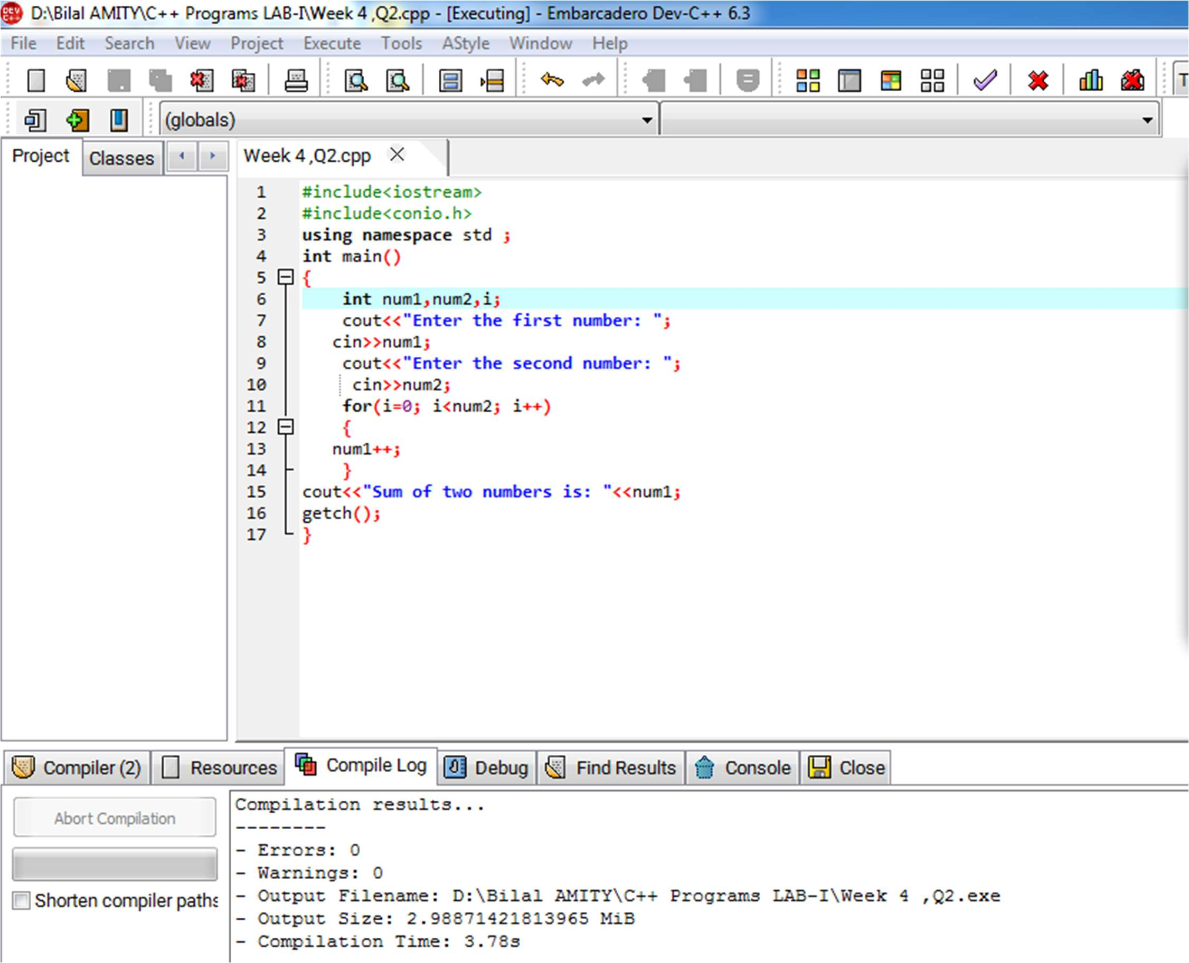



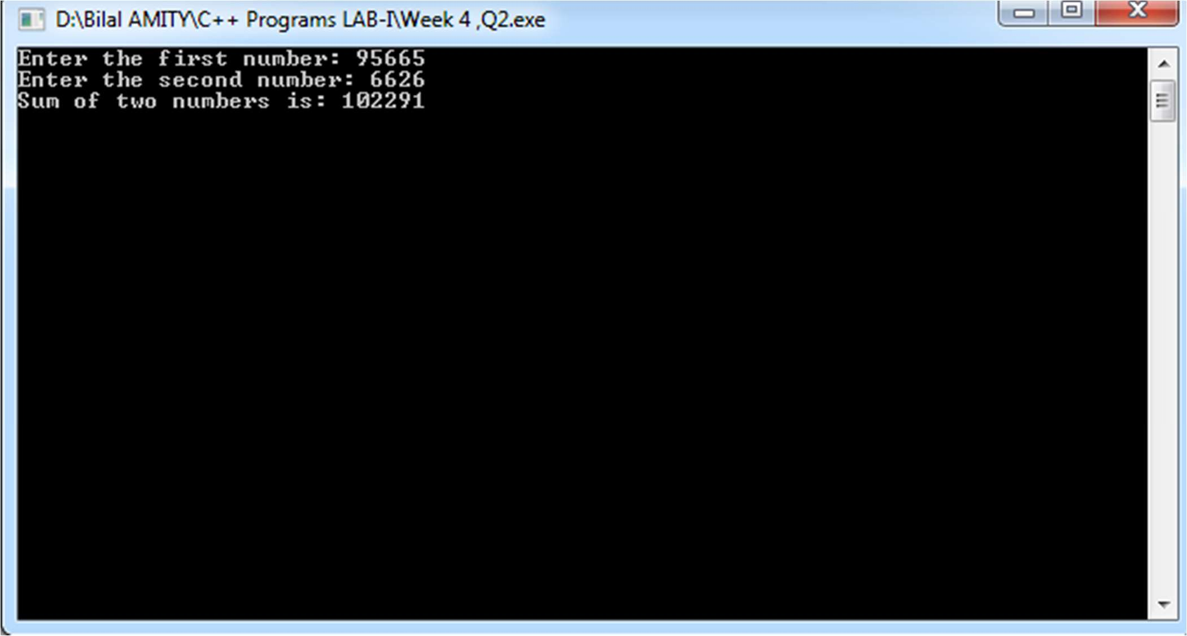

3# Write a C++ program to evaluate the arithmetic expression

((a + b / c * d - e) * (f - g)). Read the values a, b, c, d, e, f, g from the standard input device.



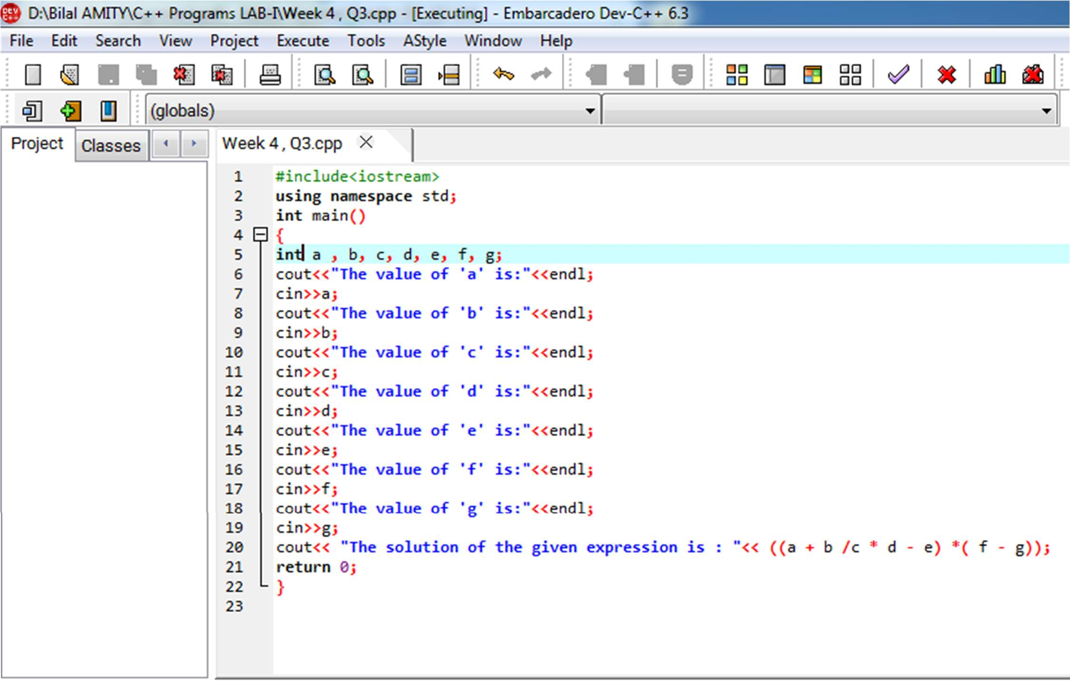



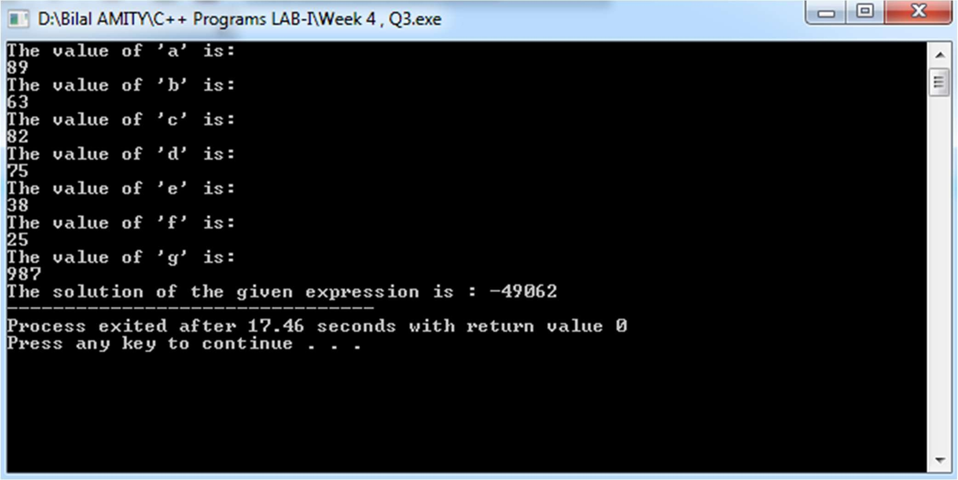

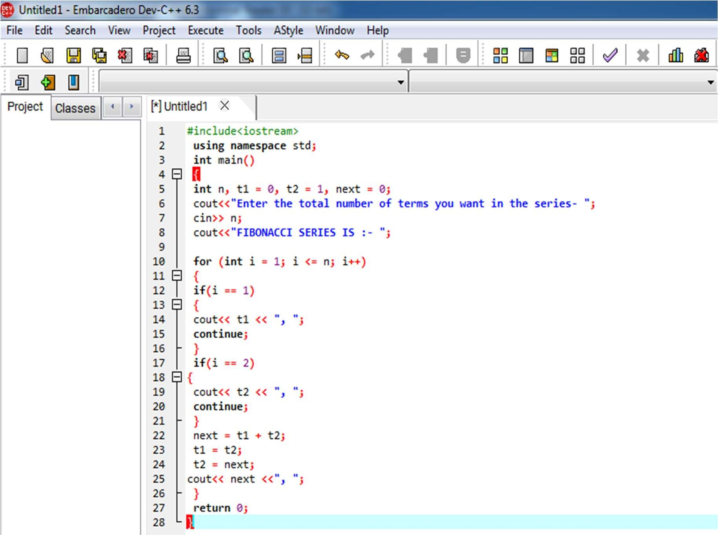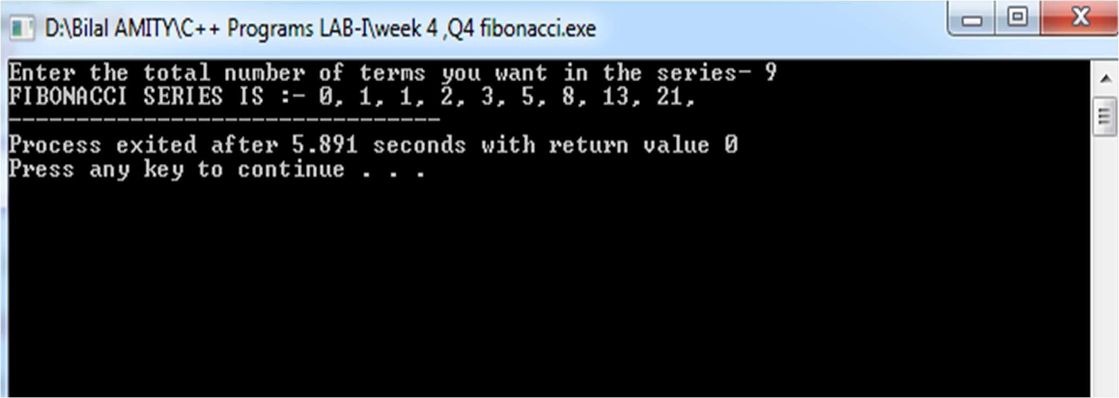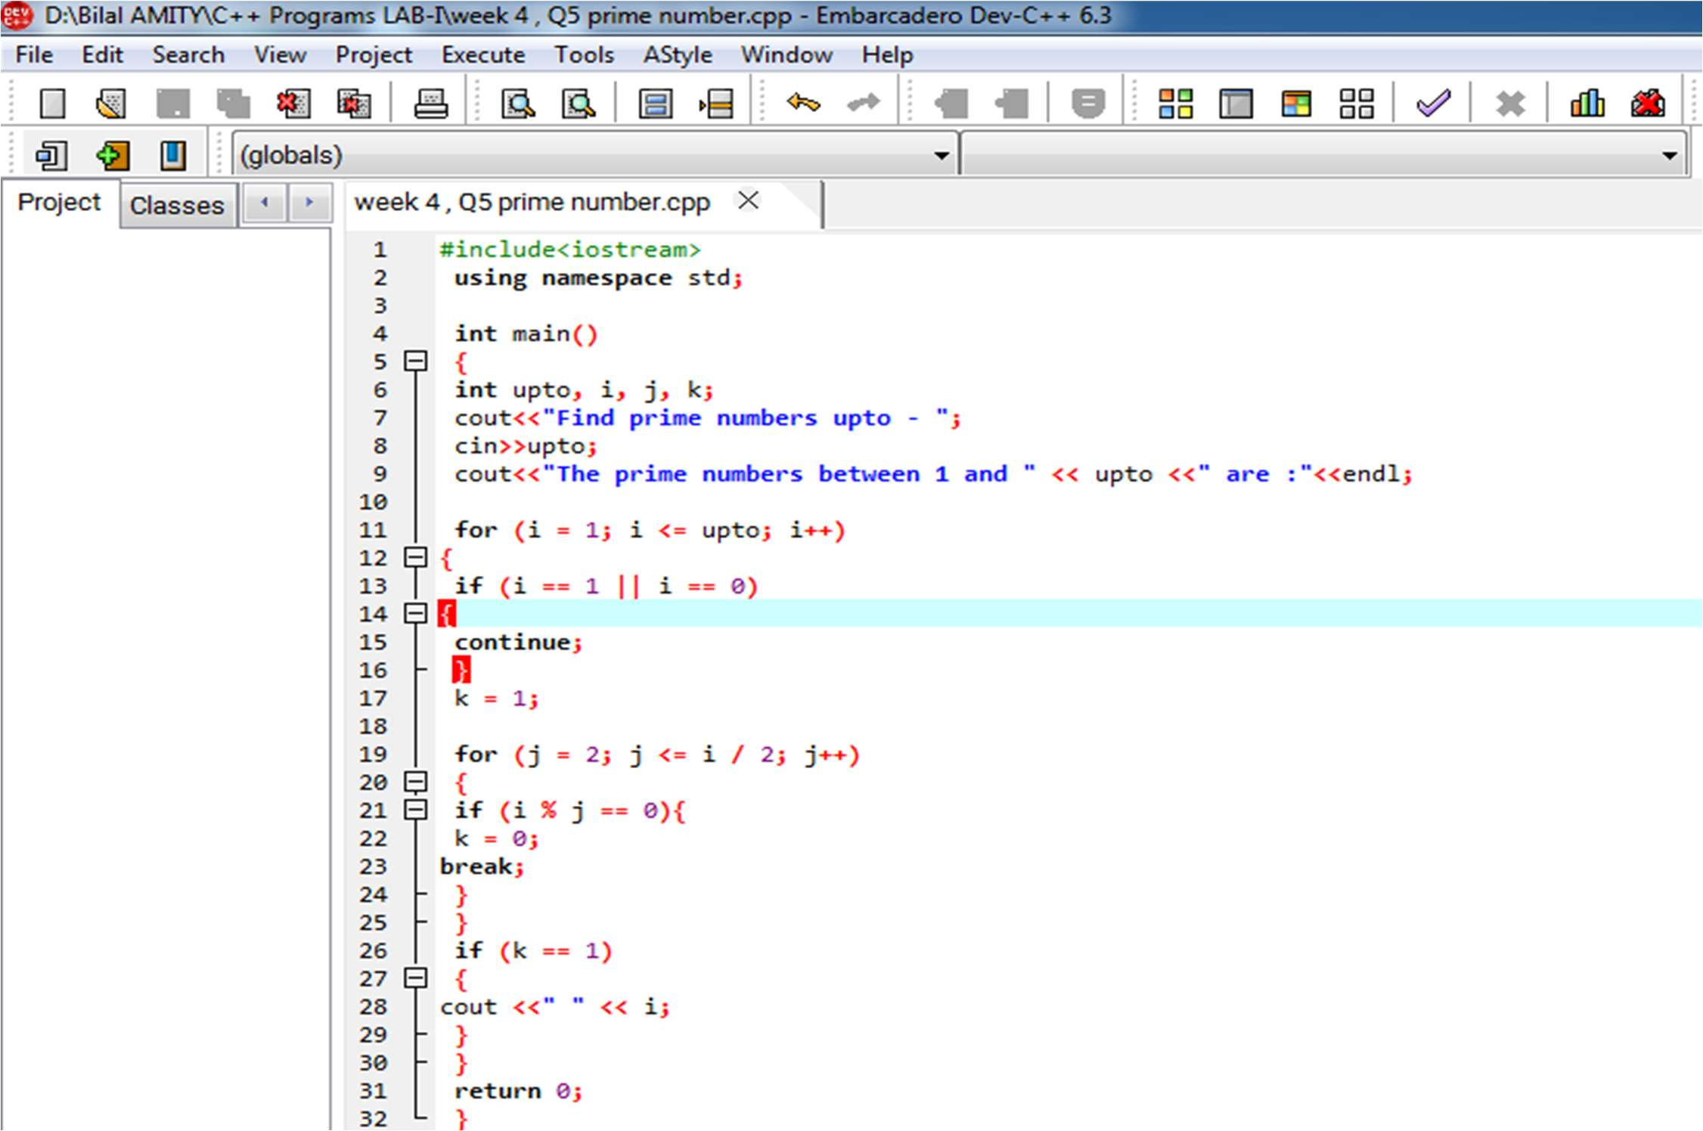



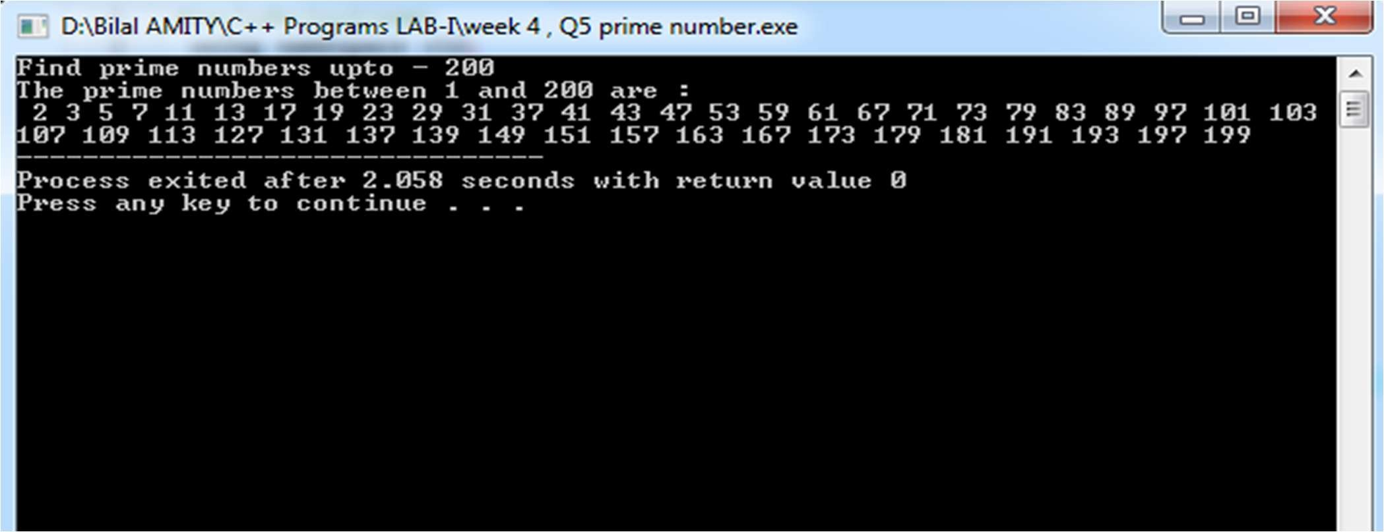





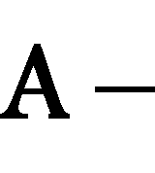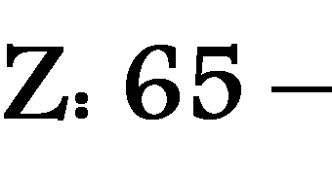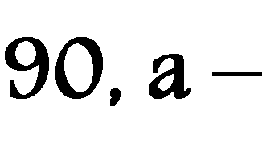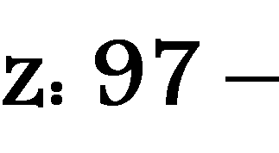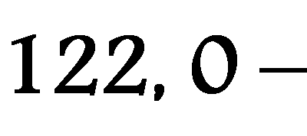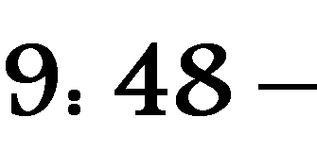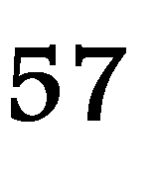



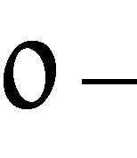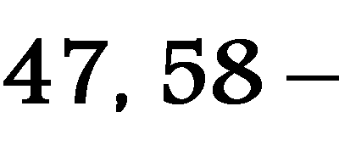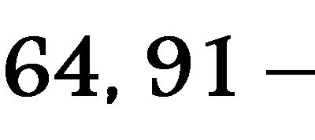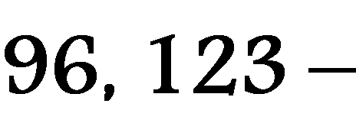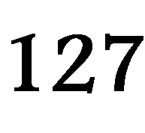

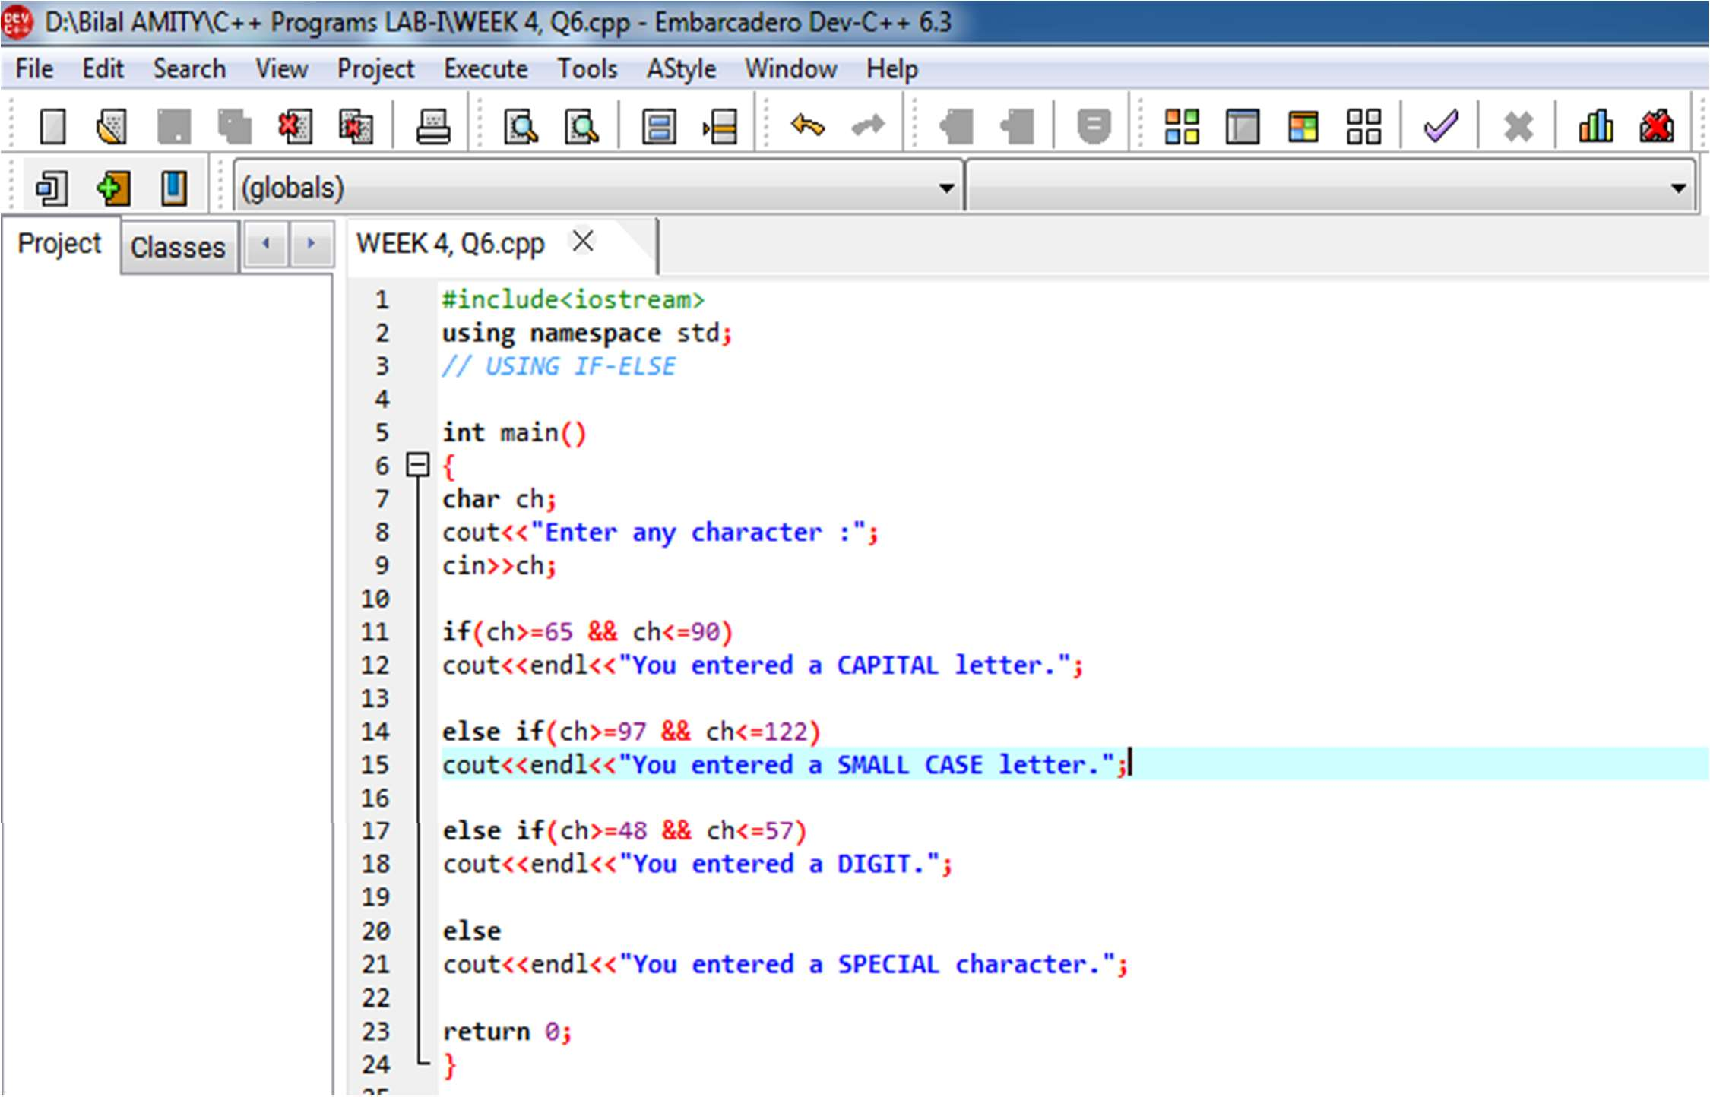



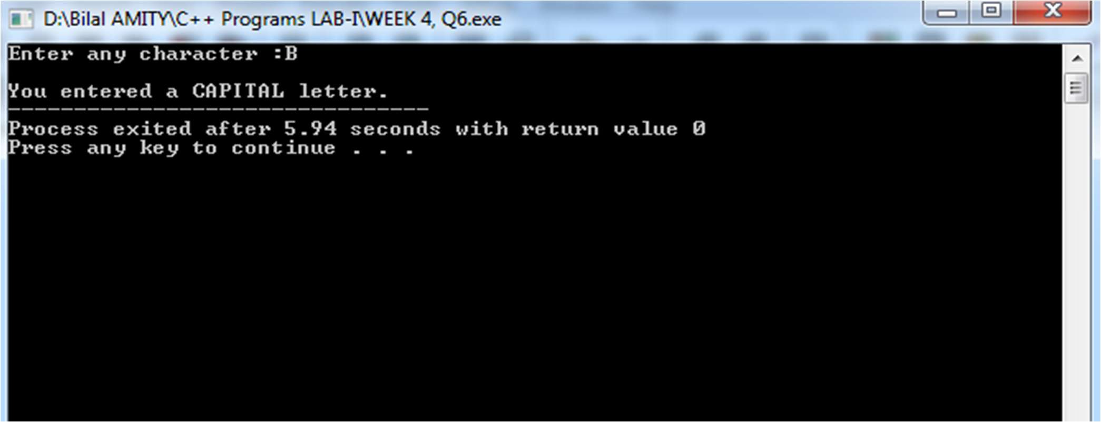

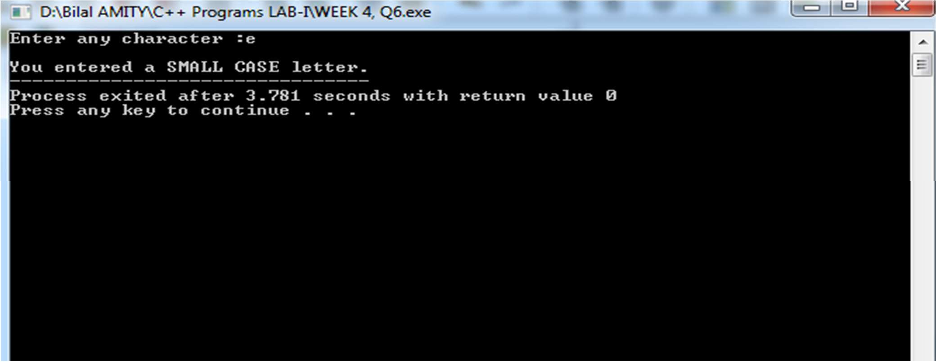

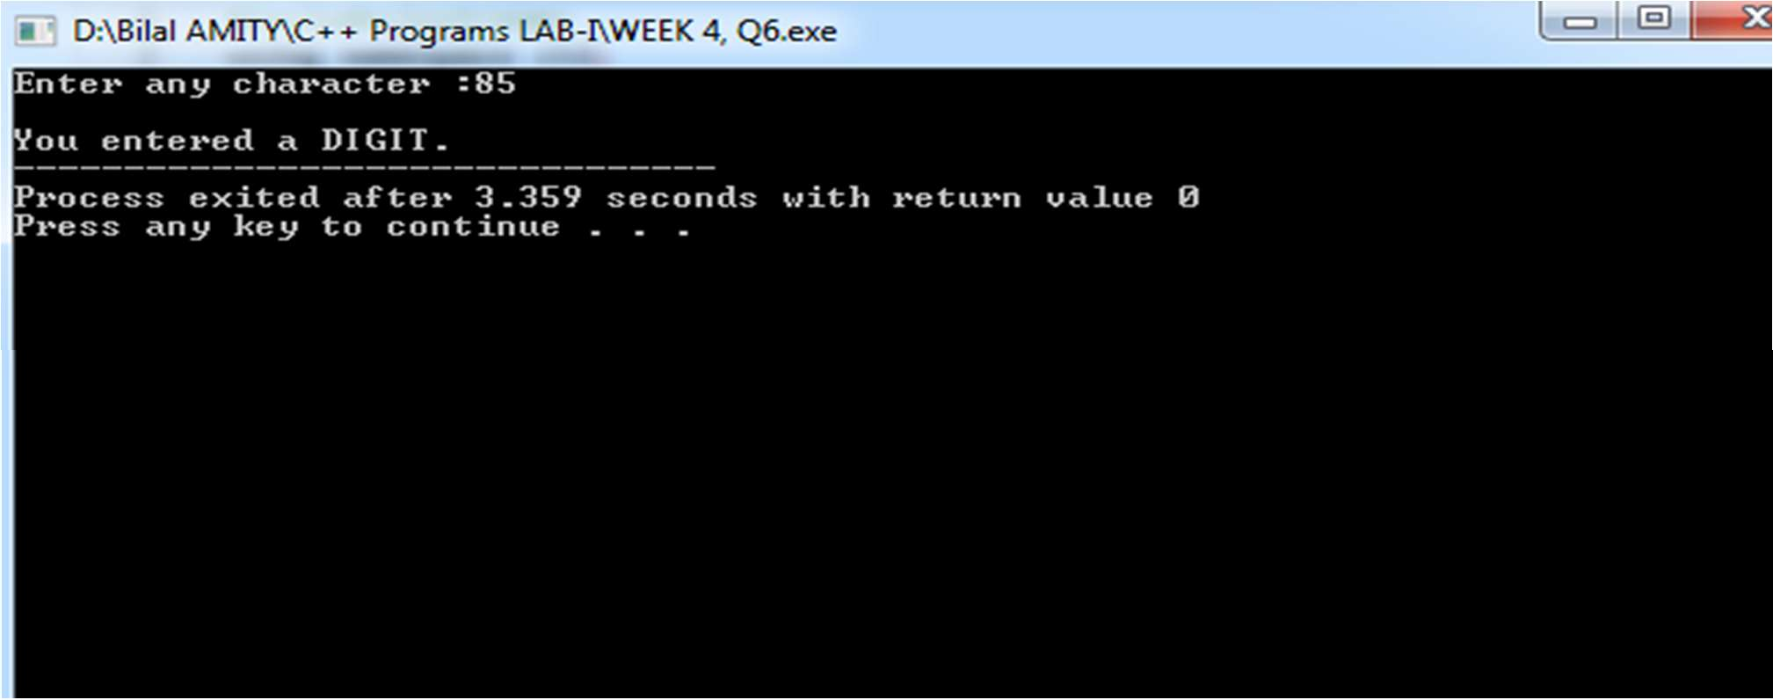

 

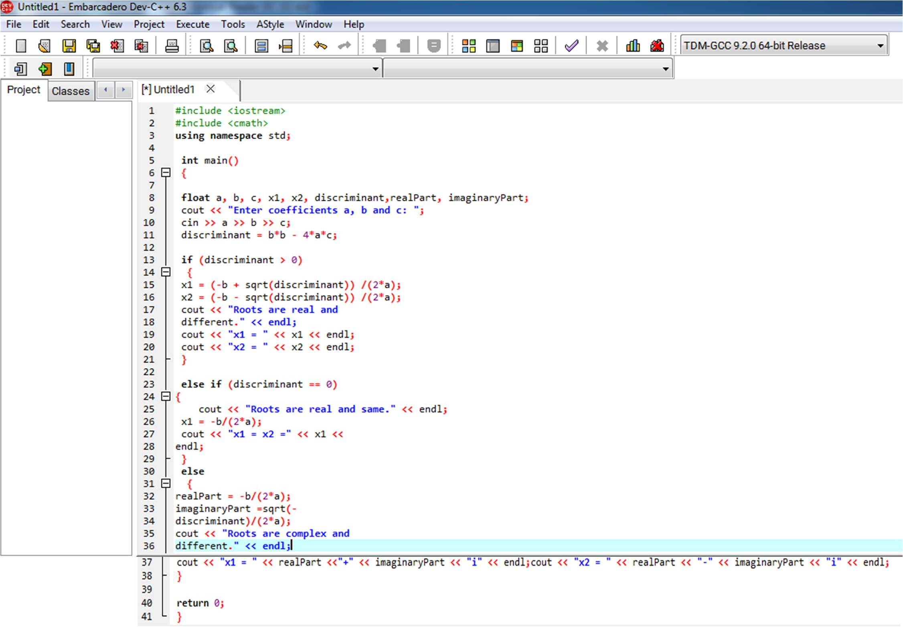

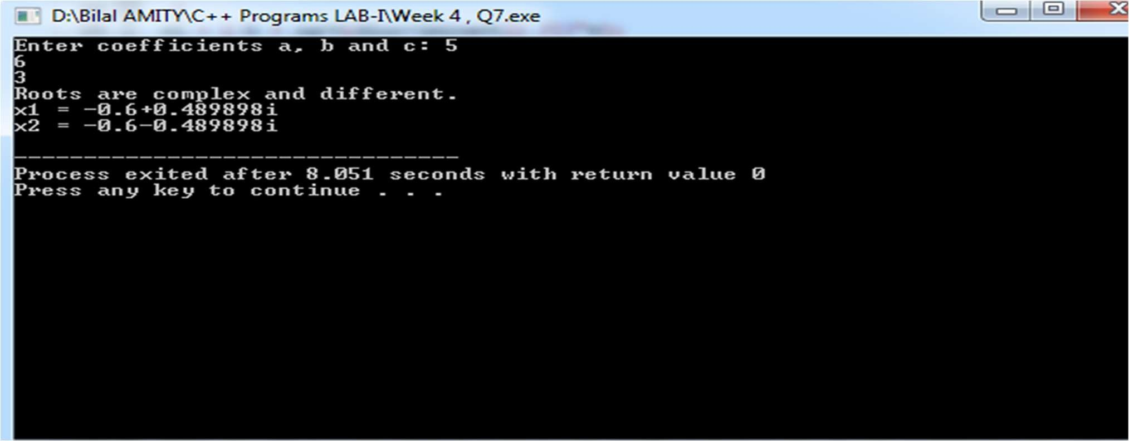







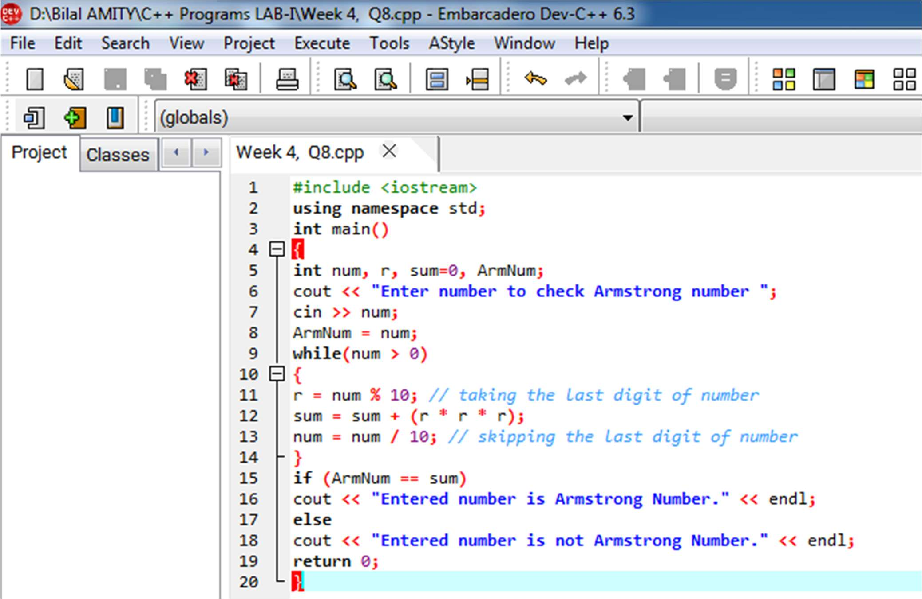

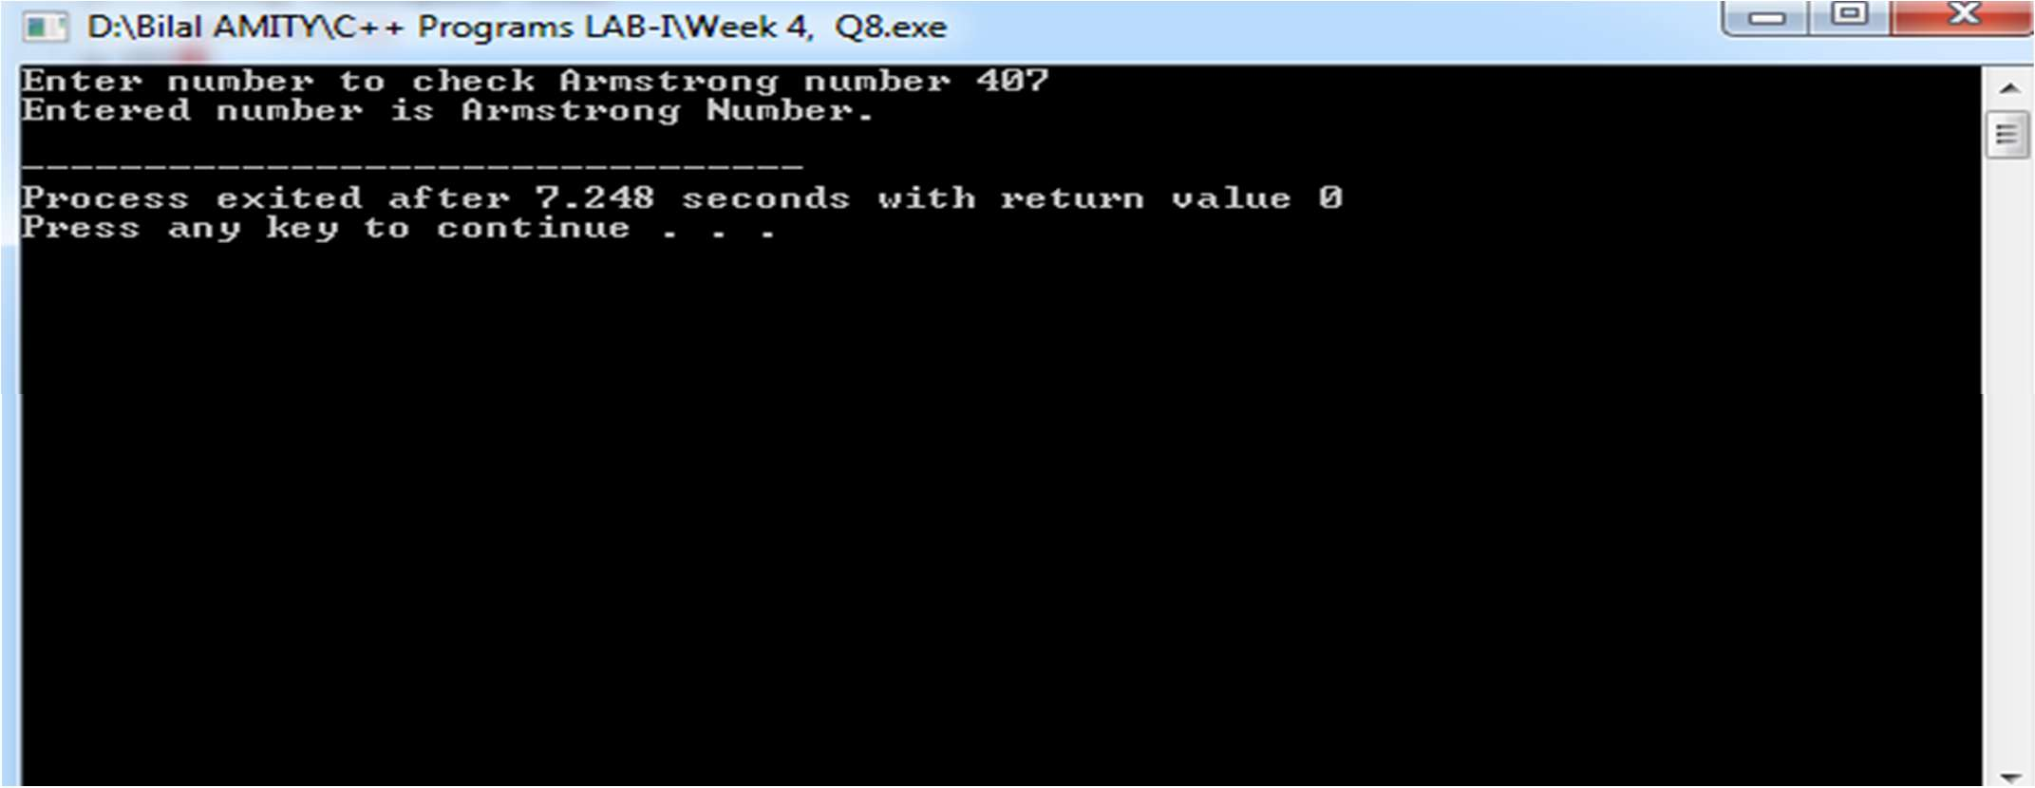

WEEK 5

# WEEK 5







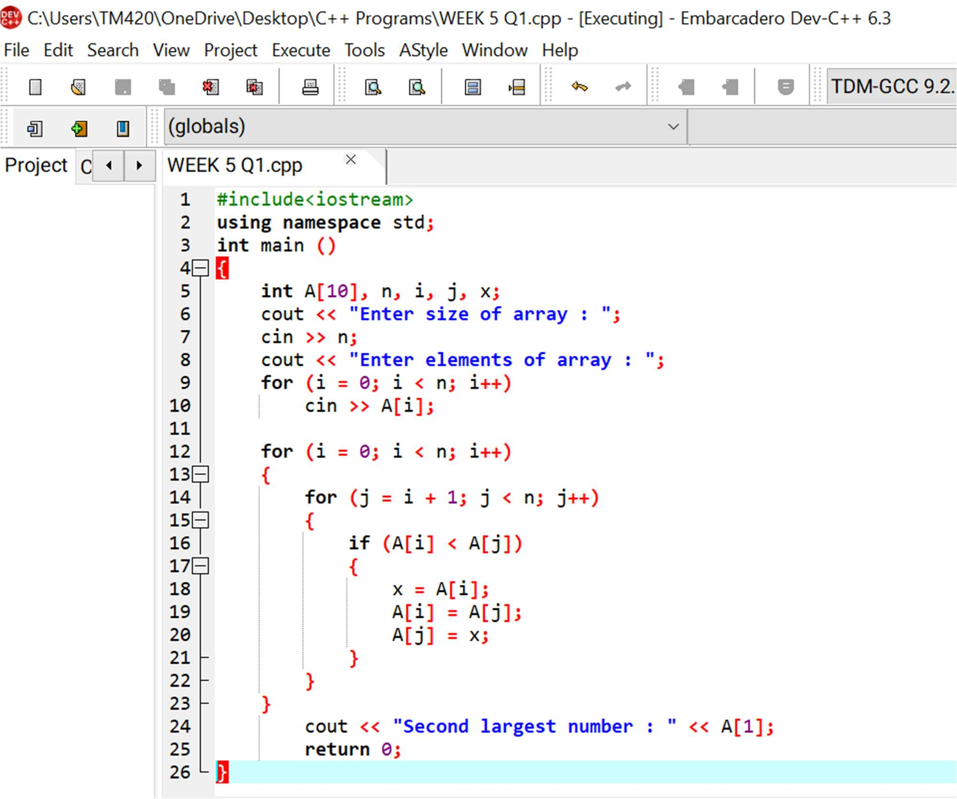



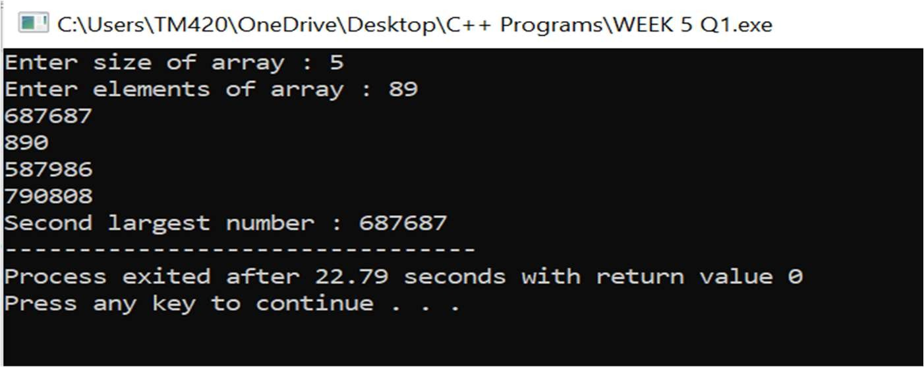









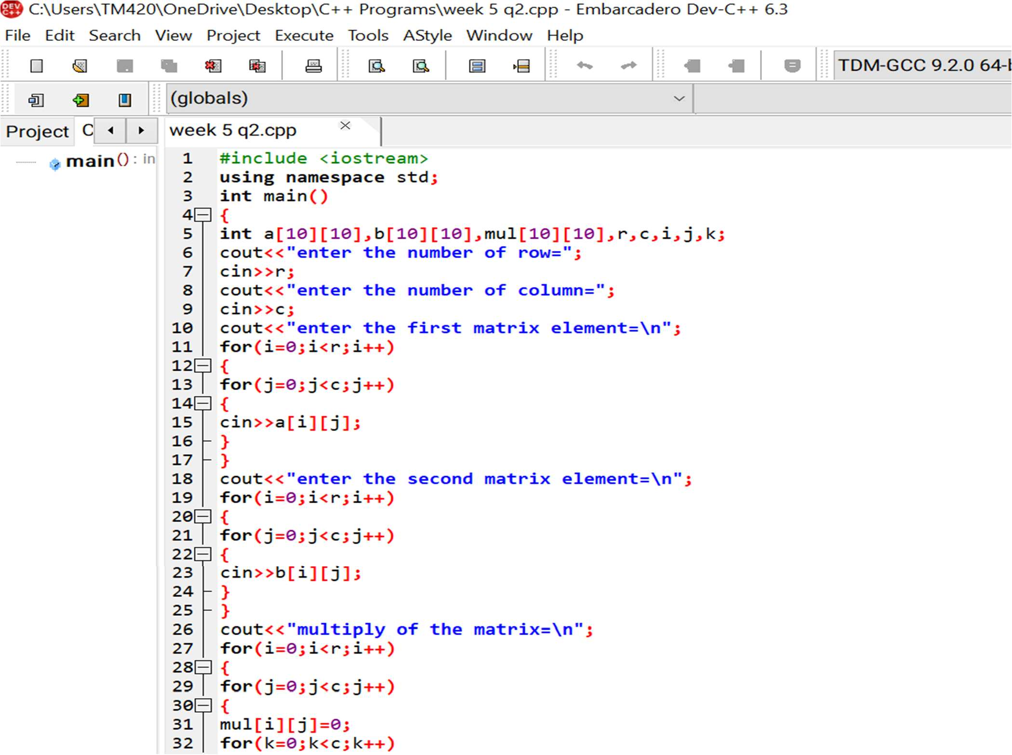

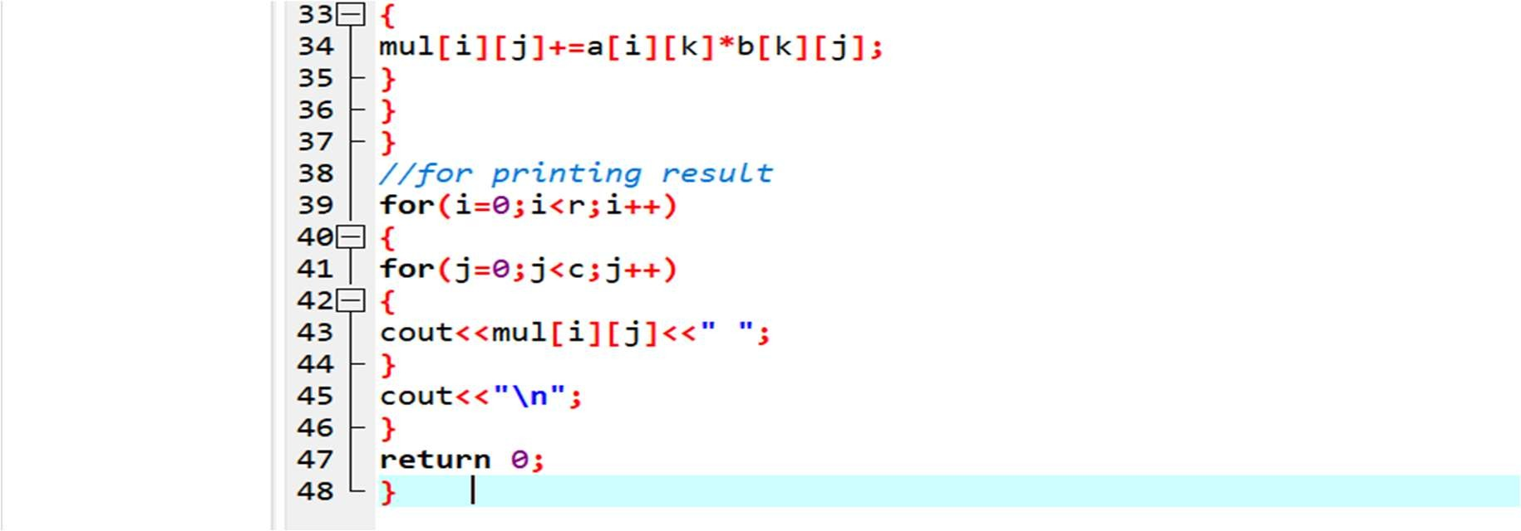



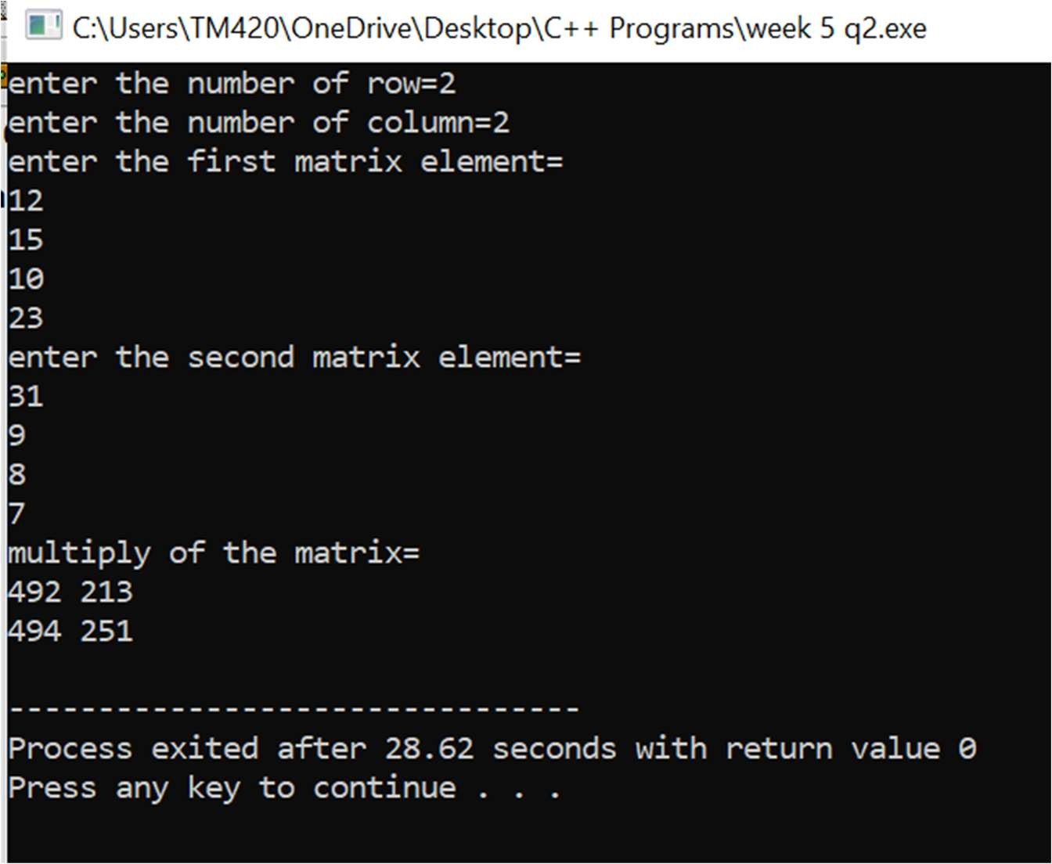



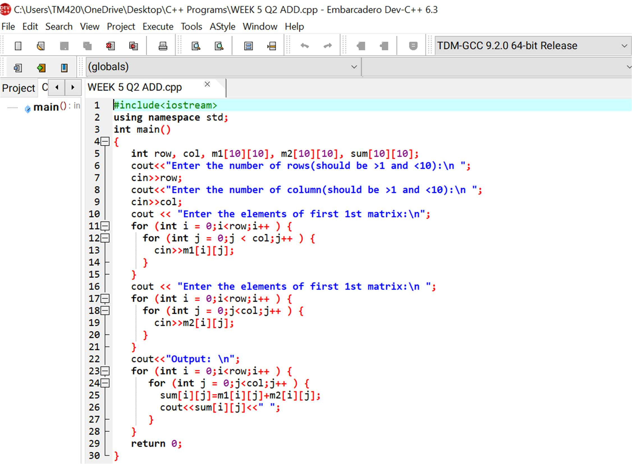

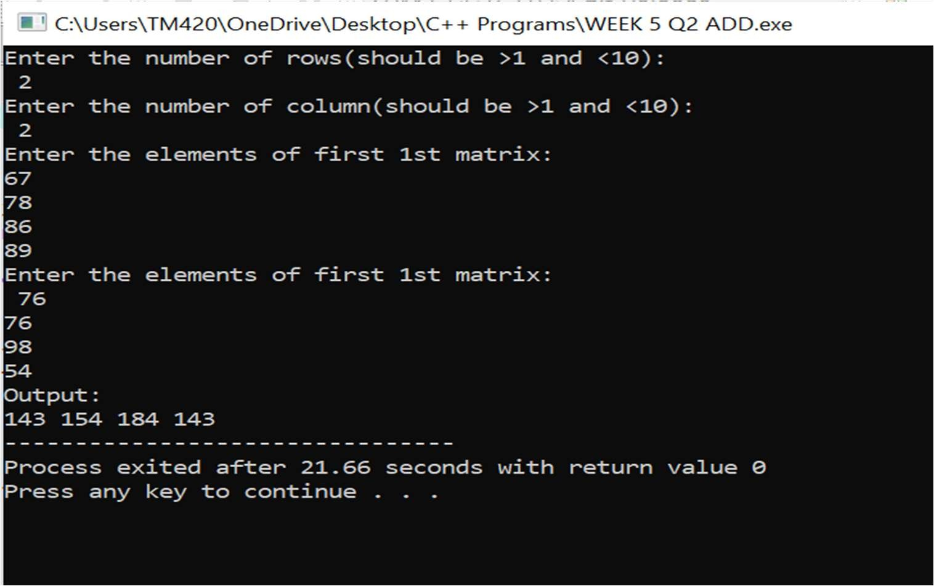





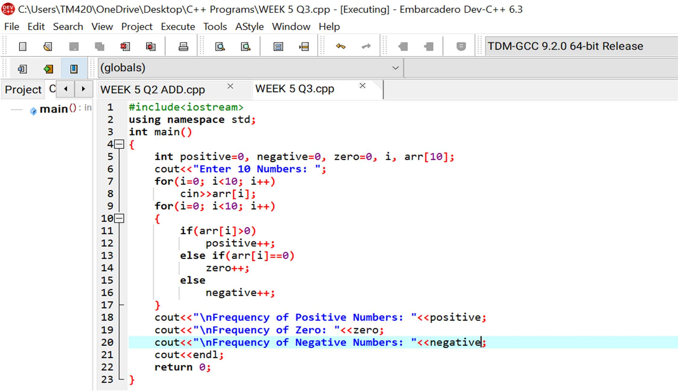



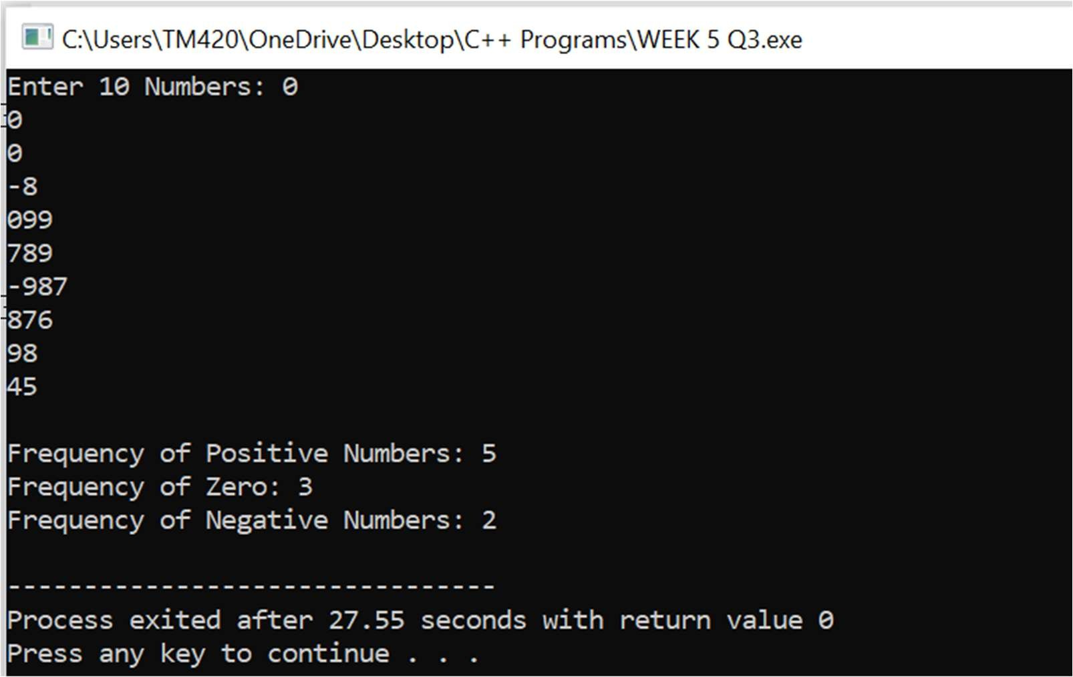

#4 Write a C++ program to merge two sorted arrays into another array in sorted order.

This is the required code:

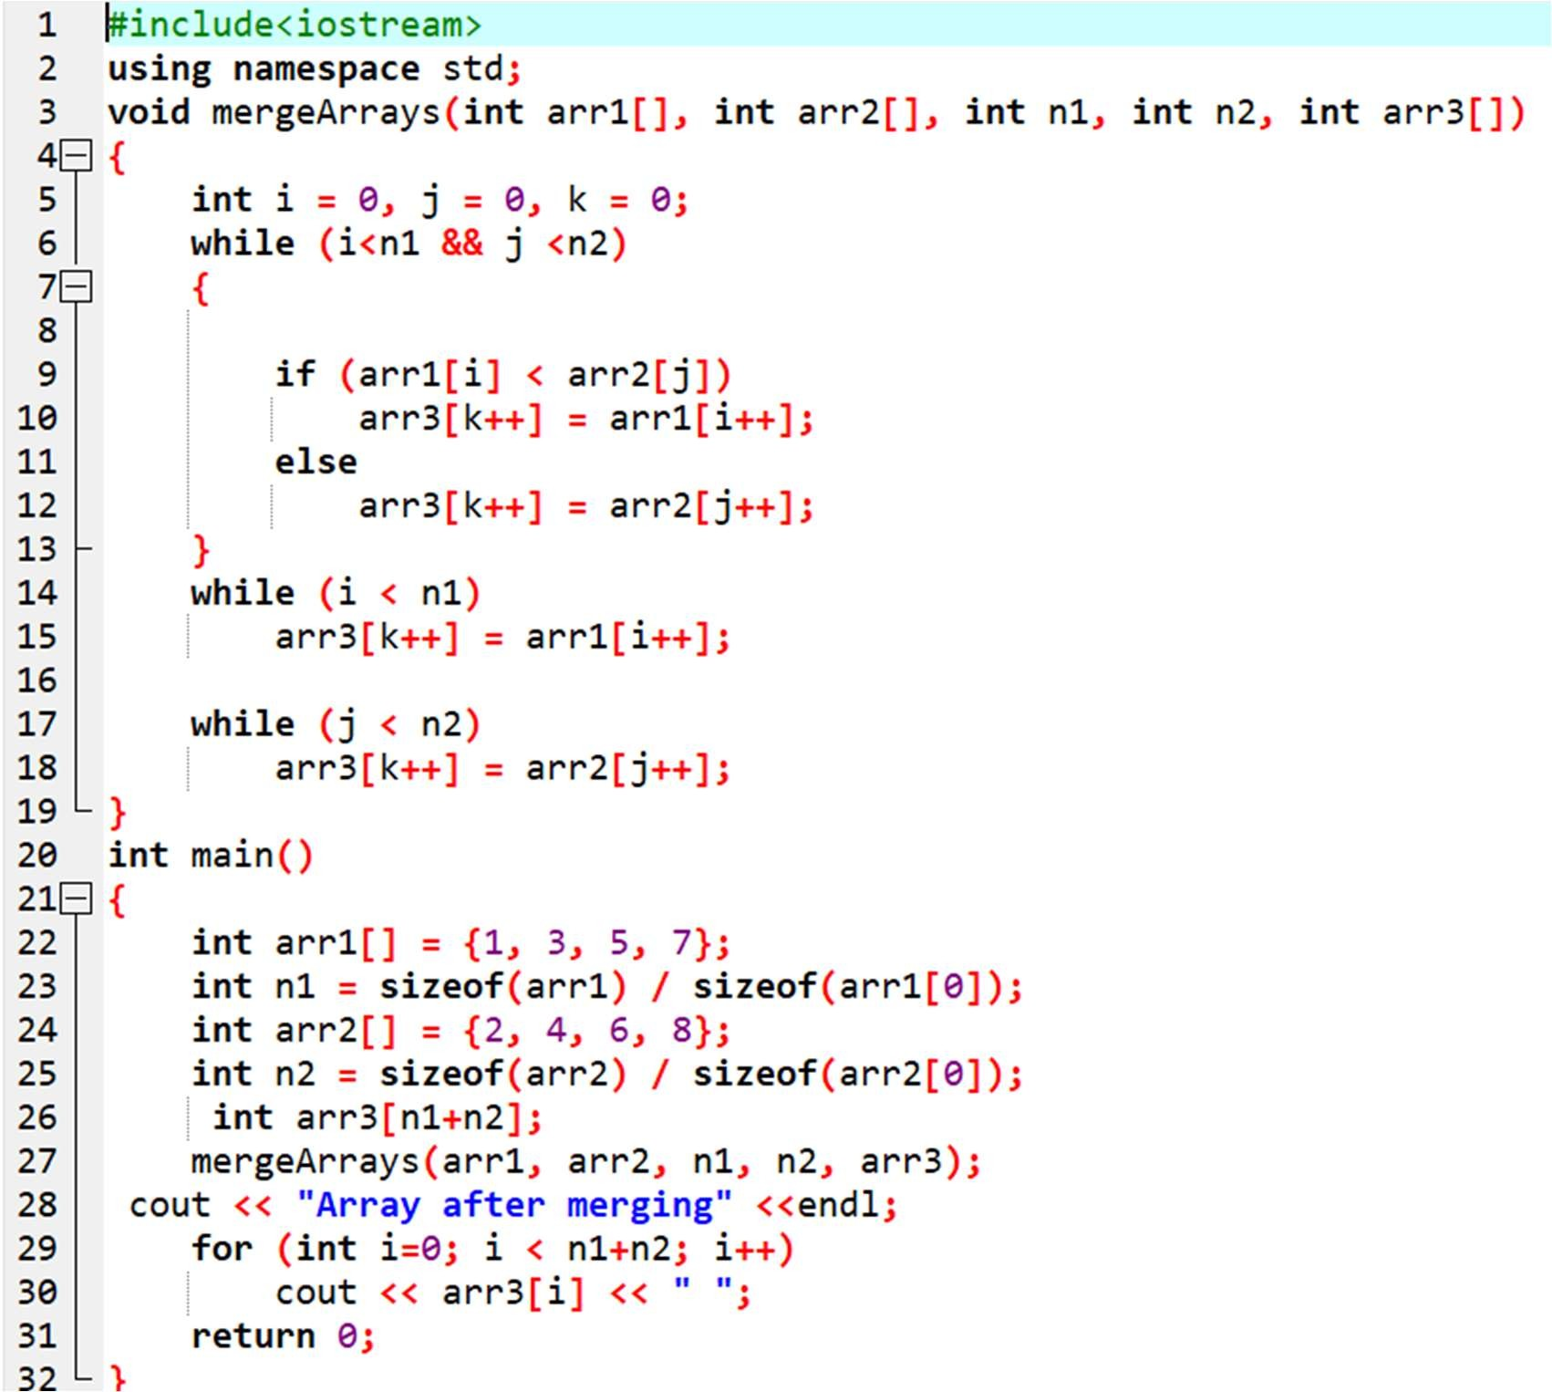

And this is its result:

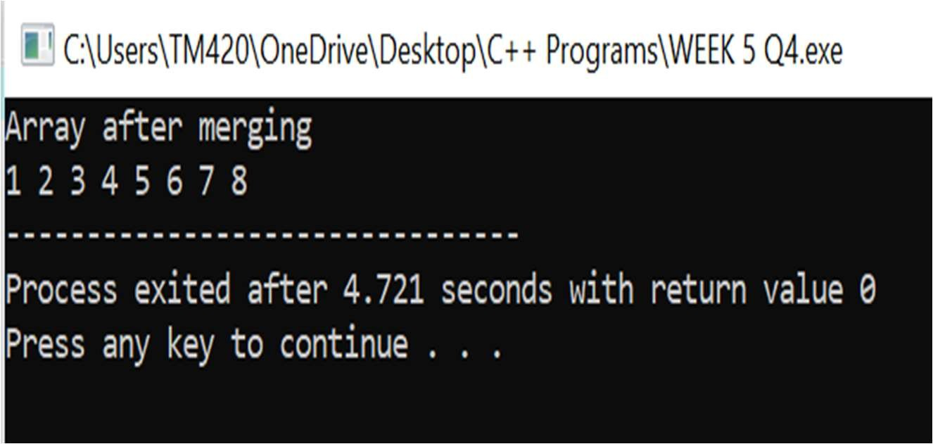

#5 Write a C++ program to find the frequency of a particular number in a list of integers.

This is the required code:

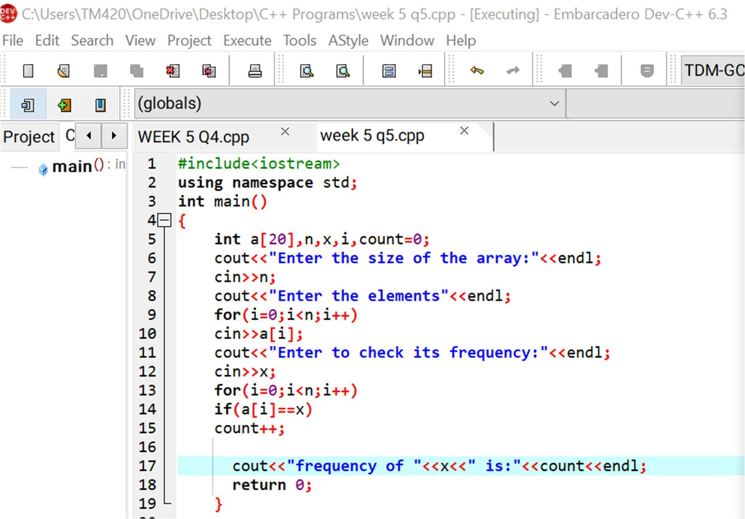

And its result is:

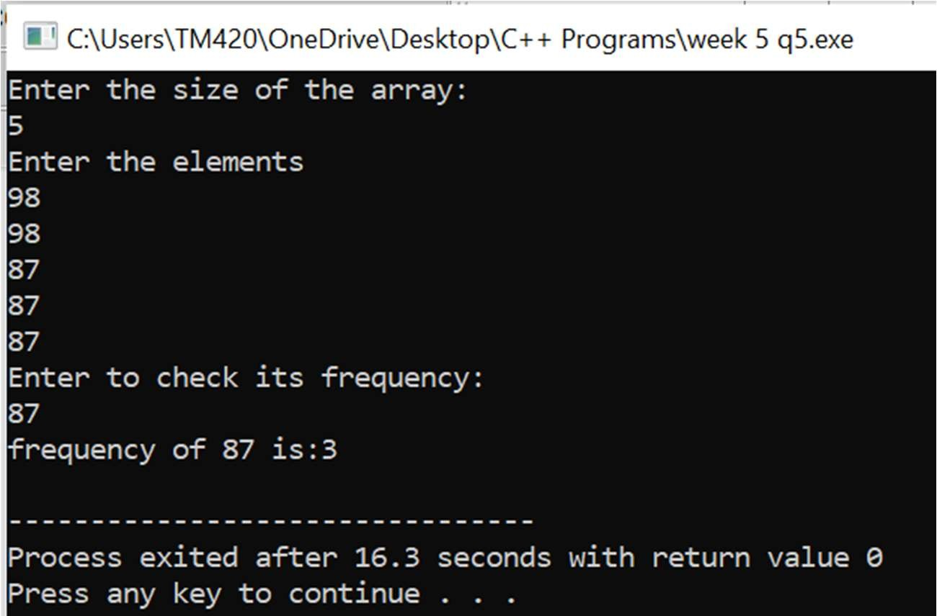



WEEK 6

# WEEK 6

#1Write a C++ program to concatenate two strings using pointers.

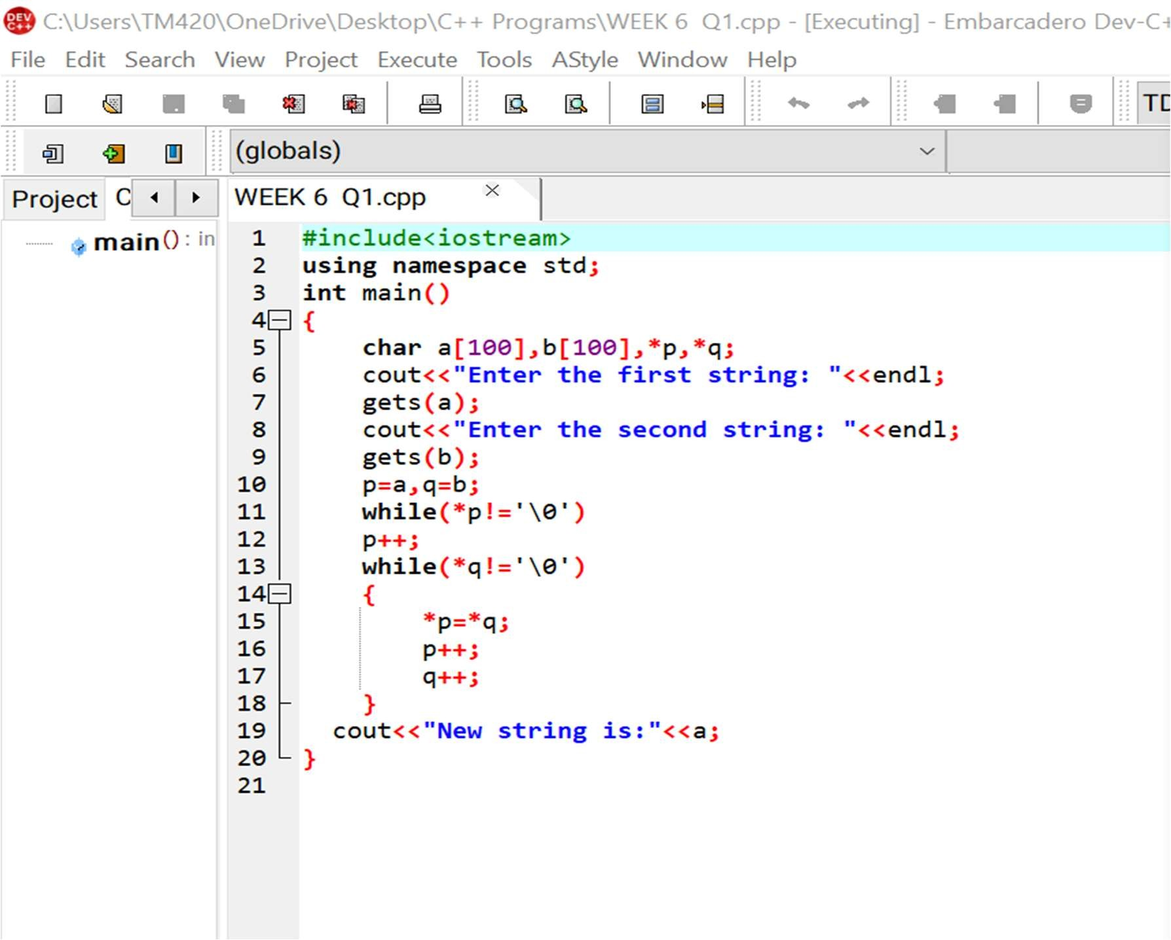This is the required code:

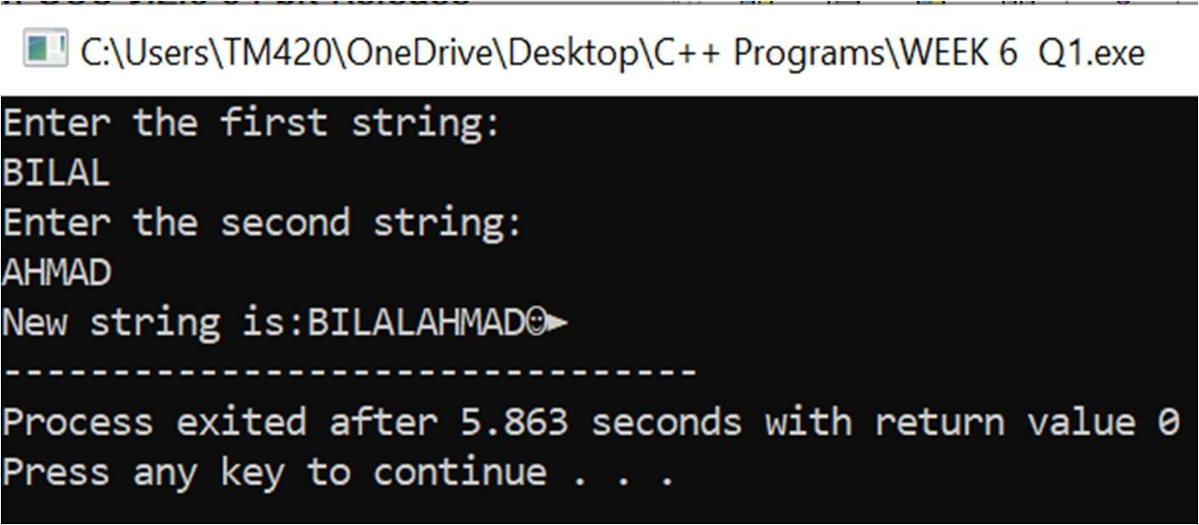And this is its result:

#2 Write a program for reading elements using a pointer into an array and display the values using an array.

1. **Declare a set of elements.**
2. **Declare pointer and initialize it to first element address of a set of elements (array).**
3. **Repeat loop until the pointer reaches to last element and display each element**.

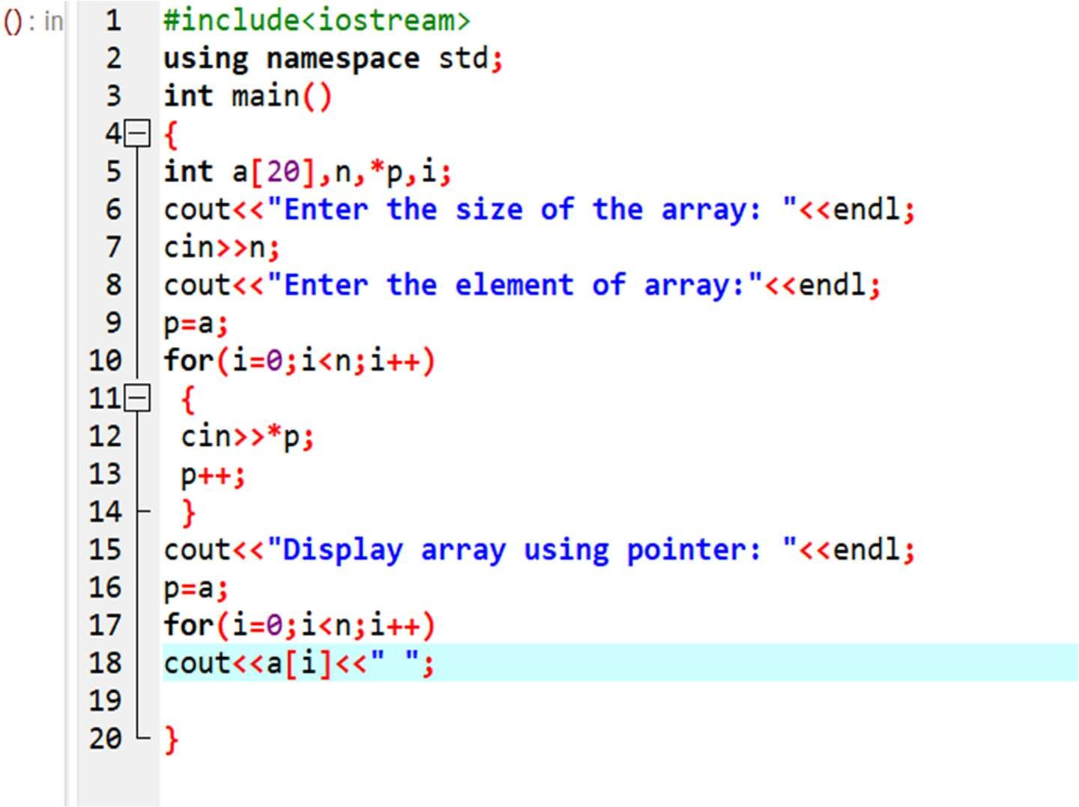This is the required code:

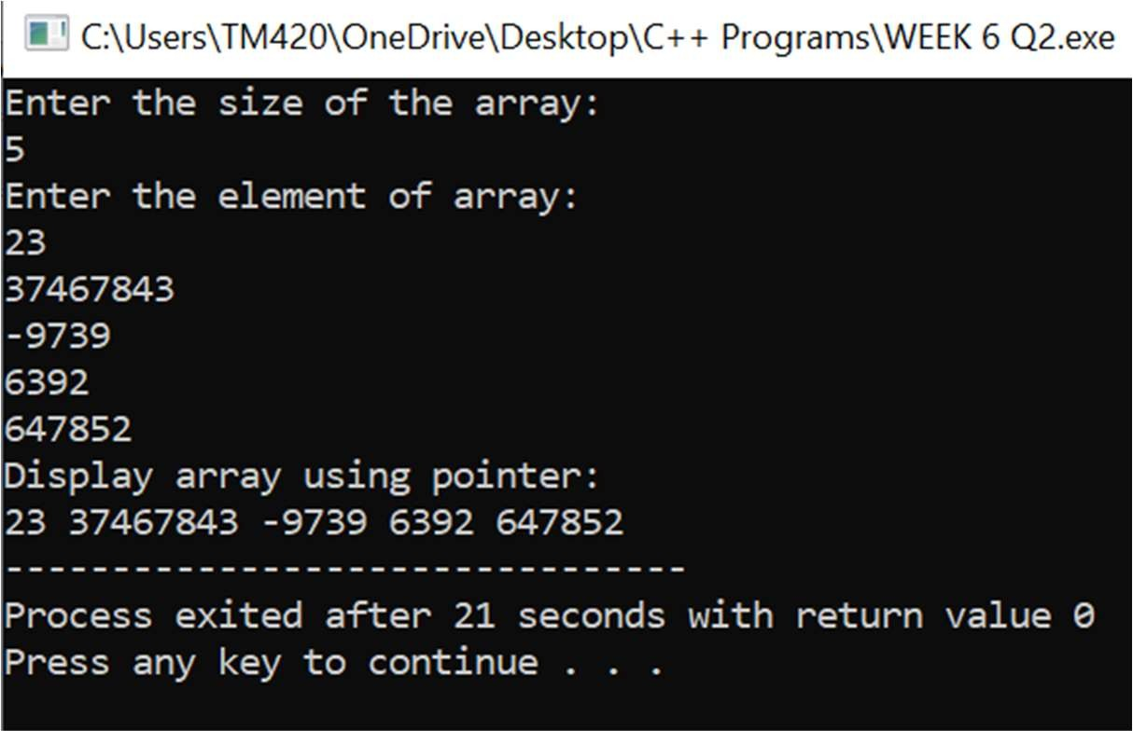And this is its result:

#3 Write a program through pointer variable to sum of n elements from array.

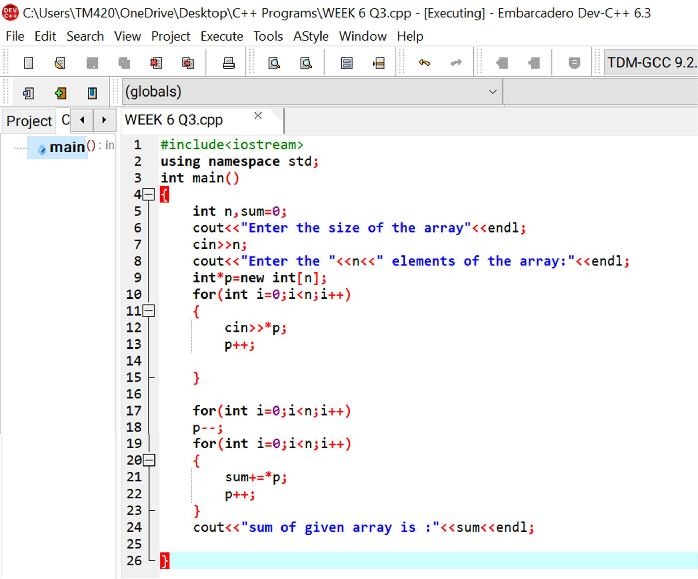This is the required code:

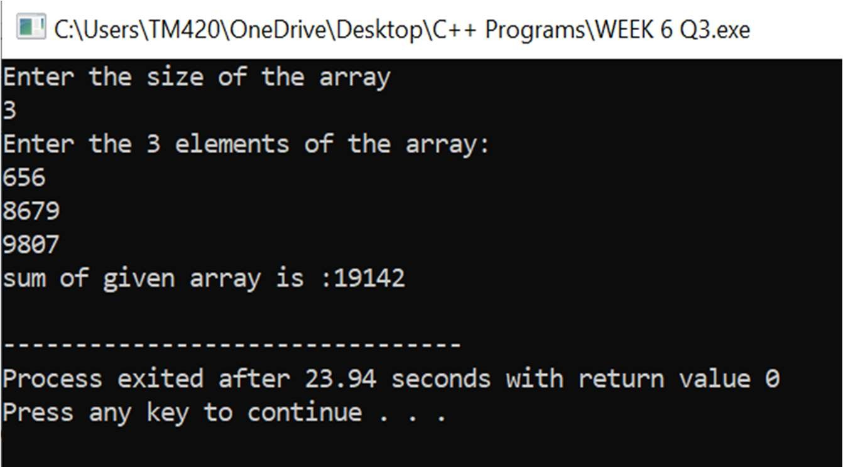And this is its result:

#4 Write a program for reading elements using pointer into array and display the values using array.

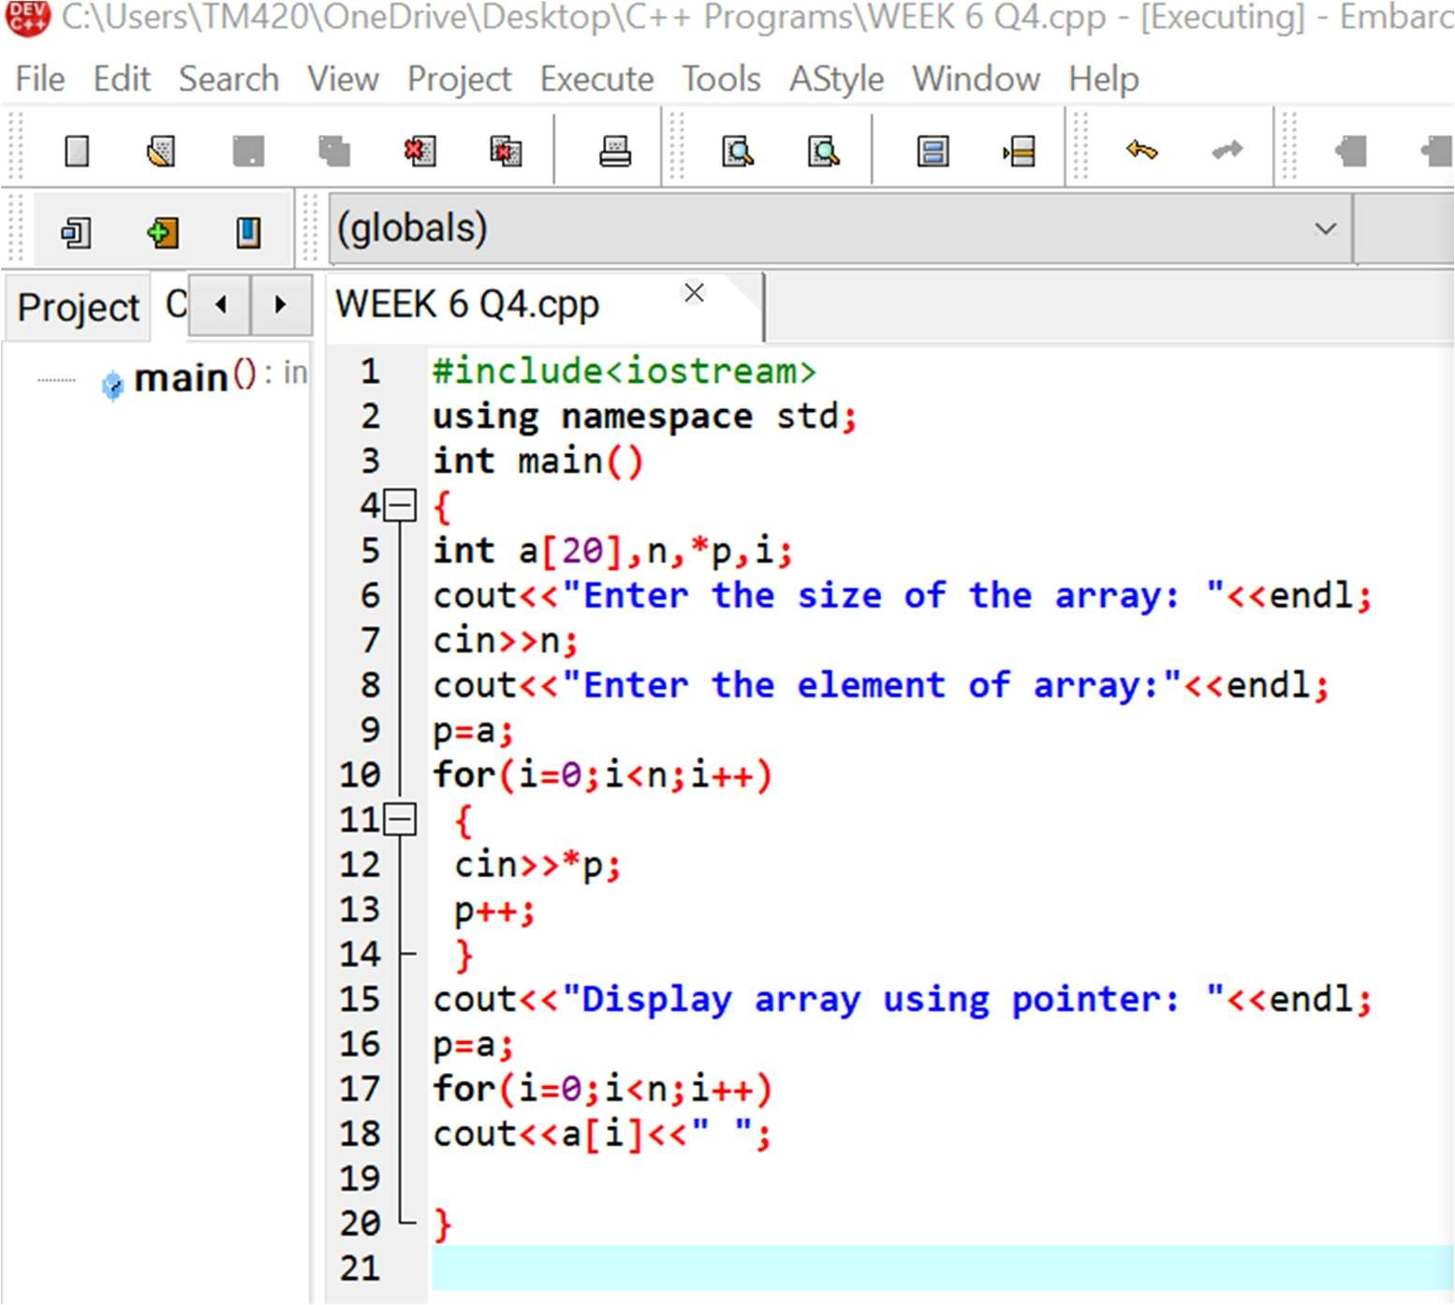This is the required code:

And this is its result:

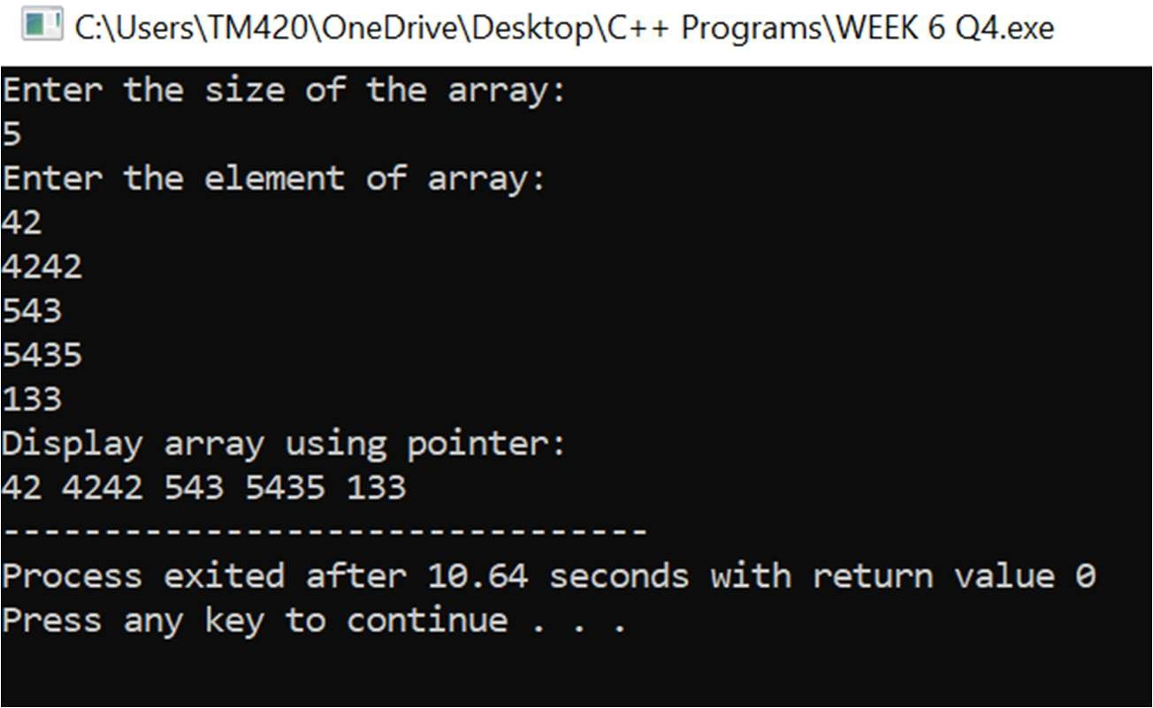

#5 Write a C++ program to reverse a string using pointers.

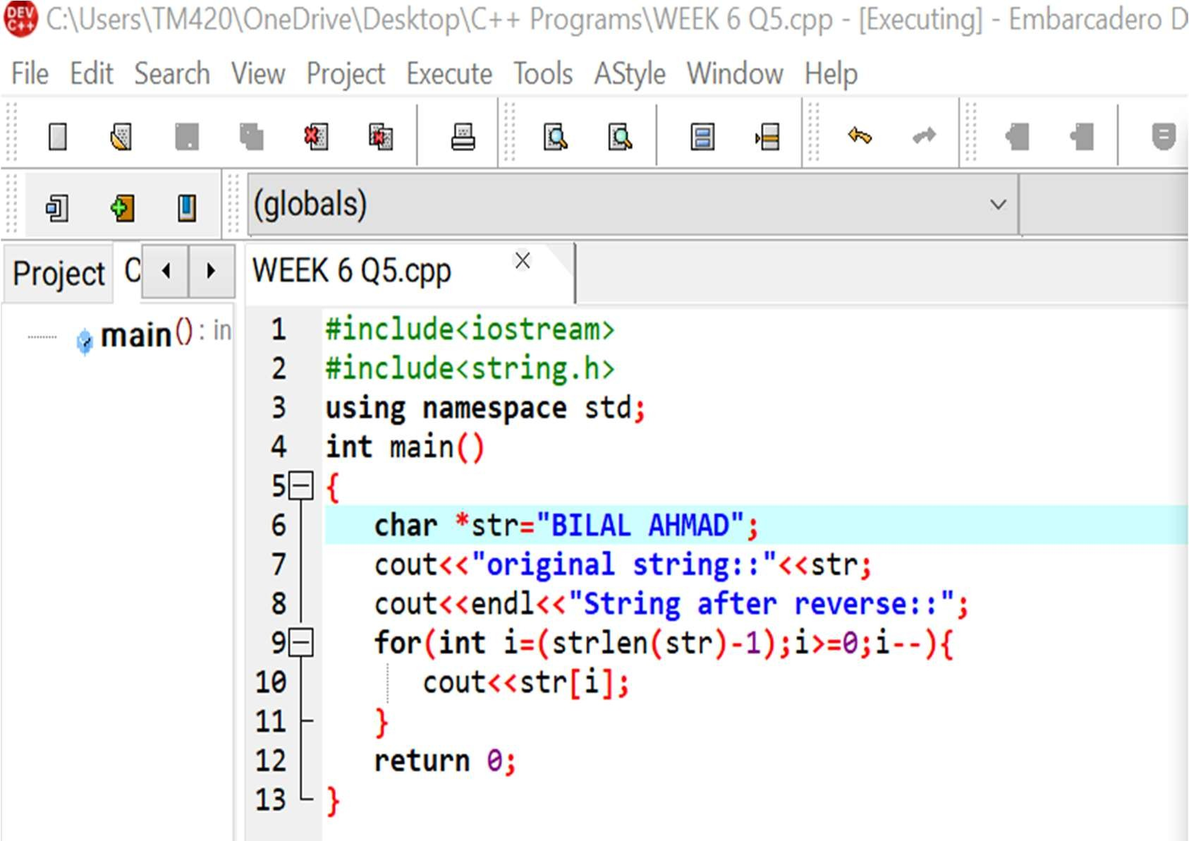This is the required code:

And this is its result:

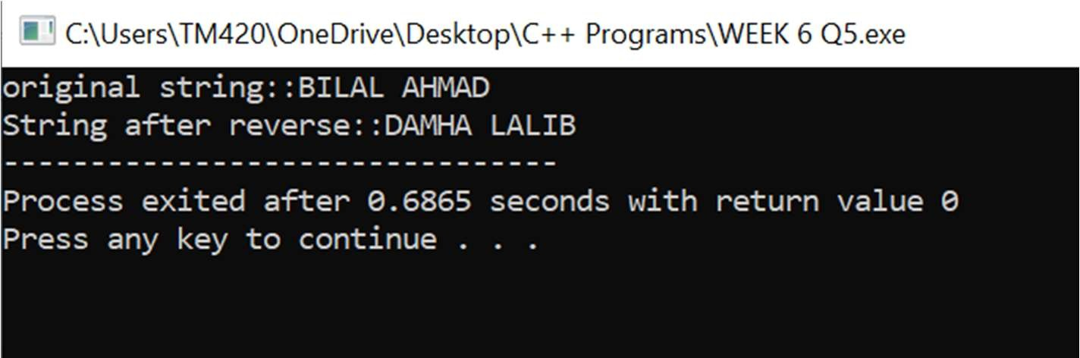



WEEK 7

# WEEK 7

#1 Write a C++ program using pointers to compute the sum, mean and standard deviation of all elements stored in an array of n real numbers.

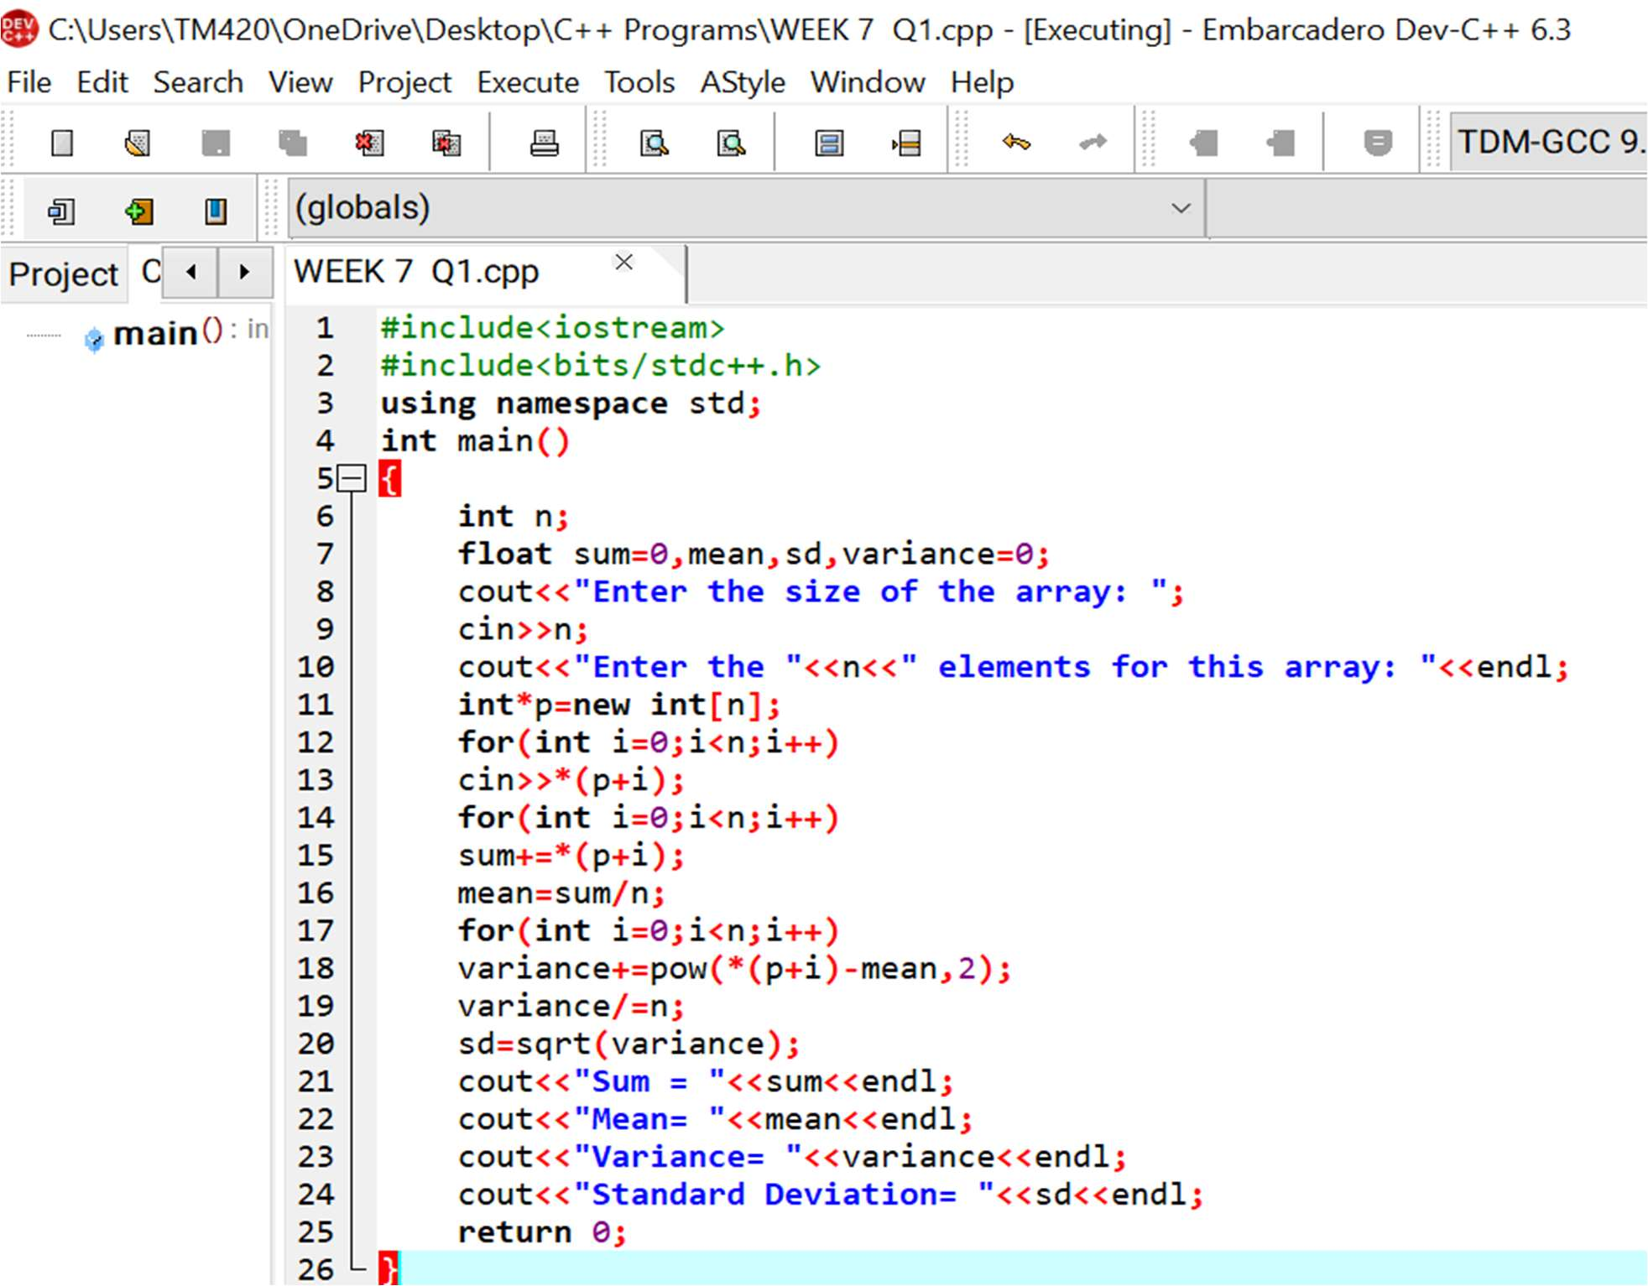This is the required code for this question:

And this is its result:

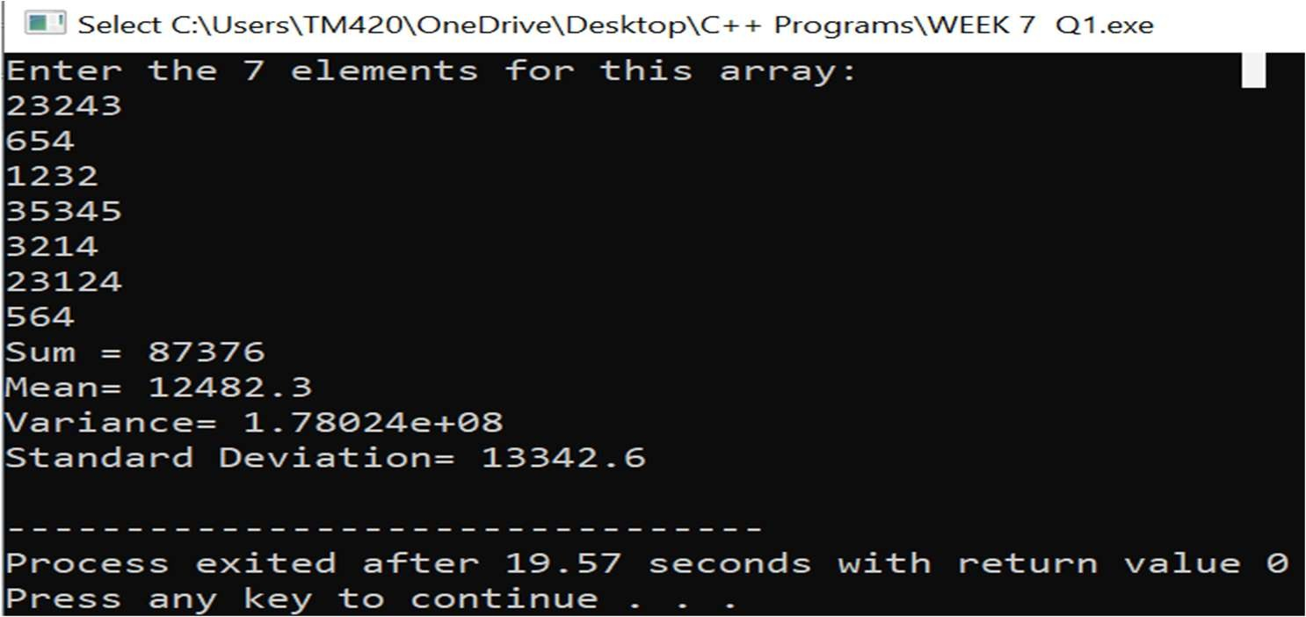

#2 Write a C++ program to create three objects for a class named pntr_obj with data members such as roll_no & name. Create a member function set_data() for setting the data values and print() member function to print which object has invoked it using ‘this’ pointer.

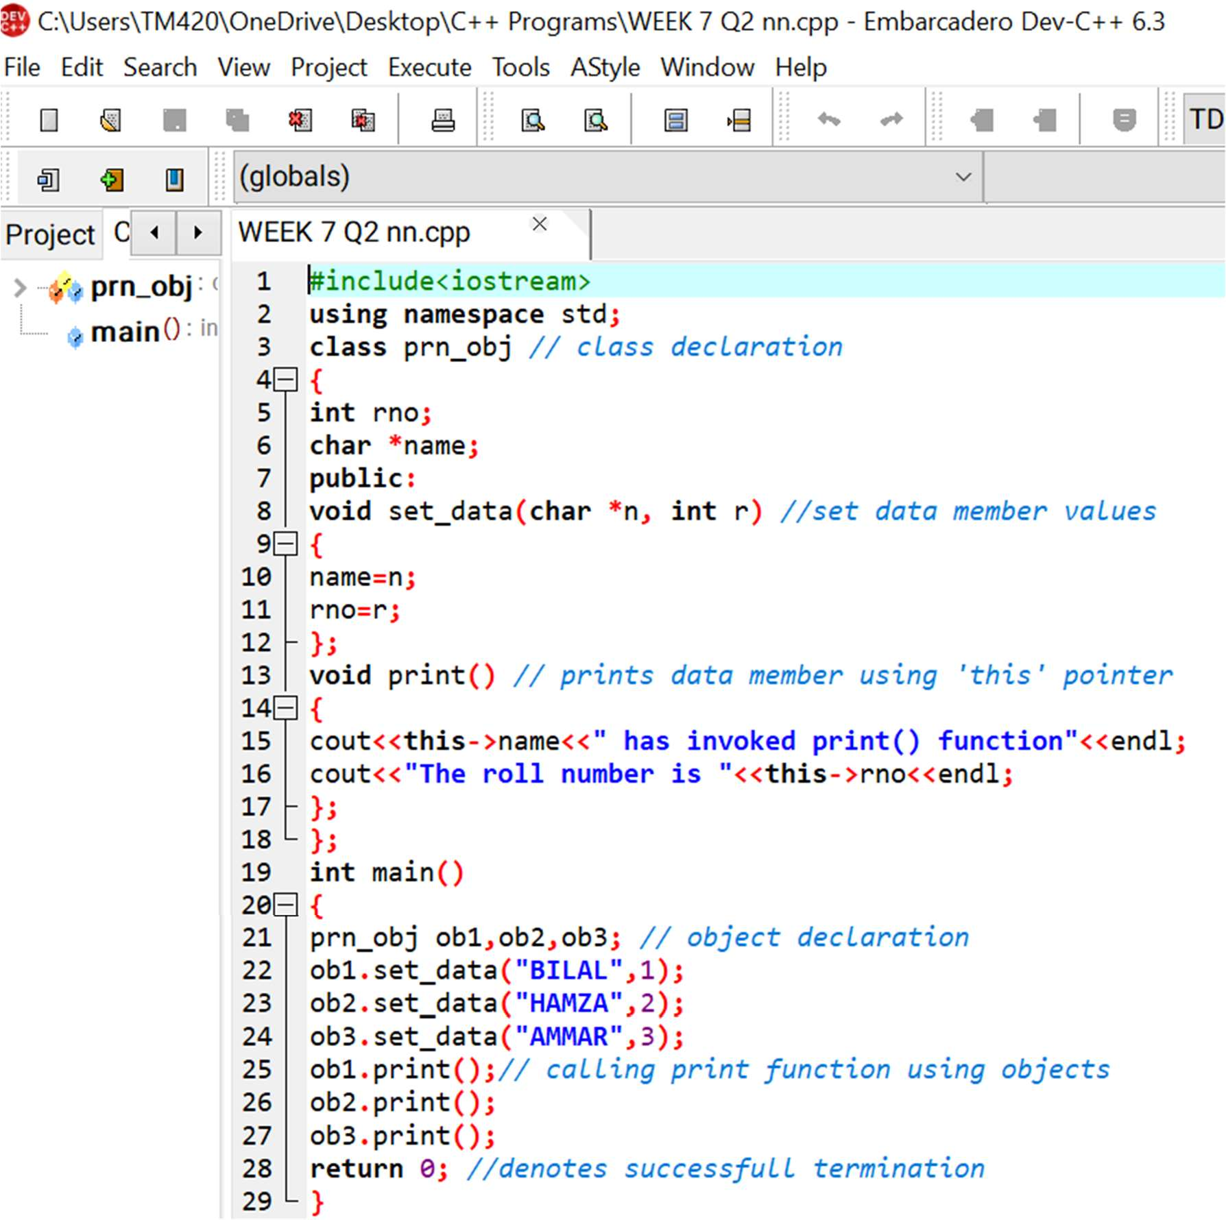This is its required code:

And this is its result:

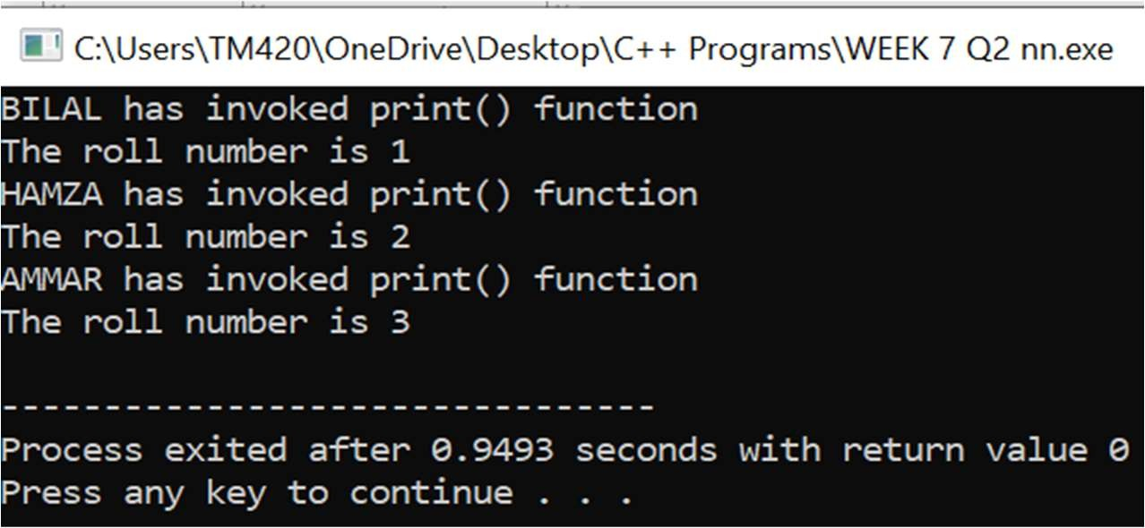

#3 Develop a C++ program to find the greatest of two numbers using this pointer which returns the member variable.

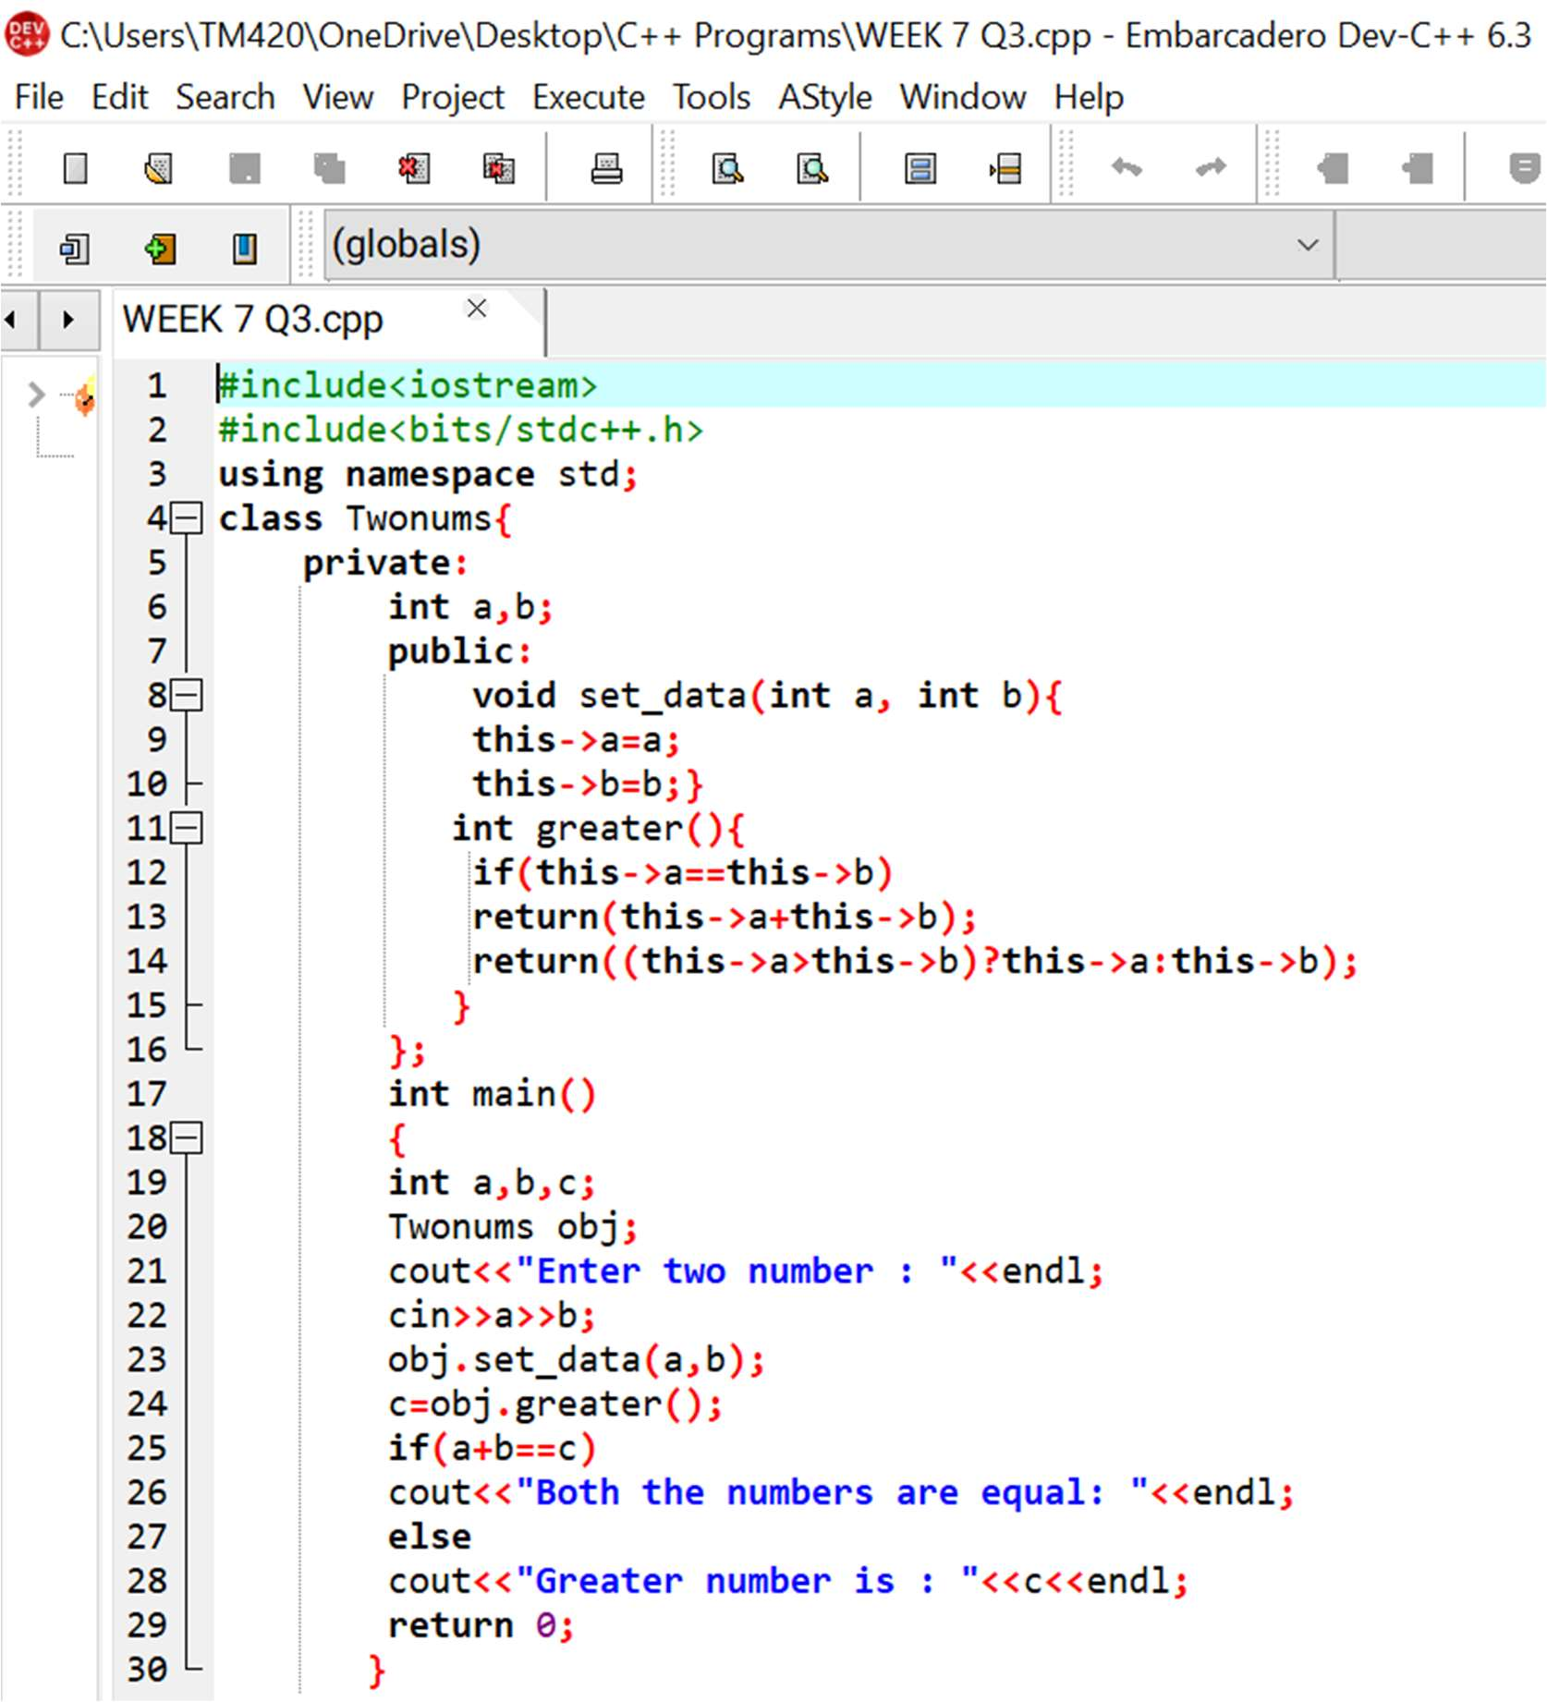This is the required code:

And this is its result:

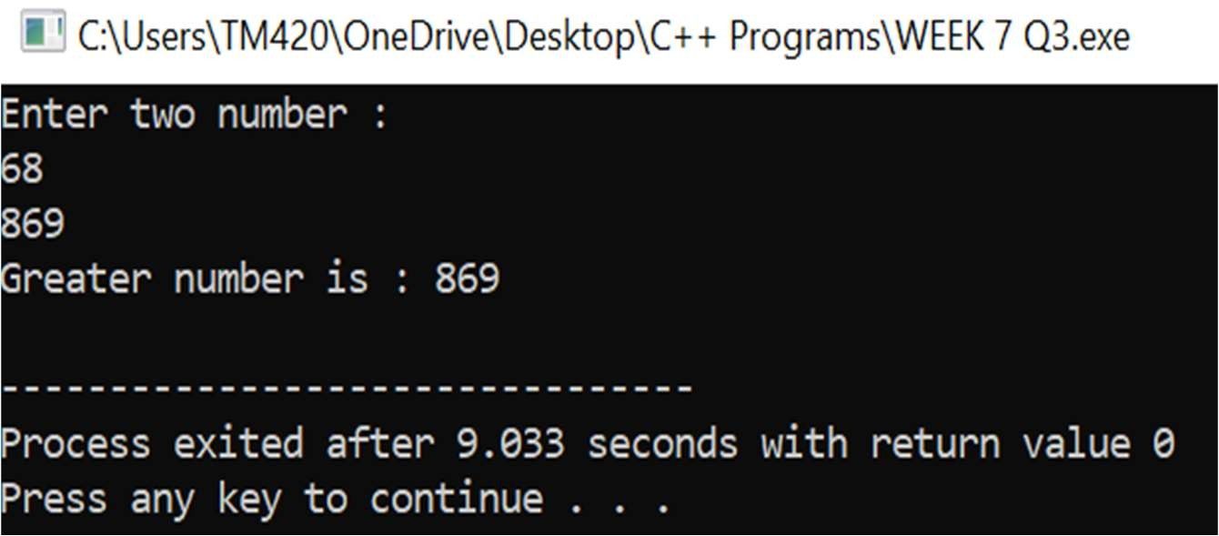

#4 Write a C++ program to implement flight class with data member as flight_no., source destination and fare. Write a member function to display the flight information using this pointer.

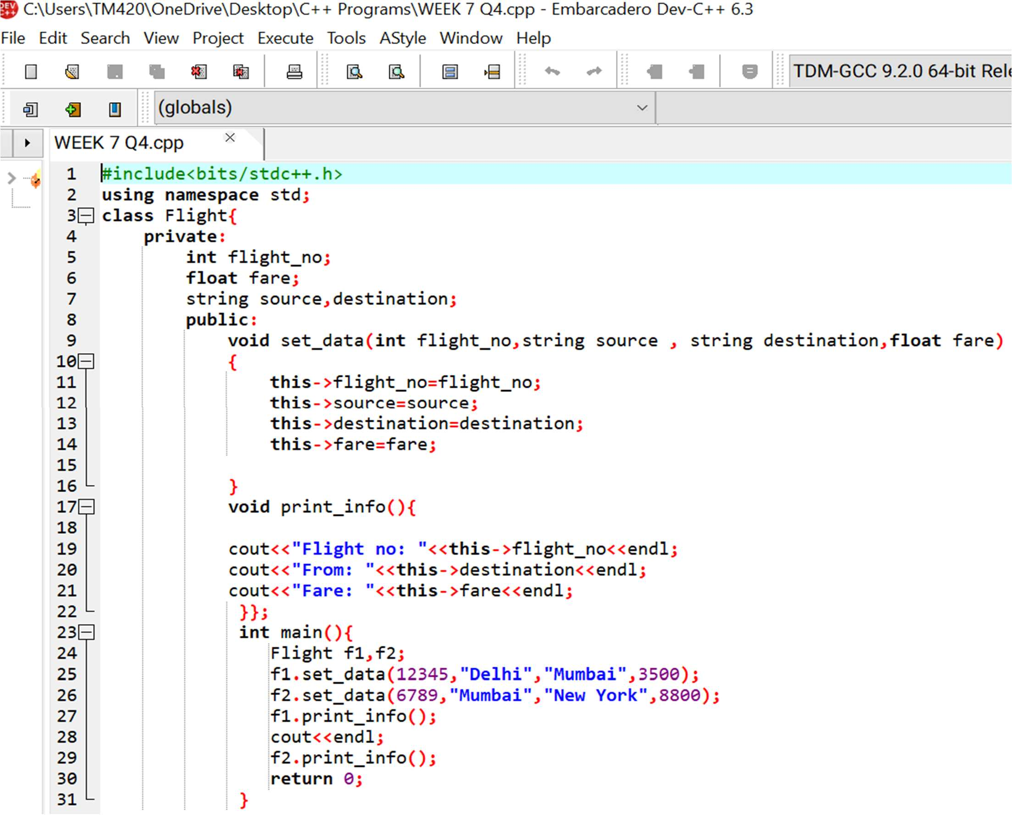The required code is given below:

And this its result:

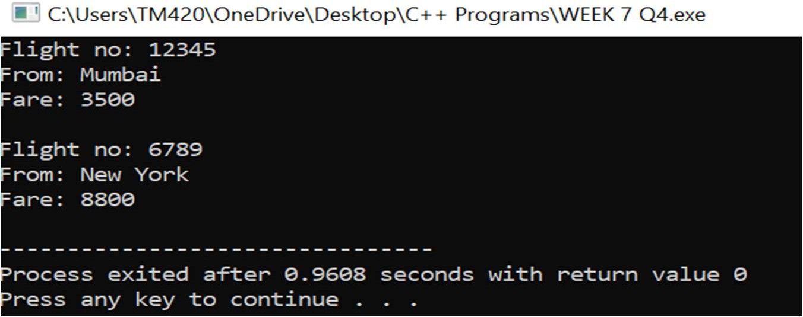

#5 Write a C++ program to use *this* pointer and return pointer reference.

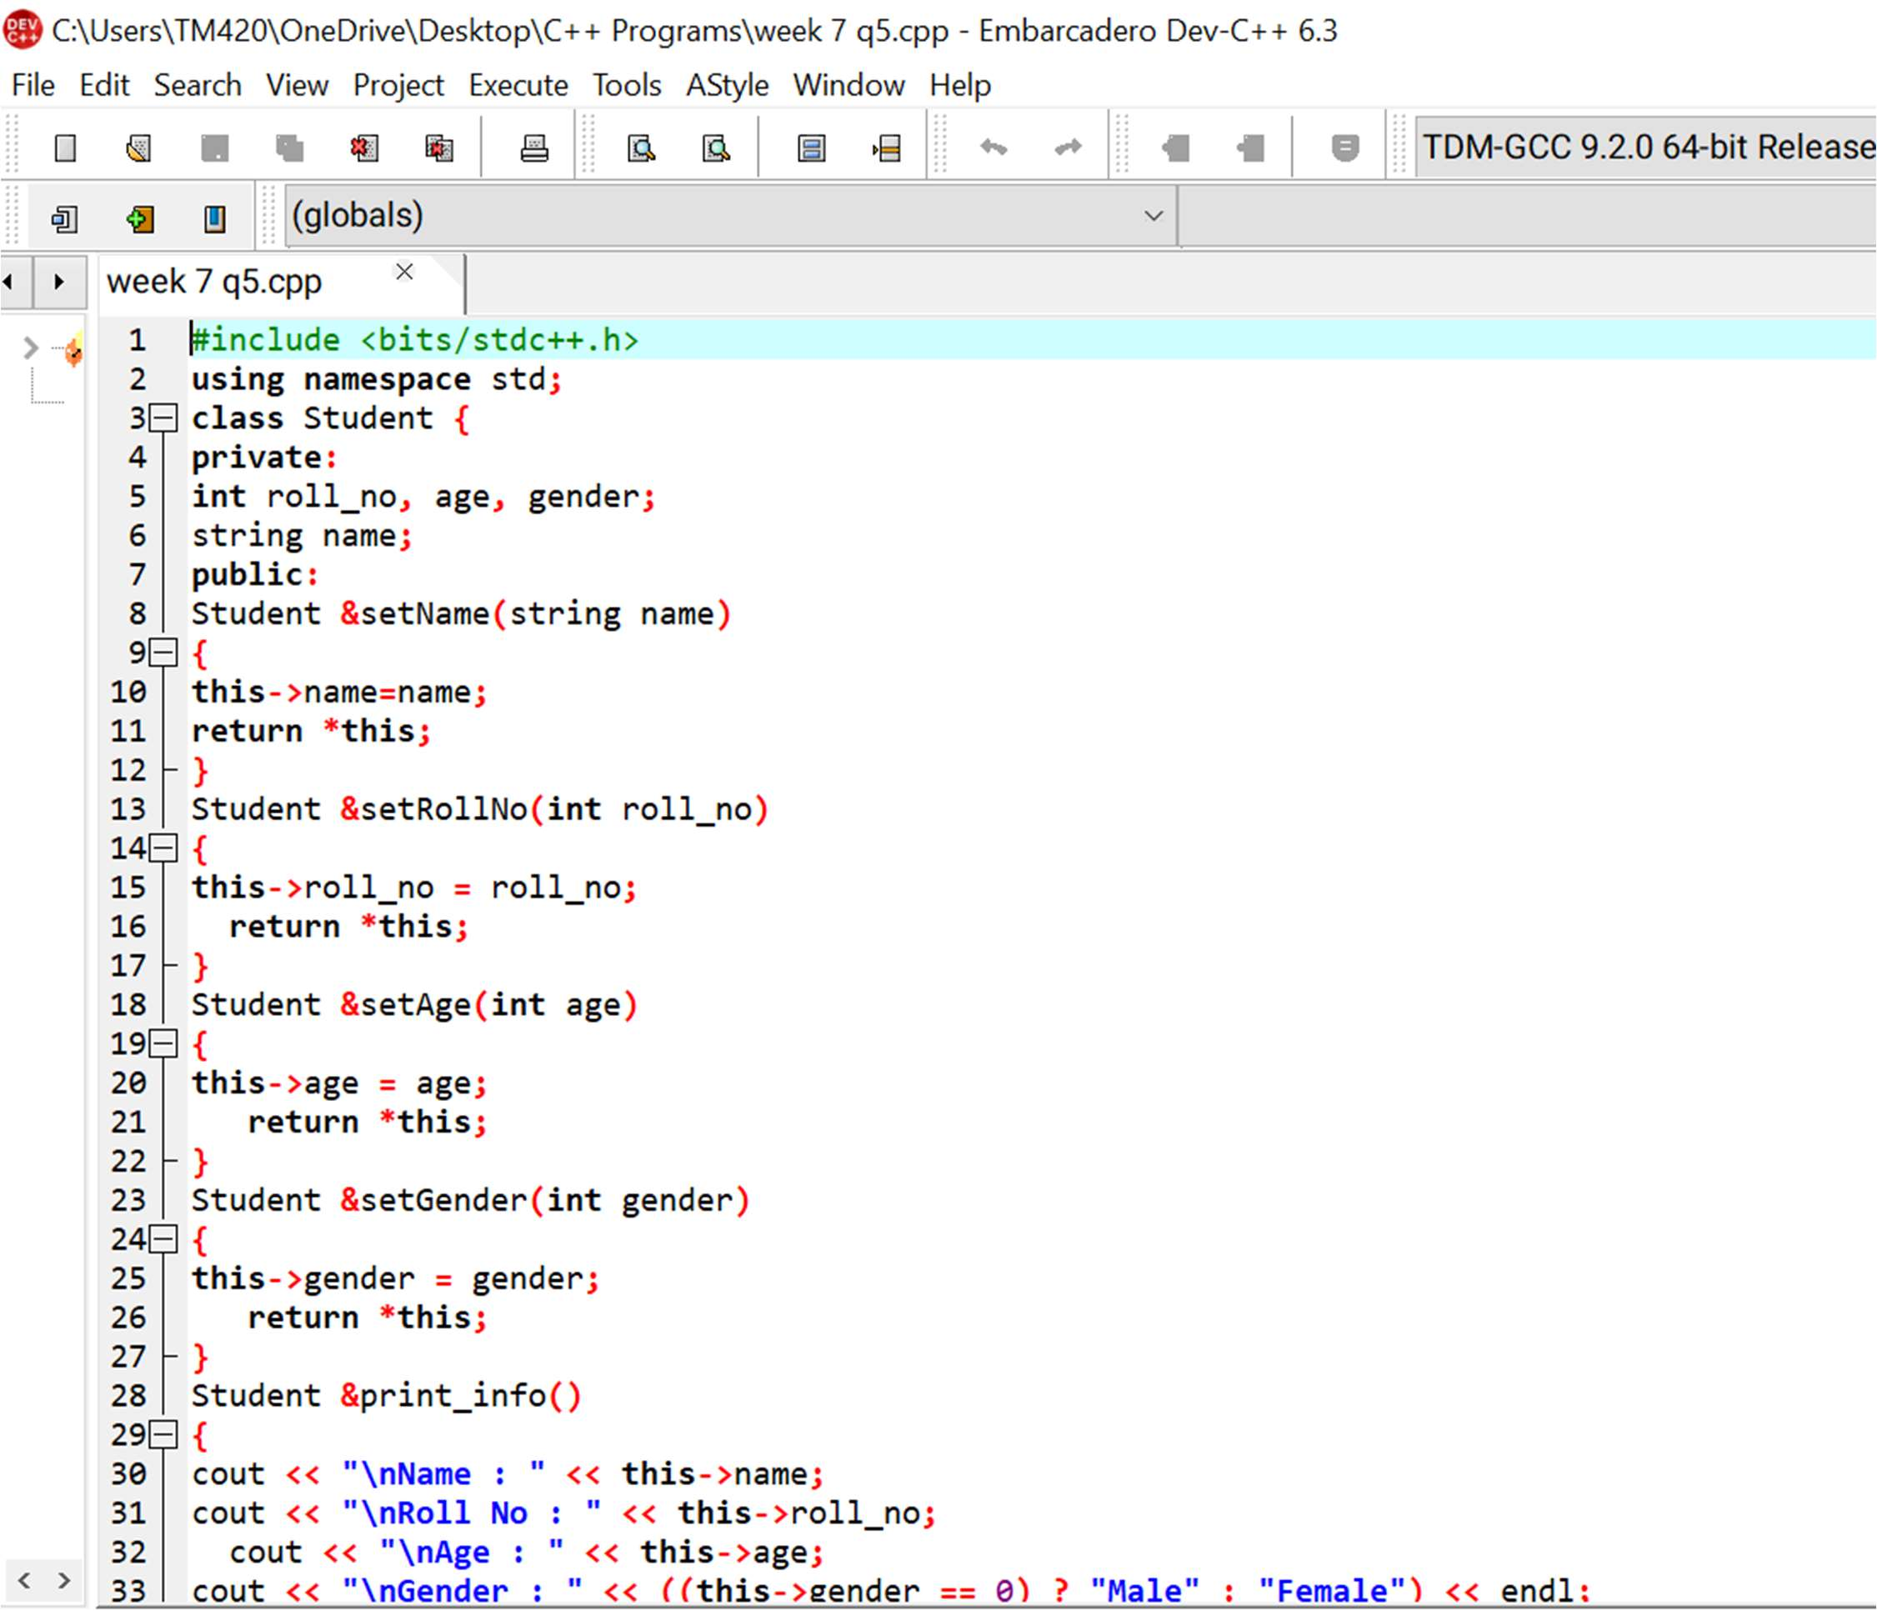This is the required code:

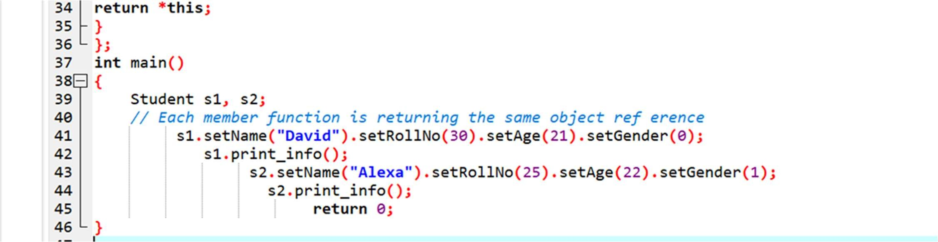

And this is its result:

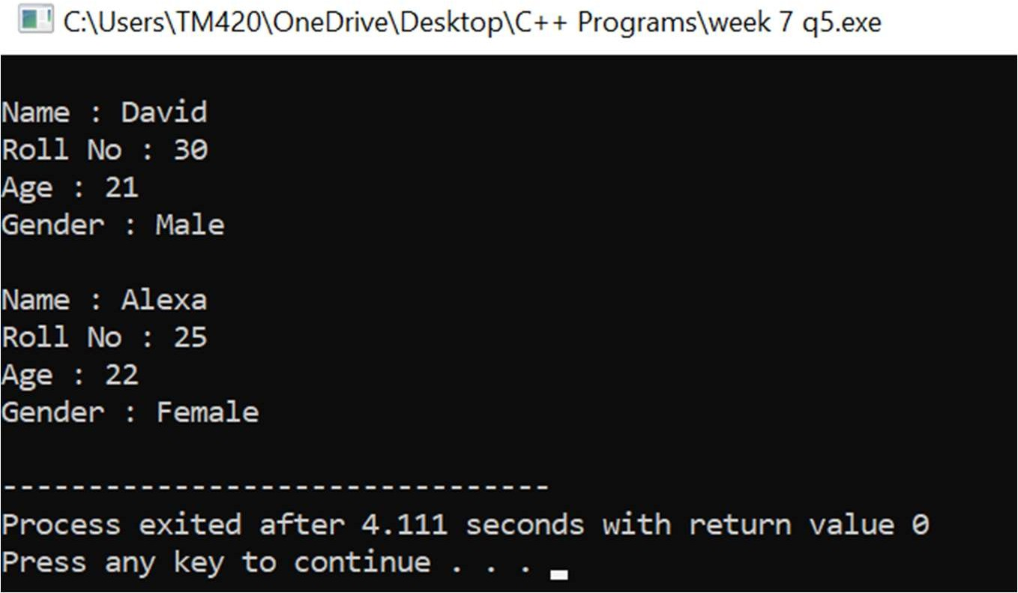



WEEK 8

# WEEK 8

#1 Write a C++ program that uses functions to perform the following operations:

1. **To insert a sub string into a given main string from a given position.**
2. **To delete n characters from a given position in a given string.**

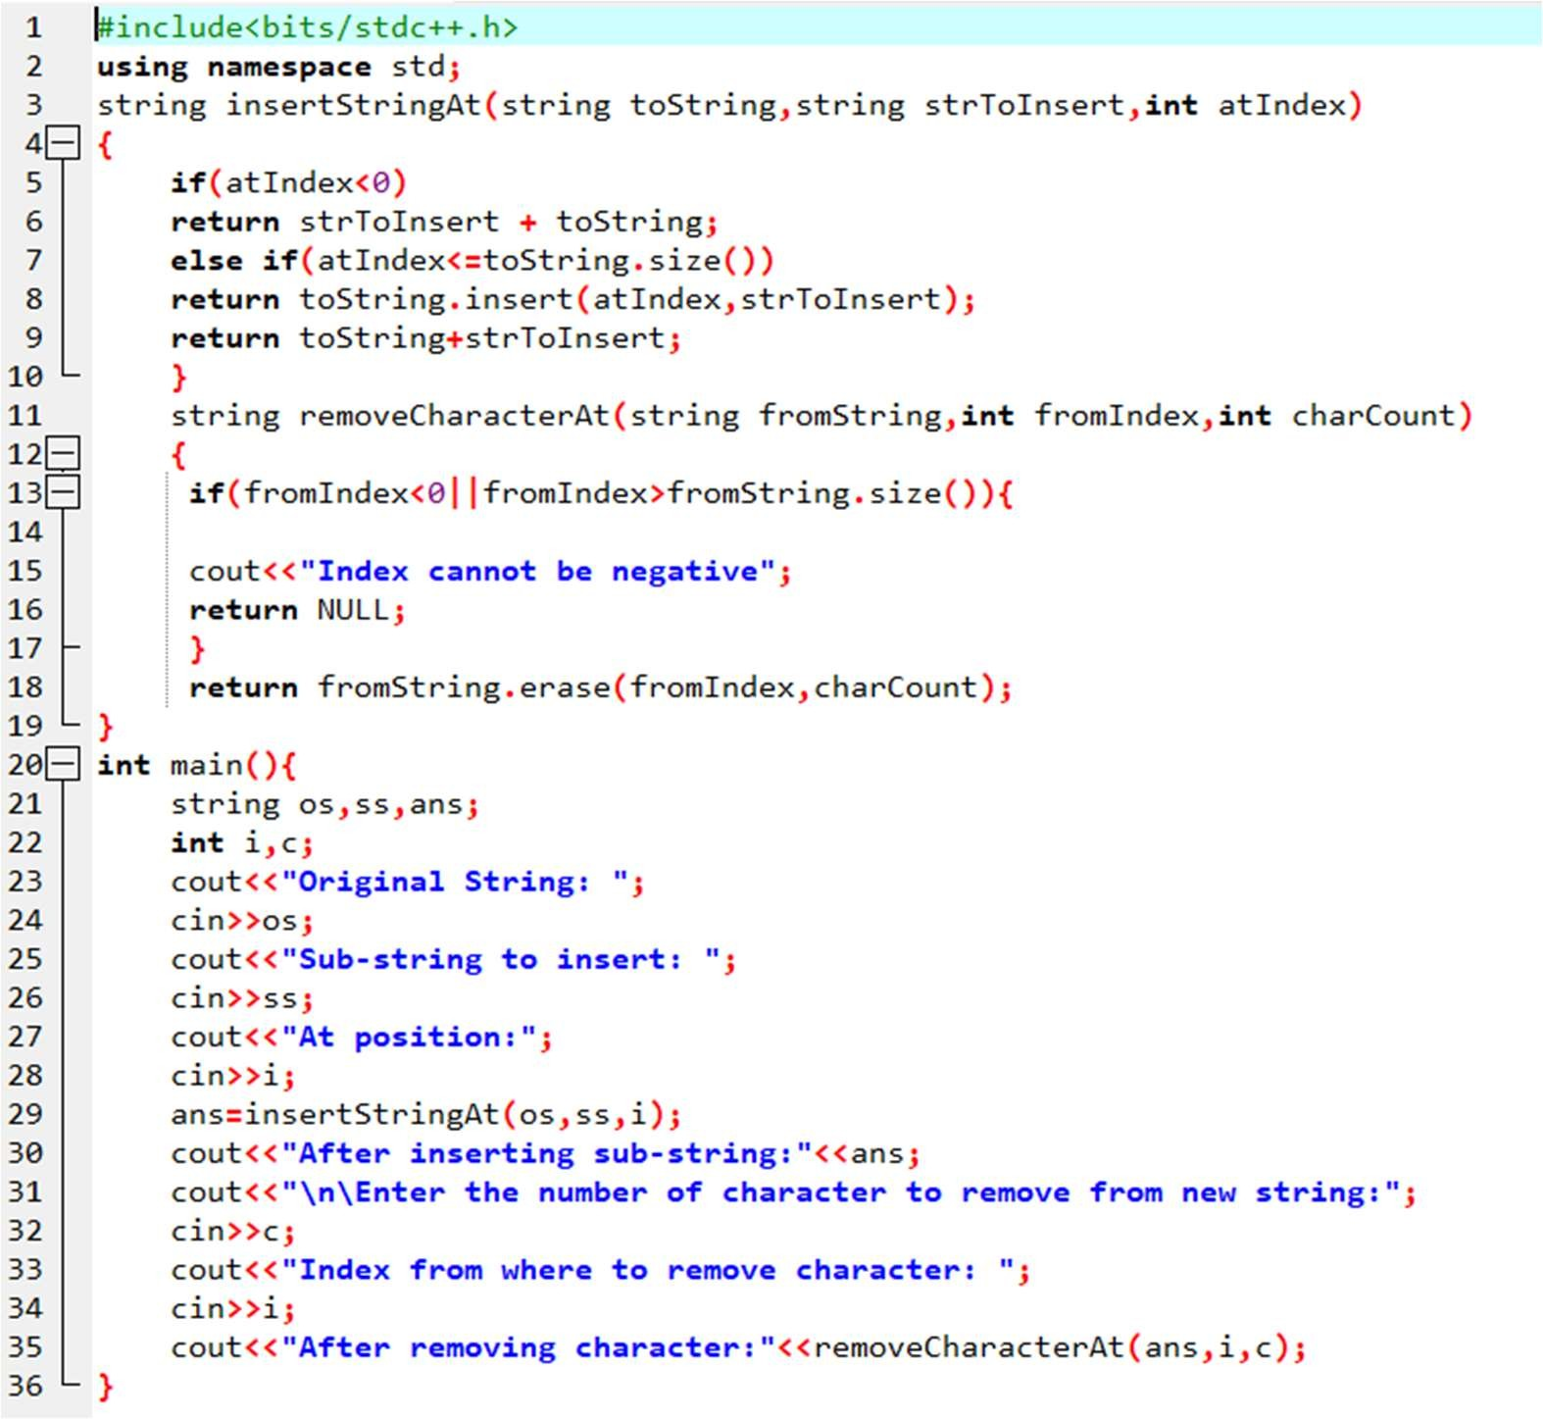This is the required code:

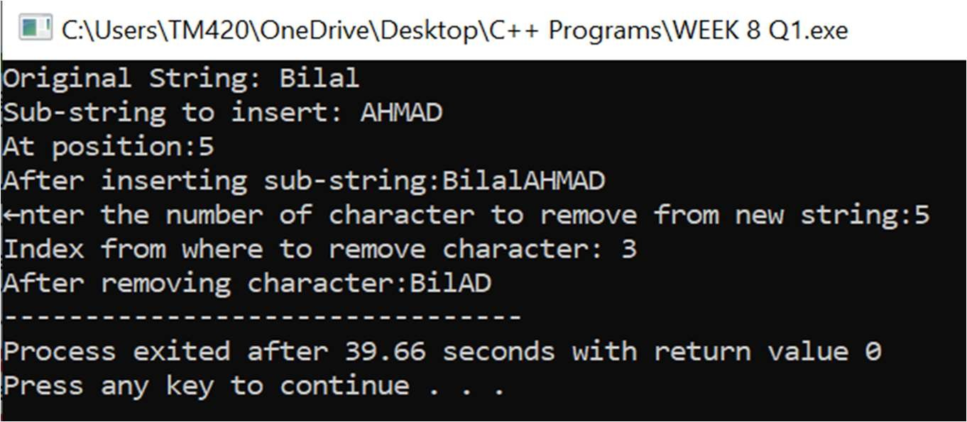And this is its result:

#2 Write a C++ program to determine if the given string is a palindrome or not.

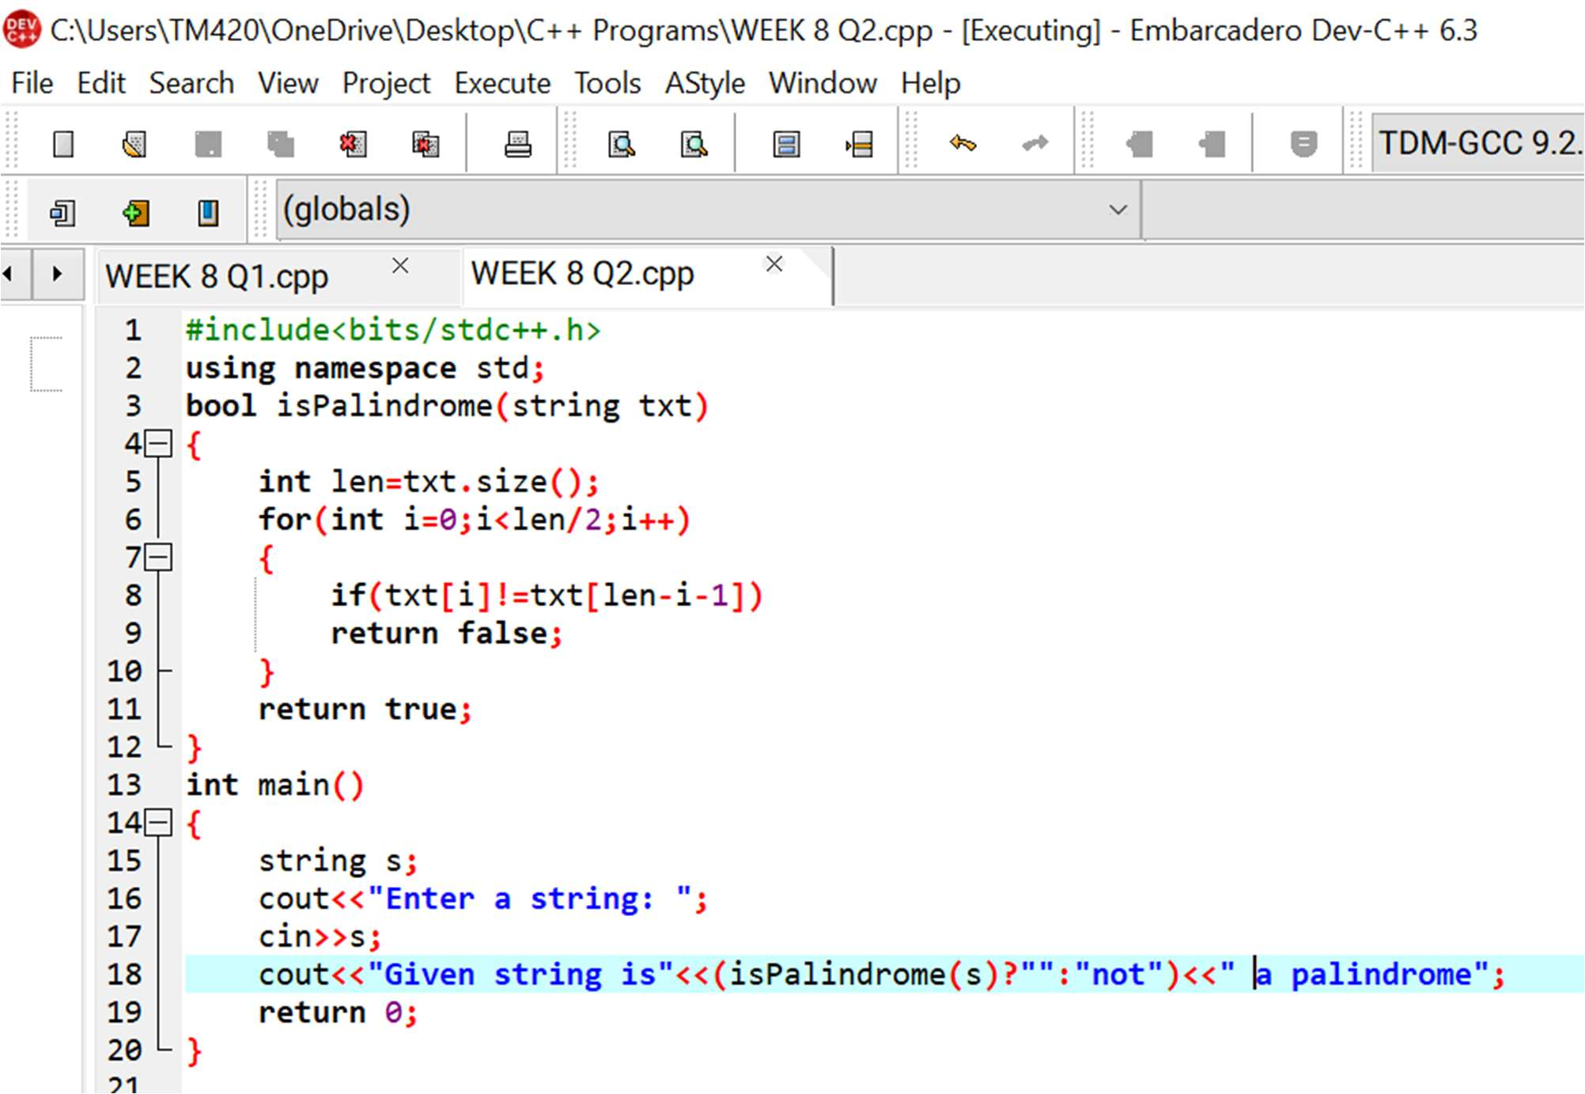This is the required code:

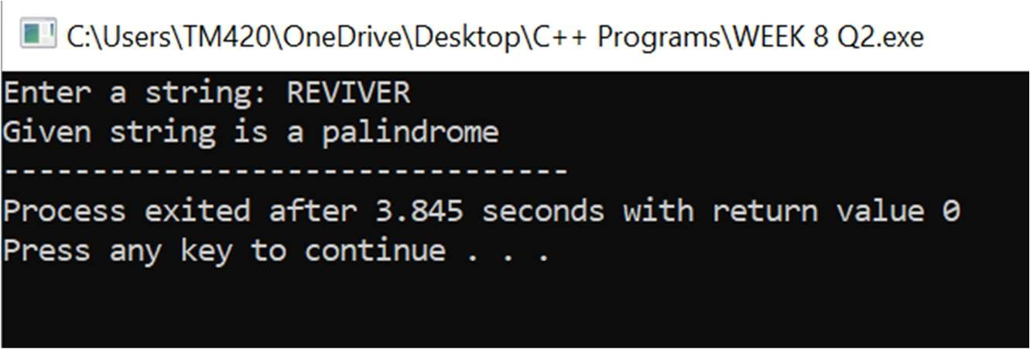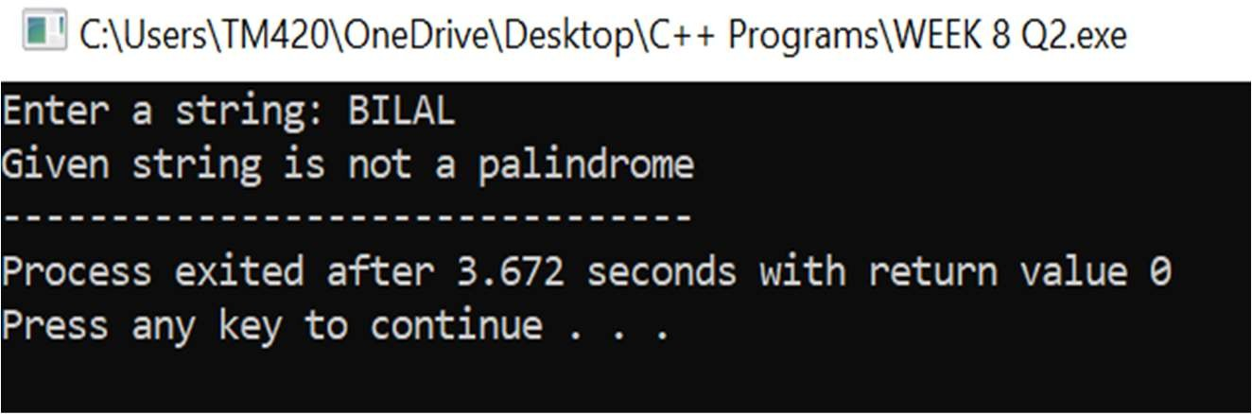And this is its result:

#3 Write a C++ program to find a string within a sentence and replace it with another string.

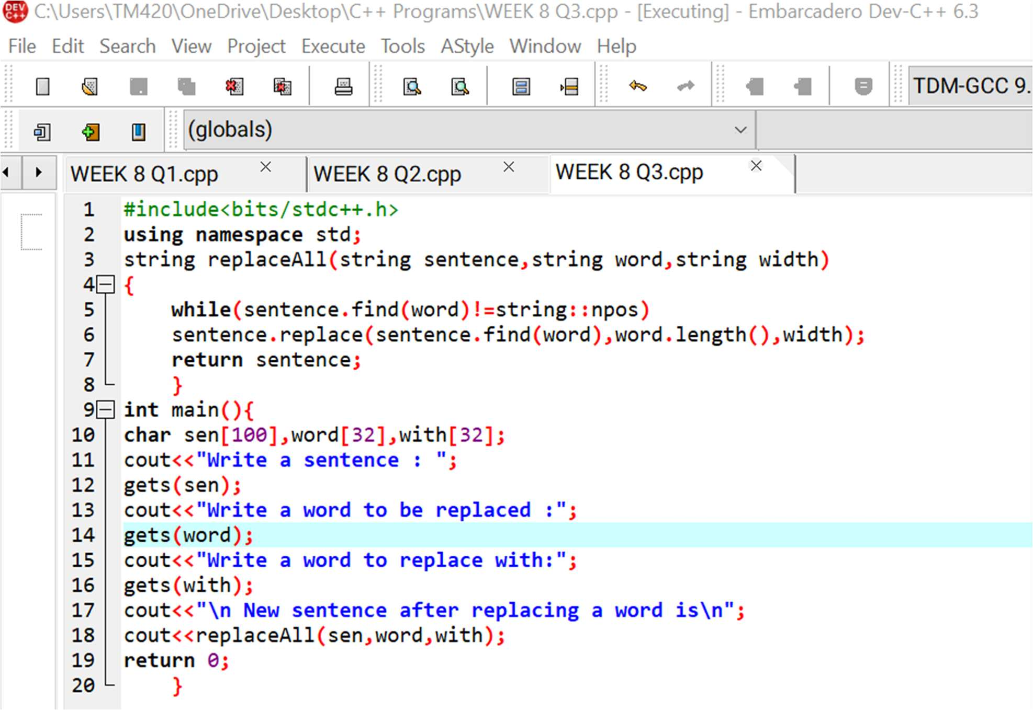This is the required code:

And this is its result:

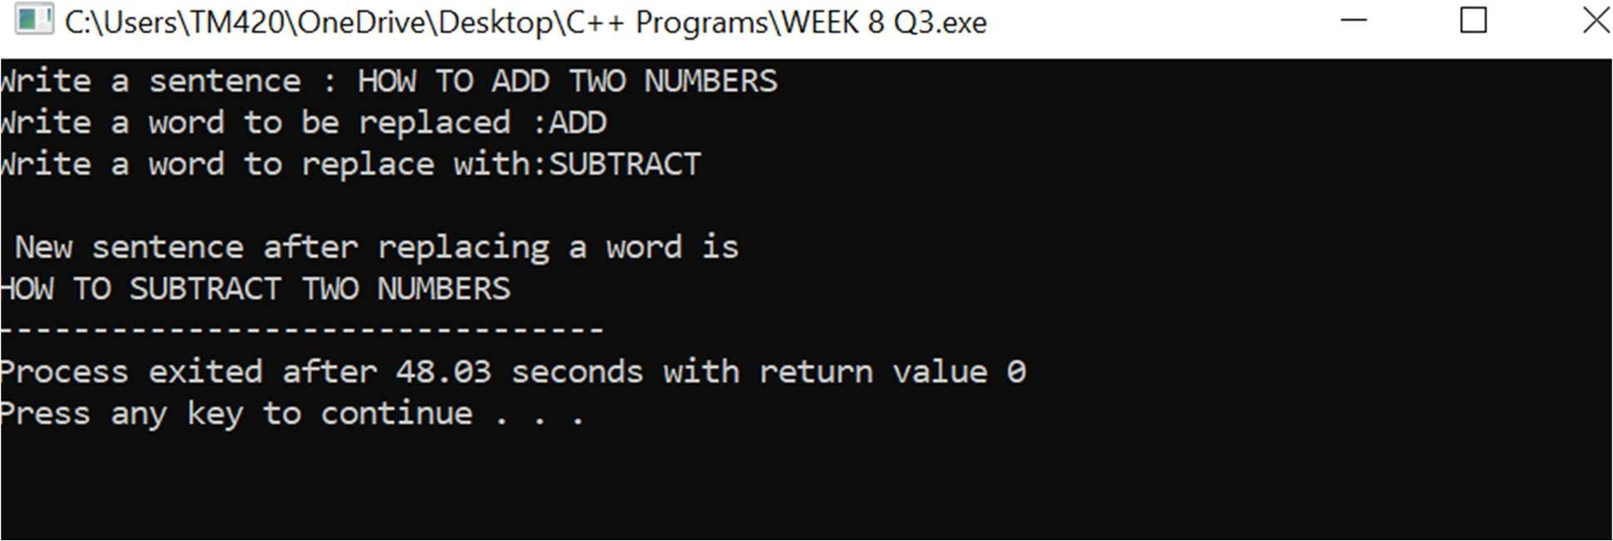

#4 Write a C++ program that reads a line of text and counts all occurrence of a particular word.

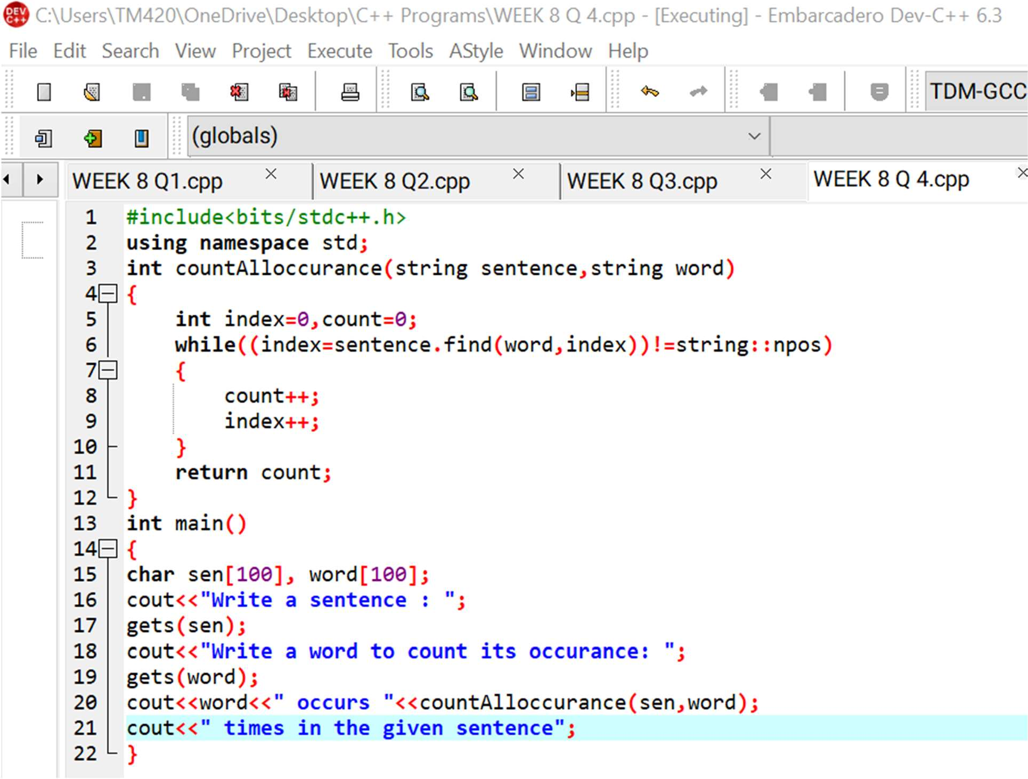This is the required code:

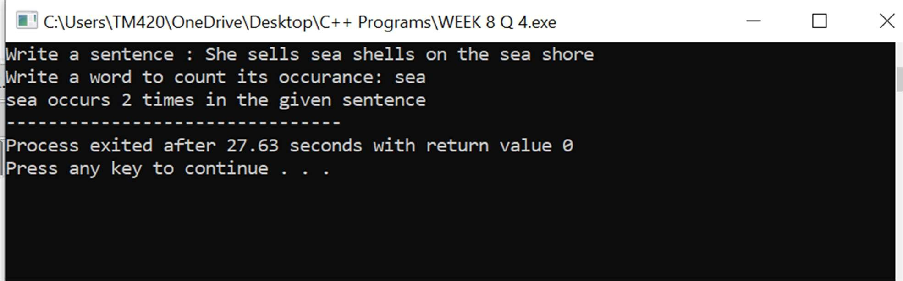And this is its result:

#5 Write a C++ program that displays the position or index in the string S where the string T begins, or 1 if S doesn’t contain T.

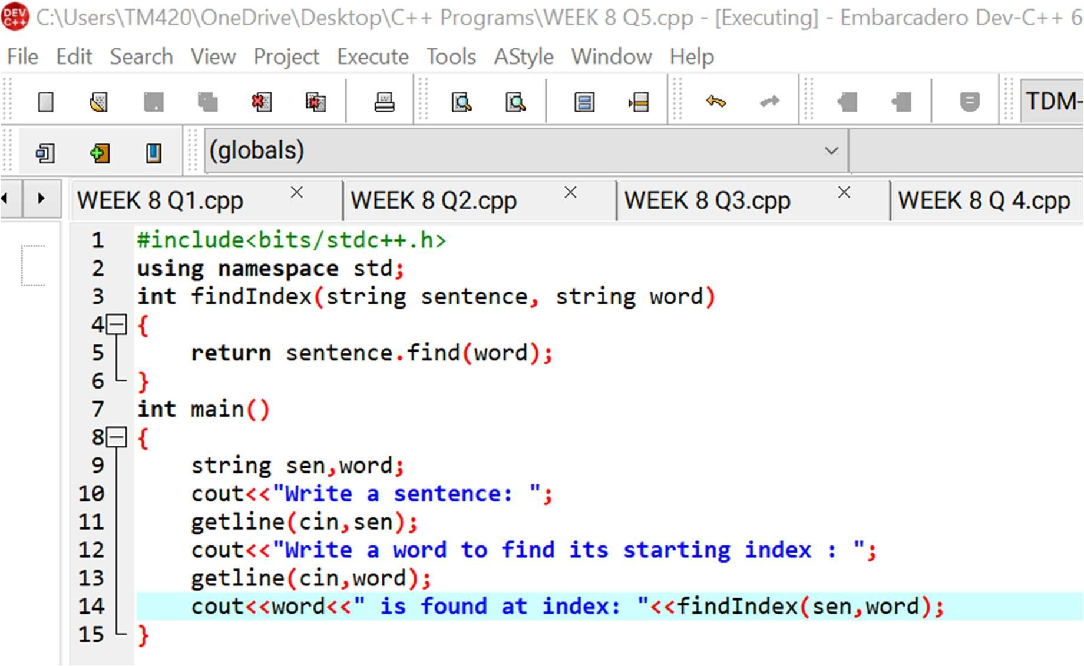This is its required code:

And this is its result:

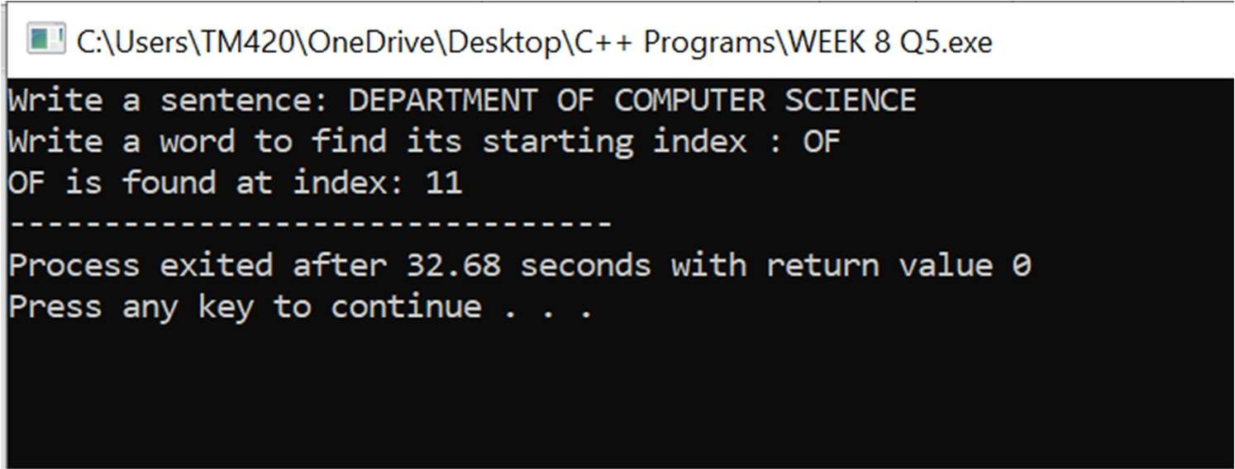



WEEK 9

# WEEK 9

#1 Write C programs that use both recursive and non-recursive functions to find:

1. **The factorial of a given integer.**
2. **To find the greatest common divisor of two given integers.**

The required code for both problems is on the next page:

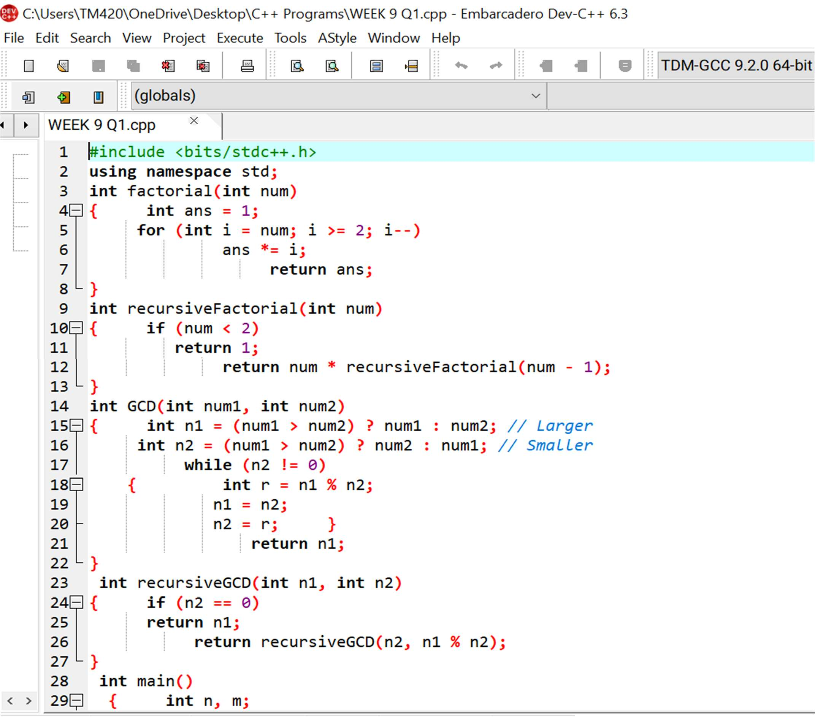

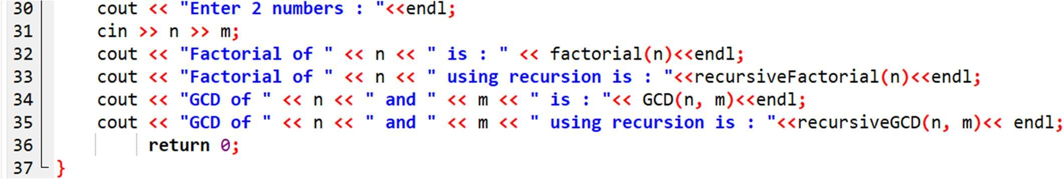

And this is its result:

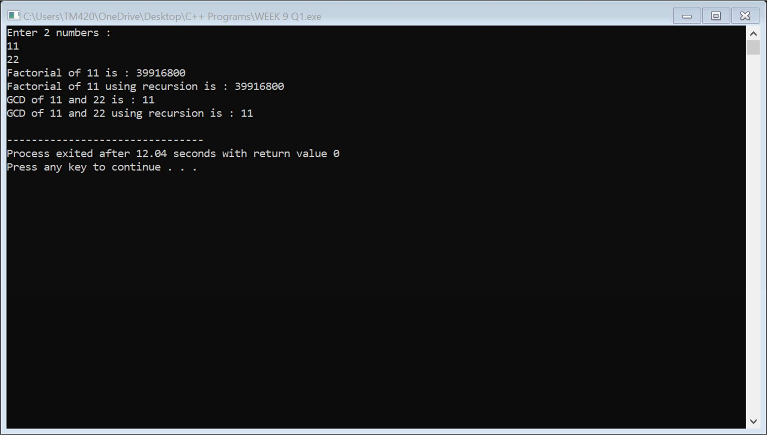

#2 Write C programs that use both recursive and non-recursive functions to solve towers of Hanoi problem.

The required code is provided in the next page:

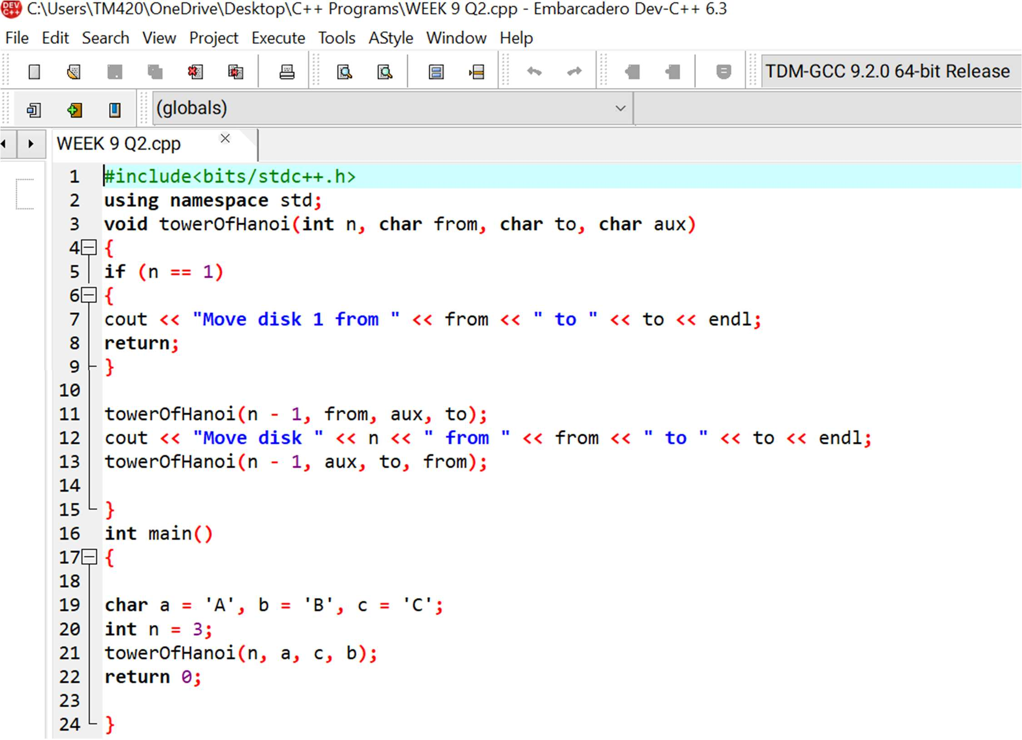

And this is its result:

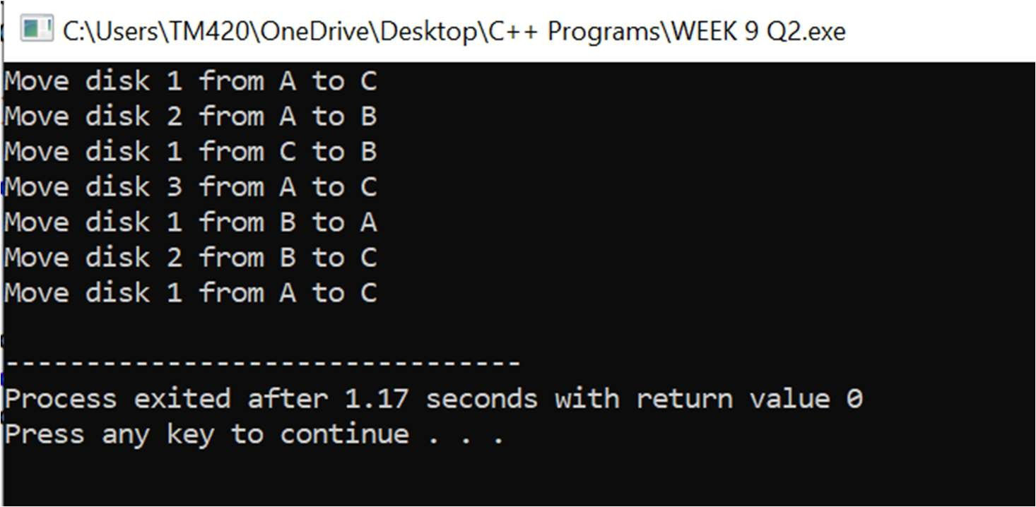

#3 Write a C++ program to print the transpose of a given matrix using a function.

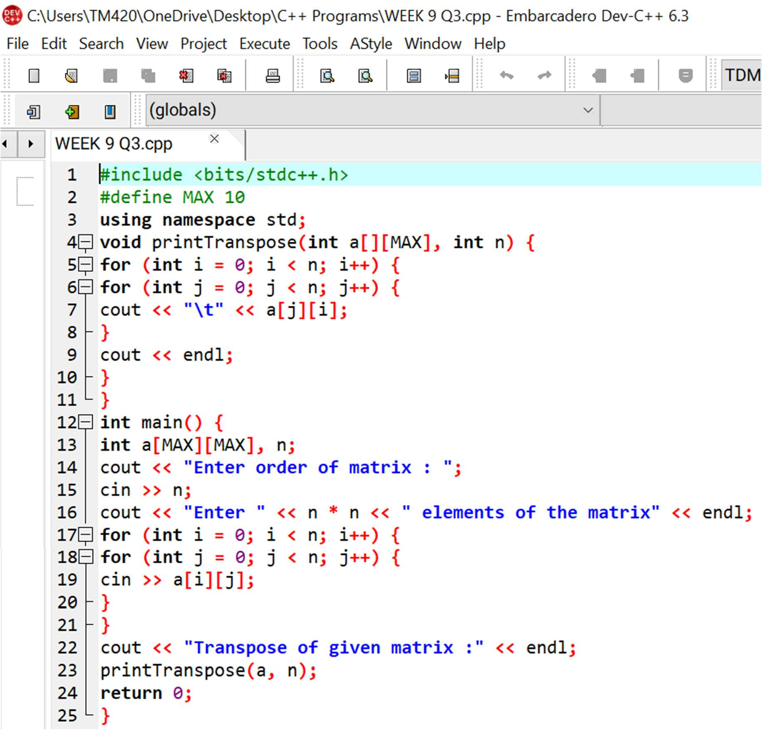This is the required code:

And this is its result:

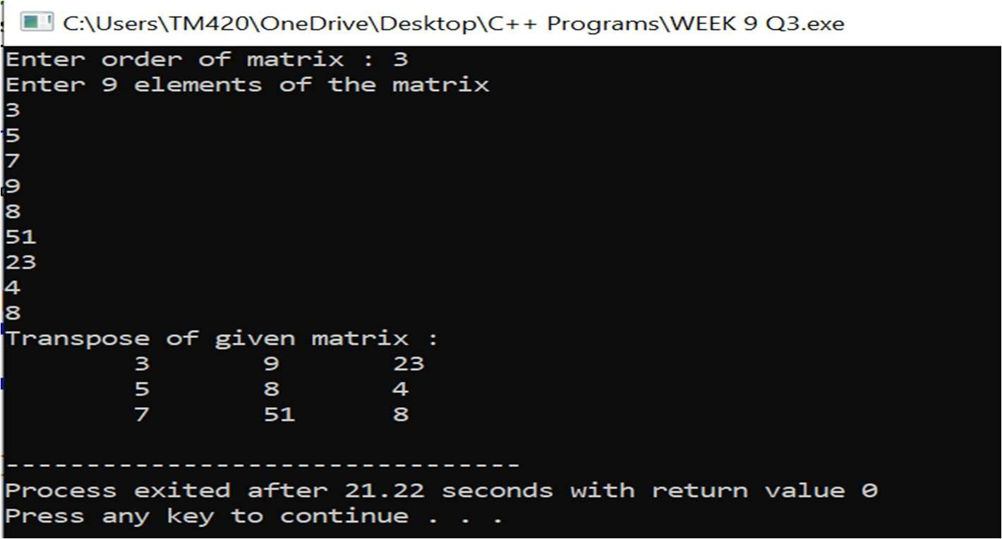

#4 Write a C++ program to swap two number by both call by value and call by reference mechanism, using two functions swap_value() and swap_reference respectively, by getting the choice from the user and executing the user’s choice by switch-case.

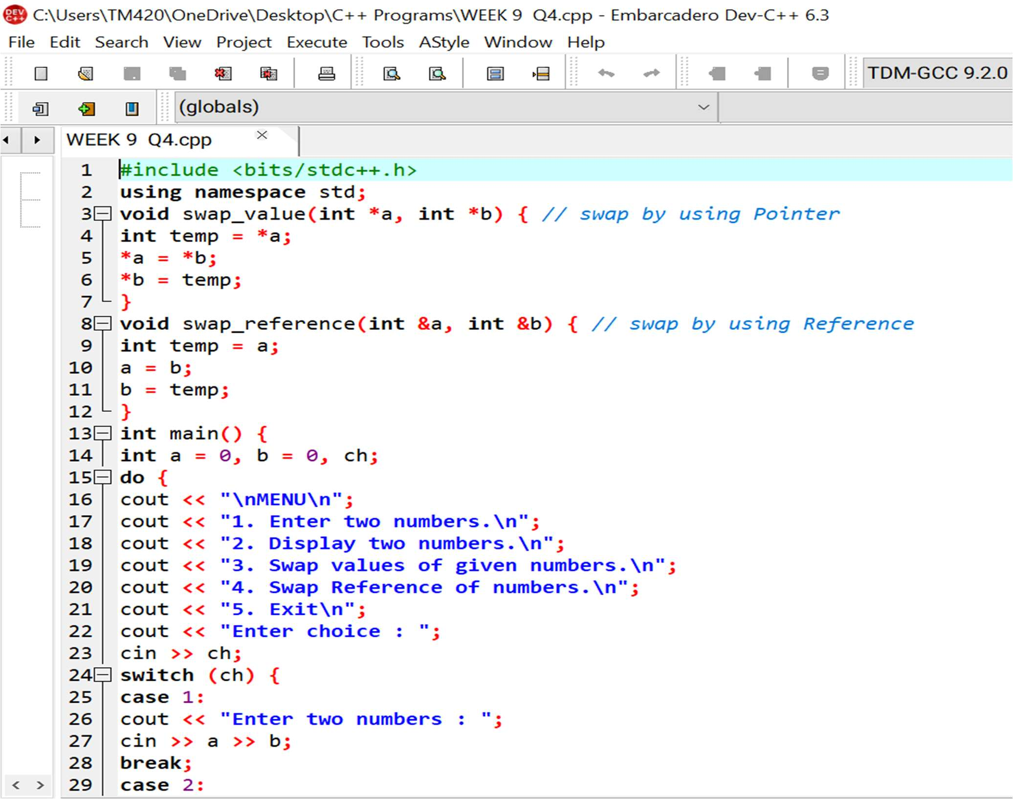This is the required code:

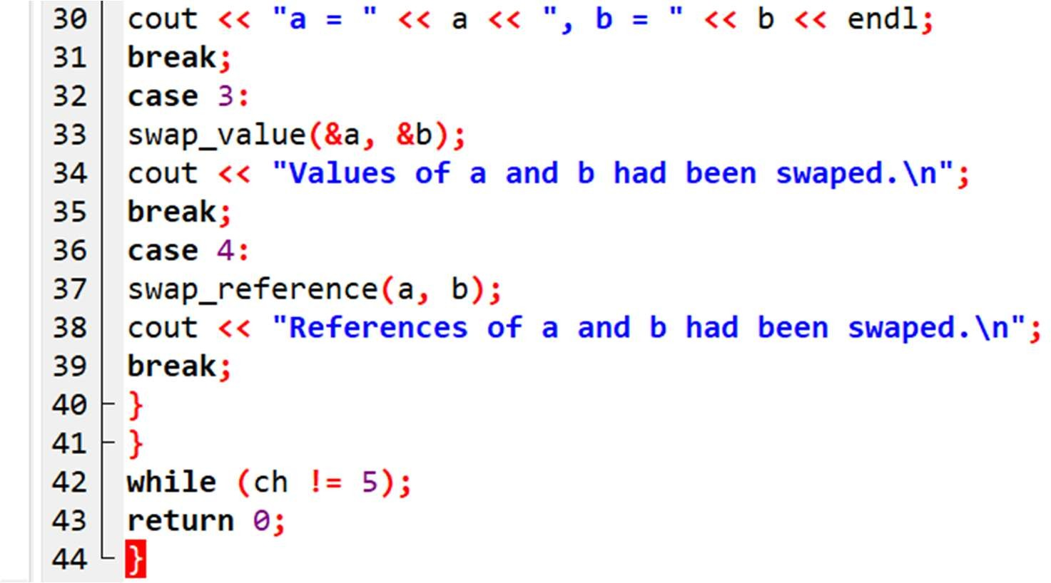

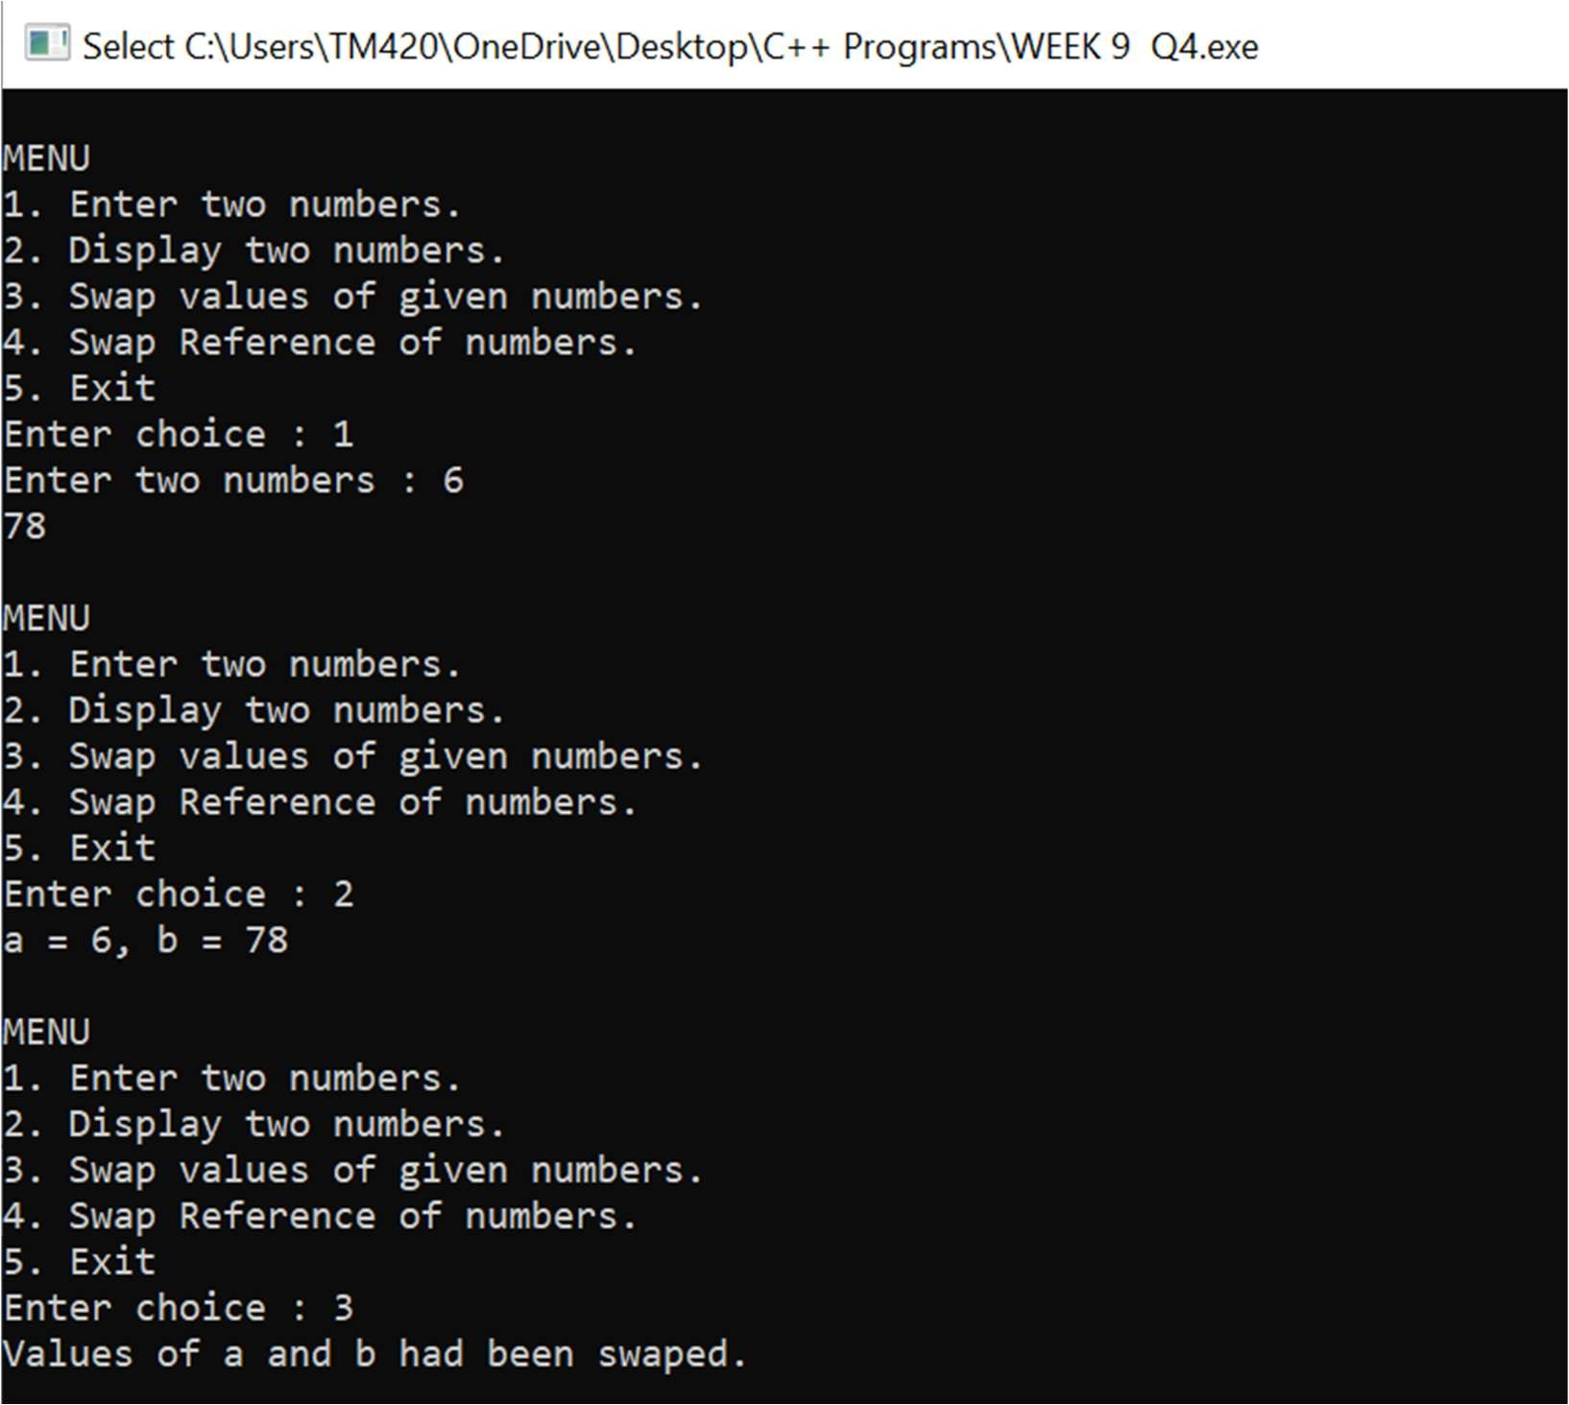And this is its result:

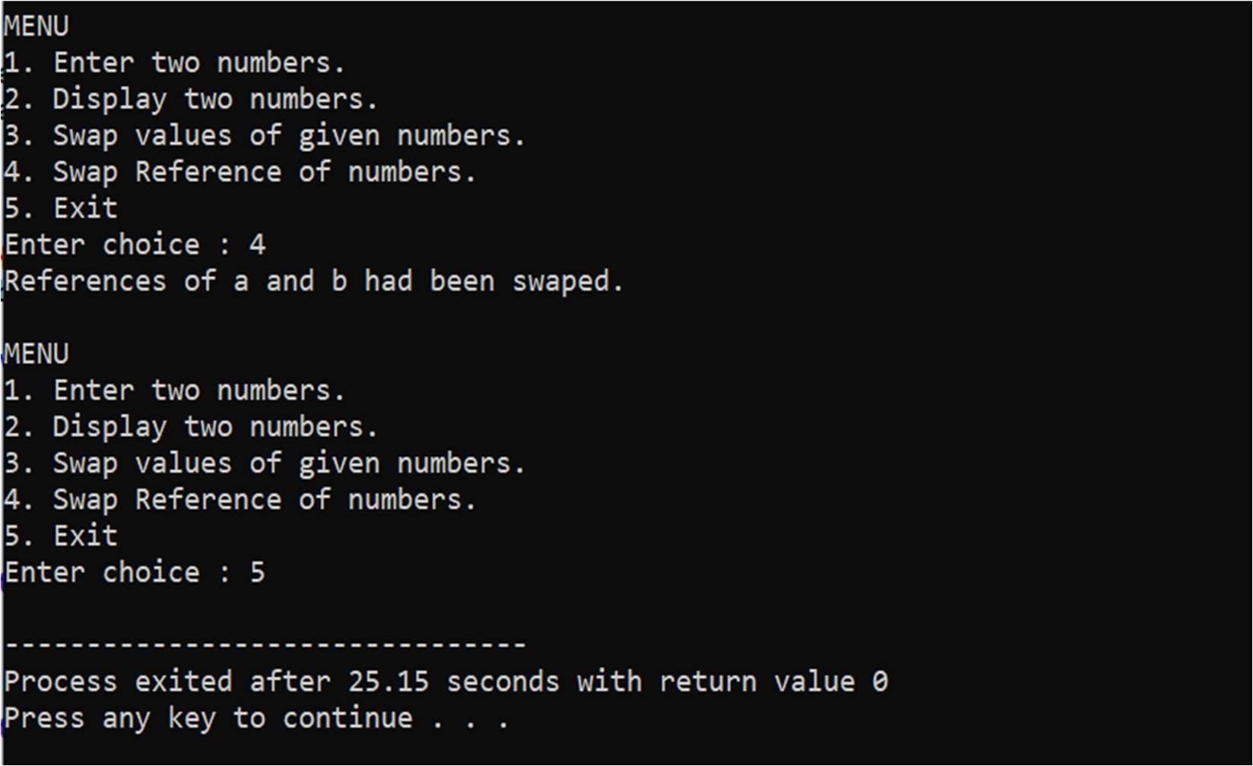

#5 Write a C++ program to display all array elements using recursion.

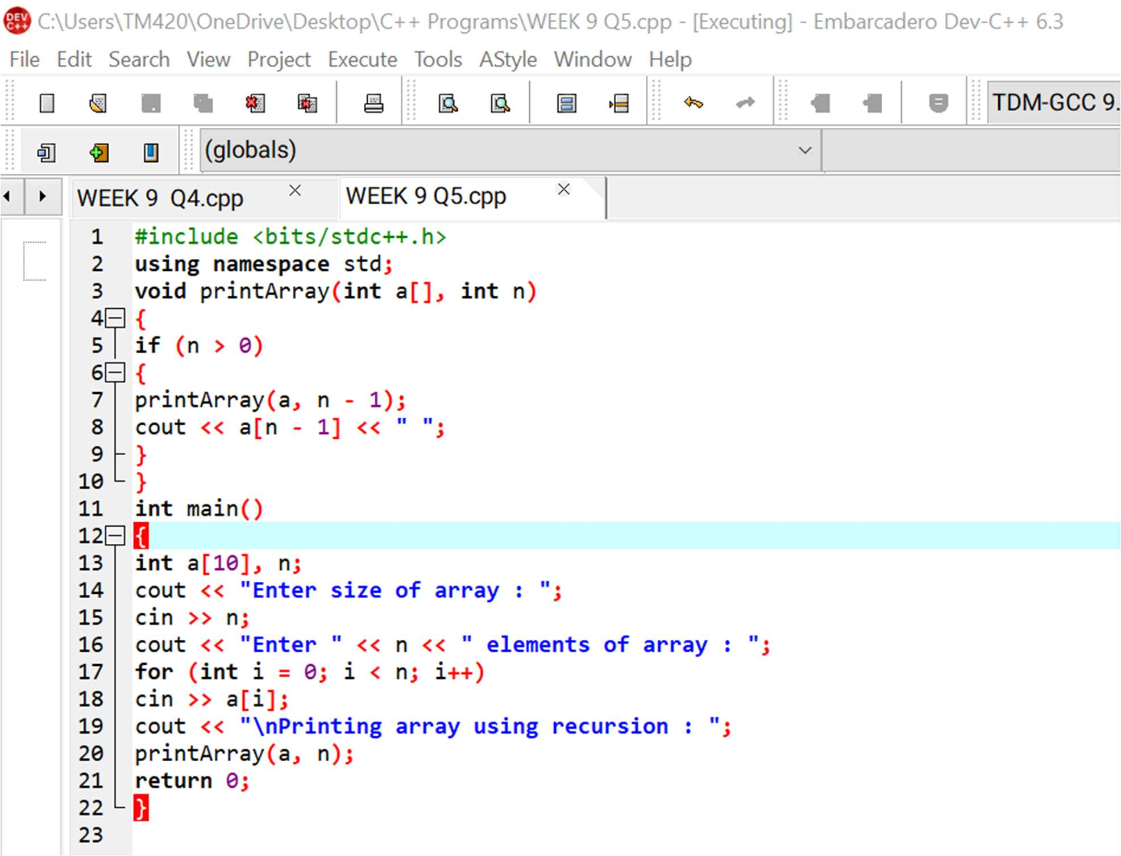This is the required code:

And this is its result:

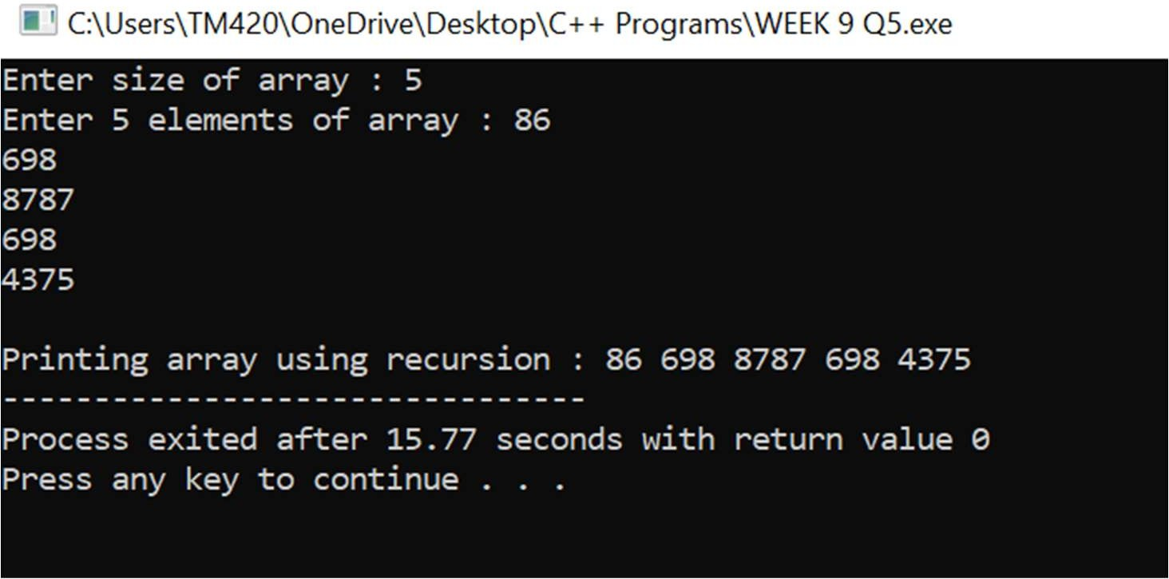

#6 Write a C++ program to find sum of elements of array using recursion.

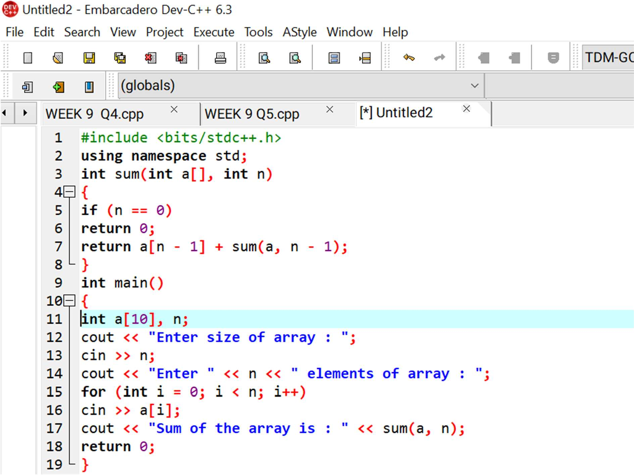This is the required code:

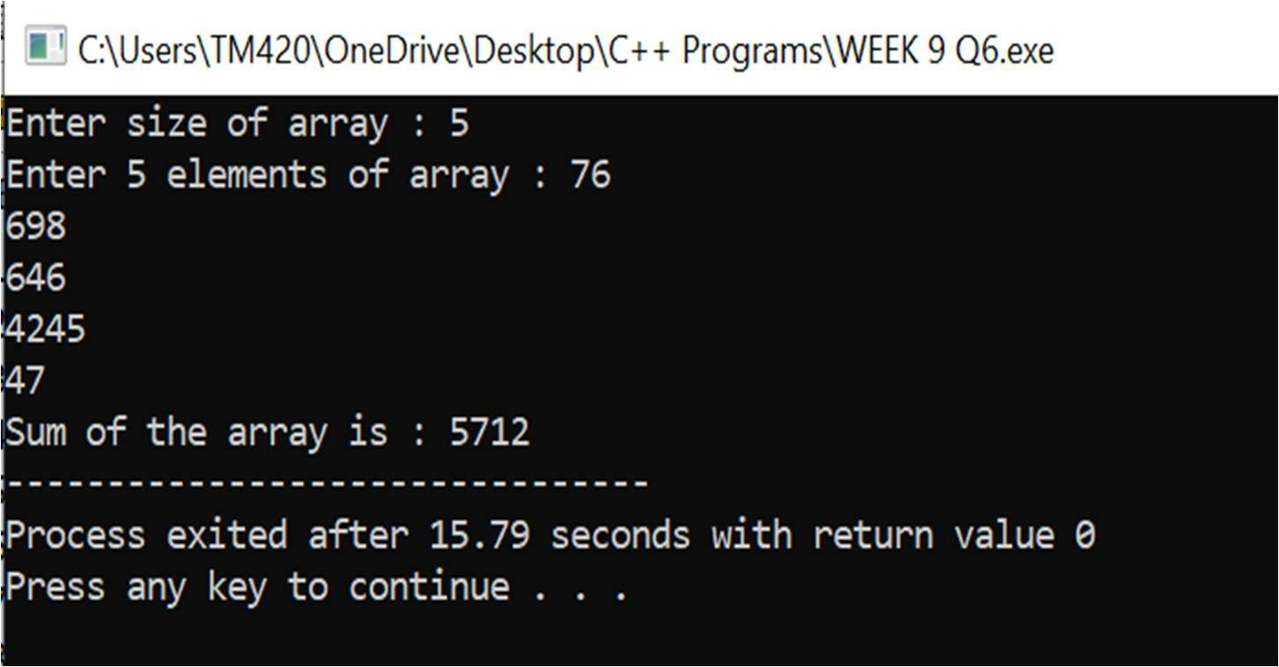And this is its result:

#7 Write a C++ program to find maximum and minimum elements in array using recursion.

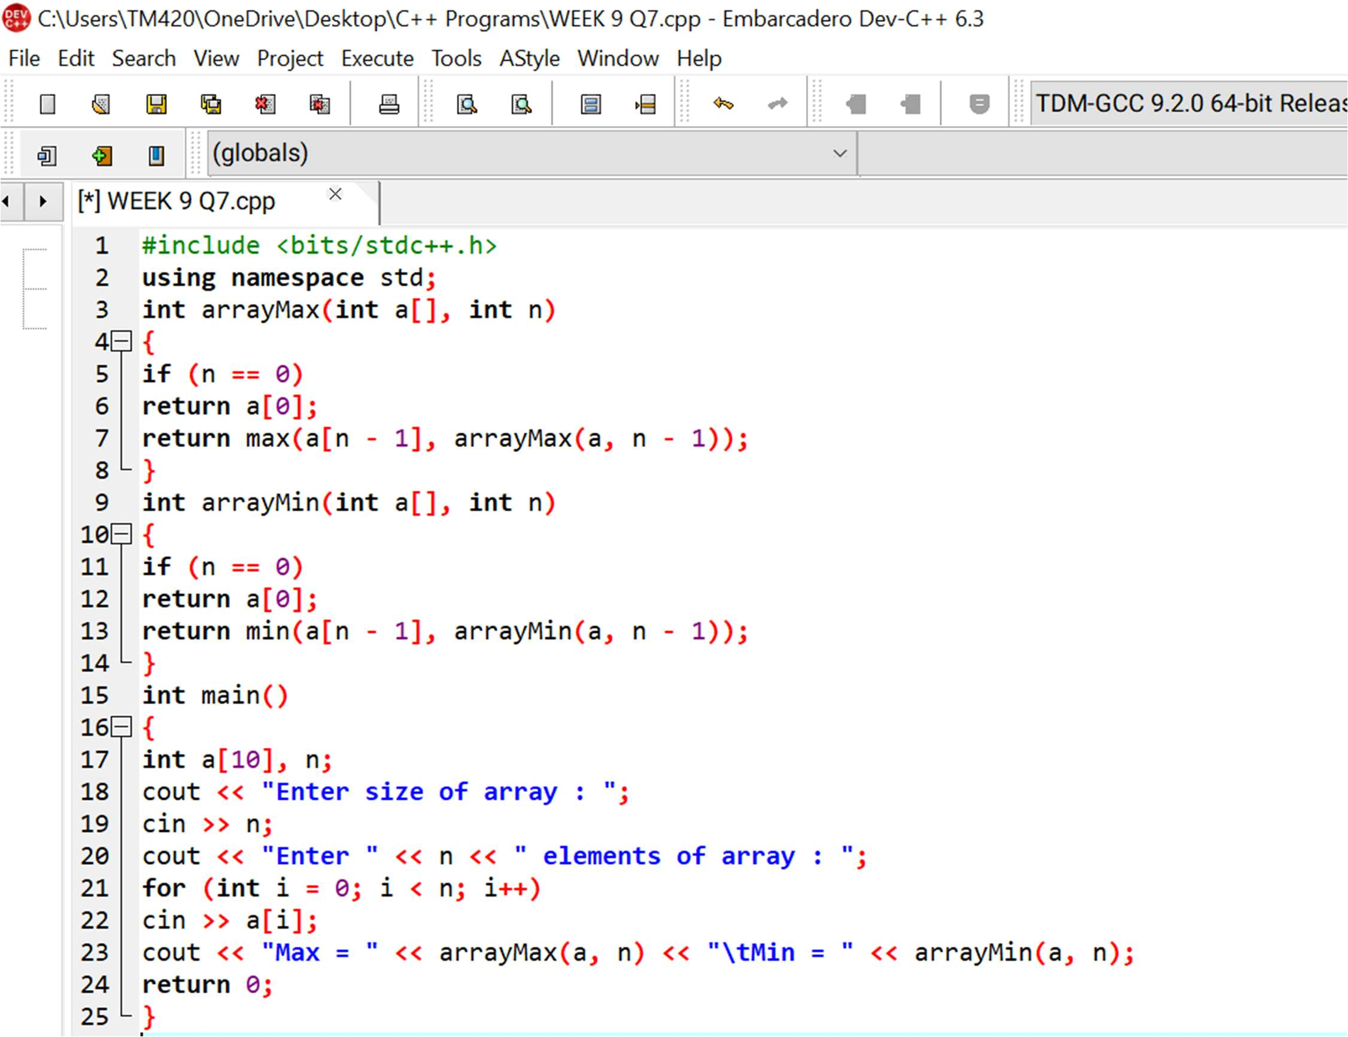This is the required code:

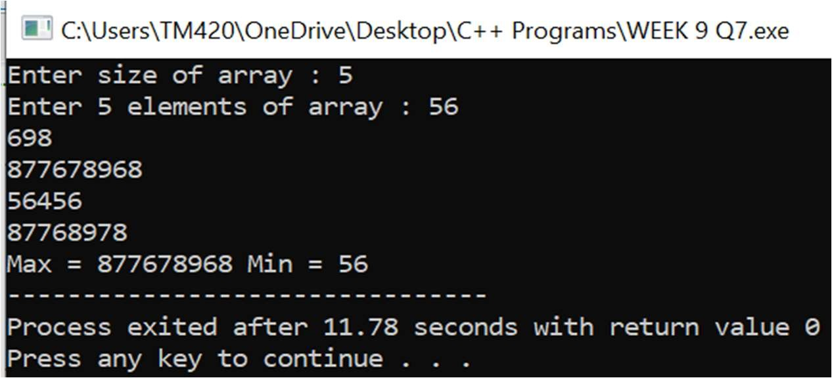And this is its result:

#8 Consider the insurance database given below. The primary keys are made bold and the data types are specified.

PERSON(driver_id:string , name:string , address:string ) CAR(regno:string , model:string , year:int ) ACCIDENT(report_number:int , accd_date:date , location:string ) OWNS(driver_id:string , regno:string )

PARTICIPATED(driver_id:string , regno:string , report_number:int , damage_amount:int).

* **Create the above tables by properly specifying the primary keys and foreign keys.**
* **Enter at least five tuples for each relation.**
* **Update the damage amount for the car with specific regno in the accident with report number 12 to 25000.**
* **Add a new accident to the database.**
* **Find the total number of people who owned cars that were involved in accidents in the year 2008.**
* **Find the number of accidents in which cars belonging to a specific model were involved.**
* Create table person(
* Driver_idvarchar(10),
* Name varchar(10),
* Address varchar(10),
* Primary key(driver_id));
* Create table car(
* Regnovarchar(10),
* Model varchar(10),
* Year int,
* Primary key(regno));
* Create table
* Accident(
* Report_numberint,
* Accd_date date,
* Location varchar(10),
* Primary key(report_number));
* Create table owns(
* Driver_idvarchar(10),
* Regnovarchar(10),
* Primary key(driver_id,regno),
* Foreign key(driver_id) references person(driver_id),
* Foreign key(regno) references car(regno));
* Create table participated(
* Driver_idvarchar(10),
* Regnovarchar(10),
* Report_numberint,
* Damage_amountint,
* Primary key(driver_id,regno,report_number),
* Foreign key(driver_id) references person(driver_id),
* Foreign key(regno) references car(regno),
* Foreign key(report_number) references accident(report_number));
* Insert into person values(‘D00001’,’Arjun’,’Aligarh’);
* Insert into person values(‘D00002’,’Mohsin’,’Mumbai’);
* Insert into person values(‘D00003’,’Abdullah’,’Delhi’);
* Insert into person values(‘D00004’,’Danish’,’Aligarh’);
* Insert into person values(‘D00005’,’Faizan’,’Delhi’);
* Insert into car values(‘RGN2504’,’BMWV8X6’,’2019’);
* Insert into car values(‘RGN3324’,’AUDI R8’,’2018’);
* Insert into car values(‘RGN4598’,’HONDA NSX’,’2008’);
* Insert into car values(‘RGN2254’,’MAYBATCH’,’2008’);
* Insert into car values(‘RGN8723’,’AUDIQ7’,’2017’);
* Insert into accident values(‘9’,’2008-07-28’,’Mumbai’);
* Insert into accident values(‘12’,’2009-08-21’,’Aligarh’);
* Insert into accident values(‘13’,’2018-11-12’,’Gwalior’);
* Insert into accident values(‘25’,’2014-01-25’,’Meerut’);
* Insert into accident values(‘33’,’2008-03-31’,’Delhi’);
* Insert into owns values(‘D00001’,’RGN2504’);
* Insert into owns values(‘D00002’,’RGN3324’);
* Insert into owns values(‘D00003’,’RGN4598’);
* Insert into owns values(‘D00004’,’RGN2254’);
* Insert into owns values(‘D00005’,’RGN8723’);
* Insert into participated values(‘D00001’,’RGN2504’,’9’,’25769’);
* Insert into participated values(‘D00004’,’RGN2254’,’25’,’60000’);
* Insert into participated values(‘D00005’,’RGN8723’,’33’,’73000’);
* Insert into participated values(‘D00002’,’RGN3324’,’12’,’30000’);
* Insert into participated values(‘D00003’,’RGN4598’,’13’,’10000’);

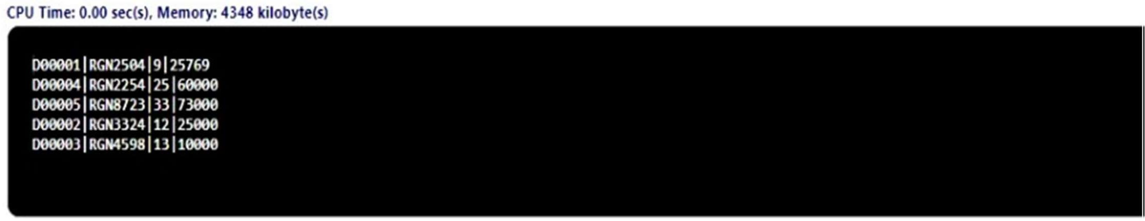

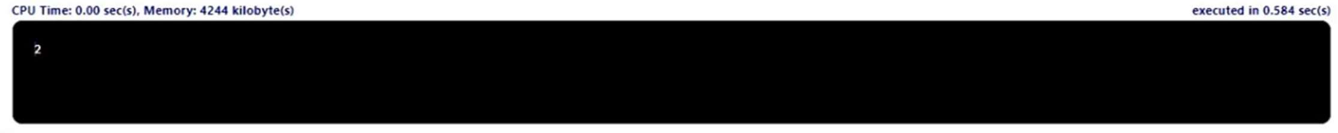

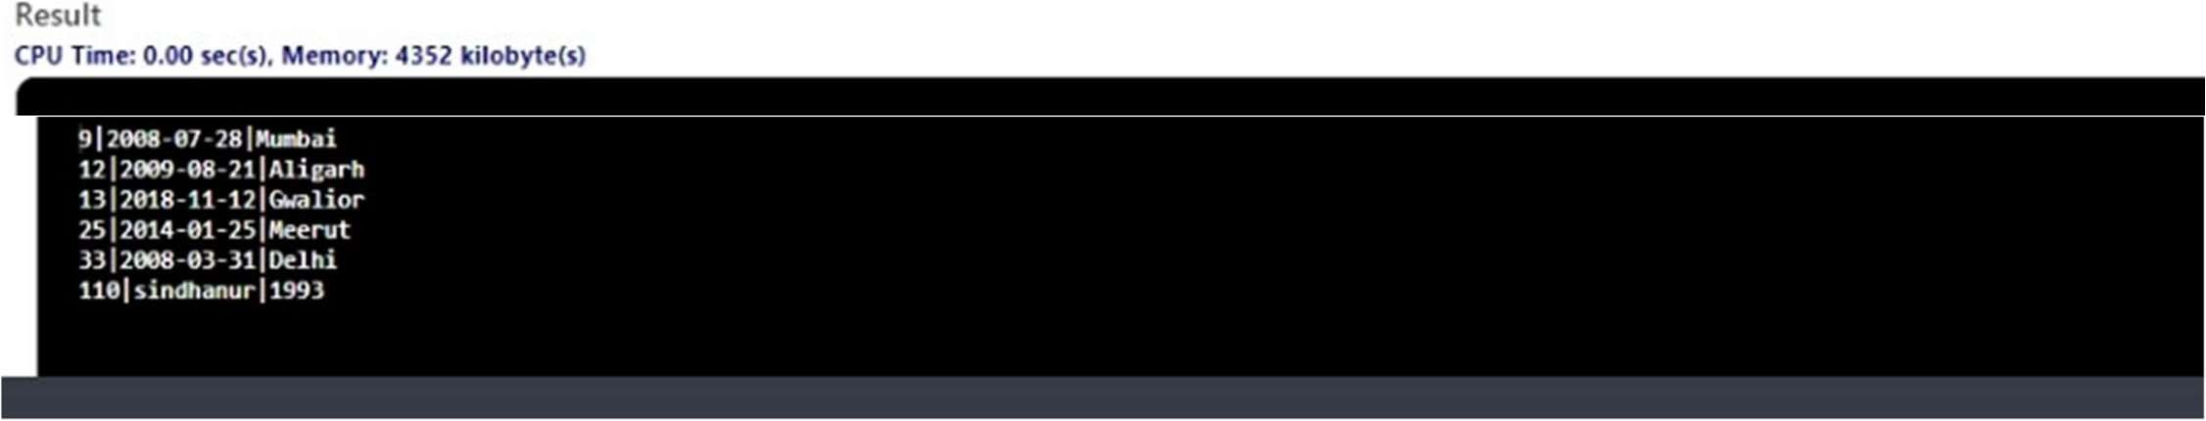

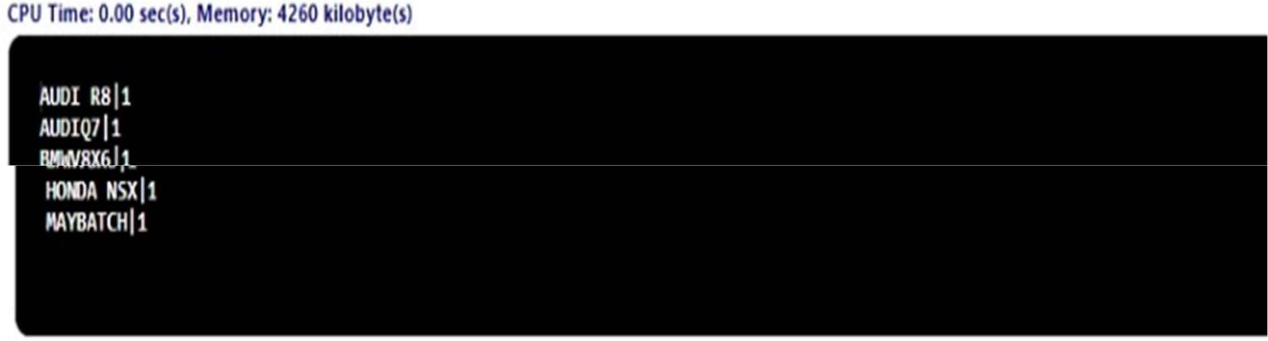



WEEK 10

# WEEK 10

#1 Write a C++ program that uses functions to perform the following operations:

1. **Reading a complex number**
2. **Writing a complex number**
3. **Addition and subtraction of two complex numbers**
4. **Multiplication of two complex numbers. Note: represent complex number using a structure.**

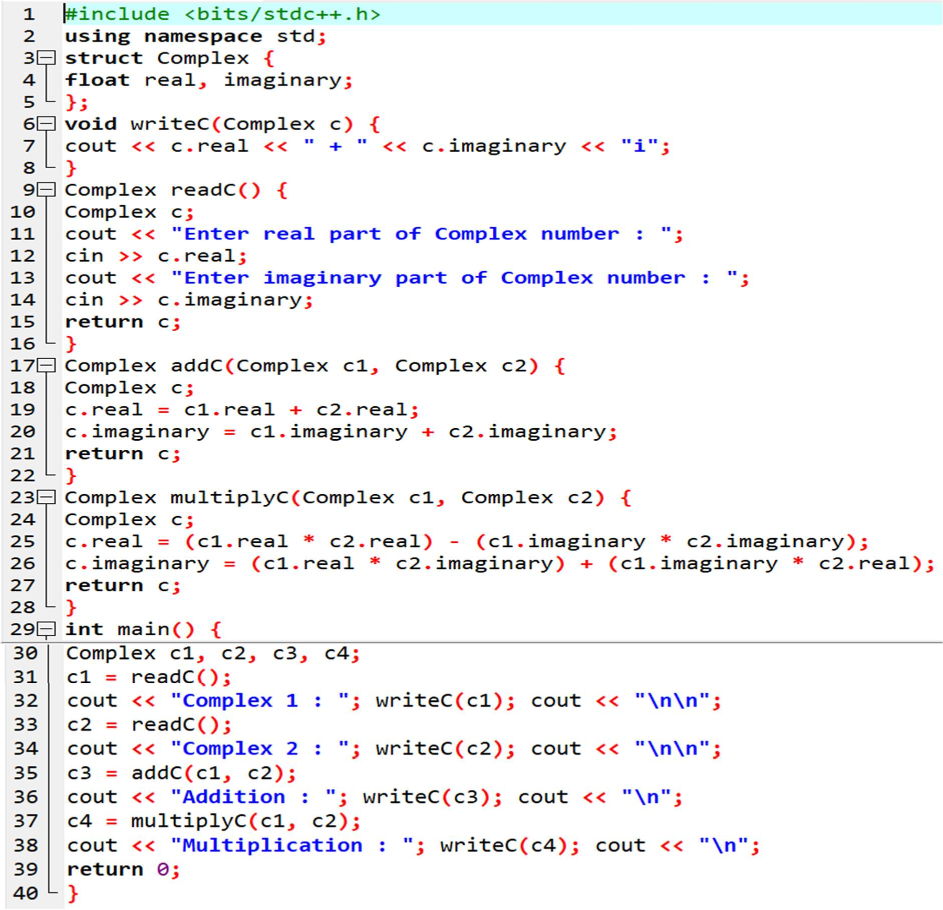This is the required code:

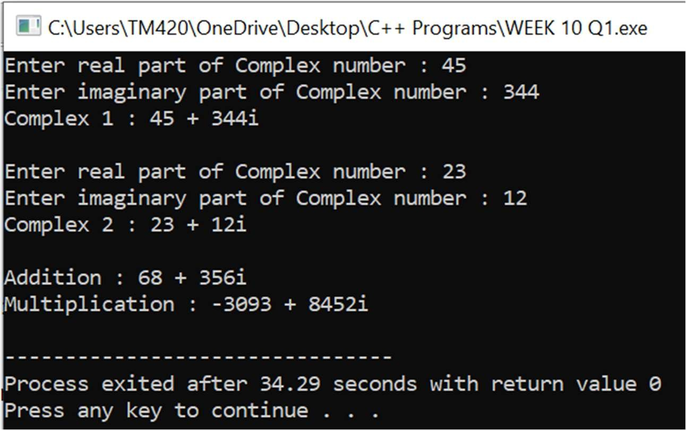And this is its result:

#2 Write a C++ program to compute the monthly pay of 100 employees using each employee’s name, basic pay. The DA is computed as 52% of the basic pay. Gross-salary (basic pay + DA). Print the employees name and gross salary.

This is the required code:

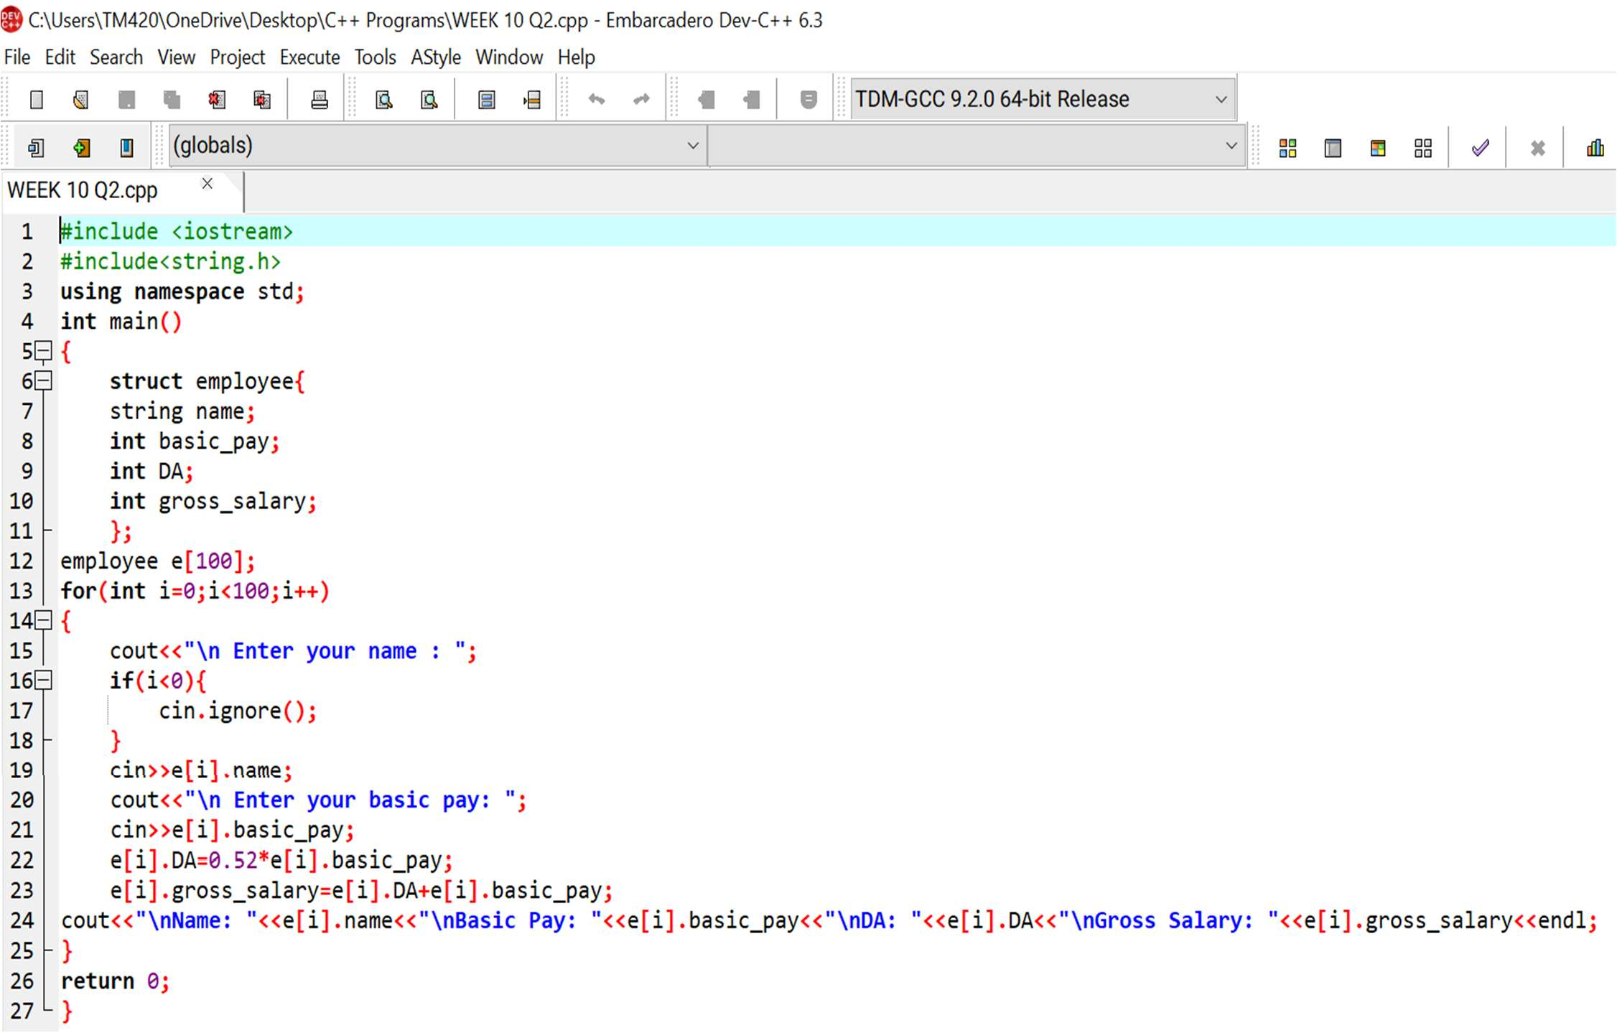

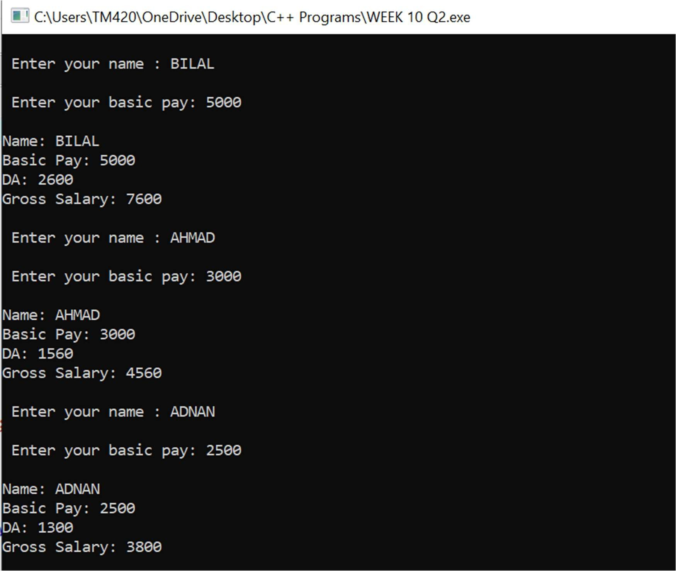And this is the result:

It is for three employees only. Although the result can print up to 100 employees I won’t be providing it here because it will become too long.

#3 Create a Book structure containing book_id, title, author name and price. Write a C++ program to pass a structure as a function argument and print the book details.

The required code is given on the next page:

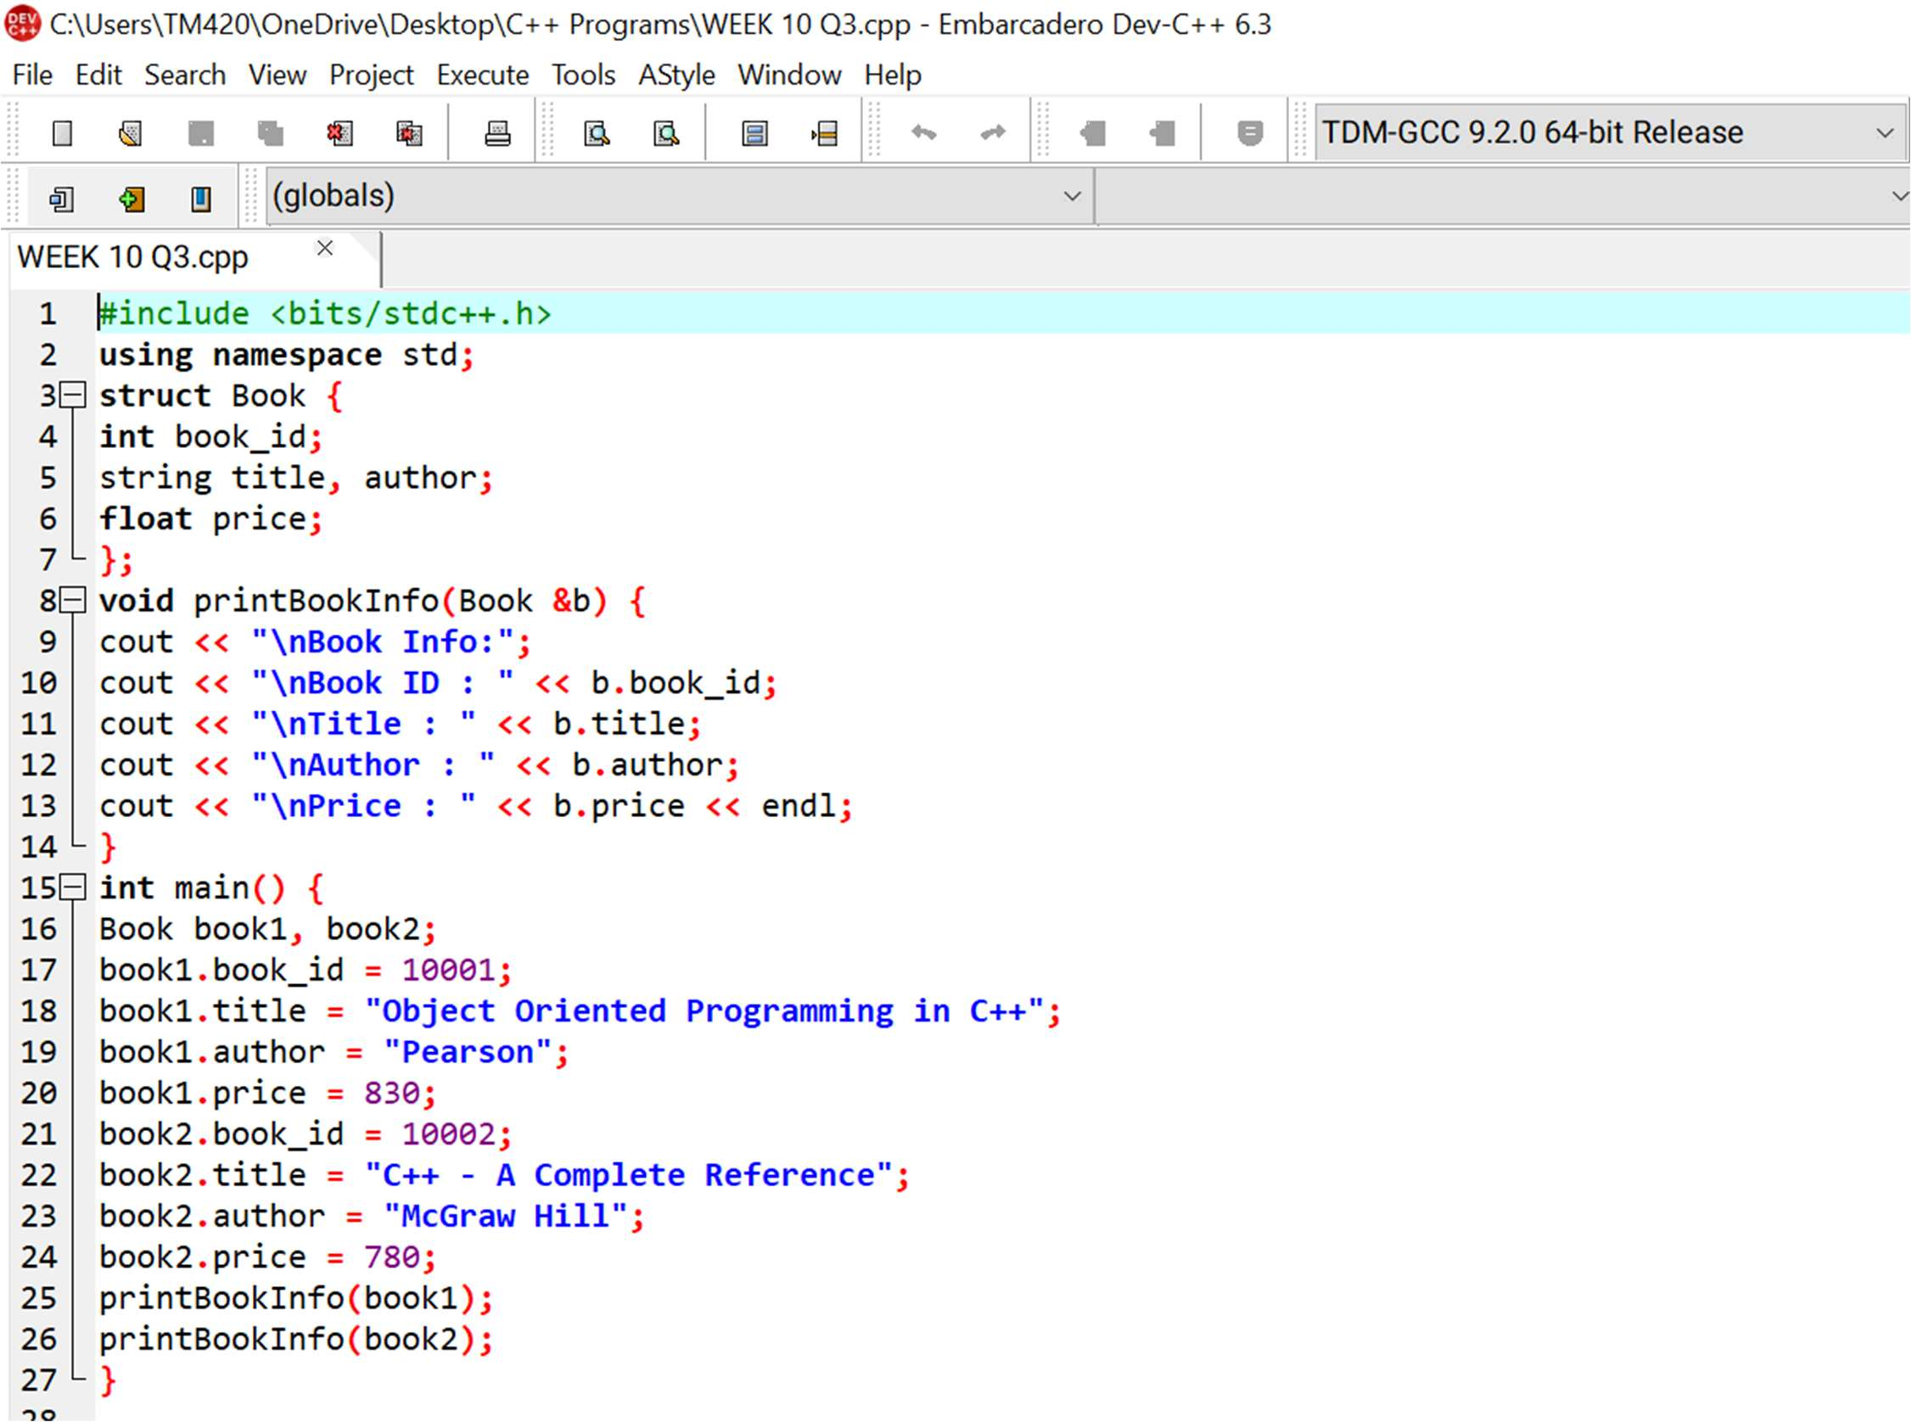

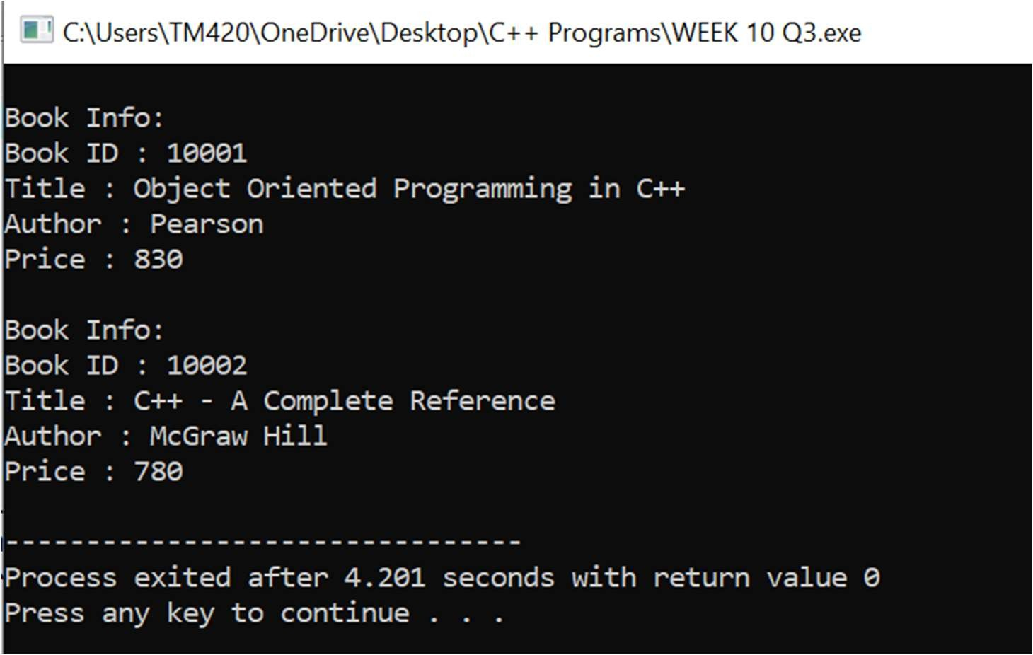And this is its result:

#4 Create a union containing 6 strings: name, home_address, hostel_address, city, state and zip. Write a C++ program to display your present address.

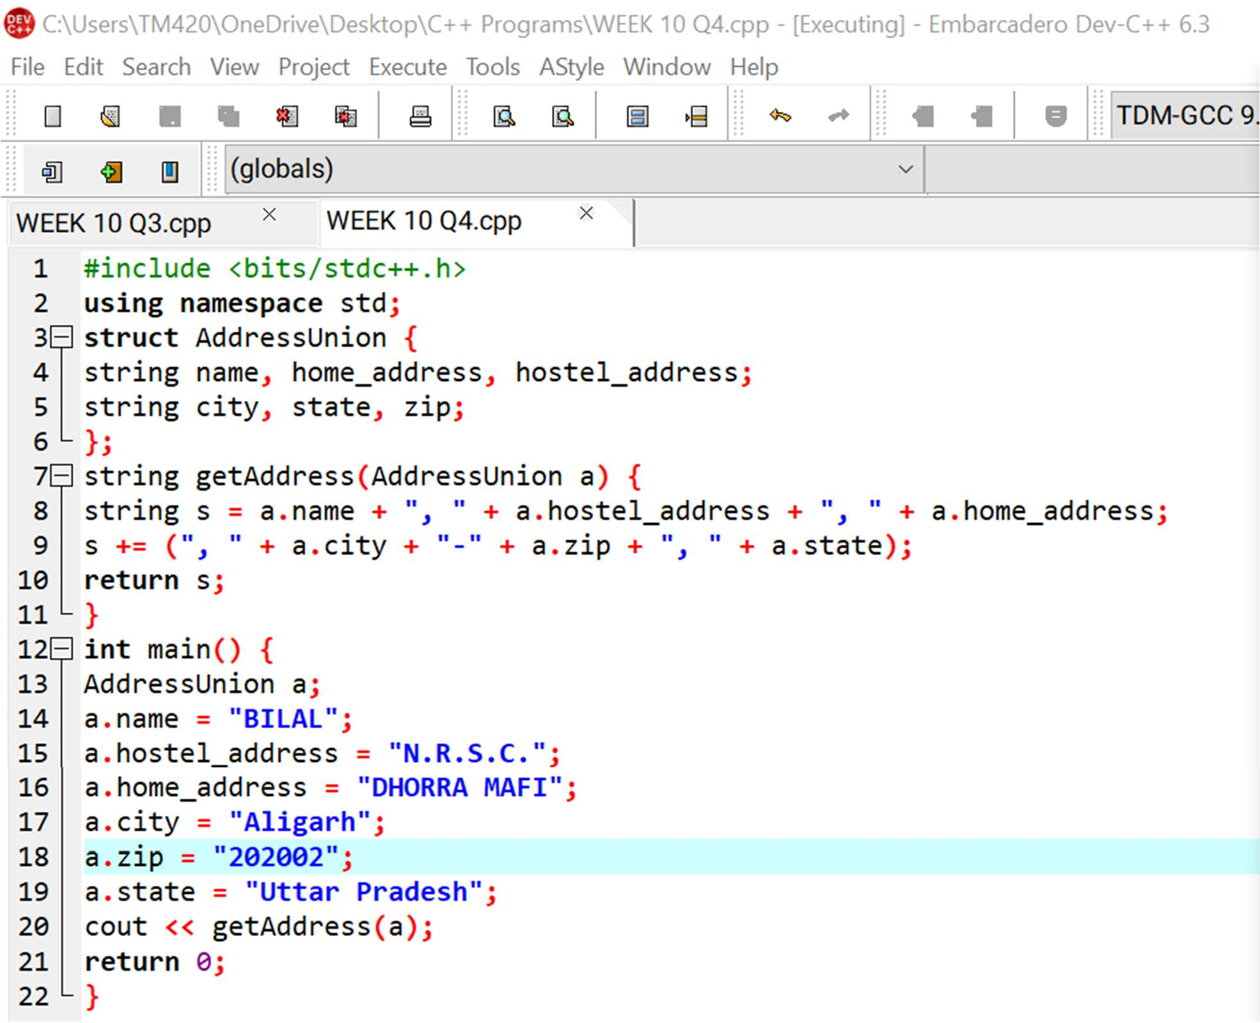This is the required code:

And this is its result:

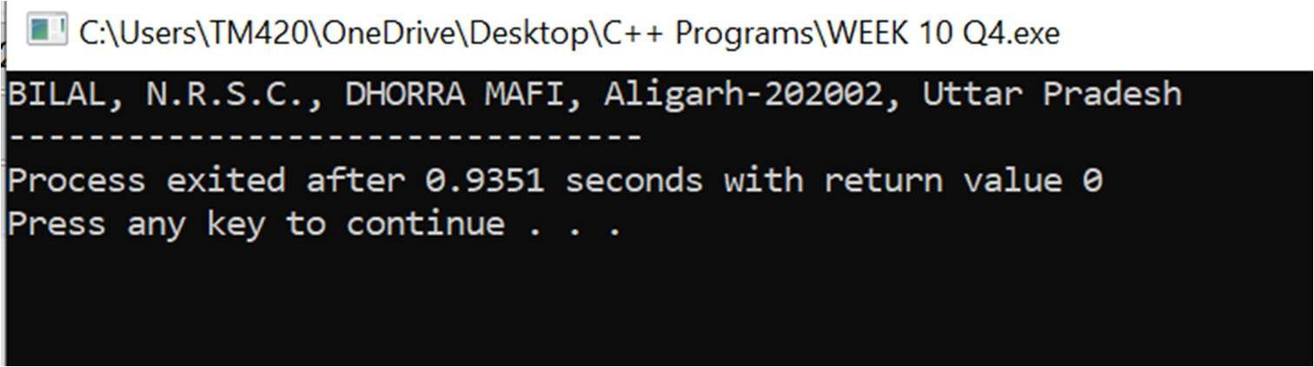

#5 Write a C++ program to define a structure named DOB, which contains name, day, month and year. Using the concept of nested structures display your name and date of birth.

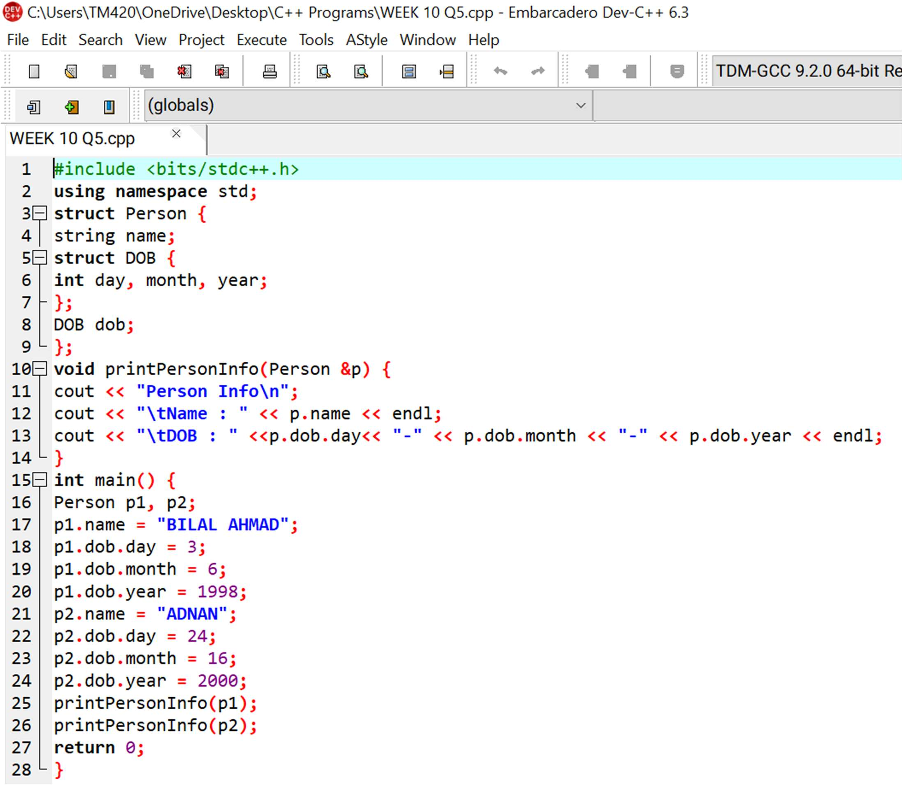This is the required code:

And this is its result:

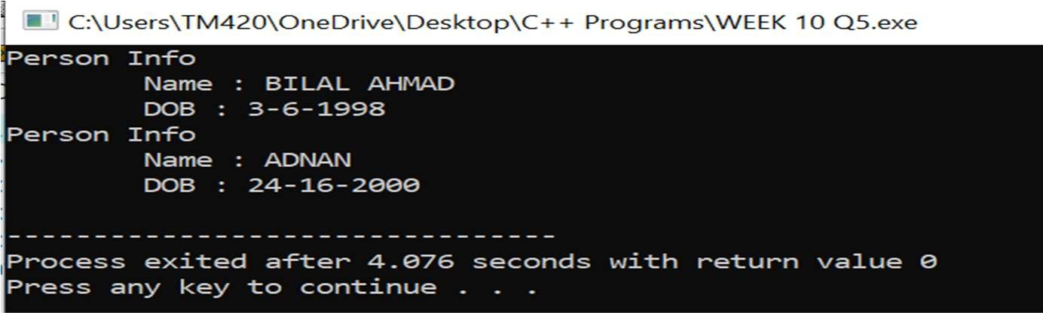

#6 Consider the following database for a banking enterprise. BRANCH( branch_name:string , branch_city:string , assets:real ) ACCOUNT( accno:int , branch_name:string , balance:real ) DEPOSITOR( customer_name:string , accno:int )

CUSTOMER( customer_name:string, customer_street:string , customer_city: string )

LOAN( loan_number:int , branch_name:string , amount:real ) BORROWER( customer_name:string , loan_number:int )

1. **Create the above tables by properly specifying the primary keys and foreign keys.**
2. **Enter at least five tuples for each relation.**
3. **Find all the customers who have at least two accounts at the main branch.**
4. **Find all the customers who have an account at all the branches located in a specific city.**
5. **Demonstrate how you delete all account tuples at every branch located in a specific city.**

This is the required code:

CREATE TABLE BRANCH (

BNAME VARCHAR(20) PRIMARY KEY, CITY VARCHAR(20) NOT NULL, ASSETS REAL

);

CREATE TABLE ACCOUNT ( ACCNO INT PRIMARY KEY, BNAME VARCHAR(20) NOT NULL, BALANCE REAL,

FOREIGN KEY (BNAME) REFERENCES BRANCH(BNAME) /* SPECIFY TRIGGER IF YOU WANT ! ON DELETE ON UPDATE ! */

);

CREATE TABLE CUSTOMER (

CNAME VARCHAR(20) PRIMARY KEY, CSTREE VARCHAR(20) NOT NULL, CITY VARCHAR(20) NOT NULL

);

CREATE TABLE DEPOSITOR ( CNAME VARCHAR(20) NOT NULL, ACCNO INT,

PRIMARY KEY (CNAME, ACCNO),

FOREIGN KEY (ACCNO) REFERENCES ACCOUNT (ACCNO) ON DELETE CASCADE,

FOREIGN KEY (CNAME) REFERENCES CUSTOMER (CNAME) ON DELETE CASCADE

);

CREATE TABLE LOAN ( INO INT PRIMARY KEY,

BNAME VARCHAR(20) NOT NULL, AMOUNT REAL,

FOREIGN KEY (BNAME) REFERENCES BRANCH (BNAME) ON DELETE CASCADE

);

CREATE TABLE BORROWER ( CNAME VARCHAR(10),

INO INT,

PRIMARY KEY (CNAME, INO),

FOREIGN KEY (CNAME) REFERENCES CUSTOMER (CNAME) ON DELETE CASCADE,

FOREIGN KEY (INO) REFERENCES LOAN (INO) ON DELETE CASCADE

);

/*

QUESTION - ENTER ATLEAST FIVE TUPLES FOR EACH RELATION !

*/

INSERT INTO BRANCH VALUES ('ABC', 'BANGALORE', 1200000); INSERT INTO BRANCH VALUES ('DEF', 'CHENNAI', 2000000); INSERT INTO BRANCH VALUES ('ABN', 'MUMBAI', 3300000); INSERT INTO BRANCH VALUES ('XYZ', 'HYDERABAD', 555555); INSERT INTO BRANCH VALUES ('MNO', 'BANGALORE', 9999999);

/* ACCOUNT APPEARS TO BE AN SQL KEYWORD ! HOWEVER IT WILL WORK HERE ... */

INSERT INTO ACCOUNT VALUES (1, 'ABC', 25000); INSERT INTO ACCOUNT VALUES (2, 'DEF', 12000); INSERT INTO ACCOUNT VALUES (3, 'DEF', 1000); INSERT INTO ACCOUNT VALUES (4, 'ABN', 10000); INSERT INTO ACCOUNT VALUES (5, 'MNO', 60000); INSERT INTO ACCOUNT VALUES (6, 'XYZ', 50000);

INSERT INTO CUSTOMER VALUES ('MIK', 'AB', 'BANGALORE'); INSERT INTO CUSTOMER VALUES ('MUJ', 'CD', 'BANGALORE'); INSERT INTO CUSTOMER VALUES ('MAJ', 'EF', 'CHENNAI'); INSERT INTO CUSTOMER VALUES ('WAJ', 'XY', 'DELHI'); INSERT INTO CUSTOMER VALUES ('PRAD', 'LM', 'MUMBAI'); INSERT INTO CUSTOMER VALUES ('NOW', 'OP', 'HYDERABAD'); INSERT INTO DEPOSITOR VALUES ('MIK', 2);

INSERT INTO DEPOSITOR VALUES ('MUJ', 1); INSERT INTO DEPOSITOR VALUES ('MUJ', 5); INSERT INTO DEPOSITOR VALUES ('PRAD', 4); INSERT INTO DEPOSITOR VALUES ('MAJ', 3); INSERT INTO DEPOSITOR VALUES ('WAJ', 6); INSERT INTO DEPOSITOR VALUES ('MIK', 3); INSERT INTO LOAN VALUES (1, 'ABC', 5000); INSERT INTO LOAN VALUES (2, 'DEF', 1500); INSERT INTO LOAN VALUES (3, 'ABN', 100000);

INSERT INTO LOAN VALUES (4, 'XYZ', 3500); INSERT INTO LOAN VALUES (5, 'MNO', 200000);

/*

QUESTION - FIND ALL THE CUSTOMERS WHO HAVE ATLEAST 2 ACCOUNTS IN THE MAIN BRANCH

*/

SELECT CNAME

FROM ACCOUNT, DEPOSITOR

WHERE ACCOUNT.ACCNO = DEPOSITOR.ACCNO AND BNAME = 'DEF' GROUP BY CNAME

HAVING COUNT(*) > 1 ;

/*

QUESTION - FIND ALL THE CUSTOMERS WHO HAVE AN ACCOUNT AT ALL THE BRANCHES LOCATED IN A SPECIFIC CITY.

YOU CAN TAKE ANY CITY NAME HERE ! LET'S TAKE IT TO BE BANGALORE HERE !

*/

SELECT CNAME

FROM BRANCH B, ACCOUNT A, DEPOSITOR D WHERE B.BNAME = A.BNAME AND

A.ACCNO = D.ACCNO AND B.CITY = 'BANGALORE'

GROUP BY CNAME HAVING COUNT( DISTINCT(B.BNAME)) = ( SELECT COUNT(BNAME)

FROM BRANCH WHERE CITY =

'BANGALORE' );

/*

QUESTION - DEMONSTRATE HOW YOU DELETE ALL ACCOUNT TUPLES AT EVERY BRANCH LOCATED IN SPECIFIC CITY.

*/

/* CHECK THE ENTRIES OF THE ACCOUNT TABLE */SELECT * FROM ACCOUNT ;

/* DELETE THE ACCOUNT ENTRY WITH CERTAIN CONDITIONS */ DELETE FROM ACCOUNT

WHERE BNAME IN (SELECT BNAME FROM BRANCH WHERE CITY = 'BANGALORE');

/* CHECK THE ACCOUNT TABLE AGAIN TO CHECK WHETHER THE ENTRY IS DELETED OR NOT !! */

SELECT * FROM ACCOUNT ; SELECT * FROM ACCOUNT ;

/* DELETE THE ACCOUNT ENTRY WITH CERTAIN CONDITIONS */ DELETE FROM ACCOUNT

WHERE BNAME IN (SELECT BNAME FROM BRANCH WHERE CITY = 'BANGALORE');

/* CHECK THE ACCOUNT TABLE AGAIN TO CHECK WHETHER THE ENTRY IS DELETED OR NOT !! */

SELECT * FROM ACCOUNT ;

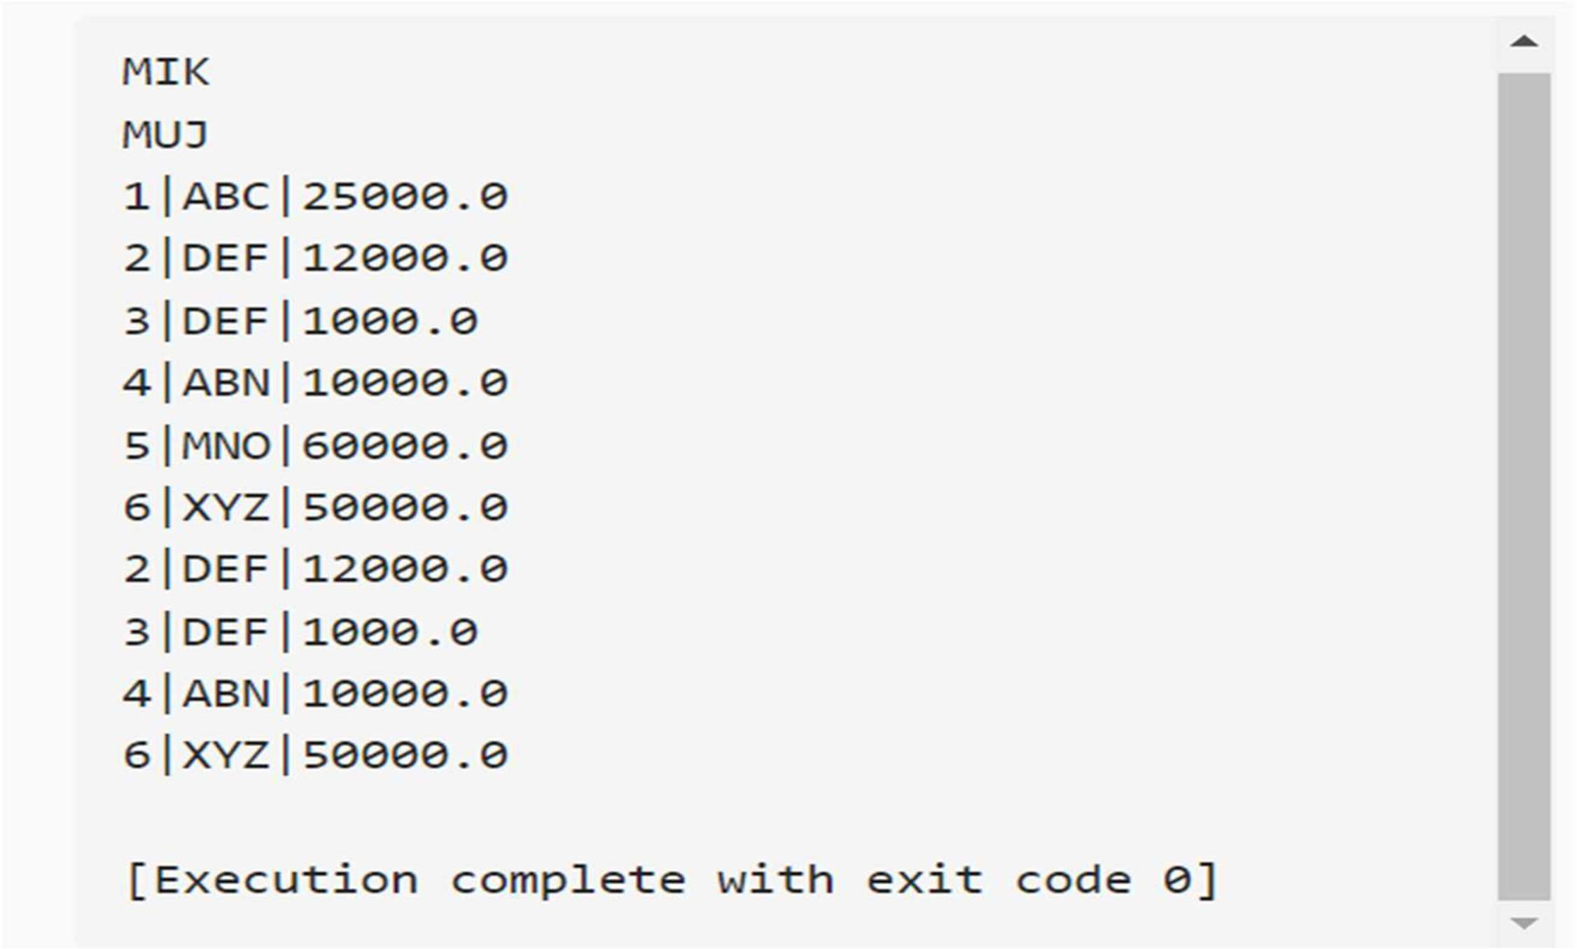**OUTPUT:**